PHOTRONICS


2025

A N N U A L RE P O RT

P r o xy S t a t em en t

For m 1 0 - K

CONTENTS
PROXY STATEMENT ................................... | 1P
FORM 10-K ............................................ | 1K
CORPORATE INFORMATION .................. | BC

Photronics is one of the worlds leading manufacturers of photomasks, which are high-precision photographic quartz plates containing microscopic images of electronic circuits. Photomasks are a key element in the manufacture of semiconductors and flat panel displays, and are used as masters to transfer circuit patterns onto semiconductor wafers and flat display substrates during the fabrication of integrated circuits and a variety of flat panel displays and, to a lesser extent, other types of electrical and optical components. The photomasks are produced by Photronics at strategically located manufacturing facilities in Asia, Europe and North America in accordance with customer-provided designs. Additional information on the Company can be accessed at www.photronics.com.


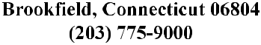
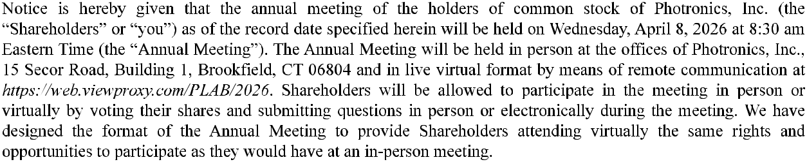
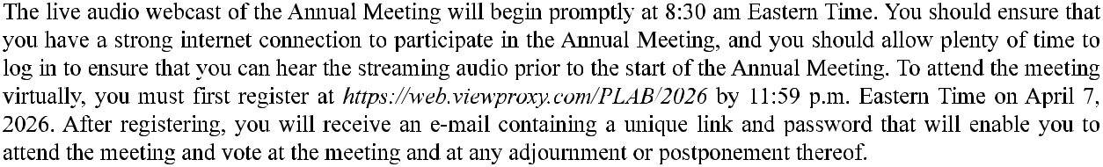
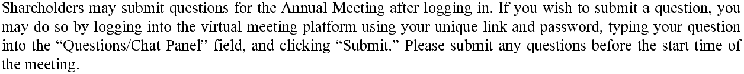
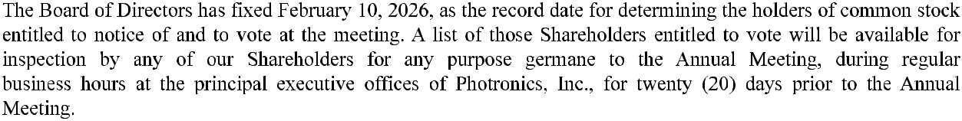

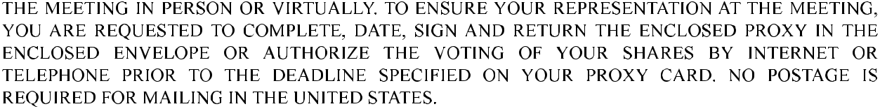
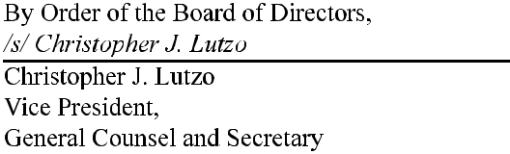

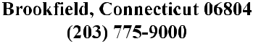
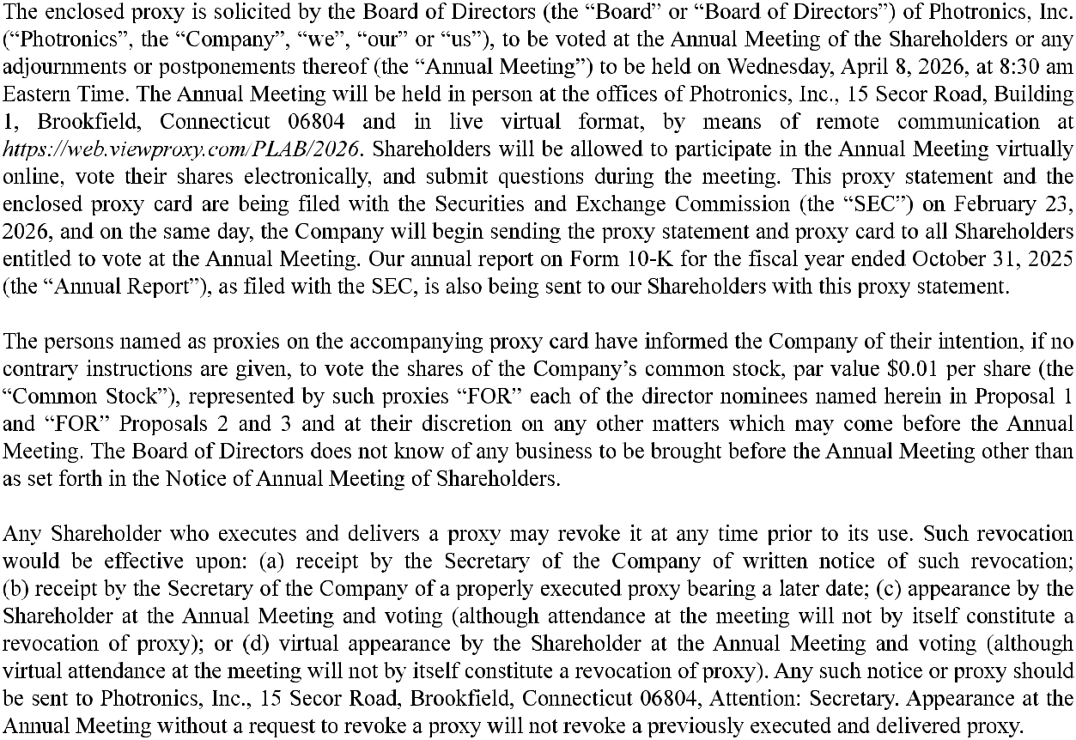

1



2

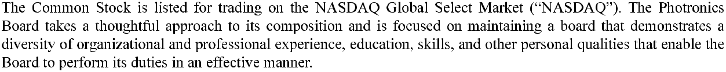
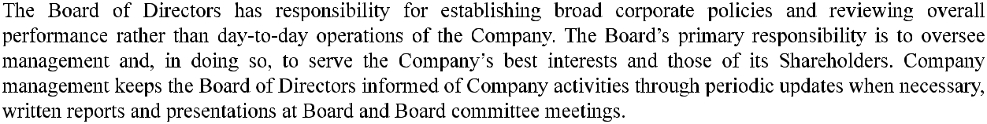
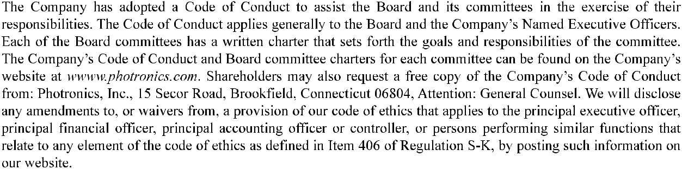


3

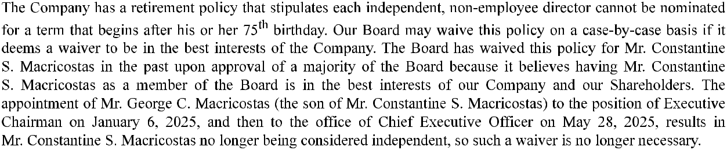
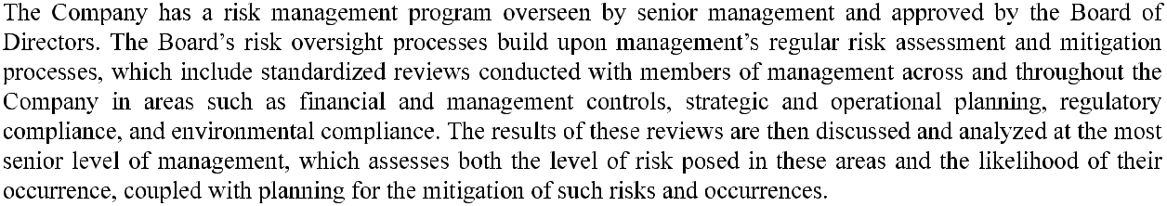
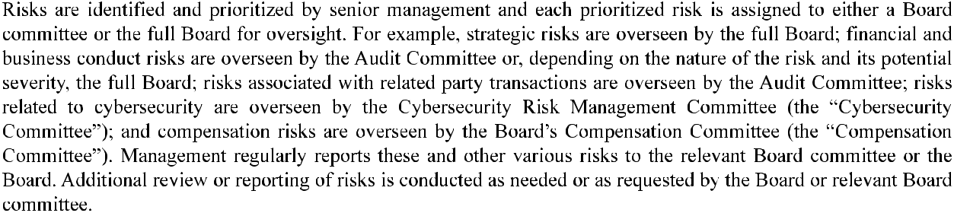
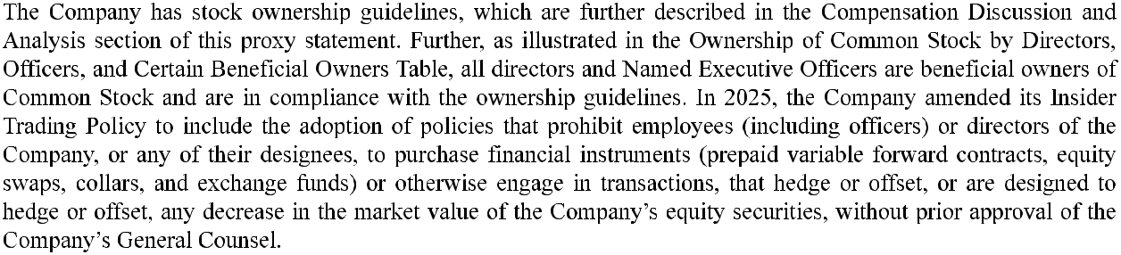

4

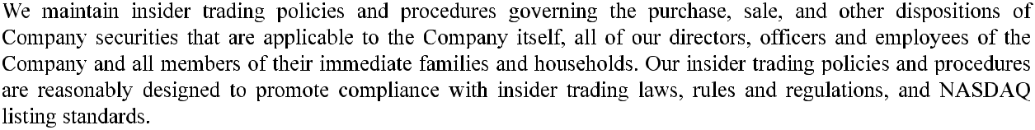
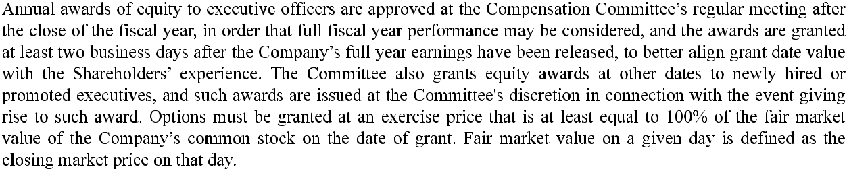

5

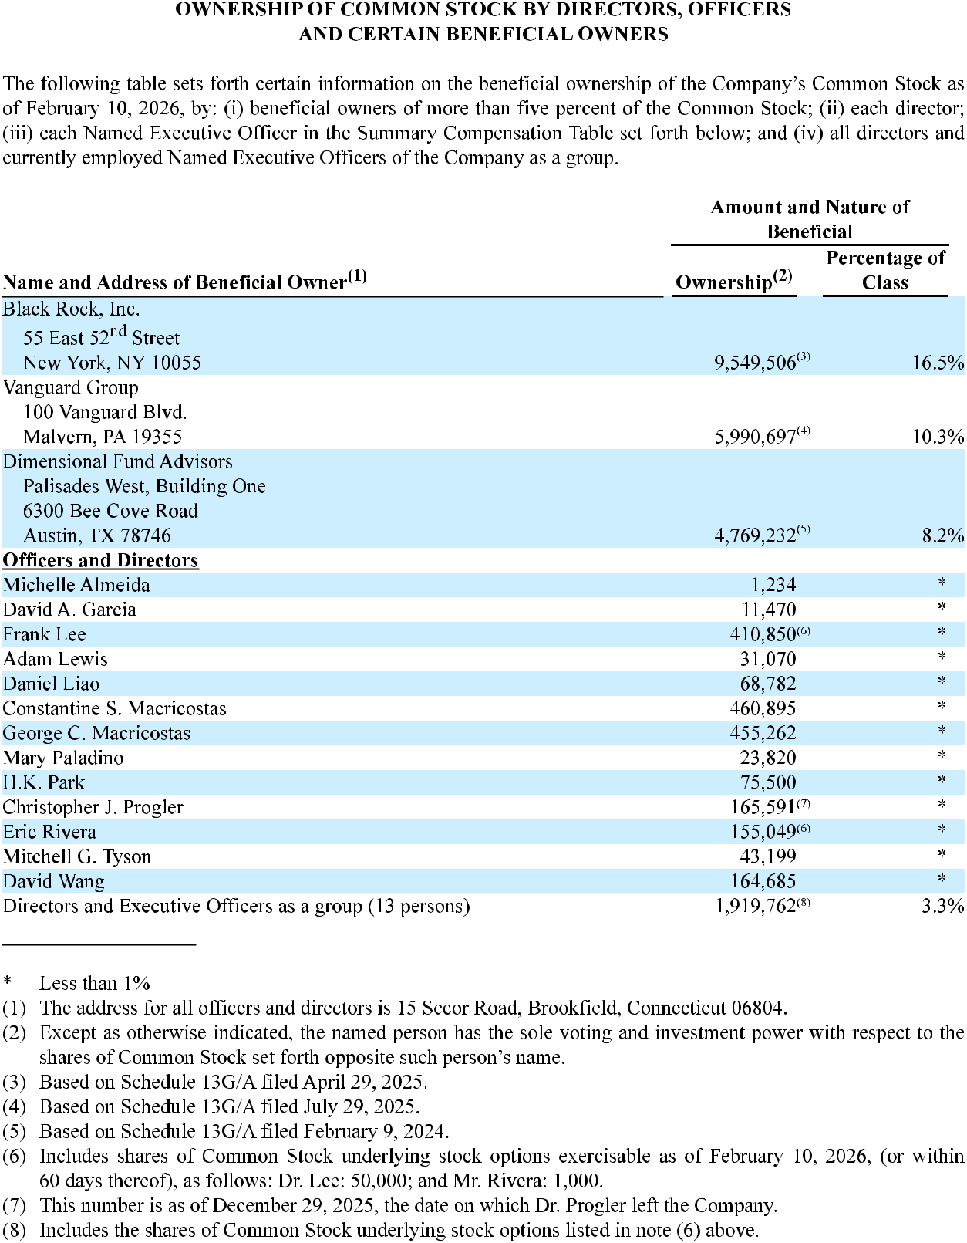

6

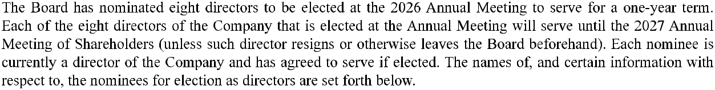
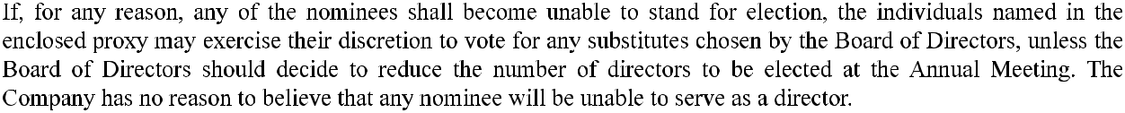
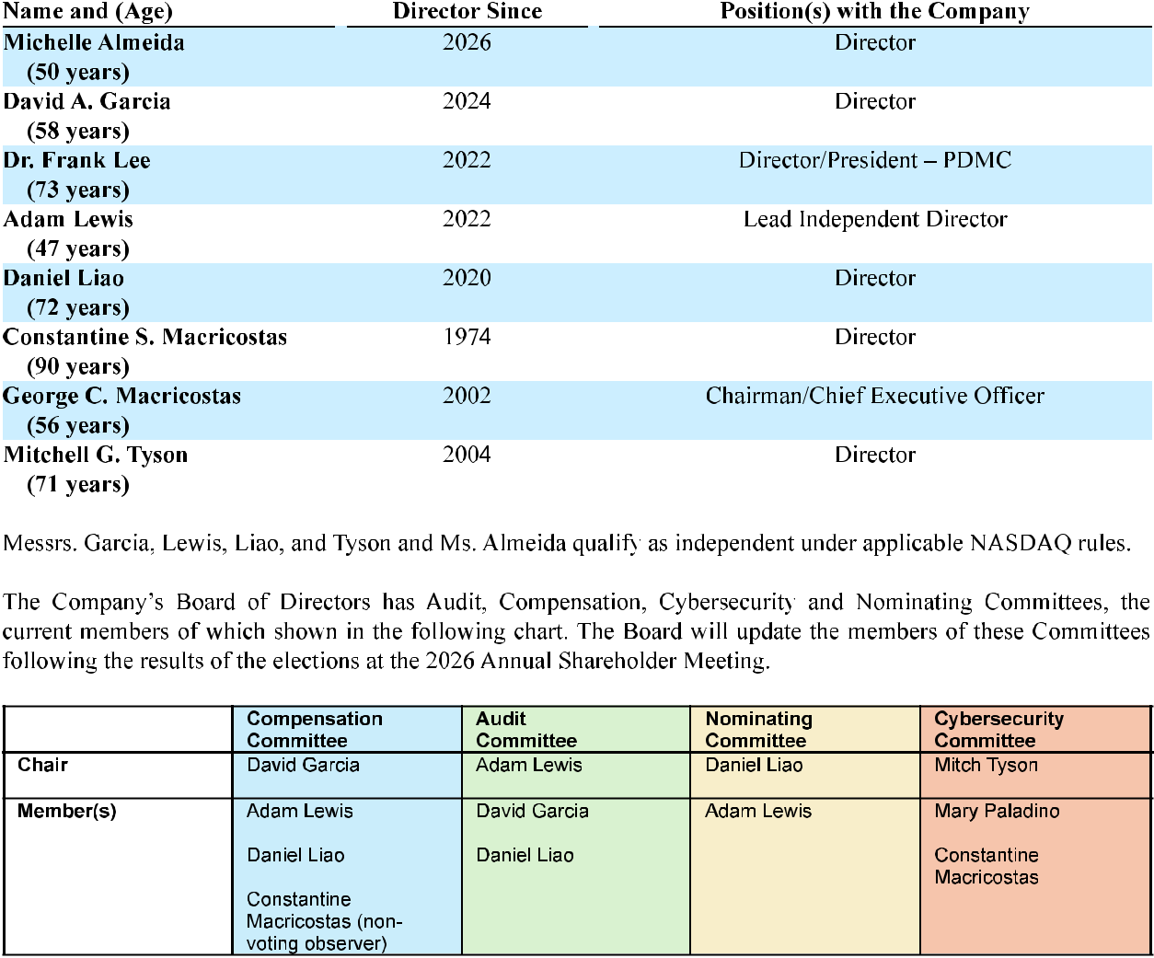

7

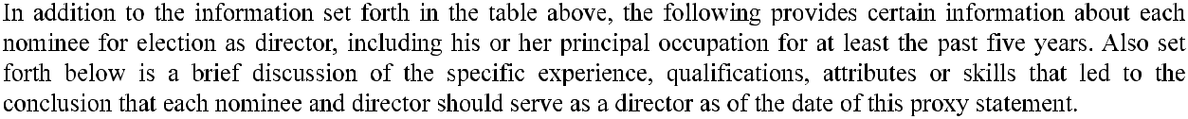


8

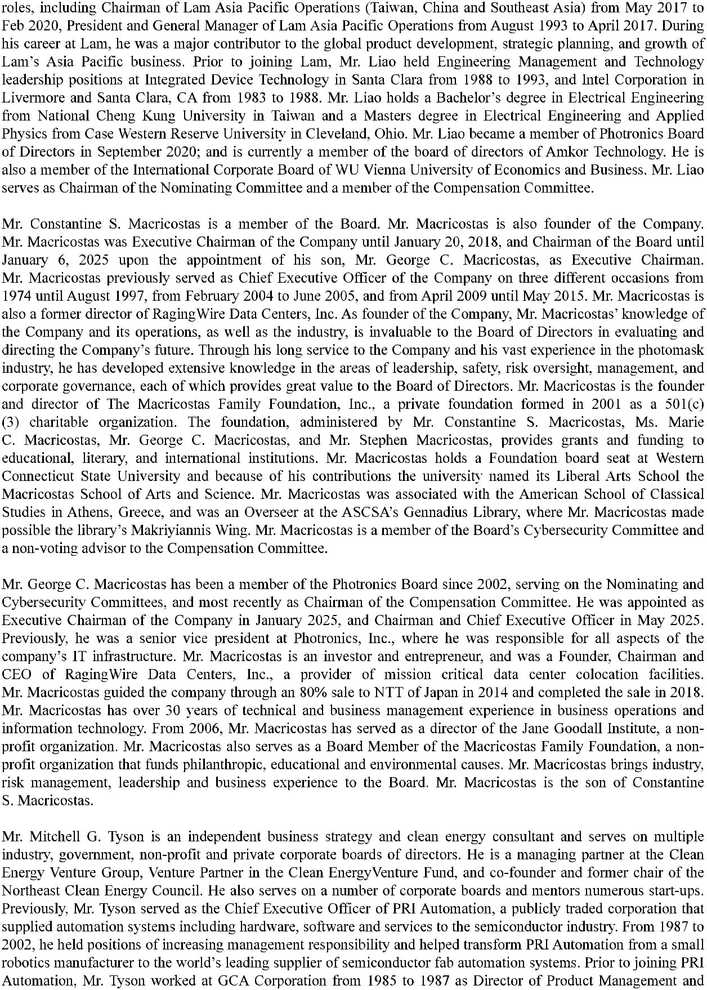

9

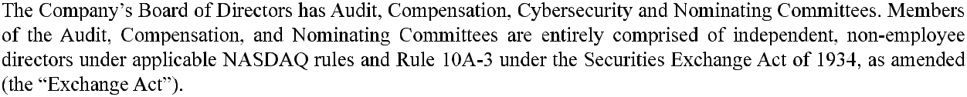


10

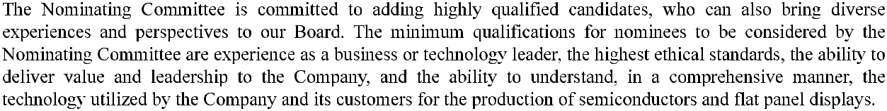
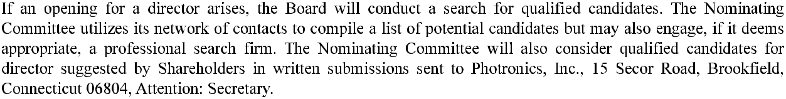
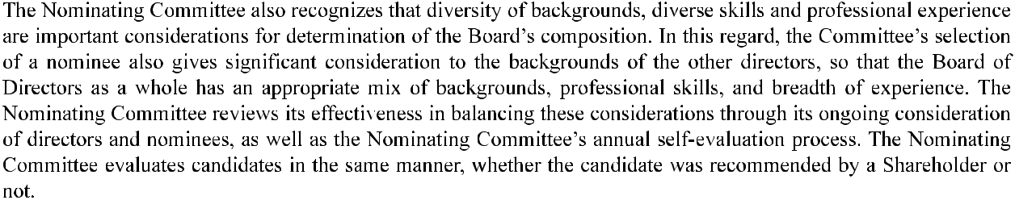
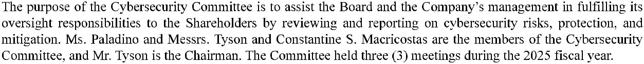
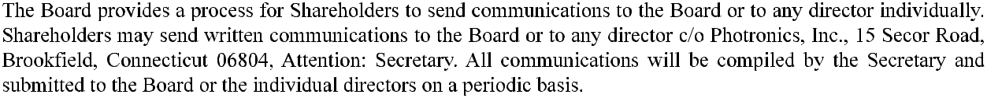
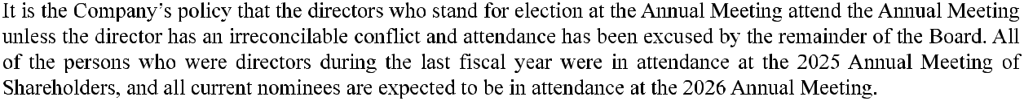

11

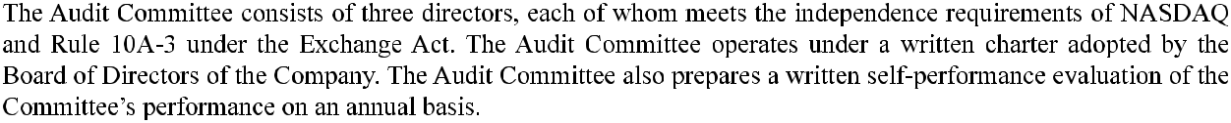
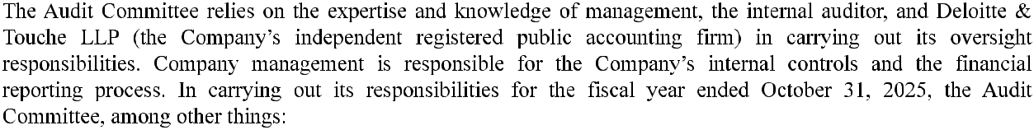
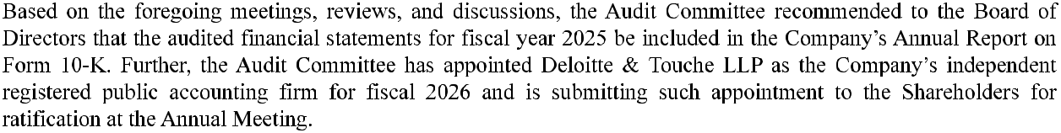
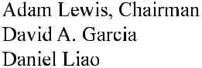

12

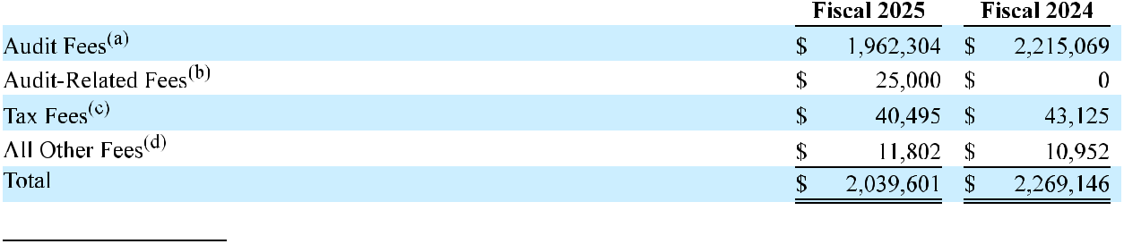
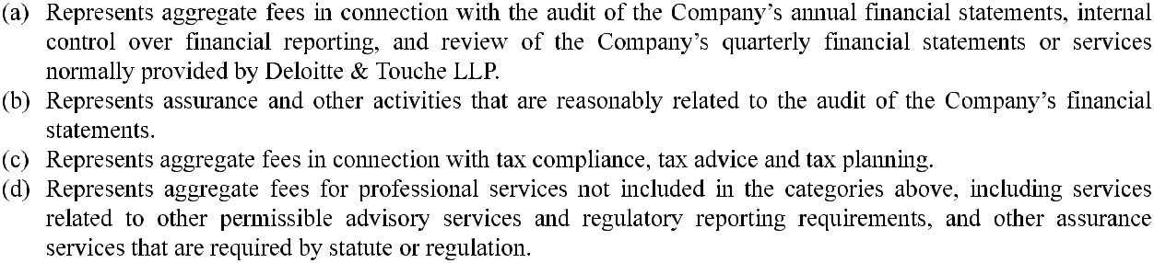
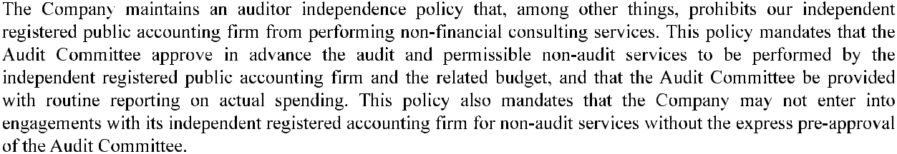

13

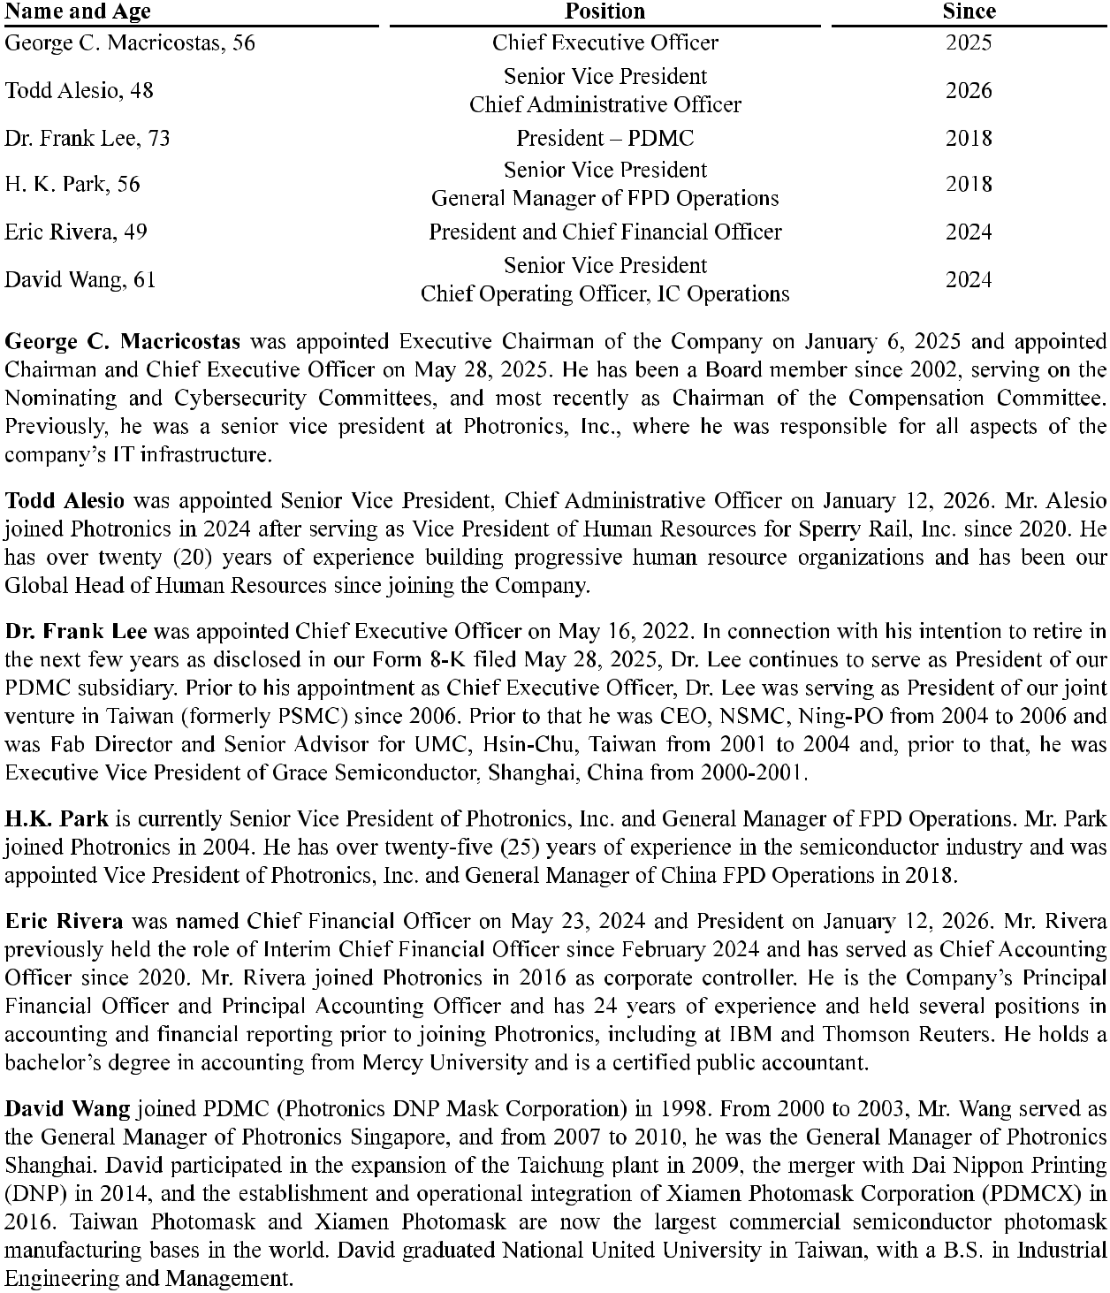

14

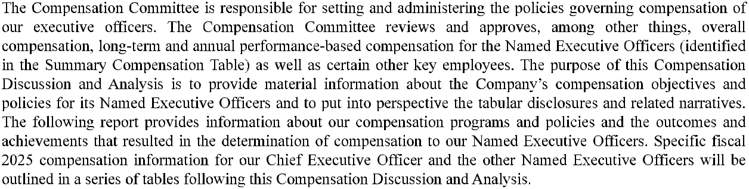
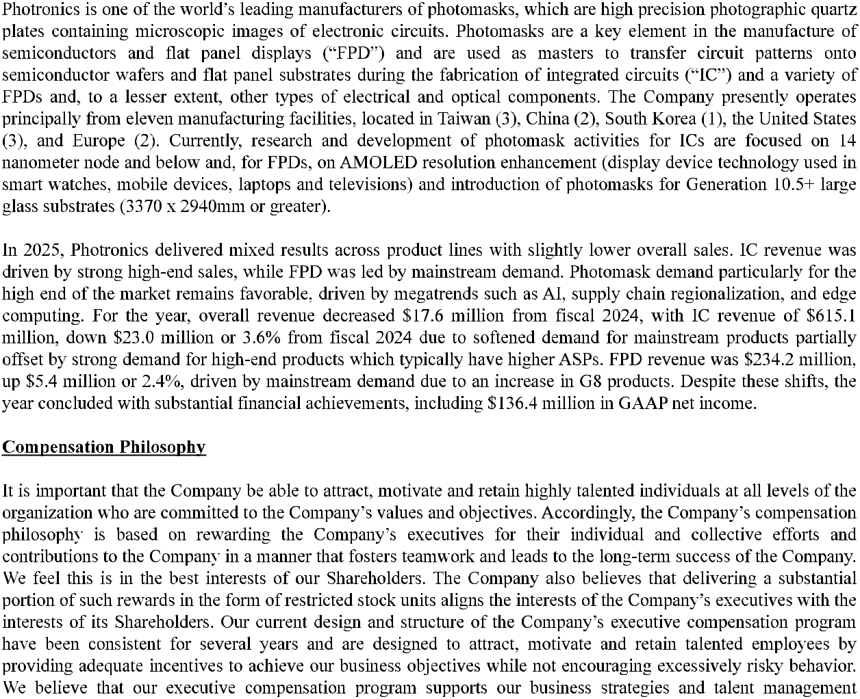

15

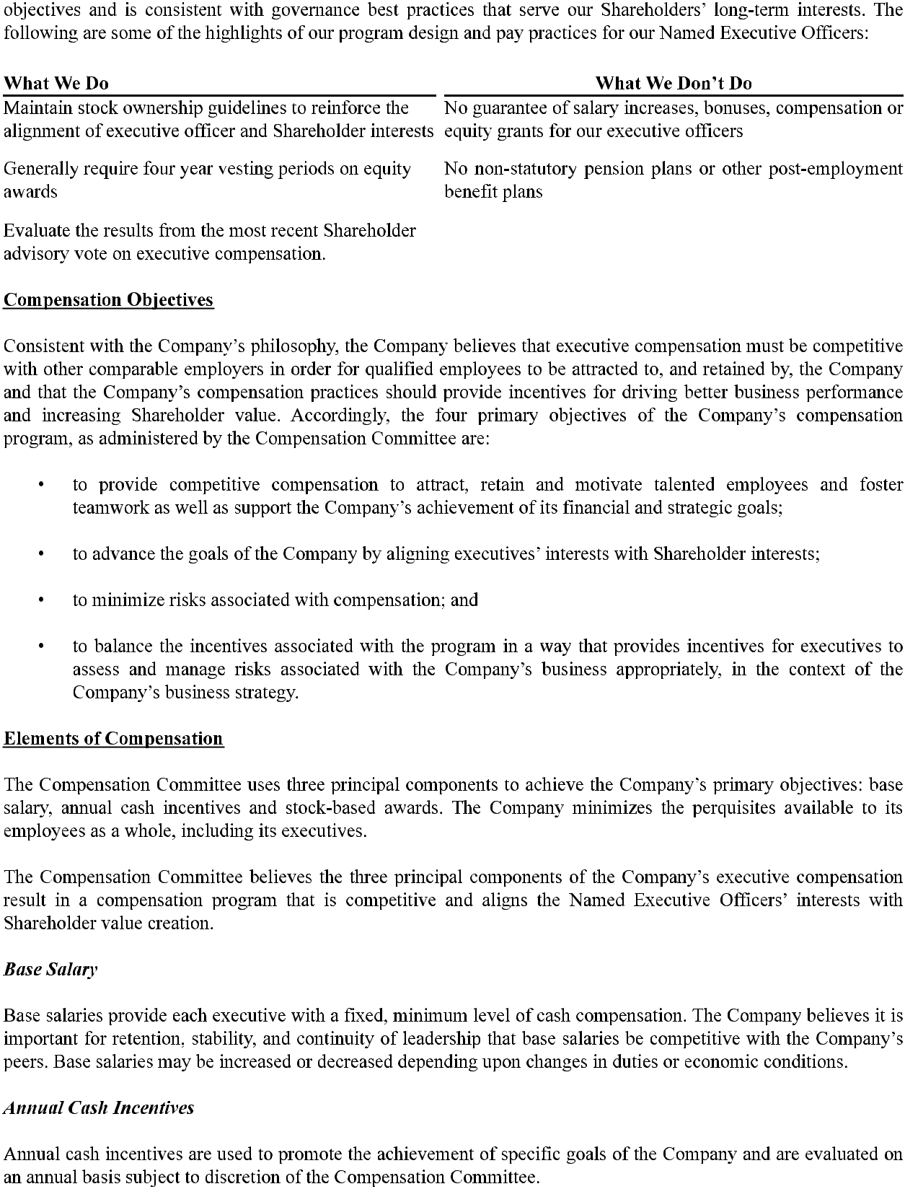

16

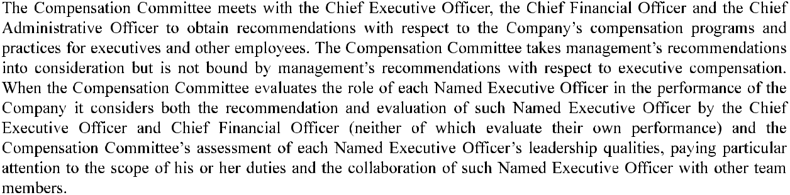
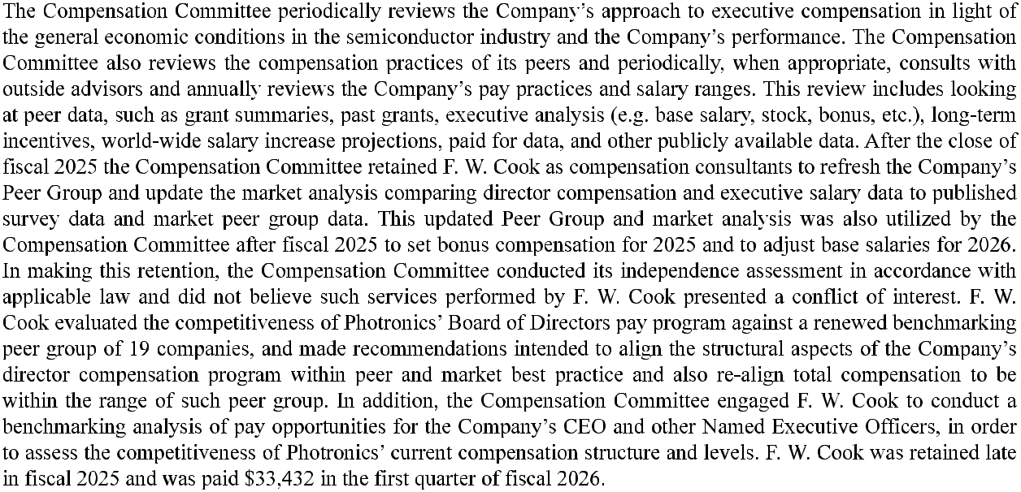

17

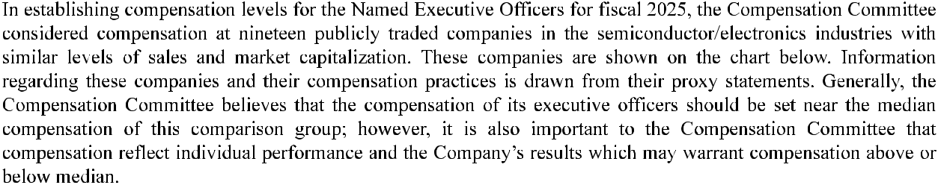
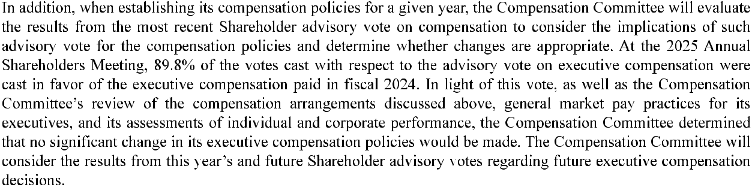

18

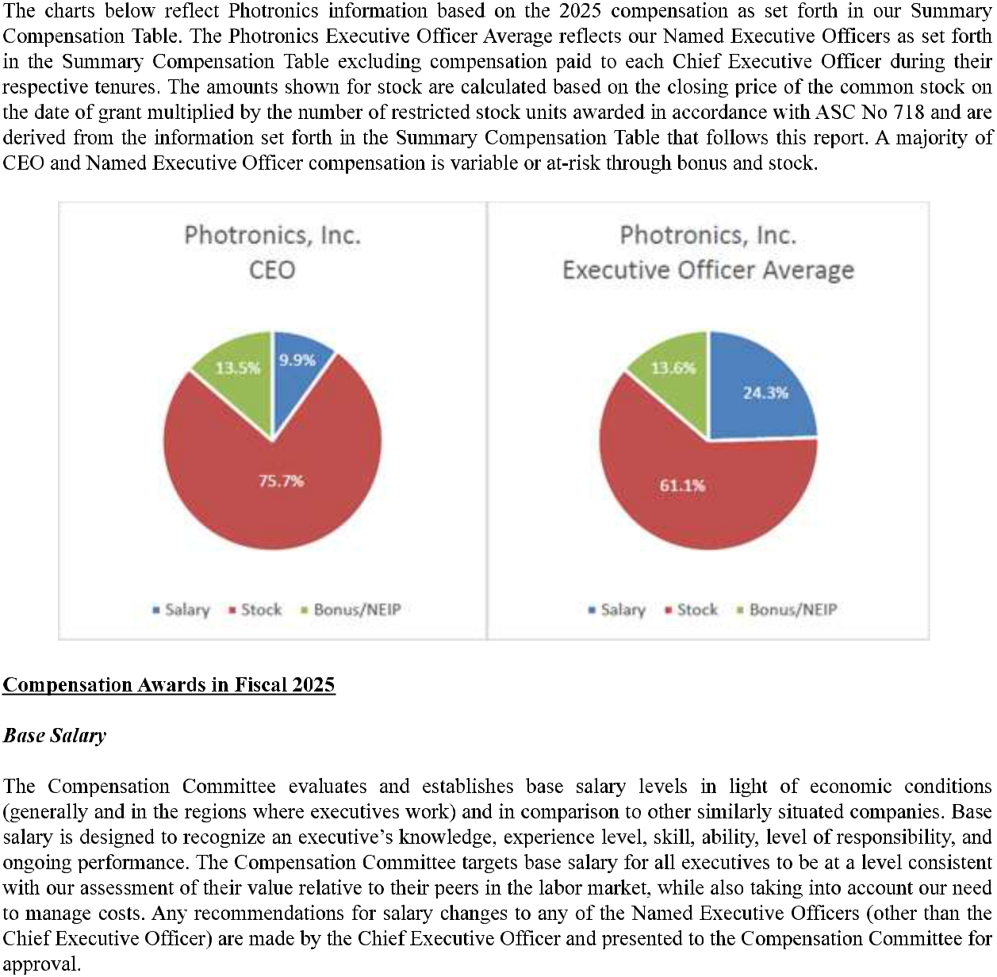

19

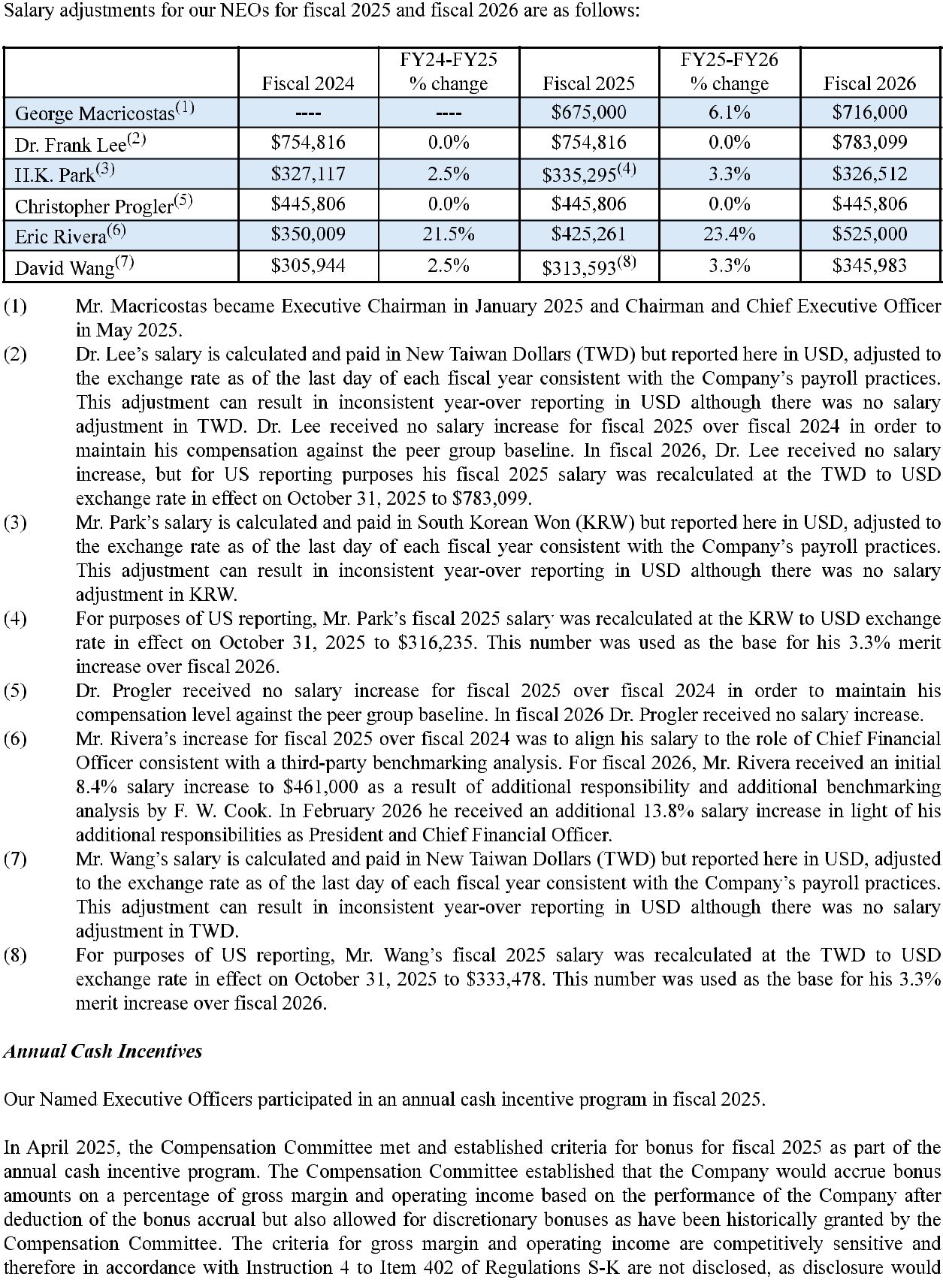

20

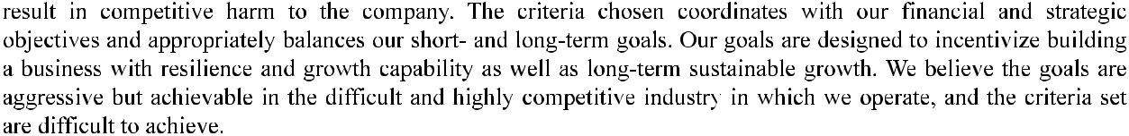
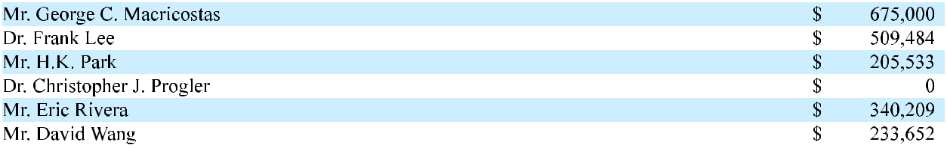
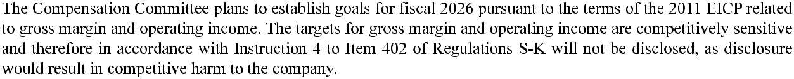
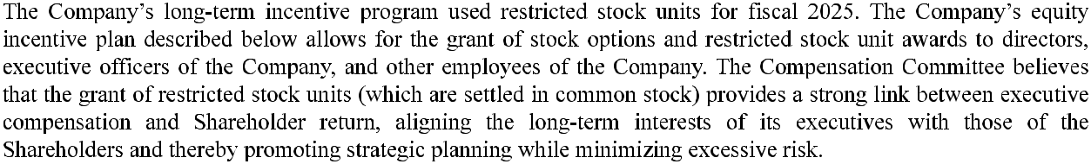
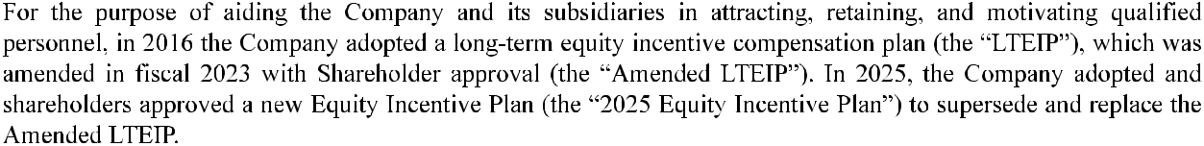
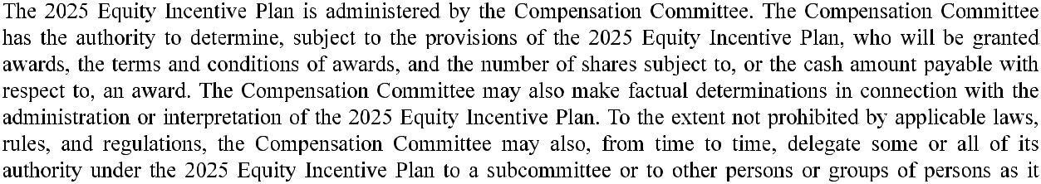

21



22

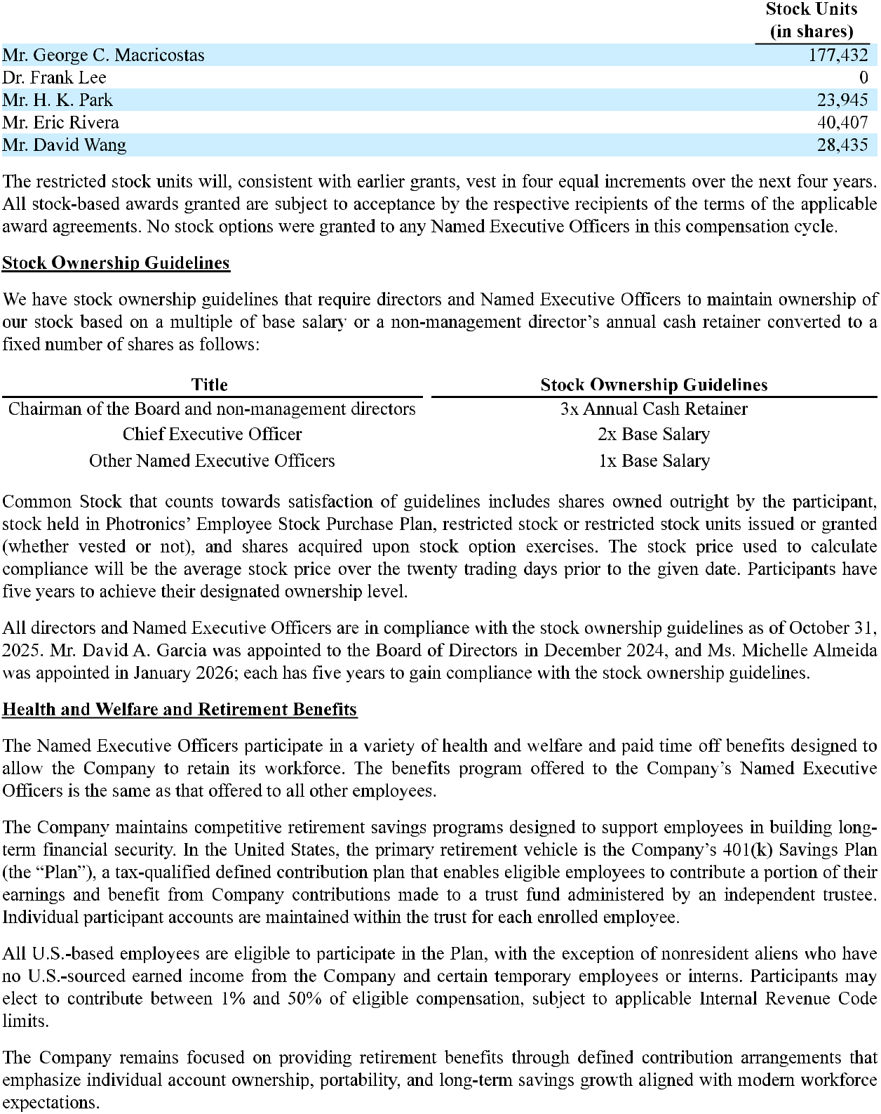

23

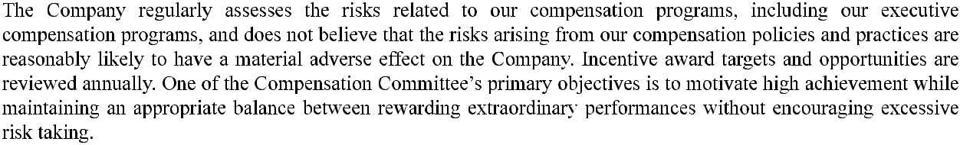
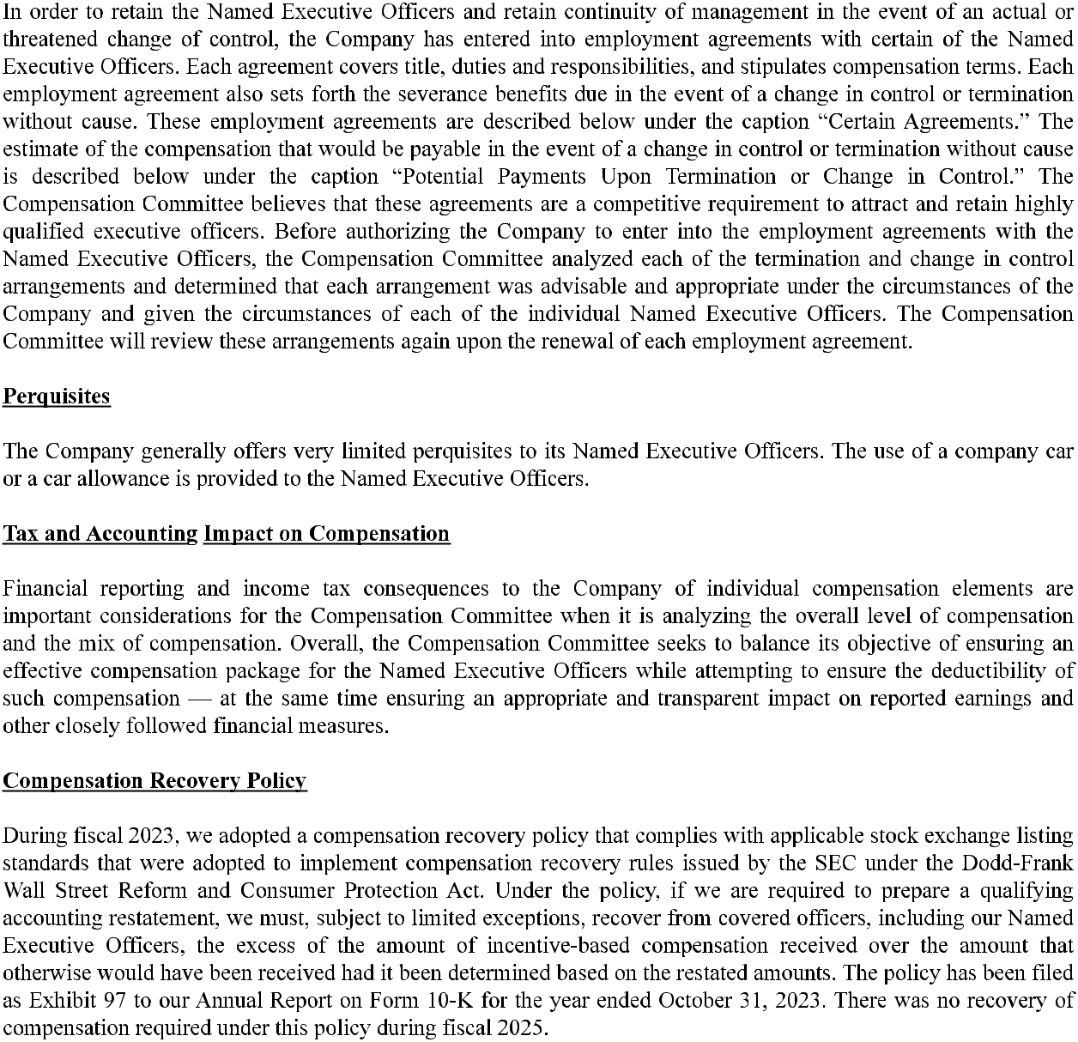

24

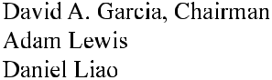

25

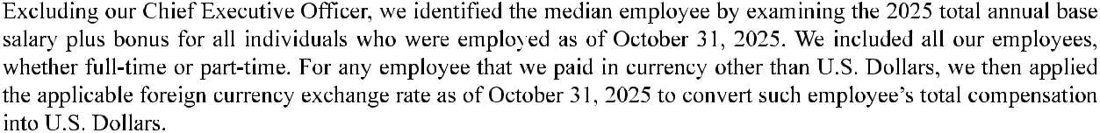
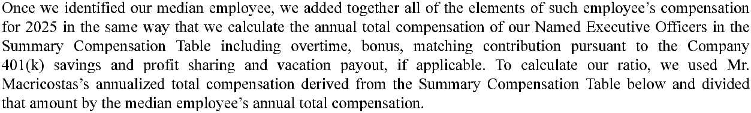
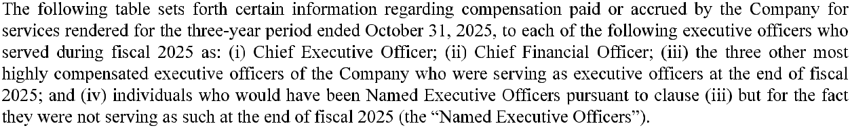

26

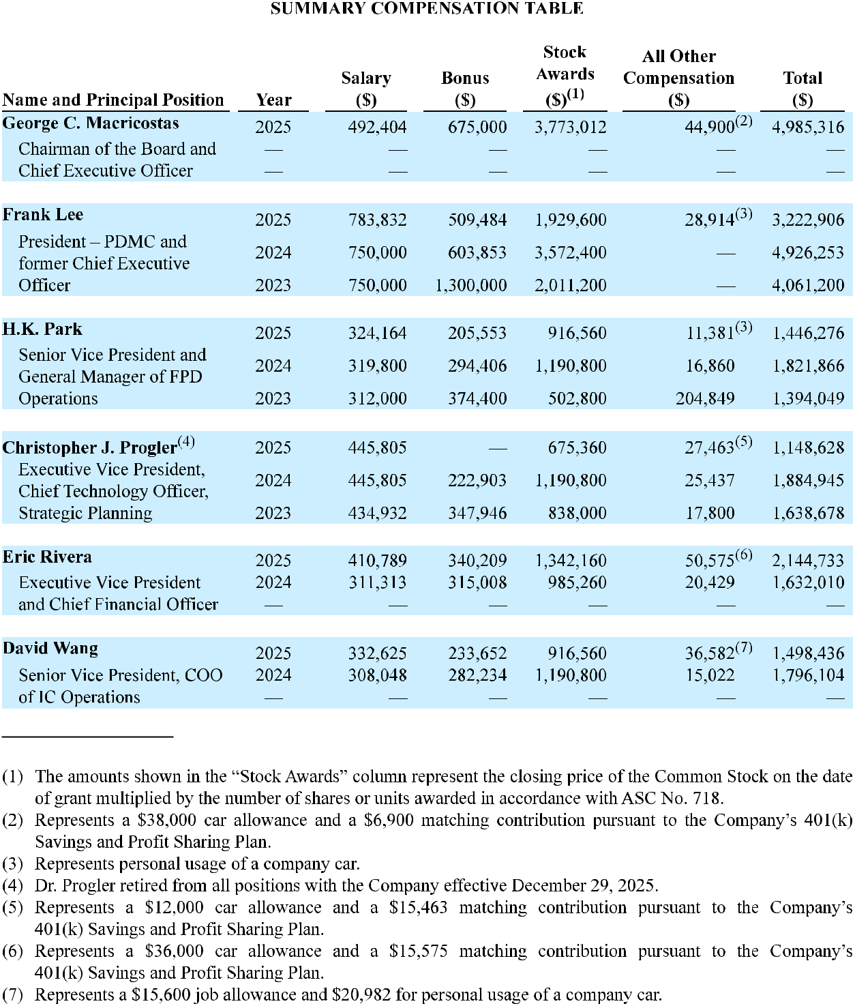

27

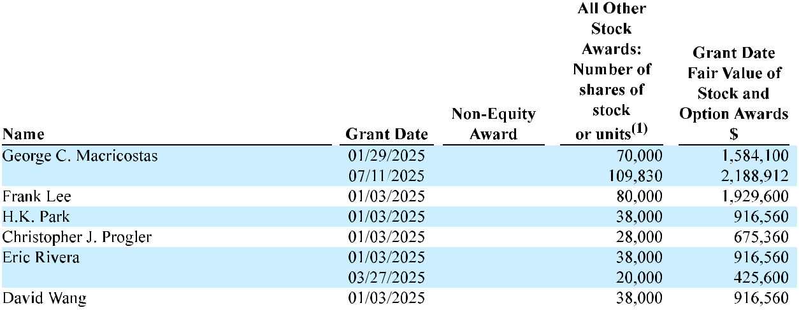

28

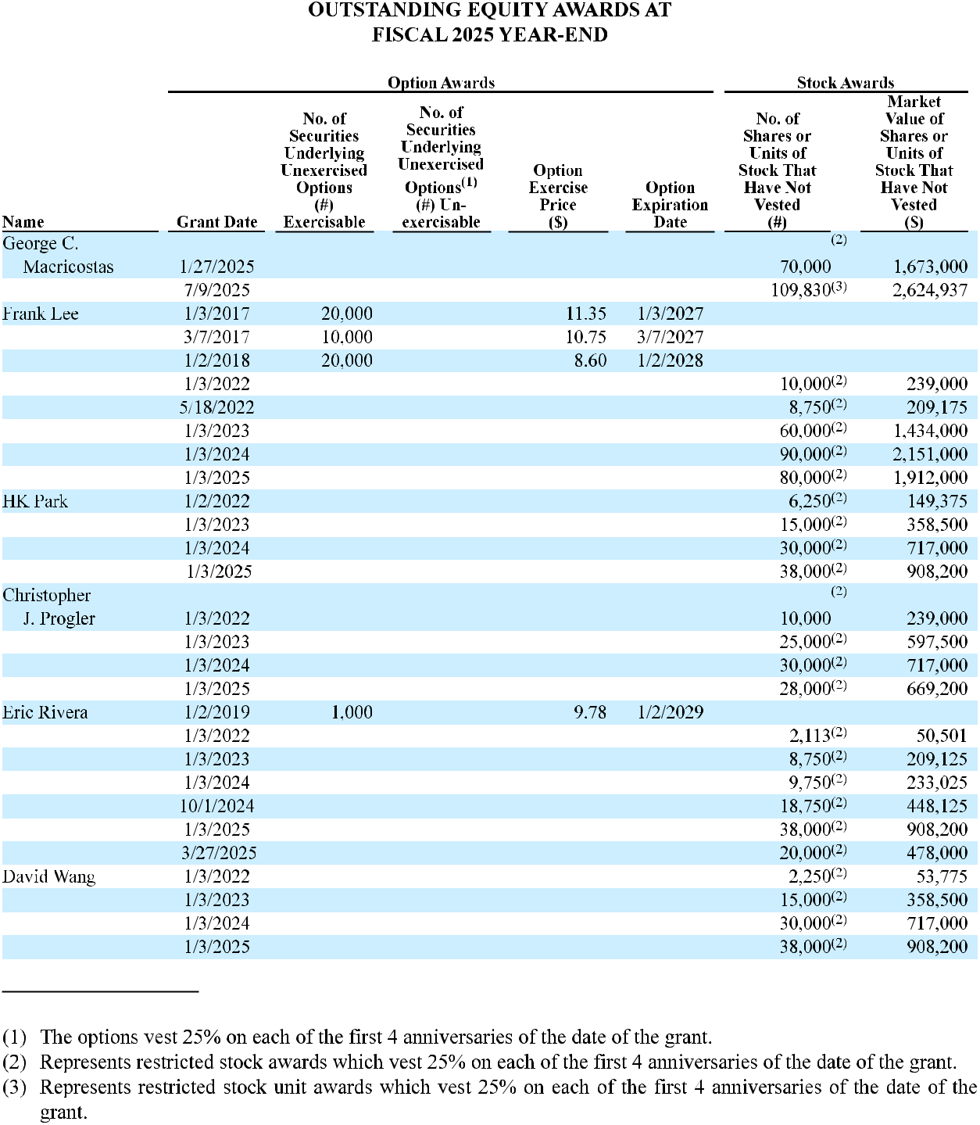

29

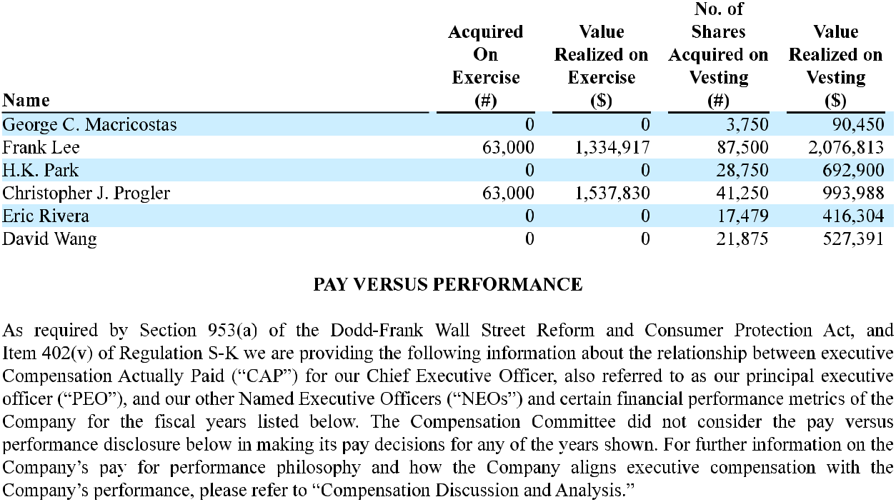

30

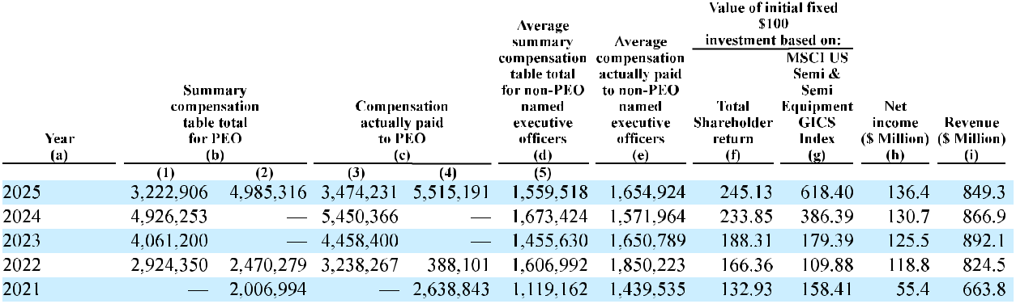
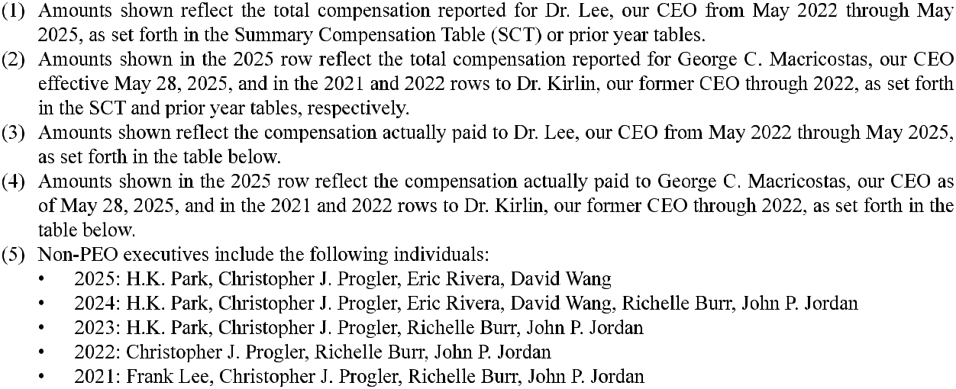

31

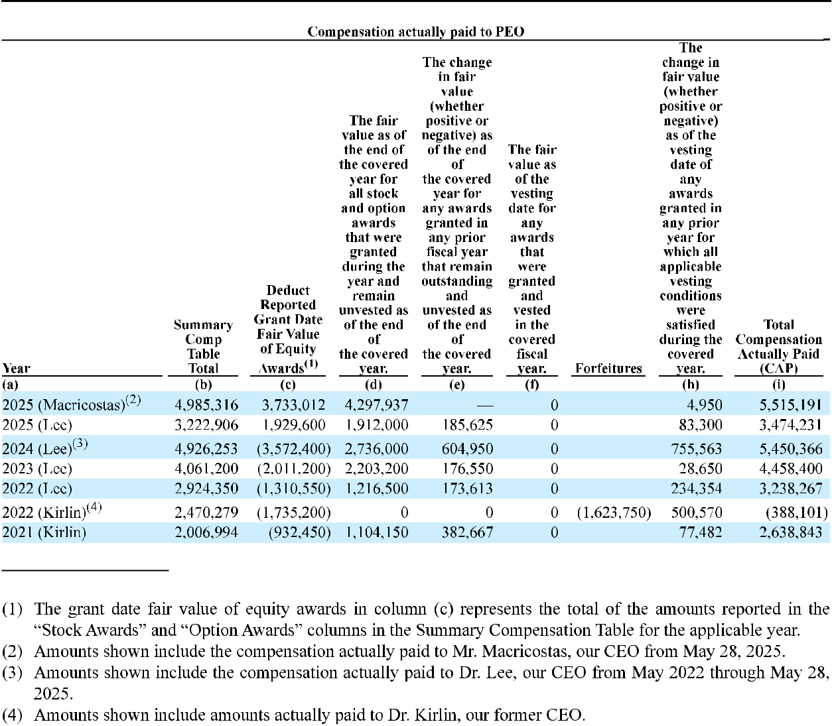

32

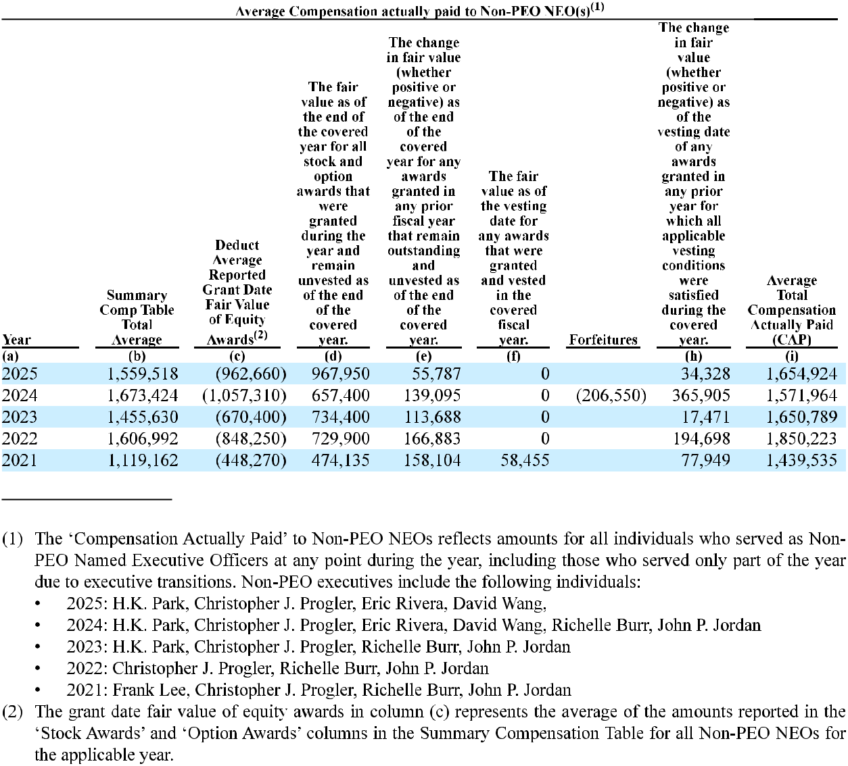

33

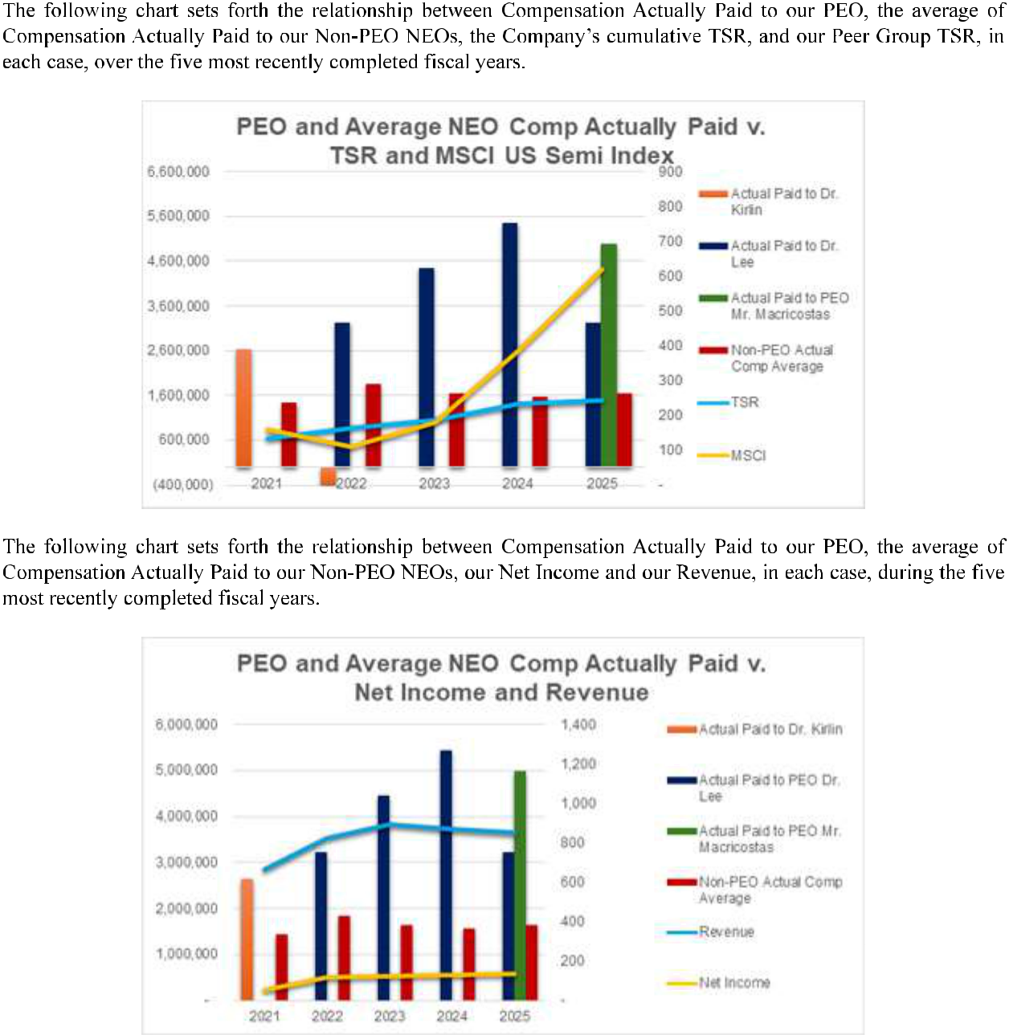

34

35

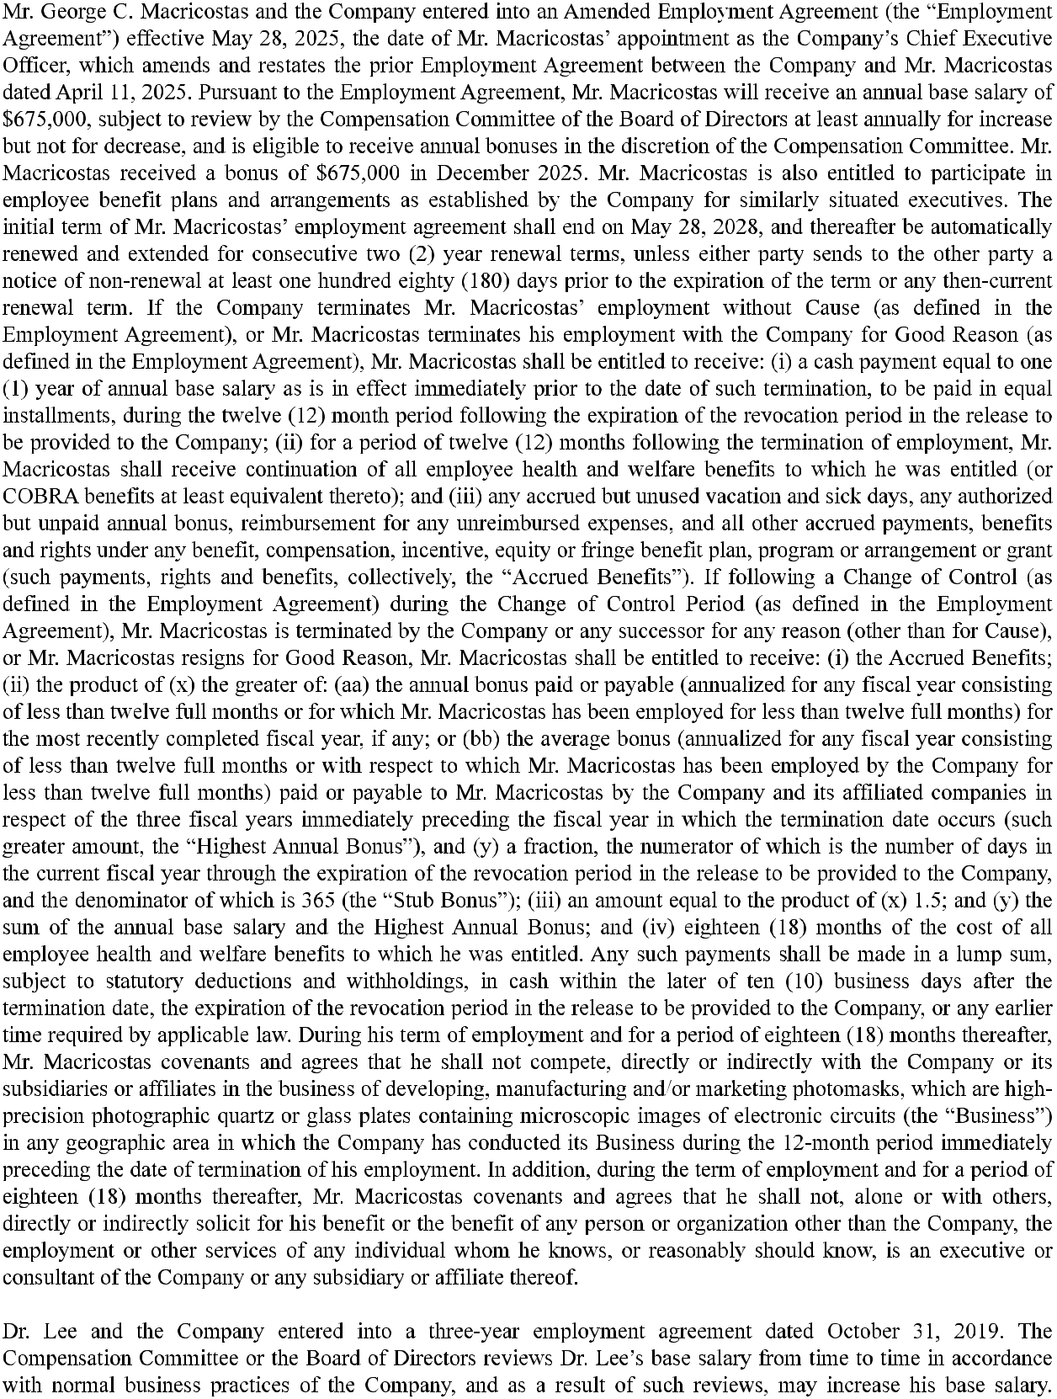

36

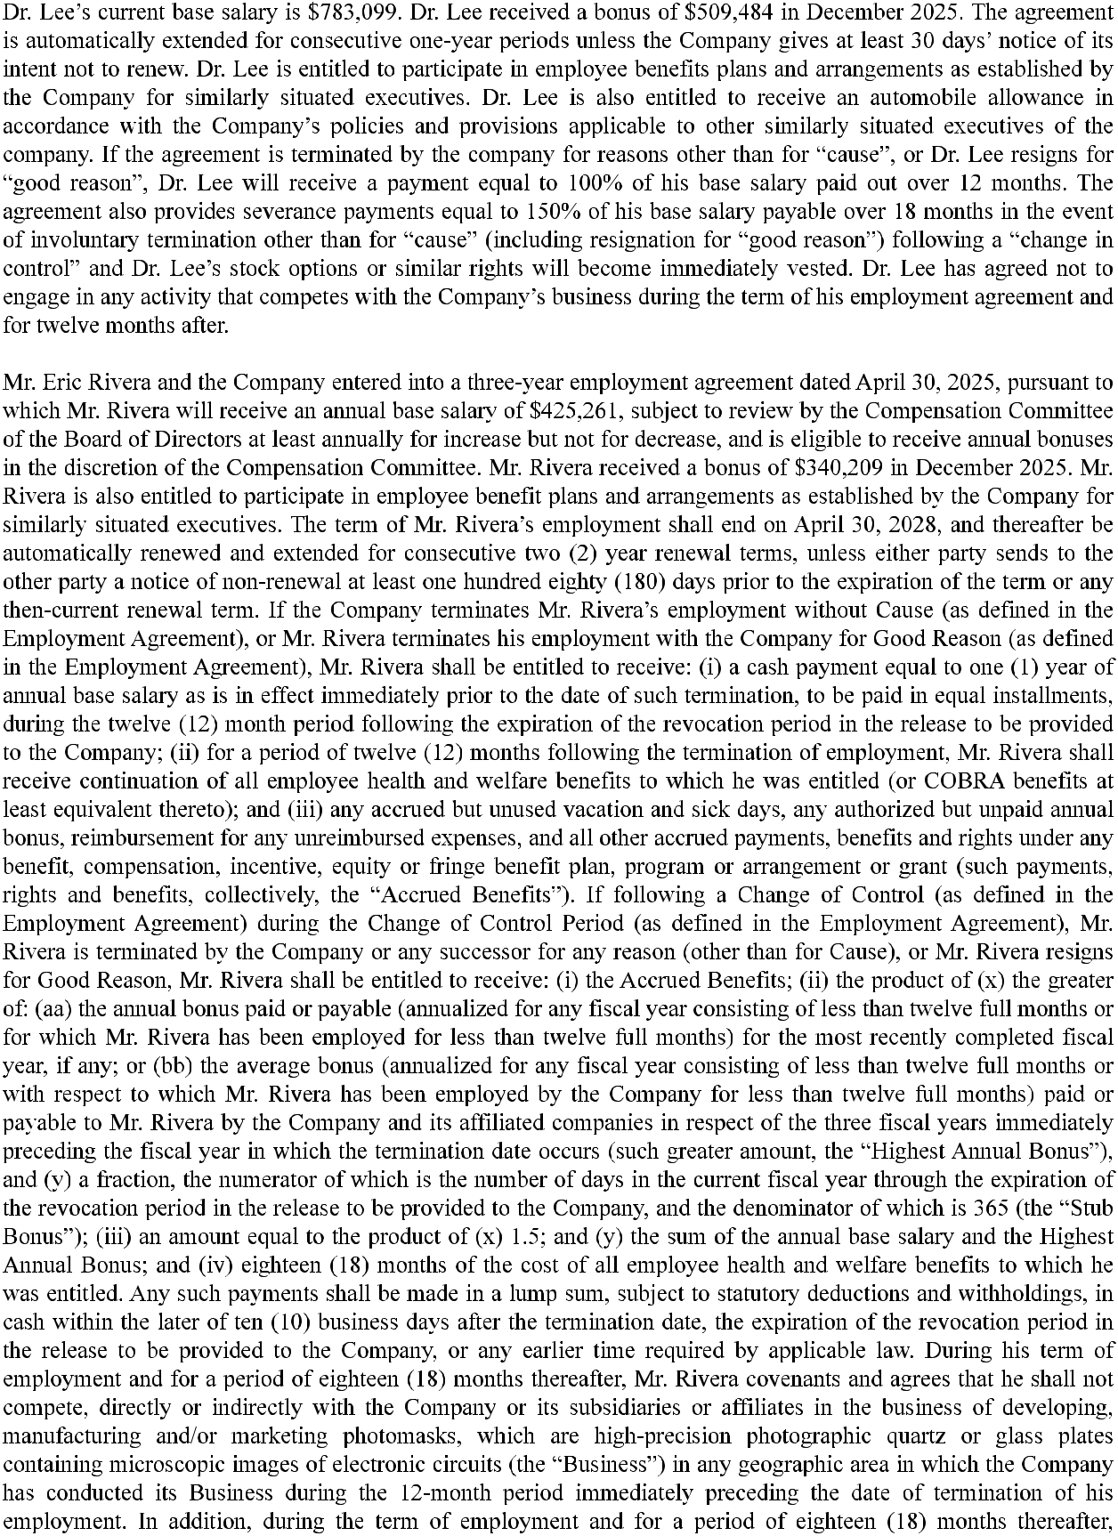

37

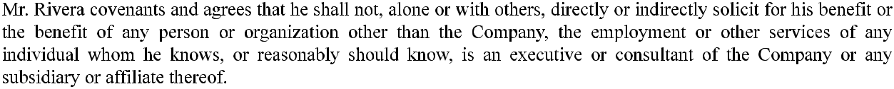
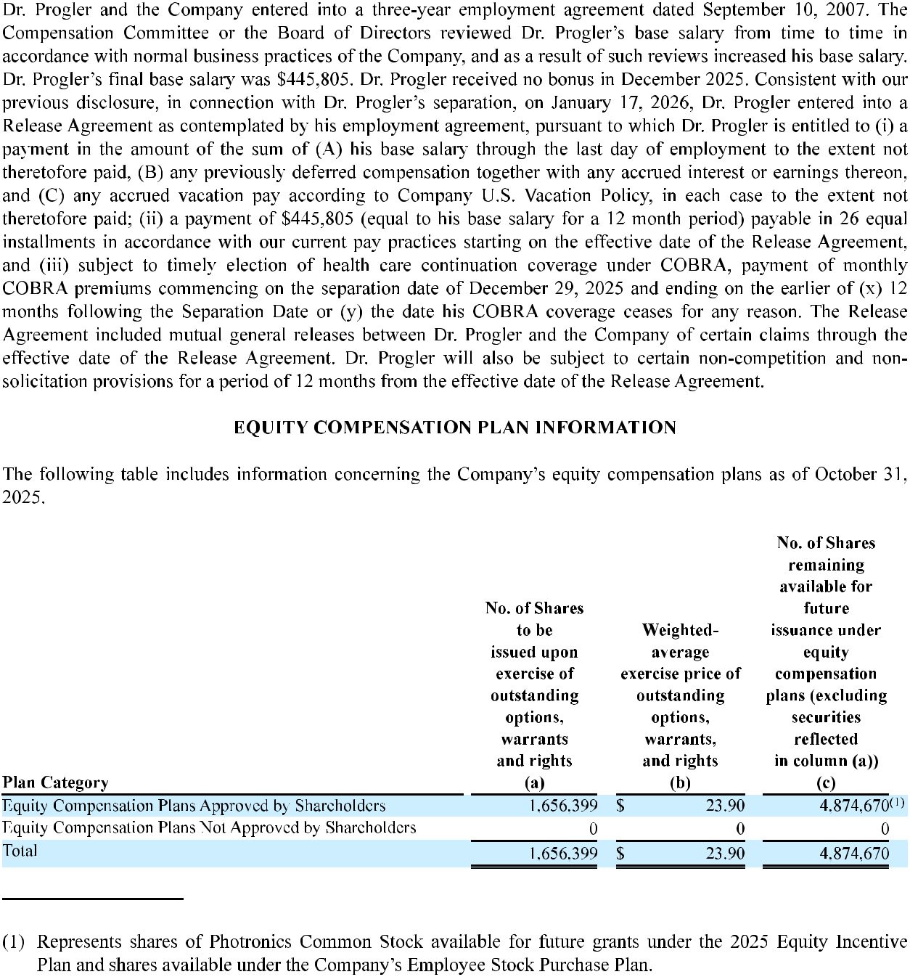

38

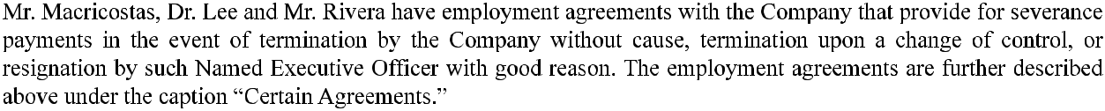
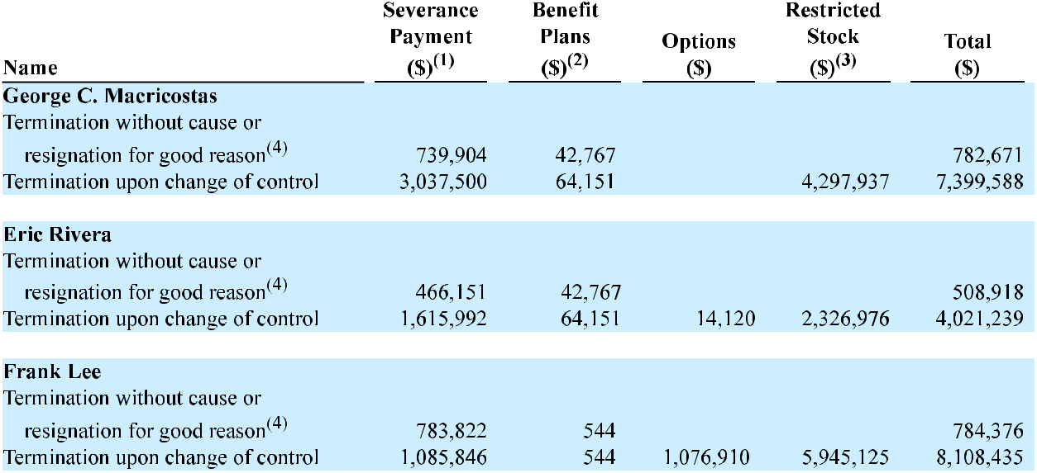
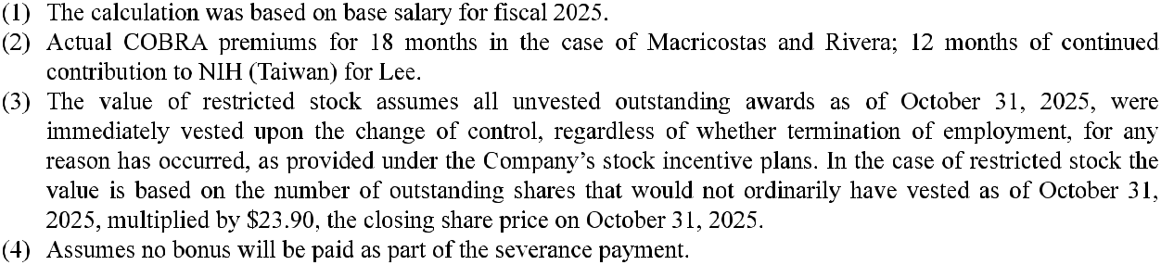

39

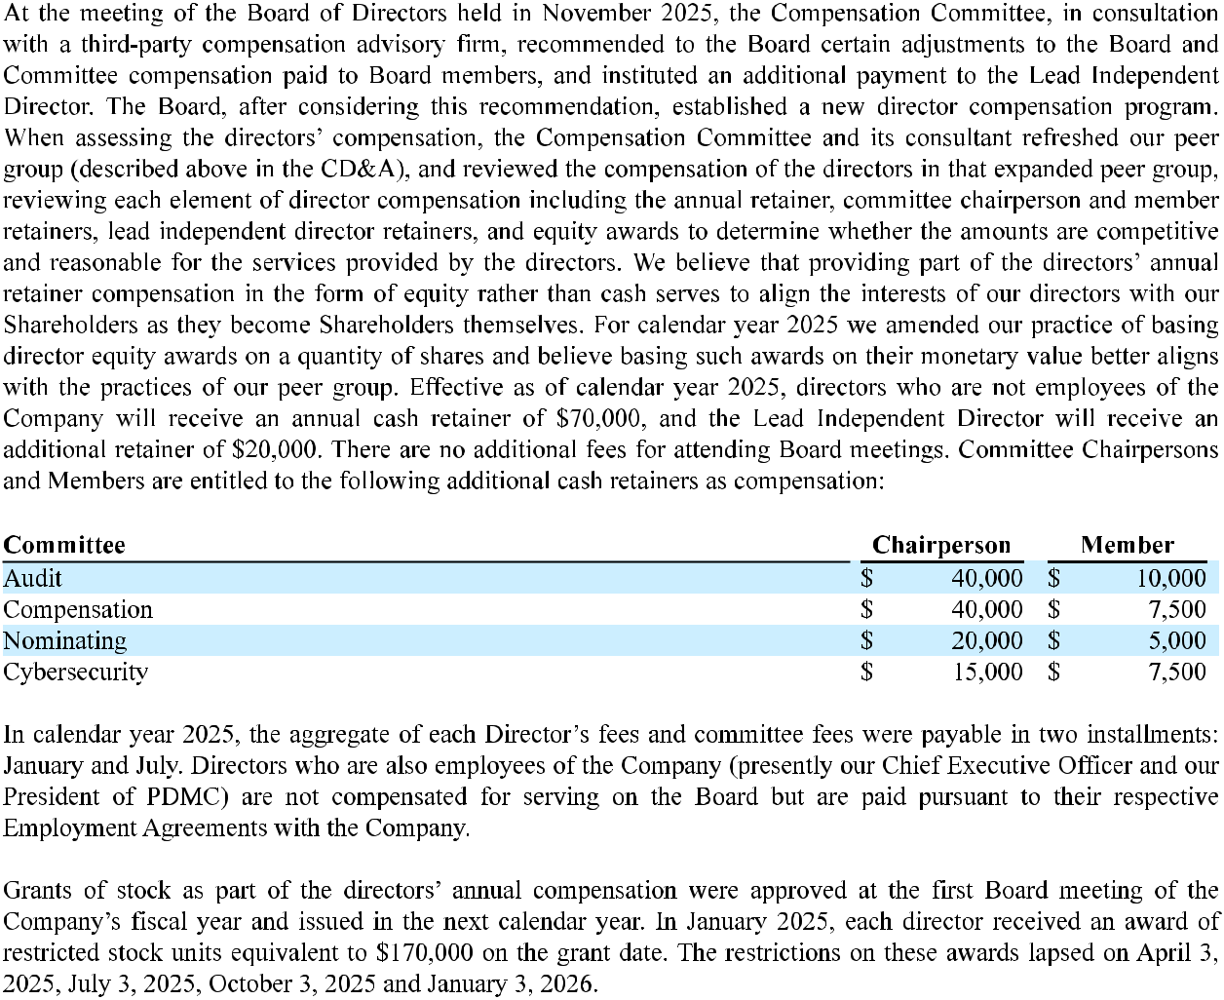

40

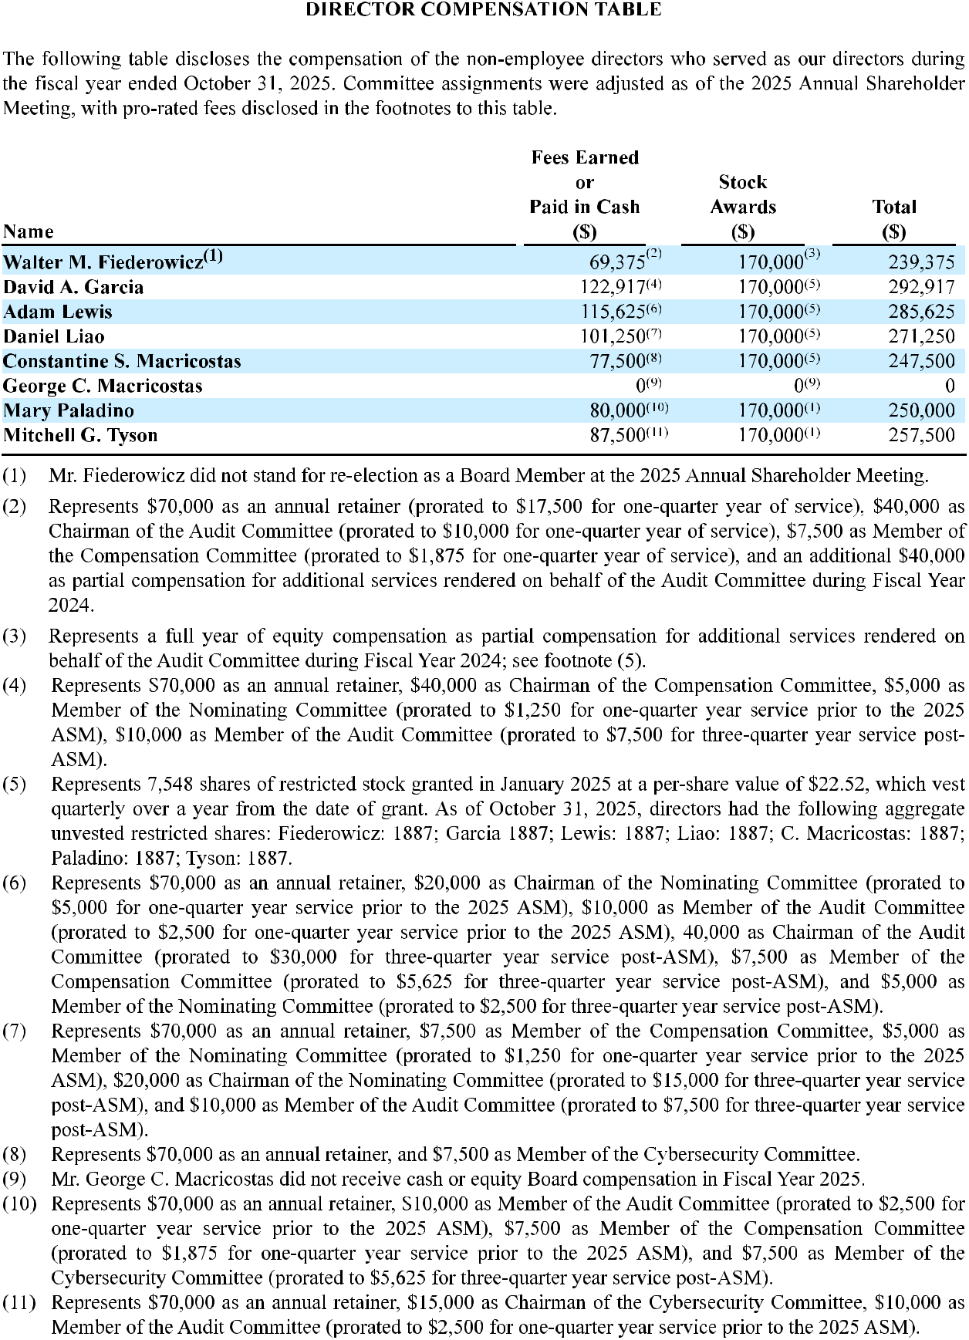

41

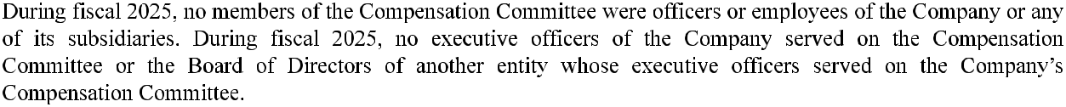

42

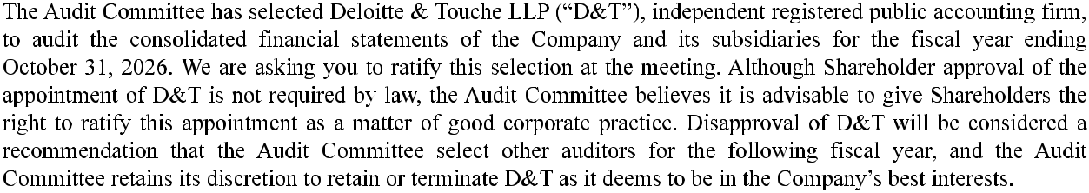

43

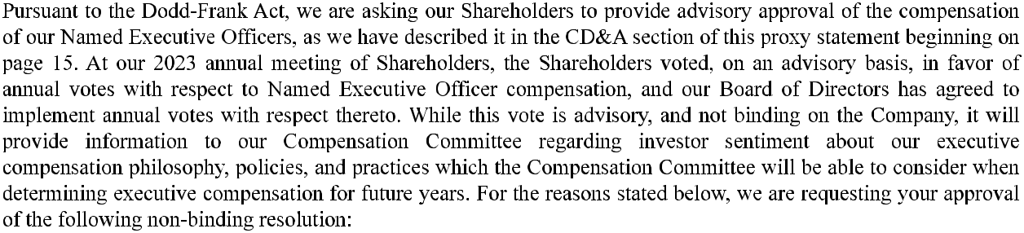
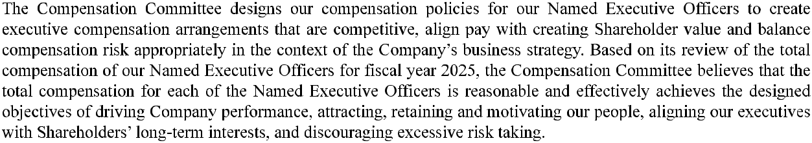

44

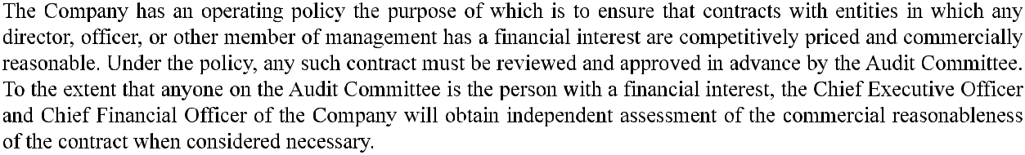
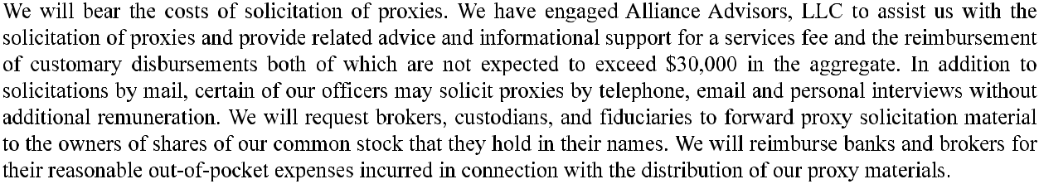
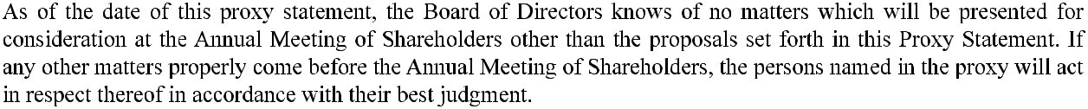
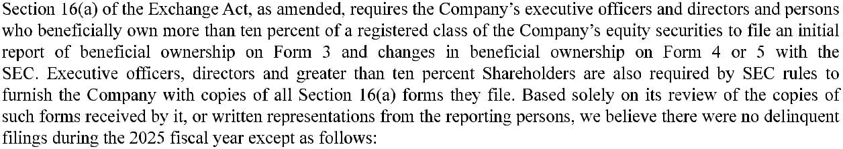
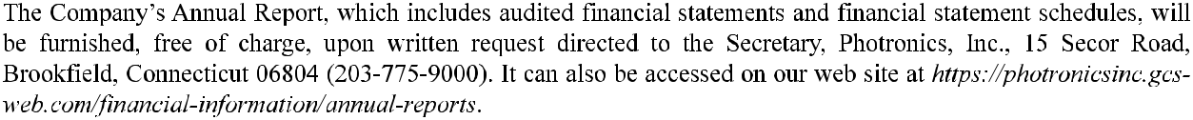

45

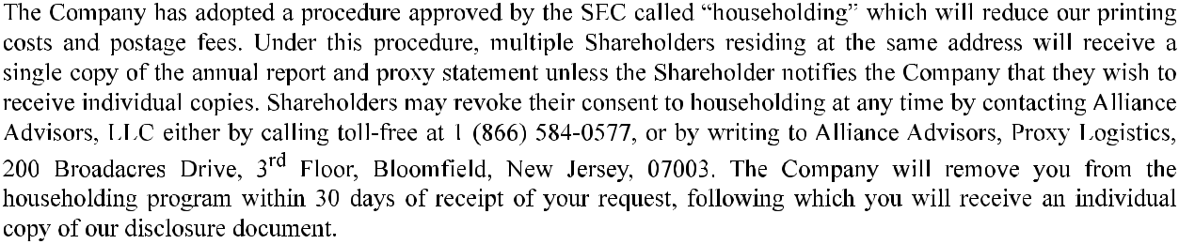
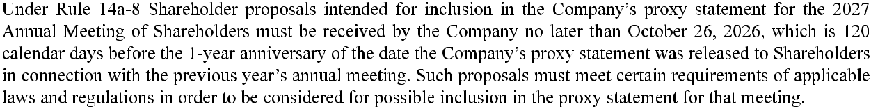
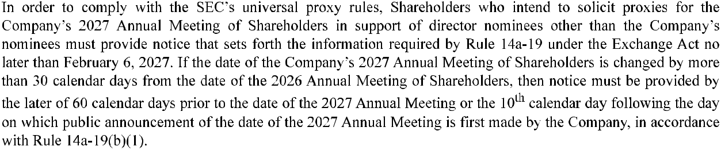

46

UNITED STATES

SECURITIES AND EXCHANGE COMMISSION
Washington, D.C. 20549

FORM 10-K

(Mark One)

ANNUAL REPORT PURSUANT TO SECTION 13 OR 15(d) OF THE SECURITIES EXCHANGE ACT OF 1934 For the fiscal year ended October 31, 2025

OR

TRANSITION REPORT PURSUANT TO SECTION 13 OR 15(d) OF THE SECURITIES EXCHANGE ACT OF 1934 For the transition period from ___ to ___

Commission file number 0-15451


PHOTRONICS, INC.

(Exact name of registrant as specified in its charter)

Connecticut

06-0854886

(State or other jurisdiction of incorporation or organization)

(IRS Employer Identification No.)

15 Secor Road, Brookfield, Connecticut 06804

(Address of principal executive offices)(Zip Code)

(203) 775-9000

(Registrant’s telephone number, including area code)

Securities registered pursuant to Section 12(b) of the Act:

 | Title of each class |  |  | Trading Symbol(s) |  | Name of each exchange on which registered
 | COMMON STOCK $0.01 par value |  |  | PLAB |  | NASDAQ Global Select Market
 |  | Securities registered pursuant to Section 12(g) of the Act:
 |  |  |  | None

Indicate by check mark if the registrant is a well-known seasoned issuer, as defined in Rule 405 of the Securities Act. Yes No Indicate by check mark if the registrant is not required to file reports pursuant to Section 13 or Section 15(d) of the Act. Yes No

Indicate by check mark whether the registrant (1) has filed all reports required to be filed by Section 13 or 15(d) of the Securities Exchange Act of 1934 during the preceding 12 months (or for such shorter period that the registrant was required to file such reports), and (2) has been subject to such filing requirements for the past 90 days. Yes No

Indicate by check mark whether the registrant has submitted electronically every Interactive Data File required to be submitted pursuant to Rule 405 of Regulation S-T (§232.405 of this chapter) during the preceding 12 months (or for such shorter period that the registrant was required to submit such files). Yes No

Indicate by check mark whether the registrant is a large accelerated filer, an accelerated filer, a non-accelerated filer, a smaller reporting company, or an emerging growth company. See definitions of “large accelerated filer,” “accelerated filer,” “smaller reporting company”, and “emerging growth company” in Rule 12b-2 of the Exchange Act.

Large Accelerated

Filer

Accelerated Filer

Non-Accelerated Filer

Smaller
Reporting Company

Emerging
Growth company

If an emerging growth company, indicate by check mark if the registrant has elected not to use the extended transition period for complying with any new or revised financial accounting standards provided pursuant to Section 13(a) of the Exchange Act.

Indicate by check mark whether the registrant has filed a report on and attestation to its management’s assessment of the effectiveness of its internal control over financial reporting under Section 404(b) of the Sarbanes-Oxley Act ((§15 U.S.C. 7262(b)) by the registered public accounting firm that prepared or issued its audit report.

If securities are registered pursuant to Section 12(b) of the Act, indicate by check mark whether the financial statements of the registrant included in the filing reflect the correction of an error to previously issued financial statements.

Indicate by check mark whether any of those error corrections are restatements that required a recovery analysis of incentive-based compensation received by any of the registrant’s executive officers during the relevant recovery period pursuant to §240.10D-1(b).

Indicate by check mark whether the registrant is a shell company (as defined in Rule 12b-2 of the Exchange Act). Yes No

As of May 2, 2025, which was the last business day of the registrant’s most recently completed second fiscal quarter, the aggregate market value of the shares of the registrant’s common stock held by non-affiliates was approximately $934,773,176 (based upon the closing price of $19.22 per share as reported by the NASDAQ Global Select Market on that date).

As of December 11, 2025, 59,064,641 shares of the registrant’s common stock were outstanding.

DOCUMENTS INCORPORATED BY REFERENCE

Portions of our Proxy Statement for the 2026 Annual Meeting of Shareholders to be filed with the U.S. Securities and Exchange Commission pursuant to regulation 14A under the Securities Exchange Act of 1934, as amended are incorporated by reference into Part III of this Annual Report on Form 10-K.

PHOTRONICS, INC.

ANNUAL REPORT ON FORM 10-K

OCTOBER 31, 2025

TABLE OF CONTENTS

 |  |  |  |  |  |  |  |  |  |  |  |  |  |  |  |  |  |  |  |  |  |  |  |  |  | Page
Glossary of Terms and Acronyms |  |  |  |  |  |  |  |  |  |  |  |  |  |  |  |  |  |  |  |  |  |  |  |  |  | 3
Cautionary Statement Regarding Forward-Looking Statements |  |  |  |  |  |  |  |  |  |  |  |  |  |  |  |  |  |  |  |  |  |  |  |  |  | 4
PART I:
ITEM 1. BUSINESS |  |  |  |  |  |  |  |  |  |  |  |  |  |  |  |  |  |  |  |  |  |  |  |  |  | 5
ITEM 1A. RISK FACTORS |  |  |  |  |  |  |  |  |  |  |  |  |  |  |  |  |  |  |  |  |  |  |  |  |  | 11
ITEM 1B. UNRESOLVED STAFF COMMENTS |  |  |  |  |  |  |  |  |  |  |  |  |  |  |  |  |  |  |  |  |  |  |  |  |  | 20
ITEM 1C. CYBERSECURITY |  |  |  |  |  |  |  |  |  |  |  |  |  |  |  |  |  |  |  |  |  |  |  |  |  | 20
ITEM 2. PROPERTIES |  |  |  |  |  |  |  |  |  |  |  |  |  |  |  |  |  |  |  |  |  |  |  |  |  | 21
ITEM 3. LEGAL PROCEEDINGS |  |  |  |  |  |  |  |  |  |  |  |  |  |  |  |  |  |  |  |  |  |  |  |  |  | 21
ITEM 4. MINE SAFETY DISCLOSURES |  |  |  |  |  |  |  |  |  |  |  |  |  |  |  |  |  |  |  |  |  |  |  |  |  | 21
PART II:
ITEM 5. MARKET FOR REGISTRANT’S COMMON EQUITY, RELATED STOCKHOLDER MATTERS AND ISSUER PURCHASES OF
EQUITY SECURITIES |  |  |  |  |  |  |  |  |  |  |  |  |  |  |  |  |  |  |  |  |  |  |  |  |  | 22
ITEM 6. [RESERVED] |  |  |  |  |  |  |  |  |  |  |  |  |  |  |  |  |  |  |  |  |  |  |  |  |  | 23
ITEM 7. MANAGEMENT’S DISCUSSION AND ANALYSIS OF FINANCIAL CONDITION AND RESULTS OF OPERATIONS |  |  |  |  |  |  |  |  |  |  |  |  |  |  |  |  |  |  |  |  |  |  |  |  |  | 24
ITEM 7A. QUANTITATIVE AND QUALITATIVE DISCLOSURES ABOUT MARKET RISK |  |  |  |  |  |  |  |  |  |  |  |  |  |  |  |  |  |  |  |  |  |  |  |  |  | 36
ITEM 8. FINANCIAL STATEMENTS AND SUPPLEMENTARY DATA |  |  |  |  |  |  |  |  |  |  |  |  |  |  |  |  |  |  |  |  |  |  |  |  |  | 37
ITEM 9. CHANGES IN AND DISAGREEMENTS WITH ACCOUNTANTS ON ACCOUNTING AND FINANCIAL DISCLOSURE |  |  |  |  |  |  |  |  |  |  |  |  |  |  |  |  |  |  |  |  |  |  |  |  |  | 73
ITEM 9A. CONTROLS AND PROCEDURES |  |  |  |  |  |  |  |  |  |  |  |  |  |  |  |  |  |  |  |  |  |  |  |  |  | 73
ITEM 9B. OTHER INFORMATION |  |  |  |  |  |  |  |  |  |  |  |  |  |  |  |  |  |  |  |  |  |  |  |  |  | 75
ITEM 9C. DISCLOSURE REGARDING FOREIGN JURISDICTIONS THAT PREVENT INSPECTIONS |  |  |  |  |  |  |  |  |  |  |  |  |  |  |  |  |  |  |  |  |  |  |  |  |  | 75
PART III:
ITEM 10. DIRECTORS, EXECUTIVE OFFICERS AND CORPORATE GOVERNANCE |  |  |  |  |  |  |  |  |  |  |  |  |  |  |  |  |  |  |  |  |  |  |  |  |  | 75
ITEM 11. EXECUTIVE COMPENSATION |  |  |  |  |  |  |  |  |  |  |  |  |  |  |  |  |  |  |  |  |  |  |  |  |  | 75
ITEM 12. SECURITY OWNERSHIP OF CERTAIN BENEFICIAL OWNERS AND MANAGEMENT AND RELATED STOCKHOLDER
MATTERS |  |  |  |  |  |  |  |  |  |  |  |  |  |  |  |  |  |  |  |  |  |  |  |  |  | 75
ITEM 13. CERTAIN RELATIONSHIPS AND RELATED TRANSACTIONS, AND DIRECTOR INDEPENDENCE |  |  |  |  |  |  |  |  |  |  |  |  |  |  |  |  |  |  |  |  |  |  |  |  |  | 75
ITEM 14. PRINCIPAL ACCOUNTANT FEES AND SERVICES |  |  |  |  |  |  |  |  |  |  |  |  |  |  |  |  |  |  |  |  |  |  |  |  |  | 76
PART IV:
ITEM 15. EXHIBITS AND FINANCIAL STATEMENT SCHEDULES |  |  |  |  |  |  |  |  |  |  |  |  |  |  |  |  |  |  |  |  |  |  |  |  |  | 76
ITEM 16. FORM 10-K SUMMARY |  |  |  |  |  |  |  |  |  |  |  |  |  |  |  |  |  |  |  |  |  |  |  |  |  | 80
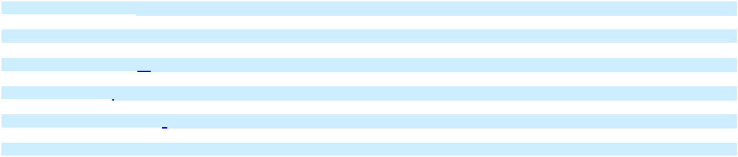


2

Glossary of Terms and Acronyms

Definitions of certain terms and acronyms that may appear in this report are provided below.

AI

AMOLED

Application-specific IC

ASC

ASP

ASU

CHIPS Act

CNY

DNP
EUV

Exchange Act

FASB

Form 10-K

Form 10-Q

FPDs
Generation

High-end (photomasks)

ICs
LTPS

Mainstream

Artificial intelligence

Active-matrix organic light-emitting diode. A technology used in mobile devices.
An integrated circuit customized for a particular use, rather than intended for general-purpose use

Accounting Standards Codification
Average Selling Price

Accounting Standards Update
U.S. CHIPS and Science Act of 2022

Chinese Yuan
Dai Nippon Printing Co., Ltd.
A wafer lithography technology using the industry standard extreme ultraviolet (EUV) wavelength. EUV photomasks function

by selectively reflecting or blocking light, in contrast to conventional photomasks which function by selectively transmitting or

blocking light
The Securities Exchange Act of 1934 (as amended)

Financial Accounting Standards Board
Annual Report on Form 10-K

Quarterly Report on Form 10-Q
Flat-panel displays, or “displays”

In reference to flat panel displays, refers to the size range of the underlying substrate to which a photomask is applied. Higher

generation (or “G”) numbers represent larger substrates
For IC, photomasks that are 28nm or smaller; for FPD, AMOLED, G10.5+, and LTPS photomasks

Integrated circuits, or semiconductors
Low-Temperature Poly Silicon, a polycrystalline silicon synthesized at relatively low temperatures; polycrystalline silicon in

thin-film transistors (TFTs) are used in liquid-crystal display (LCD) flat panels and to drive organic light-emitting diode

(OLED) displays
For IC, photomasks that service IC nodes greater than 28nm; for FPD, G8 and smaller photomasks

(photomasks)

Optical proximity

correction

PDMCX

ROU (assets)

SEC

Securities Act

SOC-1 report

U.S. GAAP

VIE
Wafer

A photolithography enhancement technique applied to compensate for the limitations of light to maintain the edge placement

integrity of an original design, imaged onto a silicon wafer, for further processing to an etched pattern.

Xiamen American Japan Photronics Mask Co., Ltd., a joint venture of Photronics and DNP
Right-of-use asset

Securities and Exchange Commission
The Securities Act of 1933 (as amended)

Service Organization Control 1 report
Accounting principles generally accepted in the United States of America

Variable Interest Entity
A wafer, or silicon wafer, is a thin slice of semiconductor material that, in the fabrication of microelectronics, serves as the

substrate for microelectronic devices built in and upon the wafer

All references to “2025”, “2024”, and “2023” are to our fiscal years ended on October 31 of those years, unless otherwise stated.

3

Cautionary Statement Regarding Forward-Looking Statements

This Form 10-K contains forward-looking statements, as defined by the SEC. The Private Securities Litigation Reform Act of 1995 provides a “safe harbor” for forward-looking statements made by us, or on our behalf. Forward-looking statements are statements other than statements of historical fact, including, without limitation, those statements that include such words as “anticipates”, “believes”, “estimates”, “expects”, “intends”, “may”, “plans”, “predicts”, and similar expressions, and, without limitation, may address our future plans, objectives, goals, strategies, events, or performance, as well as underlying assumptions and other statements that are other than statements of historical facts. On occasion, in other documents filed with the SEC, press releases, conferences, or by other means, we may discuss, publish, disseminate, or otherwise make available, forward-looking statements, including statements contained within Part II, Item 7 – “Management’s Discussion and Analysis of Financial Condition and Results of Operations” of this Form 10-K.

Forward-looking statements involve risks and uncertainties, which could cause actual results or outcomes to differ materially from those expressed. Our expectations, beliefs and projections are expressed in good faith and are believed by us to have a reasonable basis, including, without limitation, management’s examination of historical operating trends, information contained in our records, and information we have obtained from other parties. However, we can offer no assurance that our expectations, beliefs, or projections will be realized, accomplished or achieved.

Forward-looking statements within this Form 10-K speak only as of the date of its filing, and we undertake no obligation to update any such statements to reflect changes in events or circumstances that may subsequently occur. Users of this Form 10-K are cautioned that various factors may cause actual results to differ materially from those contained in any forward-looking statements found within this Form 10-K and that they should not place undue reliance on any forward-looking statement. In addition, all forward-looking statements, whether written or oral and whether made by us or on our behalf, are expressly qualified by the risk factors provided in Part I, Item 1A “Risk Factors” of this Form 10-K.

4

PART I

ITEM 1. BUSINESS

Specific industry and technical terms used in this section are defined in the subsection entitled “Glossary of Terms and Acronyms,” found below the Table of Contents.

Business Overview

Photronics, Inc. (and its subsidiaries, collectively referred to herein as “Photronics”, the “Company”, “we”, “our”, or “us”) is one of the world’s leading manufacturers of photomasks, which are high precision photographic quartz or glass plates containing microscopic images of electronic circuits. Photomasks are a key element in the manufacture of ICs and FPDs and are used as masters to transfer circuit patterns onto semiconductor wafers and FPD substrates during the fabrication of ICs, a variety of FPDs and, to a lesser extent, other types of electrical and optical components. We have eleven manufacturing facilities, which are located in Taiwan (3), China (2), South Korea (1), the United States (3), and Europe (2).

Our principal executive offices are located at 15 Secor Road, Brookfield, Connecticut, 06804, telephone (203) 775-9000. Our website address is http://www.photronics.com. We make available, free of charge through our website, our Forms 10-K, Definitive Proxy Statements on Schedule 14A, Forms 10-Q, Current Reports on Form 8-K, and any amendments to these reports as soon as reasonably practicable after such materials are electronically filed with or furnished to the SEC. The information found on, or incorporated into, our website is not part of this or any other report we file with or furnish to the SEC. The SEC also maintains a website at http://www.sec.gov that contains reports, proxy statements and other information regarding SEC registrants, including Photronics.

Segment

We operate as a single reporting segment as a manufacturer of photomasks, which are high precision quartz or glass plates containing microscopic images of electronic circuits for use in the fabrication of IC’s and FPDs. In accordance with the ASC 280 – “Segment Reporting” Topic of the ASC, the Company’s chief operating decision maker has been identified as the Chief Executive Officer, who reviews operating results to make decisions about allocating resources and assessing performance for the entire Company. Existing guidance, which is based on a management approach to segment reporting, establishes requirements to report selected segment information quarterly and to report annually entity-wide disclosures about products and services, major customers, and the countries in which the entity holds material assets and reports revenue. All material operating units qualify for aggregation under “Segment Reporting” due to their similar customer base and similarities in: economic characteristics; nature of products and services; and procurement, manufacturing and distribution processes. Since the Company operates in one segment, all financial information required by “Segment Reporting” can be found in the accompanying consolidated financial statements.

Industry

We manufacture photomasks, which are used as masters to transfer circuit patterns onto semiconductor wafers and FPD substrates. The photomasks we manufacture incorporate circuit designs provided to us on a confidential basis by our customers. Photomasks are typically sold in sets comprised of layers, with each layer having a distinct pattern that is etched onto a different photomask. The resulting series of photomasks is then used to image the circuit patterns onto each successive layer of a semiconductor wafer or FPD substrate. The typical manufacturing process for a photomask involves the receipt and conversion of circuit design data to manufacturing pattern data. A lithography system then exposes the circuit pattern onto a photomask blank. The exposed areas are developed and etched to imprint the pattern on the photomask. The photomask is then inspected for defects and conformity to the customer’s design data. After the repair of any defects, the photomask is cleaned, any required pellicles (protective translucent membranes) are applied and, after final inspection, the photomask is shipped to the customer.

“High-end” photomasks support 28 nanometer and smaller design nodes for ICs and Generation 10.5+, AMOLED, and LTPS display-based process technologies for FPDs. However, 32 nanometer and above geometries for semiconductors and Generation 8 and below (excluding AMOLED and LTPS) process technologies for displays, which we refer to as “mainstream” photomasks, constitute the majority of designs currently being fabricated in volume. At these geometries and at various high-end nodes, we can produce full lines of photomasks. Moreover, there is no significant technology employed by our competitors that is not available to us. We expect advanced-generation designs to continue to be developed, and we believe we are well positioned to service an increasing volume of this business as a result of our ongoing investments in manufacturing processes and technology in the regions where our customers are located.

5

Generally, Photronics and each of its customers engage in a qualification and correlation process before we become an approved supplier. Thereafter, based on the customer’s specifications, we typically negotiate pricing parameters for the customer’s order. Some prices may remain in effect for an extended period of time. In many instances, we enter into sales arrangements with an understanding that, as long as our performance is competitive, we will receive a specified percentage of that customer’s photomask orders.

The first several layers of photomasks are sometimes required to be delivered to customers within twenty-four hours from the time we receive customer design data. Because of the short period between order and shipment dates (typically from one day to three weeks) for a significant amount of our revenue, the dollar amount of our current backlog is not a reliable indicator of future revenue. However, the demand for some IC photomasks can extend beyond the traditional time period; thus, for some products, our backlog can expand to as long as two to three months.

The ability to manufacture high-quality photomasks within short time periods is dependent upon robust processes, efficient manufacturing methods, high production yield, available manufacturing capacity, and high equipment reliability. We work to meet these requirements by making significant investments in research and development, manufacturing capacity, preventive and on-going equipment maintenance programs, manufacturing and data processing systems, and by utilizing statistical process control methods to optimize our manufacturing processes and reduce cycle times.

Quality control is an integral part of the photomask manufacturing process. Photomasks are manufactured in temperature, humidity, and particulate-controlled clean rooms because of the high level of precision, quality and manufacturing yield required. Each photomask is inspected several times during the manufacturing process to ensure compliance with customer specifications. We continue to make substantial investments in equipment to produce, inspect and repair photomasks to ensure that customer specifications are met.

Sales and Marketing

We conduct our sales and marketing activities primarily through a staff of full-time sales personnel and customer service representatives who work closely with the Company’s management and technical personnel. We support non-U.S. customers through both our domestic and foreign facilities and consider our presence in non-U.S. markets to be an important factor in attracting new customers, as it provides global solutions to our customers, minimizes delivery time, and allows us to serve customers that utilize manufacturing foundries outside of the United States, principally in Asia. See Note 10 – Revenue and Note 19 – Risks and Concentrations to our consolidated financial statements in Part II, Item 8 of this report for the amount of revenue and long-lived assets attributable to each of our geographic areas of operations.

Research and Development

We primarily conduct research and development activities for IC photomasks at our Boise, Idaho, facility. Research and development for FPD photomasks is primarily conducted at Photronics Korea, Ltd., our subsidiary in South Korea. Additionally, we conduct region specific applications development programs to support local, strategic customer roadmaps. All of these research and development programs and activities are undertaken to advance our competitiveness in technology and manufacturing efficiency. We also conduct data and service technology development efforts to support the integration of photomasks into customer processes at regions worldwide. Currently, research and development for IC photomasks are primarily focused on photomasks enabling wafer geometries of 7 nanometer node and smaller, including EUV and, for FPDs on Generation 8.6 AMOLED and photomasks for more advanced FPD display integration across all sizes. In addition, we note the role AI is playing in driving the technology roadmap for IC devices and our technology program covers multiple initiatives to deliver AI grade photomasks in IC and advanced packaging applications. We believe these core competencies will continue to be a critical part of semiconductor and FPD manufacturing, as wafer and FPD substrate optical lithography continues to enable new high-end ICs and displays. We incurred research and development expenses of $15.8 million, $16.6 million, and $13.7 million in 2025, 2024 and 2023, respectively. It is our belief that we own, control, or license the proprietary information (including trade secrets and patents) that we need to continue to meet our customers’ requirements. Accordingly, we devote a significant portion of our human and financial resources to R&D programs and seek to maintain close relationships with customers to remain responsive to their needs. We also believe that our intellectual property and trade secret know-how will continue to be important to maintaining our technical leadership and competitive position in the field of photomasks.

6

Markets

The customers for photomasks are primarily semiconductor and FPD manufacturers and to a lesser degree fabless design and equipment companies serving those industries. The size of the photomask market is driven by the number of designs released to support IC and FPD product introductions and manufacturing expansions. The photomasks required for those designs are manufactured by independent merchant manufacturers like Photronics and by semiconductor and FPD manufacturers that produce photomasks for their own use (captive manufacturers). In rare instances, captive manufacturers also sell to other semiconductor or FPD manufacturers.

The production value of photomasks produced by merchant suppliers has transitioned from a period when there was a trend toward the divestiture or closing of captive photomask operations by semiconductor manufacturers, and to an increase in the share of the market served by independent merchant manufacturers, like Photronics. This trend was driven by the increased complexity and cost of capital equipment used in manufacturing photomasks, and the lack of economy of scale for many semiconductor and FPD manufacturers to effectively utilize the equipment.

That period was followed by a period during which, in order to reach certain roadmap milestones, some captive mask facilities invested at faster rates than independent manufacturers, and the revenue share of market transitioned back to photomasks being majority captive-supplied. More recently, there has been a tendency of more production being directed to the independent merchant manufacturers, with market share moving toward the independents. Nevertheless, most captive manufacturers maintain business and technology relationships with independent photomask manufacturers for ongoing support.

We support customers across the full spectrum of IC Production by manufacturing photomasks using electron beam or optical (laser-based) lithography systems. In addition, we have added the most advanced electron beam mask writing system for IC mask writing that employs a multi-beam writing architecture to deliver speed and performance improvements over existing systems. For FPD, the mask fabrication utilizes only optical writing systems to write the mask patterns. These systems are capable of producing the most advanced semiconductor and display photomasks for use in an array of products. End markets served with IC photomasks include devices used for artificial intelligence, cloud computing, microprocessors, memory, telecommunications, internet connected devices, automotive, industrial and other applications. We own a number of both high-end and mature electron beam and laser-based lithography systems.

We sell our products primarily to leading semiconductor and FPD designers and manufacturers. These include integrated device manufacturers, fabless semiconductor companies, and “pure-play” foundries. During 2025, we sold our products to approximately 636 customers. For fiscal year 2025, Customer A, B and C accounted for approximately 16%, 13% and 8%, of consolidated revenue, respectively. For fiscal year 2024, Customer A, B and C accounted for approximately 15%, 12% and 9% of consolidated revenue, respectively. For fiscal year 2023, Customer A, B and C accounted for approximately 14%, 10% and 13% of consolidated revenue, respectively. No other customer represented 10% or more of consolidated revenue in any of the three fiscal years. Our five largest customers, in the aggregate, accounted for approximately 50%, 50% and 51% of our revenue in 2025, 2024 and 2023, respectively. A significant decrease in the amount of revenue from any of these customers could have a material adverse effect on our financial performance and business prospects.

Competition

The photomask industry is highly competitive, and most of our customers utilize multiple photomask suppliers. Our ability to compete depends primarily upon the consistency of our product quality, timeliness of delivery, competitive pricing, technical capability, and service, which we believe are the principal factors considered by customers in selecting their photomask suppliers. An inability to meet these requirements could adversely affect our financial condition, results of operations, and cash flows. We also believe that geographic proximity to customers is an important factor in certain markets where cycle time from order to delivery is critical. While some of our competitors may have greater financial, sales, marketing, or other resources than Photronics, we believe that we are able to compete effectively because of our dedication to customer service, ongoing investments in state-of-the-art photomask equipment and facilities, and experienced technical employees.

7

The semiconductor equipment industry is highly competitive and is characterized by a small number of participants ranging in size. Our competitors include Compugraphics International, Ltd., Dai Nippon Printing Co., Ltd (outside of Taiwan and China), Hoya Corporation, LG Innotek Co., Ltd., Shenzhen Newway Photomask Making Co., Ltd., Shenzhen Qingyi Photomask, Ltd., SK-Electronics Co., Ltd., Taiwan Mask Corporation, and Tekscend Photomask. We also compete with semiconductor and FPD manufacturers' captive photomask manufacturing operations that supply photomasks for internal use and, in some instances, also for external customers and foundries. We expect to face continued competition which, in the past, has led to pressure to reduce prices. We believe the pressure to reduce prices, together with the significant investment required in capital equipment to manufacture high-end photomasks will continue in the future.

International Operations

Revenues from our non-U.S. operations were approximately 82%, 83% and 86% of our total revenues in 2025, 2024 and 2023, respectively. We believe that our ability to serve non-U.S. markets is enhanced by our having, among other things, a local presence in the markets we serve. This requires significant investments in financial, managerial, operational, and other resources.

Sales and operations outside of the United States are subject to inherent risks, and may be adversely affected by fluctuations in currency exchange rates, the imposition of government controls, political and economic conditions in various countries, legal compliance and regulatory requirements, tariffs and other trade barriers, difficulties with staffing and managing international operations, longer accounts receivable collection cycles, potential restrictions on transfers of funds, and potentially adverse tax consequences. These factors may have a material adverse effect on our ability to generate revenue outside of the United States and may require us to deploy resources where they could otherwise be used to their greatest advantage. Note 10 – Revenue and Note 19 – Risks and Concentrations of our consolidated financial statements, in Part II, Item 8 of this report, respectively, present our revenue and long-lived assets by geographic area. These factors, as well as any of the other risk factors related to our international business and operations including our joint venture operations in China and Taiwan are described in Item 1A “Risk Factors,” could have a material adverse effect on our future business and financial results.

Resources

Raw materials used by Photronics generally include: high precision quartz substrates (including large area substrates for FPD), which are used as photomask starting blanks and are primarily obtained from Japanese and South Korean suppliers; pellicles and electronic grade chemicals, which are used in the manufacturing process; and compacts, which are durable plastic containers in which photomasks are shipped. These materials are generally sourced from several suppliers. We believe that our utilization of a select group of strategic suppliers enables us to access the most technologically advanced materials available. On an ongoing basis, we continue to consider additional supply sources.

We typically enter into annual pricing agreements with our suppliers, some of which include volume-based incentives that have resulted in substantial cost savings; these agreements do not require us to purchase minimum dollar amounts or quantities of their subject materials.

We rely on a limited number of equipment suppliers to develop and provide the equipment used in the photomask manufacturing process. Although, historically, we have been able to obtain equipment on a timely basis, an inability to obtain or repair equipment when required could have a material adverse effect on our business and results of operations.

Intellectual Property Rights

We have developed and hold ownership interests in intellectual property (“IP”) rights, in the forms of patents issued in the U.S., and other trademark and trademark registrations in the U.S. and other countries. Patents in which we hold ownership interests generally relate to the manufacture of photomasks or the use of photomasks to manufacture other products. While we believe that our IP rights are, and will continue to be, important to our technical leadership in the field of photomasks, our operations are not dependent on any one individual IP right. In addition to patenting, when practicable, we further protect our IP rights, and our other proprietary processes and trade secrets, by utilizing non-disclosure agreements with employees, customers, and vendors.

Seasonality

Our business is typically impacted during the first quarter of our fiscal year by the North American, European, and Asian holiday periods, as some customers reduce their development and buying activities during those periods.

8

Government Contracts

We are party to a limited number of fixed-price contracts with the U.S. government. Revenues earned from these contracts do not comprise a significant portion of our total revenue.

Government Regulation

We are subject to government regulations within the U.S. and in other countries in which we produce or market our products. The effects of compliance with these regulations are currently not material to our results of operations, capital expenditures, or competitive position. However, compliance with changes to existing or new regulations may have a material adverse effect on our future results of operations, capital expenditures, or competitive position. We discuss the potential impact of our not adhering to a number of these regulations in Item 1A. “Risk Factors”, of this Form 10-K. The following is a list of major subjects of the regulations that pertain to our business:

- Regulations, such as those under the Foreign Corrupt Practices Act, that prohibit providing remuneration to government officials for the purpose of obtaining or securing business in the jurisdictions in which they serve;

- Regulations that require the minimization and proper disposal of the by-products of our manufacturing processes;

- Regulations that require us to provide a safe working environment for our employees;

- Regulations that restrict our ability to transfer assets between operations not within the same legal jurisdiction;

- Regulations that require us to provide information through the submission of government surveys;

- Regulations that require us to maintain an effective system of internal accounting controls;

- Regulations that prohibit us from engaging in business in specified countries, or with specified customers;

- Regulations that require us to protect the personal information of our customers and employees;

- Regulations that require us to accurately determine our liabilities to taxing authorities, and to settle such liabilities within their statutorily prescribed time periods;

- Regulations that require us to withhold and timely remit taxes on our employees’ compensation to government authorities;

- Regulations that require us to contribute to government-sponsored social insurance plans;

- Regulations that require us to contribute to employee severance plans;

- Regulations that prohibit us from disseminating material nonpublic information prior to the public announcement of such information;

- Regulations pertaining to financial reporting, insider transactions, executive compensation, and other areas overseen by the SEC and governing bodies in other countries in which our operations are located.

9

Human Capital

As of October 31, 2025, we had approximately 1,908 full-time and part-time employees worldwide. Our business results depend in part on our ability to successfully manage our human capital resources, including attracting, identifying, and retaining key talent. Factors that may affect our ability to attract and retain qualified employees include employee morale, our reputation, competition from other employers, and availability of qualified individuals. As of October 31, 2025, none of our employees at any of our worldwide facilities was represented by a union. We consider our employee relations to be good.

We believe our commitment to our diverse human capital resources is an important component of our mission to deliver superior photomasks and customer care. We provide all employees with the opportunity to share their opinions in open dialogues with our human resources department and senior management. We provide all employees a wide range of career development opportunities, both formal and informal. Our formal offerings include tuition reimbursement, leadership development experiences and vocational training. The safety of our employees is a paramount value for us.

We provide mandatory safety trainings in our production facilities, which are designed to focus on empowering our employees with the knowledge and tools they need to make safe choices and to minimize risks. Supervisors complete safety management courses as well. The health and wellness of our employees are critical to our success.

We provide our employees with access to a variety of innovative, flexible and convenient health and wellness programs. Such programs are designed to support employees’ physical and mental health by providing tools and resources to help them improve or maintain their health status and encourage engagement in healthy behaviors. Additionally, we provide robust compensation and benefits. In addition to salaries, these programs, which vary by country/region, can include annual bonuses, stock-based compensation awards, a 401(k) plan with employee matching opportunities, healthcare and insurance benefits, health savings and flexible spending accounts, paid time off, family leave, family care resources, employee assistance programs, and tuition assistance.

10

ITEM 1A. RISK FACTORS

Set forth below are discussions of the risk factors we believe can make an investment in our business speculative or risky.

Concentration Related Risk Factors

Our dependency on the microelectronics industry, which as a whole is volatile, could create volatility in our demand and have a negative material impact on our business.

We sell substantially all of our photomasks to designers and manufacturers of IC and FPD electronic devices. We believe that the demand for photomasks depends primarily on design activity rather than sales volume from products using photomask technologies. Consequently, an increase in semiconductor or FPD sales does not necessarily result in a corresponding increase in photomask sales. In addition, the reduced use of application-specific ICs, reductions in design complexities, other changes in the technology or methods of manufacturing or designing semiconductors or FPDs, or a slowdown in the introduction of new semiconductor or FPD designs could reduce demand for photomasks even if the demand for semiconductors and FPDs increases. Historically, the microelectronics industry has been volatile, with sharp periodic downturns and slowdowns. These negative trends have been characterized by, among other things, diminished product demand, excess production capacity, and accelerated erosion of selling prices with a concomitant effect on revenue and profitability.

We depend on a limited number of suppliers for equipment and raw materials and, if those suppliers fail to timely deliver their products to us, we may be unable to fulfill orders from our customers, which could adversely affect our business and results of operations.

We rely on a limited number of photomask equipment manufacturers to develop, supply, and repair the equipment we use. These equipment manufacturers usually require lead times of twelve months or longer between the order date and the delivery of certain photomask imaging and inspection equipment. The failure of our suppliers to develop, deliver or service such equipment on a timely basis due to internal issues, supply chain constraints or government-imposed restrictions could have a material adverse effect on our business and results of operations. In addition, the manufacturing equipment necessary to produce advanced photomasks could become prohibitively expensive, which could similarly affect us.

We use high-precision quartz photomask blanks, pellicles, and electronic grade chemicals in our manufacturing processes. There are a limited number of suppliers of these raw materials, and we do not have long-term contracts with these suppliers. Any delays or quality problems in connection with significant raw materials, particularly photomask blanks, could cause delays in the shipments of photomasks, which could have a material adverse effect on our business and results of operations. The fluctuation of foreign currency exchange rates, with respect to prices of equipment and raw materials used in manufacturing, could also have a material adverse effect on our business and results of operations.

We have been dependent on sales to a limited number of large customers; the loss of any of these customers or a significant reduction in orders from these customers could have a material adverse effect on our revenues and results of operations.

Historically, we have sold a significant proportion of photomasks to a limited number of IC and FPD manufacturers. During 2025, 2024 and 2023, our two largest customers accounted for an aggregate of 29%, 27% and 27%, respectively, of our revenue. Our five largest customers accounted for an aggregate of 50%, 50% and 51% of our revenue in 2025, 2024 and 2023, respectively. The loss of a significant customer, a significant reduction or delay in orders from any significant customer (including reductions or delays due to customer departures from recent buying patterns), or an unfavorable change in competitive conditions in the semiconductor or FPD industries could have a material adverse effect on our financial performance and business prospects. The consolidation of semiconductor manufacturers, or an economic downturn in the semiconductor industry, may increase the likelihood of losing a significant customer and could also have an adverse effect on our financial performance and business prospects.

11

Financing Related Risk Factors

Our cash flows from operations and current holdings of cash may not be adequate for our current and long-term needs.

Our liquidity, as we operate in a high fixed-cost environment, is highly dependent on our revenue volume and the timing of our capital expenditures, which can vary significantly from period to period. Depending on conditions in the semiconductor and FPD markets, our cash flows from operations and current holdings of cash may not be adequate to meet our current and long-term needs for capital expenditures, operations, and debt repayments.

Historically, in certain years, we have used external financing to fund these needs. Due to conditions in the credit market, some financing instruments used by us in the past may not be available. Therefore, we cannot provide assurance that additional sources of financing would be available to us on commercially favorable terms, if at all, should our cash requirements exceed our existing cash, and operating cash flows.

Our operations will continue to require substantial capital expenditures, for which we may be unable to provide or obtain funding.

The manufacture of leading-edge photomasks requires us to make substantial investments in additional manufacturing capability. We expect that we will be required to continue to make substantial capital expenditures to meet customer requirements and to position us for future growth. Our capital expenditure payments for fiscal 2026 are expected to be approximately $330 million, of which approximately $13.0 million was included in Accounts payable and Accrued liabilities on our October 31, 2025 consolidated balance sheet. We cannot provide assurance that we will be able to obtain the additional capital required to fund our operations or capital expenditures on reasonable terms, if at all, or that any such inability will not have a material adverse effect on our business and results of operations.

Industry and Competitive Related Risk Factors

Our business depends on managerial and technical personnel, who are in great demand, and our inability to attract and retain qualified employees could adversely affect our business and results of operations.

Our success depends, in part, upon key managerial and technical personnel, as well as our ability to continue to attract and retain additional qualified personnel. The loss of certain key personnel (for example, our Chief Executive Officer, Chief Financial Officer, or Chief Technology Officer) could have a material adverse effect on our business and results of operations. We cannot offer assurance that we can retain our key managerial and technical employees, or that we can attract similar additional employees in the future.

The photomask industry is dependent on the semiconductor and display industries, which are subject to rapid technological change and fluctuations in capacity needs. Consequently, we might fail to adequately time our capabilities to market needs, which could have a material adverse effect on our business and results of operations.

The photomask industry has been, and we expect it to continue to be, characterized by technological change and evolving industry requirements, which recent supply chain regionalization efforts have accelerated. In order to remain competitive, we will be required to continually anticipate, respond to, and scale technologies of increasing complexity in both the traditional and emerging markets that we serve. In particular, we believe that, as semiconductor geometries continue to become smaller and FPDs become larger or otherwise more advanced, we will be required to manufacture photomasks of increasingly challenging complexity. Moreover, the demand for photomasks in non-leading-edge nodes may increase beyond our ability to meet our customers’ requirements within adequate response times. Additionally, the demand for photomasks has been, and could in the future be, adversely affected by changes in semiconductor and high-performance electronics fabrication methods that affect the type or quantity of photomasks utilized, such as changes in semiconductor demand that favor programmable IC devices and other approaches that replace application-specific ICs, or the use of certain chip-stacking methodologies that lessen the emphasis on conventional lithography technology. Furthermore, evidence of the viability and the corresponding market acceptance of alternative methods of transferring IC designs onto semiconductor wafers could reduce or eliminate the need for photomasks in the production of semiconductors.

12

The risk of loss of our intellectual property, trade secrets, or other sensitive business or customer confidential information or disruption of operations due to cyberattacks or data breaches could negatively impact our financial results.

Cyberattacks or data breaches could compromise confidential, business-critical information, cause disruptions in our operations, expose us to potential litigation, or harm our reputation. We have important assets, including intellectual property, trade secrets, and other sensitive, business-critical and/or confidential information which may be vulnerable to such incidents. While we have a comprehensive cybersecurity program that is continually reviewed, maintained, and upgraded, we cannot assure that we are invulnerable to cyberattacks and data breaches which, if significant, could negatively impact our business and financial results.

We may be unable to enforce or defend our ownership and use of proprietary technology, and the utilization of unprotected Company developed technology by our competitors could adversely affect our business, results of operations, and financial position.

We believe that the success of our business depends more on proprietary technology, information and processes, and know-how than on our patents or trademarks. Much of our proprietary information and technology related to manufacturing processes is not patented and may not be patentable. We cannot offer assurance that:

- we will be able to adequately protect our technology;

- competitors will not independently develop similar technology;

- international intellectual property laws will adequately protect our intellectual property rights.

We may become the subject of infringement claims or legal proceedings by third parties with respect to current or future products or processes. Any such claims, with or without merit, or litigation to enforce or protect our intellectual property rights that require us to defend against claimed infringements of the rights of others, could result in substantial costs, diversion of resources, and product shipment delays or could force us to enter into royalty or license agreements, rather than dispute the merits of these claims. Any of the foregoing could have a material adverse effect on our business, results of operations, and financial position.

We operate in a highly competitive environment, and, should we be unable to meet our customers’ requirements for product quality, timeliness of delivery or technical capabilities, our revenue could be adversely affected.

The photomask industry is highly competitive, and most of our customers utilize more than one photomask supplier. Our competitors include Compugraphics International, Ltd., Dai Nippon Printing Co., Ltd (outside of Taiwan and China), Hoya Corporation, LG Innotek Co., Ltd., Shenzhen Newway Photomask Making Co., Ltd., Shenzhen Qingyi Photomask, Ltd., SK-Electronics Co. Ltd., Taiwan Mask Corporation, and Tekscend Photomask. We also compete with semiconductor and FPD manufacturers' captive photomask manufacturing operations, some of which market their photomask manufacturing services to outside customers. We expect to face continued competition from these and other suppliers in the future. Some of our competitors have substantially greater financial, sales, marketing, or other resources than we do. Also, when producing smaller geometry photomasks, some of our competitors may be able to more rapidly develop and produce such masks and achieve higher manufacturing yields than we can. We believe that consistency of product quality, timeliness of delivery, competitive pricing, technical capability and service are the principal factors considered by customers when selecting their photomask suppliers. Our inability to meet these competitive requirements could have a material adverse effect on our business and results of operations. In the past, competition has led to pressure to reduce prices and the need to invest in advanced manufacturing technology, which we believe contributed to the decrease in the number of independent photomask suppliers, several years ago. These pressures may worsen in the future, causing further consolidation.

Investment Related Risk Factors

Joint ventures may not operate according to their business plans if our partners fail to fulfill their obligations, which may adversely affect our results of operations and compel us to dedicate additional resources to these joint ventures.

13

The nature of a joint venture requires us to share control in certain areas with unaffiliated third parties and it is always possible that the alignment that brought us and our joint venture partner together may change over time, whether due to change in business strategy, change in control, change in market conditions or applicable laws, or other events. Differing views among joint venture participants may result in delayed decisions or failures to agree on major issues. If our joint venture partner does not fulfill its obligations or that alignment changes, the affected joint venture may not be able to operate in accordance with its business plan or the parties may seek to exit the joint venture under the terms of the joint venture agreement or otherwise. Under such a scenario, among other possible consequences, our results of operations may be adversely affected, we may be compelled to increase the level of our resources devoted to the joint venture or our company-wide business plan may need to be adjusted. If such differences caused a joint venture to deviate from its business plan, or put, change of control or other exit or termination provisions are triggered, our results of operations could be materially adversely affected.

Our operations in China expose us to substantial risks.

In 2019, we commenced operations at our two manufacturing facilities in China. These investments are subject to substantial risks which may include, but are not limited to: the inability to protect our intellectual property rights under Chinese law, which may not offer as high a level of protection as U.S. law; unexpectedly long negotiation periods with Chinese suppliers and customers; quality issues related to materials sourced from local vendors; unexpectedly high labor costs due to a tight labor supply; and difficulty in repatriating funds and selling or transferring assets. Our investments in China also exposed us to a significant additional foreign currency exchange risk, which we had not been subject to in prior years. In addition, as tensions have, from time to time, escalated between the U.S. and China, we believe there is an enhanced risk that our substantial investments in China may be subject to unforeseen or additional restrictions, which may include expropriation of our investments by the Chinese government or restrictions imposed on our operations by the U.S. or other countries. These and other risks may result in our not realizing a return on, or losing some, or all, of our investments in China, which would have a material adverse effect on our financial condition and financial performance.

We may incur unforeseen charges related to possible future facility closures, restructurings, or forfeitures.

We cannot provide assurance that there will not be facility closures, restructurings, or forfeitures in the near or long term, nor can we assure that we will not incur significant charges should there be any future facility closures, restructurings, or forfeitures.

We may not be able to consummate future acquisitions or joint ventures or integrate acquisitions into our business, which could result in unanticipated expenses and losses.

As part of our business growth strategy, we have acquired businesses and entered into joint ventures in the past, and we may pursue acquisitions and joint venture opportunities in the future. Our future efforts to grow the Company may include expanding into new or related markets or industries. Our ability to implement this component of our growth strategy may be limited by both our ability to identify appropriate acquisition or joint venture candidates and our financial resources, including our available cash and borrowing capacity. The expense incurred in consummating acquisitions or entering into joint ventures, the time it takes to integrate an acquisition, or our failure to integrate businesses successfully, could result in unanticipated expenses and losses. Furthermore, we may not be able to realize any of the anticipated benefits from acquisitions or joint ventures.

The process of integrating acquired operations into our existing operations may result in unforeseen operating difficulties, and may require significant financial resources that would otherwise be available for the ongoing development or expansion of existing operations. Some of the risks associated with the integration of acquisitions include: potential disruption of our ongoing business; distraction of management; unforeseen claims and liabilities, including unexpected environmental exposures; unforeseen adjustments, taxes, charges and write-offs; problems enforcing the indemnification obligations of sellers of businesses or joint venture partners for claims and liabilities; unexpected losses of customers of, or suppliers to, the acquired business; difficulty in conforming the acquired business’ standards, processes, procedures and controls with our operations; variability in financial performance arising from the implementation of acquisition accounting; inability to coordinate new product and process development; loss of senior managers and other critical personnel; problems with new labor unions; and challenges arising from the increased scope, geographic diversity, and complexity of our operations.

14

Operations Related Risk Factors

Our quarterly operating results fluctuate significantly and may continue to do so in the future.

We have experienced fluctuations in our quarterly operating results, and we anticipate that such fluctuations will continue and could intensify in the future. Fluctuations in operating results may result in volatility in the prices of our common stock and financial instruments that could be linked to its value. Operating results may fluctuate as a result of many factors, including the size and timing of orders and shipments, the loss of significant customers, changes in product mix, the flow of customer design releases, technological change, fluctuations in manufacturing yields, the actions of our competitors, and general economic conditions. We operate in a high fixed-cost environment and, should our revenues and asset utilization decrease, our operating margins could be negatively impacted.

Our customers generally order photomasks on an as-needed basis; thus, our revenue in any quarter is dependent primarily on orders received during that quarter. Since we operate with little backlog, and the rate of new orders may vary significantly from quarter to quarter, our capital expenditures and consequential expense levels are, to some extent, based primarily on sales forecasts and technological advancements in photomask manufacturing equipment. Consequently, if anticipated revenues in any quarter do not occur when expected, our capital investments could result in underutilized capacity and disproportionately high expense levels, causing operating results to be adversely affected. Due to the foregoing factors, we believe that quarter to quarter comparisons of our operating results cannot be relied upon as indicators of future performance. In addition, in future quarters, our operating results could be below guidance we may provide or the expectations of public market analysts and investors, which could have a material adverse effect on the market price of our common stock.

Our substantial non-U.S. operations are subject to additional risks.

Revenues from our non-U.S. operations were approximately 82%, 83% and 86% of our total revenues in 2025, 2024 and 2023, respectively. We believe that maintaining significant international operations requires us to have, among other things, a local presence in the geographic markets that we supply. This requires significant investments in financial, managerial, operational, and other resources. Since 1996, we have significantly expanded our operations in international markets by acquiring existing businesses in Europe and Asia, and building manufacturing facilities in Taiwan and China. In order to enable us to optimize our investments and other resources, we closely monitor the semiconductor and FPD manufacturing markets for indications of geographic movement and, in conjunction with these efforts, continue to assess the locations of our manufacturing facilities. These assessments could result in the opening of additional facilities or closing of our current facilities.

Operations outside of the United States are subject to inherent risks, including: fluctuations in currency exchange rates; unstable political and economic conditions in various countries; changes in economic alliances; unexpected changes in regulatory requirements including import and export regulations; compliance with a variety of burdensome foreign laws and regulations; compliance with anti-bribery and anti-corruption laws (such as the Foreign Corrupt Practices Act); tariffs and other trade barriers; difficulties in staffing and managing international operations; and longer accounts receivable collection cycles. In addition: foreign countries may enact other restrictions on foreign trade or investment, including: currency exchange controls; trade sanctions which result in our losing access to customers and suppliers; legislation which renders agreements to be difficult to enforce; impositions on the movement of funds or other assets; or we may be subject to adverse tax consequences. These factors may have a material adverse effect on our costs or our ability to generate revenues outside of the United States and, consequently, on our business and results of operations.

We could be subject to damages based on claims brought against us by our customers, or lose customers as a result of the failure of our products to meet certain quality specifications.

Our products provide important performance attributes for our customers’ products. If a product fails to perform in a manner consistent with quality specifications, or has a shorter useful life than warrantied, a customer could seek replacement of the product or damages for costs incurred as a result of the product failing to perform, particularly if such products are sold under agreements that contain limited performance and life cycle warranties. Our customers often require us to guarantee that our products conform to certain product specifications that they provide. Any failure to comply with such specifications could result in claims or legal action. A successful claim, or series of claims, against us could have a material adverse effect on our financial condition and results of operations and could result in a loss of one or more customers.

15

We face risks associated with the use of sophisticated equipment and complex manufacturing processes and technologies. Our inability to effectively utilize such equipment and technologies and perform such processes could have a material adverse effect on our business and results of operations.

Our complex manufacturing processes require the use of expensive and technologically sophisticated equipment and materials, and are continually modified in an effort to improve manufacturing yields and product quality. Minute impurities, defects, or other difficulties in the manufacturing process can lower manufacturing yields and render products unmarketable. Moreover, the manufacture of leading-edge photomasks is more complex and time consuming than manufacturing less advanced photomasks, and their fabrication may result in delays in the manufacture of all levels of photomasks. We have, on occasion, experienced manufacturing difficulties and capacity limitations that have delayed our ability to deliver products within the time frames contracted for by our customers. We cannot provide assurance that we will not experience these or other manufacturing difficulties, or be subject to increased costs, which could result in a loss of customers or otherwise have a material adverse effect on our business and results of operations.

We have a high level of fixed costs.

Because of the capital-intensive nature of the photomask manufacturing business, we have a high level of fixed costs and a high degree of operating leverage. Accordingly, should our sales volumes decline as a result of a decrease in design releases from our customers or for any other reason, we may have excess or underutilized production capacity which could significantly impact our operating margins or result in write-offs from asset impairments.

Regulatory Related Risk Factors

Additional taxes could adversely affect our financial results.

Our tax filings are subject to audits by tax authorities in the various jurisdictions in which we do business. These audits may result in assessments of additional taxes that are subsequently resolved with the taxing authorities or through the courts. Currently, we believe there are no outstanding assessments whose resolution would result in a material adverse financial result. However, we cannot offer assurances that unasserted or potential future assessments would not have a material adverse effect on our financial condition or results of operations.

Risks related to tariffs and global trade policies could adversely affect our business, financial condition, and results of operations.

In FY25, new tariffs were announced on imports to the U.S., followed by various modifications and delays. Further changes are expected to be made in the future, which may include additional sector-based tariffs or other measures. The U.S. Department of Commerce has initiated an investigation under Section 232 of the Trade Expansion Act of 1962, as amended, into, among other things, imports of semiconductors, semiconductor manufacturing equipment, and their derivative products, including downstream products that contain semiconductors. Tariffs and trade restrictions may increase costs and complexity in our supply chain, including the procurement of semiconductor manufacturing equipment, raw materials, and critical components. They may also elevate the cost of our products, reduce demand, and negatively affect customer purchasing behavior.

Our products and technology could be subject to U.S. export control laws and/or the export control laws of the foreign jurisdictions where we operate.

We are subject to various laws relating to the export of products we manufacture, and the technology related thereto, and our failure to comply with these laws could subject us to substantial fines, penalties, and even injunctions, the imposition of which could have a material adverse effect on the success of our business.

16

Certain of our products are or could be subject to the Export Administration Regulations (“EAR”) if they are manufactured in the U.S., or based on U.S. technology, or contain more than a de minimis amount of controlled U.S. content. The EAR could prohibit the export of certain products out of the US or could prohibit our foreign sites from manufacturing or delivering photomasks to certain restricted entities. Additionally, the Company has a large, global business with sales outside the U.S. representing a majority of the Company’s total net sales, and the Company believes that it generally benefits from growth in international trade. However, trade policies and disputes and other international conflicts can result in tariffs, sanctions and other measures that restrict international trade, and can materially adversely affect the Company’s business, particularly if these measures occur in regions where the Company derives a significant portion of its revenues.

Based on the complex relationships between the United States and certain foreign countries including, but not limited to China, there is inherent risk that political, diplomatic and national security influences might lead to trade disputes, impacts and/or disruptions to our operations or our ability to sell our photomasks. The United States and other countries have imposed and may continue to impose trade restrictions and have also levied tariffs and taxes on certain goods and imposed export restrictions. Increases in tariffs, additional taxes or other trade restrictions and retaliatory measures may increasingly impact customer demand and customer investment in manufacturing equipment, increase our manufacturing costs, decrease margins, reduce the competitiveness of our products, or inhibit our ability to sell, export products or purchase necessary equipment and supplies, which could have a material adverse effect on our business, results of operations, or financial condition.

We may be unprepared for changes to environmental laws and regulations and may incur liabilities arising from environmental matters.

We are subject to numerous environmental laws and regulations that impose various environmental controls on, among other things, the discharge of pollutants into the air and water and the handling, use, storage, disposal, and cleanup of solid and hazardous wastes. Changes in these laws and regulations may have a material adverse effect on our financial position and results of operations, and inadequate compliance with their requirements could give rise to significant liabilities.

If we violate environmental, health or safety laws or regulations, in addition to being required to correct such violations, we can be held liable in administrative, civil, or criminal proceedings, and substantial fines and other sanctions could be imposed that could disrupt or limit our operations. Liabilities associated with the investigation and cleanup of hazardous substances, as well as personal injury, property damages or natural resource damages arising from the release of, or exposure to, such hazardous substances, may be imposed in many situations without regard to violations of laws or regulations or other fault, and may also be imposed jointly and severally (so that a responsible party may be held liable for more than its share of the losses involved, or even the entire loss). Such liabilities may also be imposed on many different entities with a relationship to the hazardous substances at issue, including, for example, entities that formerly owned or operated the property affected by the hazardous substances and entities that arranged for the disposal of the hazardous substances at the affected property, as well as entities that currently own or operate such property. The nature of our business, including historical operations at our current and former facilities, exposes us to risks of liability under these laws and regulations due to the production, storage, use, transportation and sale of materials that can cause contamination or personal injury if released into the environment. Additional information may arise in the future concerning the nature or extent of our liability with respect to identified sites and additional sites that may be identified, for which we are alleged to be liable.

General Risk Factors

We could be negatively impacted by Environmental, Social and Governance (ESG), climate change and other sustainability-related matters.

In recent years, there has been an increased focus from stakeholders on environmental, social, and governance matters, including greenhouse gas emissions and climate-related risks, sustainability, renewable energy, water stewardship, waste management, diversity, equity and inclusion, responsible sourcing and supply chain, human rights, and social responsibility. Evolving stakeholder expectations and our efforts to manage these issues, report on them, and accomplish our goals present numerous operational, regulatory, reputational, financial, legal, and other risks, any of which could have a material adverse impact, including on our reputation and stock price, reputational harm, including damage to our relationships with customers, suppliers, investors, governments, or other stakeholders, adverse impacts on our ability to manufacture and sell products and maintain our market share, the success of our collaborations with third parties, increased risk of litigation, investigations, or regulatory enforcement action, unfavorable environmental, social, and governance ratings or investor sentiment, diversion of resources and increased costs to control, assess, and report on environmental, social, and governance metrics.

17

Ineffective internal controls could impact our business and operating results.

Our internal controls over financial reporting may not prevent or detect misstatements because of their inherent limitations in detecting human errors, the circumvention or overriding of controls, or fraud; even effective internal controls can provide only reasonable assurance with respect to the preparation and fair presentation of financial statements. If we: fail to maintain the adequacy of our internal controls, including any failure to implement required new or improved controls; otherwise fail to prevent financial reporting misstatements; or experience difficulties in implementing internal controls, our business and operating results could be adversely impacted, and we could fail to meet our financial reporting obligations.

Our business could be adversely impacted by global or regional catastrophic events.

Our business could be materially adversely affected by terrorist acts, widespread outbreaks of infectious diseases, government responses emplaced to limit the impact of infectious diseases (such as shelter-in-place directives), or the outbreak or escalation of wars including, but not limited to, the invasion of Ukraine by the Russian Federation. Such events in the geographic regions in which we do business, including escalations of political tensions and military conflicts in the U.S., Europe, the Republic of South Korea, the People’s Republic of China, or the Republic of China (Taiwan), and any governmental sanctions enacted in reaction thereto, could result in a global energy crisis, economic inflation, supply-chain disruptions, or the confiscation or destruction of our facilities; all and any of these outcomes could have material, adverse impacts on our results of operations, financial condition, and cash flows.

Our production facilities could be damaged or disrupted by natural or manmade disasters or labor strikes, either of which could adversely affect our financial position, results of operations, and cash flows.

A major catastrophe, such as an earthquake, flood, fire, or other disaster, labor strike, or work stoppage at any of our manufacturing facilities, or a manufacturing facility of our suppliers or customers, could result in a prolonged interruption of our business. A disruption resulting from any one of these events could cause significant delays in shipments of our products and the loss of revenue and customers, which could have a material adverse effect on our financial position, results of operations, and cash flows. Our facilities in Taiwan are located in a seismically-active area.

Our sales can be impacted by the health and stability of the general economy, which could adversely affect our results of operations and cash flows.

Unfavorable general economic conditions in the U.S. or other countries in which we or our customers conduct business may have the effect of reducing the demand for photomasks. Economic downturns may lead to a decrease in demand for end products whose manufacturing processes involve the use of photomasks, which may result in a reduction in new product design and development by semiconductor or FPD manufacturers and adversely affect our results of operations and cash flows.

Technology failures or cyber security breaches could have a material adverse effect on our operations.

We rely on information technology systems to process, transmit, store, and protect electronic information. For example, a significant portion of the communications between our personnel, customers, and suppliers depends on information technology. Our information technology systems may be vulnerable to a variety of interruptions due to events beyond our control, including, but not limited to, natural disasters, terrorist attacks, telecommunications failures, computer viruses, hackers, and other security issues. Although we have technology and information security processes and disaster recovery plans in place to mitigate our risks to these vulnerabilities, these measures may not be adequate to ensure that our operations will not be disrupted, should such an event occur.

18

The General Data Protection Regulation (“GDPR”) applies to the collection, use, retention, security, processing, and transfer of personally identifiable information of residents of E.U. countries. The GDPR created a range of new compliance obligations and imposes significant fines and sanctions for violations. It is possible that the GDPR may be interpreted or applied in a manner that is adverse to, or unforeseen by us, including requirements that are inconsistent with our practices, or that we may otherwise fail to construe its requirements in ways that are satisfactory to the E.U. authorities. Upon leaving the E.U. on January 31, 2021, the U.K. enacted a new domestic data privacy law called the “U.K. – General Data Protection Regulation” (“UK-GDPR”). Although somewhat less restrictive than the GDPR, the UK-GDPR is similar to the GDPR with respect to both an entity’s obligation to protect personal information and the imposition of significant fines for violations.

Any failure, or perceived failure, by us to comply with the GDPR or the UK-GDPR, or with any applicable regulatory requirements or orders, including, but not limited to privacy, data protection, information security, or consumer protection related privacy laws and regulations, in one or more jurisdictions within the E.U., the U.K. or elsewhere, could: result in proceedings or actions against us by governmental entities or individuals; subject us to significant fines, penalties, and/or judgments; require us to change our business practices; limit access to our products and services in certain countries, or otherwise adversely affect our business, as we would be at risk to lose both customers and revenue, and incur substantial costs.

We may, in the future, incur net losses.

Although the Company has been profitable since fiscal 2010, it has, in the past, incurred net losses. We cannot provide assurance that the Company will not incur net losses in the future.

Market Related Risk Factors

Changes in foreign currency exchange rates could have a material adverse effect on our results of operations, financial condition, or cash flows.

Our consolidated financial statements are prepared in accordance with U.S. GAAP and are reported in U.S. dollars. Our operations have transactions and balances denominated in currencies other than the U.S. dollar; primarily the South Korean won, New Taiwan dollar, Japanese yen, Chinese Yuan, Euro, Singapore dollar, and the British pound sterling. In 2025, we recorded a net loss from changes in foreign currency exchange rates of $8.3 million in our consolidated statement of income, while our net assets decreased by 0.1 million as a result of the translation of foreign currency financial statements to U.S. dollars. Significant foreign currency fluctuations may adversely affect our results of operations, financial condition, or cash flows.

Our hedging activity could negatively impact our results of operations and cash flows.

We may enter into derivatives to manage our exposures to interest rate and currency movements. If we do not accurately forecast our results of operations, execute contracts that do not effectively mitigate our economic exposures to interest rates and currency rates, elect to not apply hedge accounting (when doing so would have mitigated our losses), or fail to comply with the complex accounting requirements for hedging transactions, our results of operations and cash flows could be volatile, as well as negatively impacted.

The market price of our common stock is subject to volatility and could fluctuate widely in response to various factors, many of which are beyond our control.

Factors that may influence the price of our common stock include, but are not limited to, the following:

- loss of any of our key customers or suppliers;

- additions or departures of key personnel;

- third party sales of common stock;

- short interest in our common stock;

19

- our ability to execute our business plan, including but not limited to, our expansion into China;

- announcements and consummations of business acquisitions;

- operating results that fall below or exceed expectations;

- announcements of forecasted earnings or material transactions;

- issuances or repurchases of our common stock;

- intellectual property disputes;

- reputational damage suffered with or without merit;

- industry developments;

- news about or disclosures made by our competitors or customers;

- business combinations, divestitures, or bankruptcies by customers, suppliers, or competitors;

- economic and other external factors including (but not limited to) inflation, recessions, natural disasters, military actions, political instability, or social unrest; and

- period to period fluctuations in our financial results.

In addition, securities markets have from time-to-time experienced significant price and volume fluctuations that are unrelated to the operating performance of particular companies. These market fluctuations may also materially and adversely affect the market price of our common stock. Such fluctuations may be the result of imbalances between buy and sell offers, the actions of quantitative or algorithmic stock traders and short-sellers, or low trading volume which can magnify the effects of a small number of transactions on the price of a stock.

We operate in a global, competitive environment which gives rise to operating and market risk exposure.

We sell our products in a competitive, global environment, and compete worldwide for sales on the basis of product quality, price, technology, and customer service. Sales of our products are also subject to federal, state, local, and foreign taxes, laws and regulations, trade agreements, import and export controls, duties, and tariffs. The imposition of additional regulations or controls including export controls, duties, tariffs, or changes to bilateral and regional trade agreements, could negatively impact our results of operations.

ITEM 1B. UNRESOLVED STAFF COMMENTS

None.

ITEM 1C. CYBERSECURITY

Risk Management Strategy

Securing the Company’s business information, customer, supplier, and employee data and information technology systems is an important part of our overall risk management framework. We rely on certain key information technology systems, some of which are dependent on services provided by third parties, including cloud vendors, for various business functions necessary to operate and manage our business. We select key third-party service providers based on several factors, including the type of data processed and the nature of services offered, and we oversee such key third-party service providers by conducting vendor diligence upon onboarding and ongoing monitoring, including a review of SOC-1 reports on an annual basis.

We have adopted processes, guided by the Center for Internet Security (CIS) Cybersecurity Framework, designed to identify, assess and manage material risks from cybersecurity threats. Those processes include response to and an assessment of internal and external threats to the security, confidentiality, integrity and availability of our data and information systems, along with other material risks to our operations. We have implemented controls, such as Multi-Factor Authentication (MFA) and endpoint detection and response (EDR) solutions, to help govern the processes put in place by management designed to protect our IT assets, data, and services from threats and vulnerabilities. Furthermore, we maintain a formal, Incident Response Plan (IRP) and conduct mandatory, ongoing security awareness training for all employees. Although, to date, we have not experienced a material cybersecurity incident resulting in a significant interruption of our operations, the scope of any future incident cannot be predicted with any meaningful accuracy. See “Item 1A. Risk Factors” for more information.

20

Governance

Management is responsible for the day-to-day management of the risks we face, while our Board of Directors has ultimate responsibility for the oversight of risk management, including risks from cybersecurity threats. The Board of Directors has delegated primary oversight of cybersecurity risk to the Cyber Security Risk Management Committee. The Committee, in turn, ensures its members either possess or have access to relevant cybersecurity and risk management expertise to effectively challenge and guide management's program. The Committee regularly assesses how management is managing these risks and reports on its activities to the full Board of Directors at least quarterly to promote effective coordination and ensure the entire Board remains apprised of the cybersecurity risk landscape and the program's effectiveness.

The day-to-day cybersecurity program is led by the Company’s Vice President, IT Infrastructure & Information Security. This role is supported by a dedicated security team and reports directly to the Chief Executive Officer. The Vice President, IT Infrastructure & Information Security provides formal, quarterly updates to the Cyber Security Risk Management Committee. These updates cover cyber risk management governance, the status of ongoing efforts to strengthen cybersecurity effectiveness, key risk metrics and the material outcomes of risk assessments, and significant cybersecurity-related news events impacting the industry. In addition to scheduled reports, the Board of Directors engages in ad hoc conversations with management to discuss any significant updates to our cybersecurity risk management and initiatives, particularly in response to emerging threats.

ITEM 2. | PROPERTIES
The following table presents certain information about the Company’s photomask manufacturing facilities:
 |  | Type of
Location |  | Interest
Allen, Texas |  | Owned
Boise, Idaho |  | Owned
Brookfield, Connecticut |  | Owned
Bridgend, Wales |  | Leased
Cheonan, South Korea |  | Owned
Hefei, China |  | Owned ⁽¹⁾
Dresden, Germany |  | Leased
Hsinchu, Taiwan |  | Owned (1)
Hsinchu, Taiwan |  | Leased
Taichung, Taiwan |  | Owned (1)
Xiamen, China |  | Owned (1)

- We own our manufacturing facilities in Hefei, Taichung, Xiamen, and one of our manufacturing facilities in Hsinchu. However, we lease the related land at these sites.

We believe our facilities, with planned expansions, are adequate to support our current and near-term requirements.

ITEM 3. LEGAL PROCEEDINGS

Please refer to Note 16 – Commitments and Contingencies to our consolidated financial statements in Part II, Item 8 of this report for information on legal proceedings involving the Company.

ITEM 4. MINE SAFETY DISCLOSURES

Not applicable.

21

PART II

ITEM 5. MARKET FOR REGISTRANT’S COMMON EQUITY, RELATED STOCKHOLDER MATTERS AND ISSUER PURCHASES OF EQUITY SECURITIES

Market Information

Our common stock is traded on the NASDAQ Global Select Market (“NASDAQ”) under the symbol PLAB.

Approximate Number of Holders of Common Stock

Based on available information, as of December 11, 2025, we have 212 registered shareholders.

Dividends

To date, we have not paid any cash dividends on Photronics shares, and, for the foreseeable future, we anticipate that earnings will continue to be retained for use in our business.

Securities Authorized for Issuance Under Equity Compensation Plans

The information regarding our equity compensation required to be disclosed by Item 201(d) of Regulation S-K is incorporated by reference from the Photronics, Inc. 2026 Definitive Proxy Statement in Item 12 of Part III of this report. The 2026 Definitive Proxy Statement will be filed within 120 days after our fiscal year ended October 31, 2025.

Stock Price Performance Graph
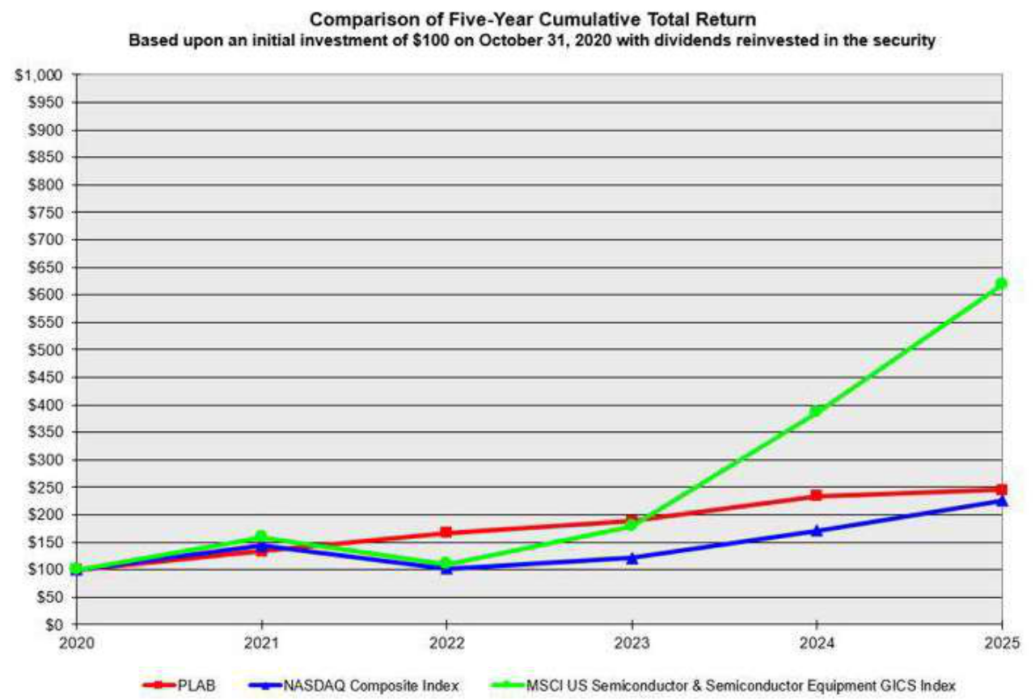

22

Purchase of Equity Securities by Registrant and Affiliated Purchasers

In September 2020, the Company’s Board of Directors authorized the repurchase of up to $100 million of its common stock, pursuant to a repurchase plan under Rule 10b-18 of the Exchange Act. The repurchase authorization by the Board of Directors has no expiration date, does not obligate the Company to acquire any common stock, and is subject to market conditions. From September 2020 through October 2022, the Company repurchased 5.8 million shares at a cost of $68.3 million. In August 2024, the Board of Directors authorized an increase to the Company’s existing share repurchase program from the remaining $31.7 million up to $100 million. In June 2025, the Board of Directors authorized an additional $25 million share repurchase. No shares were repurchased during the three-month period ended October 31, 2025. In fiscal year 2025, the Company repurchased 5.0 million shares at a cost of $97.4 million (an average of $19.52 per share). All shares repurchased under the program have been retired prior to the end of the fiscal year in which they were purchased. As of October 31, 2025, $27.6 million remained available under this authorization for the repurchase of additional shares.

ITEM 6. [RESERVED]

23

ITEM 7. MANAGEMENT’S DISCUSSION AND ANALYSIS OF FINANCIAL CONDITION AND RESULTS OF OPERATIONS

The following should be read in conjunction with “Cautionary Statement Regarding Forward Looking Statements” and our combined consolidated financial statements and notes thereto included in Part II, Item 8 of this Annual Report on Form 10-K.

For a comparison of results of operations for the fiscal years ended October 31, 2024 and 2023, see Part II, Item 7. Management’s Discussion and Analysis of Financial Condition and Results of Operations of Photronics Inc.’s Annual Report on Form 10-K for the fiscal year ended October 31, 2024, filed with the SEC on December 19, 2024.

Overview

We sell substantially all of our photomasks to designers and manufacturers of IC and FPD electronic devices. Photomask technology is also being applied to the fabrication of other high-technology products including advanced packaging modules, micro optical components for applications such as virtual reality/augmented reality and silicon photonics, micro-electronic mechanical systems (MEMS), and diverse nanotechnology applications. Our selling cycle is tightly interwoven with the development and release of new semiconductor and display designs and applications, particularly as they relate to the semiconductor industry's migration to more advanced design nodes and fabrication processes. The demand for photomasks is primarily correlated with new product design activity and to a lesser extent scaling up of manufacturing of end products. Consequently, an increase in semiconductor or display sales does not always result in a corresponding increase in photomask sales. To the extent integrated circuit and flat panel display applications rely less on new design activity, it could result in a reduction in demand for photomasks. In addition, new design methodologies driving a reduction in complexity of photomasks could also reduce demand for photomasks even if the demand for semiconductors and FPDs increases. More broadly, advances in semiconductor, display, and photomask design and production methods that shift the burden of achieving device performance away from lithography could also reduce the demand for photomasks. While there is no indication today that such diminishing of long range photomask demand is occurring or will occur, the microelectronics industry has been volatile, experiencing periodic downturns and slowdowns in design activity. These negative trends have been characterized by, among other things, diminished product demand, excess production capacity, and accelerated erosion of selling prices with a concomitant effect on revenue and profitability.

We are typically required to fulfill customer orders within a short period of time, sometimes within twenty-four hours. This results in a minimal level of backlog orders, typically one to two weeks of backlog for IC photomasks and two to three weeks of backlog for FPD photomasks. However, the demand for some IC photomasks can extend longer than the traditional time period; thus, for some products, our backlog can expand to as long as two to three months.

The global semiconductor and FPD industries are driven by end markets which have broad application in the global economy including but not limited to consumer-driven applications, data centers that support AI implementation, electric vehicles and national security. While we cannot predict the timing of the industry's transition to volume production of next-generation technology nodes, or the timing of up and down-cycles with precise accuracy, we believe that such transitions and cycles will continue into the future, beneficially and adversely affecting our business, financial condition, and operating results as they occur. We believe our ability to remain successful in these environments is dependent upon the achievement of our goals of being a service and technology leader and efficient solutions supplier, which we believe should enable us to continually reinvest in our global infrastructure.

We are focused on improving our competitiveness by advancing our technology and reducing costs and, in connection therewith, have invested and plan to continue to invest in manufacturing equipment to serve both the high-end photomask and mainstream markets. As we face challenges that require us to make significant improvements in our competitiveness, we continue to implement programs to streamline, drive efficiency and reduce cost in our infrastructure.

State-of-the-art production for semiconductor masks is considered to be 7 nanometer and smaller including EUV lithography for ICs and Generation 8.6 AMOLED display-based process technologies for FPDs. However, we define our high-end product category as 28nm and below for semiconductors and Generation 10.5 plus, Generation 6 and 8 AMOLED and LTPS for displays. This is consistent with current merchant mask industry definitions.

Moreover, design nodes above 28nm and FPD processes for standard LCD displays below Generation 10 are considered mainstream or standard products. At these geometries and various high-end nodes, we can produce full lines of photomasks, and there is no significant technology employed by our competitors that is not available to us. We expect advanced-generation designs to continue to move to production throughout fiscal 2026, and we believe we are well positioned to service an increasing volume of this business as a result of our investments in manufacturing processes and technology in the regions where our customers are located.

24

The photomask industry has been, and is expected to continue to be characterized by technological change and evolving industry standards. In order to remain competitive, we will be required to continually anticipate, respond to, and utilize changing technologies. In particular, we believe that, as semiconductor geometries continue to become smaller, and display designs become larger or otherwise more advanced, we will be required to manufacture even more complex products, including photomasks with optical proximity correction, phase-shift and EUV photomasks. Additionally, demand for photomasks has been, and could in the future be, adversely affected by changes in high-performance electronics fabrication methods that affect the type or quantity of photomasks used, such as changes in semiconductor demand that favor programmable IC devices and other approaches that replace application-specific ICs, or the use of certain chip-stacking methodologies that lessen the emphasis on conventional lithography technology. Furthermore, increased market acceptance of alternative methods of transferring circuit designs onto semiconductor wafers could reduce or eliminate the need for photomasks in the production of semiconductors.

Our revenues have benefited, and our costs, including depreciation, have been affected by the increased demand for high-end-technology photomasks

that require more advanced manufacturing capabilities, but generally command higher ASPs. Our capital expenditure payments were $188.1 million,

$130.9 million and $131.3 million in 2025, 2024 and 2023, respectively. Nonetheless, we intend to continue to make the required investments to support

the technological and production requirements of our customers that we believe will continue to enable our growth. This includes investments to replace

end-of-life mask-making equipment with higher-performing systems that better serve our customers. In support of this effort, we expect capital expenditure

payments to be approximately $330 million in fiscal year 2026.

The manufacture of photomasks for use in fabricating ICs, FPDs, and other related products built using comparable photomask-based process technologies has been, and continues to be, capital intensive. Our employees and our integrated global manufacturing network represent a significant portion of our fixed operating cost base. Should our revenue decrease as a result of a decrease in design releases from our customers, we may have excess or underutilized production capacity, which could significantly impact our operating margins, or result in write-offs from asset impairments.

25

Results of Operations

The following tables present selected operating information expressed as a percentage of revenue. The columns may not foot due to rounding.

Revenue

Cost of goods sold

Gross profit

Selling, general and administrative expenses

Research and development expenses

Operating income

Non-operating (expense) income, net

Income before income tax provision

Income tax (benefit) provision

Net income

Net income attributable to noncontrolling interests

Net income attributable to Photronics, Inc. shareholders

Revenue

Cost of goods sold

Gross profit

Selling, general and administrative expenses

Research and development expenses

Operating income

Non-operating income

Income before income tax provision

Income tax provision

Net income

Net income attributable to noncontrolling interests

Net income attributable to Photronics, Inc. shareholders

Three Months Ended
October 31, |  | August 3, |  | October 31,
2025 |  | 2025 |  | 2024
100.0% |  | 100.0% |  | 100.0%
65.0 |  | 66.3 |  | 63.0
35.0 |  | 33.7 |  | 37.0
9.3 |  | 8.8 |  | 9.4
1.5 |  | 2.0 |  | 2.4
24.1 |  | 22.9 |  | 25.2
11.1 |  | (4.5) |  | (0.5)
35.2 |  | 18.4 |  | 24.7
(1.2) |  | 4.6 |  | 6.5
36.4 |  | 13.8 |  | 18.2
7.8 |  | 3.0 |  | 2.9
28.6% |  | 10.9% |  | 15.3%
 |  | Year Ended
October 31, |  | October 31, |  | October 31,
2025 |  | 2024 |  | 2023
100.0% |  | 100.0% |  | 100.0%
64.7 |  | 63.6 |  | 62.3
35.3 |  | 36.4 |  | 37.7
8.9 |  | 9.0 |  | 7.8
1.9 |  | 1.9 |  | 1.5
24.5 |  | 25.6 |  | 28.4
1.6 |  | 3.0 |  | 1.9
26.1 |  | 28.5 |  | 30.3
3.7 |  | 7.3 |  | 7.9
22.4 |  | 21.2 |  | 22.4
6.3 |  | 6.1 |  | 8.3
16.1% |  | 15.1% |  | 14.1%

Note: All the following tabular comparisons, unless otherwise indicated, are for the three months ended October 31, 2025 (Q4 FY25), August 3, 2025 (Q3 FY25) and October 31, 2024 (Q4 FY24), and for the fiscal years ended October 31, 2025 (YTD FY25), October 31, 2024 (YTD FY24), and October 31, 2023 (YTD FY23). Please refer to Part II, Item 7 of our 2024 Form 10-K for comparative discussion of our fiscal years ended October 31, 2024, and October 31, 2023. The tables in this section (Part II, Item 7) may not foot due to rounding.

26

Revenue

Our quarterly revenues can be affected by the seasonal purchasing practices of our customers. As a result, demand for our products is typically reduced during the first quarter of our fiscal year by the North American, European, and Asian holiday periods, as some of our customers reduce their development and, consequently, their buying activities during those periods.

The following tables present changes in revenue disaggregated by product type and geographic origin, in Q4 FY25 and YTD FY25 from revenue in prior reporting periods.

Quarterly Changes in Revenue by Product Type ($ in millions)

 |  | Q4 FY25 compared with Q3 FY25 |  |  |  |  |  |  |  |  | Q4 FY25 compared with Q4
 |  |  |  |  |  |  |  |  |  |  | FY24
 |  | Revenue in |  |  | Increase |  |  | Percent |  |  | Increase |  |  | Percent
 |  | Q4 FY25 |  |  | (Decrease) |  |  | Change |  |  | (Decrease) |  |  | Change
IC |  |  |  | $
High-end * | $ | 65.8 |  | $ | 12.2 |  |  | 22.7% |  | $ | 5.8 |  |  | 9.6%
Mainstream |  | 91.6 |  |  | (2.5) |  |  | (2.7)% |  |  | (12.1) |  |  | (11.6)%
Total IC | $ | 157.4 |  | $ | 9.7 |  |  | 6.5% |  | $ | (6.3) |  |  | (3.8)%
FPD |  |  |  | $
High-end * | $ | 48.7 |  | $ | (4.8) |  |  | (8.9)% |  | $ | 0.4 |  |  | 0.8%
Mainstream |  | 9.6 |  |  | 0.5 |  |  | 5.5% |  |  | (0.9) |  |  | (8.8)%
Total FPD | $ | 58.3 |  | $ | (4.3) |  |  | (6.8)% |  | $ | (0.5) |  |  | (0.9)%
Total Revenue | $ | 215.8 |  | $ | 5.4 |  |  | 2.6% |  | $ | (6.8) |  |  | (3.1)%

* High-end photomasks typically have higher ASPs than mainstream products.

Quarterly Changes in Revenue by Geographic Origin ($ in millions) **

 |  | Q4 FY25 compared with Q3 FY25 |  |  |  |  |  |  |  | Q4 FY25 compared with Q4
 |  |  |  |  |  |  |  |  |  | FY24
 |  | Revenue in |  |  | Increase |  | Percent |  |  | Increase |  | Percent
 |  | Q4 FY25 |  |  | (Decrease) |  | Change |  |  | (Decrease) |  | Change
Taiwan | $ | 67.3 |  | $ | (1.1) |  | (1.6)% |  | $ | (2.4) |  | (3.4)%
China |  | 58.1 |  |  | 7.5 |  | 14.8% |  |  | (2.7) |  | (4.5)%
South Korea |  | 37.0 |  |  | (6.7) |  | (15.4)% |  |  | (3.0) |  | (7.5)%
United States |  | 43.5 |  |  | 5.7 |  | 15.3% |  |  | 1.8 |  | 4.2%
Europe |  | 9.0 |  |  | (0.1) |  | (1.3)% |  |  | (0.9) |  | (9.4)%
Other |  | 0.9 |  |  | 0.1 |  | 11.1% |  |  | 0.4 |  | 87.2%
Total revenue | $ | 215.8 |  | $ | 5.4 |  | 2.6% |  | $ | (6.8) |  | (3.1)%

** This table disaggregates revenue by the location in which it was earned.

27

Revenue in Q4 FY25 of $215.8 million represented an increase of 2.6% compared with Q3 FY25, and a decrease of 3.1% from Q4 FY24.

Overall IC revenue increased $9.7 million or 6.5% in Q4 FY25 from Q3 FY25 due to strong order patterns globally including the U.S. IC revenue decreased $6.3 million or 3.8% from Q4 FY24, as a result of a decline in maintream products partially offset by an increase in high-end demand. IC mainstream revenue decreased $2.5 million or 2.7% from Q3 FY25, and $12.1 million or 11.6% from Q4 FY24 primarily due to market conditions and geopolitical impacts.

FPD revenue decreased $4.3 million or 6.8% in Q4 FY25 from Q3 FY25, and $0.5 million or 0.9% from Q4 FY24 mainly due to the decrease in high-end products, which decreased $4.8 million or 8.9% in Q4 FY25 from Q3 FY25 due to timing of order patterns.

Year-over-Year Changes in Revenue by Product Type ($ in millions)

 |  |  |  |  | YTD FY25 compared with YTD FY24
 |  |  |  |  | Revenue in |  |  |  | Increase |  | Percent
 |  |  |  |  | YTD FY25 |  |  |  | (Decrease) |  | Change
IC
High-end * |  |  | $ |  | 238.9 |  | $ |  | 10.4 |  | 4.6%
Mainstream |  |  |  |  | 376.2 |  |  |  | (33.4) |  | (8.2)%
 | Total IC |  | $ |  | 615.1 |  | $ |  | (23.0) |  | (3.6)%
FPD
High-end * |  |  | $ |  | 195.5 |  | $ |  | 0.2 |  | 0.1%
Mainstream |  |  |  |  | 38.7 |  |  |  | 5.2 |  | 15.7%
 | Total FPD |  | $ |  | 234.2 |  | $ |  | 5.4 |  | 2.4%
Total Revenue |  |  | $ |  | 849.3 |  | $ |  | (17.6) |  | (2.0)%
* High-end photomasks typically have higher ASPs than mainstream photomasks.
Year-over-Year Changes in Revenue by Geographic Origin ($ in millions)**
 |  |  |  |  | YTD FY25 compared with YTD FY24
 |  |  |  |  | Revenue in |  |  |  | Increase |  | Percent
 |  |  |  |  | YTD FY25 |  |  |  | (Decrease) |  | Change
Taiwan |  |  | $ |  | 283.8 |  | $ |  | (4.4) |  | (1.5)%
China |  |  |  |  | 221.0 |  |  |  | (11.9) |  | (5.1)%
South Korea |  |  |  |  | 158.5 |  |  |  | 0.5 |  | 0.3%
United States |  |  |  |  | 148.9 |  |  |  | 2.3 |  | 1.5%
Europe |  |  |  |  | 34.2 |  |  |  | (5.2) |  | (13.2)%
Other |  |  |  |  | 2.9 |  |  |  | 1.1 |  | 61.3%
 |  |  | $ |  | 849.3 |  | $ |  | (17.6) |  | (2.0)%

** This table disaggregates revenue by the location in which it was earned.

28

Overall revenue decreased $17.6 million or 2.0% in YTD FY25 from YTD FY24, driven by a $23.0 million or 3.6% decrease in IC revenue due to lower demand for mainstream products earlier in the year, partially offset by strong demand for high-end products. FPD revenue increased by $5.4 million or 2.4%, driven by a $5.2 million or 15.7% increase in mainstream product revenue due to an increase in G8 products.

Gross Margin
 |  |  |  |  | Percent |  |  | Percent
 |  | Q4 FY25 |  | Q3 FY25 | Change |  | Q4 FY24 | Change
Gross profit | $ | 75.5 | $ | 70.9 |  | 6.5% $ | 82.3 | (8.3)%
Gross margin |  | 35.0% |  | 33.7% |  |  | 37.0%

Gross margin increased to 35% in Q4 FY25 from 33.7% in Q3 FY25, primarily due to favorable product mix and lower manufacturing cost, partially offset by higher overhead costs.

Gross margin decreased to 35% in Q4 FY25 from 37% in Q4 FY24, primarily due to unfavorable product mix and higher labor costs, partially offset by lower equipment costs as a percentage of revenue.

 |  |  |  |  |  |  | Percent
 |  | YTD FY25 |  |  |  | YTD FY24 | Change
Gross profit | $ | 299.8 | $ |  |  | 315.9 | (5.1)%
Gross margin |  | 35.3% |  |  |  | 36.4%

Gross margin decreased to 35.3% in YTD FY25 from 36.4% in YTD FY24, primarily due to increased material costs resulting from unfavorable product mix.

Selling, General and Administrative Expenses

Selling, general and administrative expenses were $20.0 million in Q4 FY25, compared with $18.4 million in Q3 FY25, and $21.0 million in Q4 FY24. The $1.6 million increase from Q3 FY25 was primarily the result of additional compensation and related expenses of $1.2 million. The $1.0 million decrease from Q4 FY24 was primarily the result of decreased professional fees of $0.5 million.

Selling, general and administrative expenses were $75.6 million in YTD FY25, compared with $77.8 million in YTD FY24. The decrease of $2.2 million is primarily due to a decrease in compensation and related expenses of $1.1 million and professional fees of $1.0 million.

Research and Development Expenses

Research and development expenses, which primarily consist of development and qualification efforts related to process technologies for high-end IC and FPD applications, decreased $1.1 million to $3.2 million in Q4 FY25, from Q3 FY25; the decrease was primarily caused by decreased qualification activities in the U.S. Research and development expenses in Q4 FY25 decreased by $2.1 million from Q4 FY24 as a result of decreased development activities in the U.S. and Asia. On a full year basis, research and development expenses decreased $0.8 million, to $15.8 million, primarily due to decreased development activities in Asia, partially offset by increased research and development activity in the U.S.

29

Other Income (Expense), net
 |  |  | Q4 FY25 |  |  |  | Q3 FY25 |  |  |  | Q4 FY24
Foreign currency transactions impact, net | $ |  | 18.6 | $ |  |  | (14.3) |  | $ |  | (7.7)
Interest expense, net |  |  | - |  |  |  | - |  |  |  | (0.1)
Interest income and other income, net |  |  | 5.3 |  |  |  | 4.8 |  |  |  | 6.8
Other income (expense), net | $ |  | 23.9 |  | $ |  | (9.4) |  | $ |  | (1.0)

Other income increased $33.3 million in Q4 FY25 from Q3 FY25 and $24.9 million from Q4 FY24, primarily due to foreign currency impacts. The foreign currency impacts were primarily driven by favorable movements of the New Taiwan dollar and the South Korean won, against the U.S. dollar for both periods.

 |  |  | YTD FY25 |  |  |  |  | YTD FY24
Foreign currency transactions impact, net |  | $ | (8.3) |  |  | $ |  | 2.2
Interest expense, net |  |  | (0.1) |  |  |  |  | (0.3)
Interest income and other income, net |  |  | 22.0 |  |  |  |  | 24.0
 |  |  |  |  |  | $
Other income (expense), net |  | $ | 13.6 |  |  |  |  | 25.9

Other income decreased $12.3 million in YTD FY25, compared with YTD FY24, due to unfavorable movements of the New Taiwan dollar and the South Korean won, against the U.S. dollar for the period.

30

Income Tax Provision
 |  | Q4 FY25 |  |  | Q3 FY25 |  |  | Q4 FY24
Income tax provision | $ | (2.7) |  | $ | 9.6 |  | $ | 14.6
Effective income tax rate |  | (3.5)% |  |  | 24.8% |  |  | 26.6%

The effective income tax rates are sensitive to the jurisdictional mix of our earnings, due, in part, to the non-recognition of tax benefits on losses in jurisdictions with valuation allowances.

The effective income tax rate decreased in Q4 FY25 compared with Q3 FY25 primarily due to the release of a $16.7 million valuation allowance related to deferred tax assets that are now expected to be realized in future periods, as well as $2.8 million of reversals of uncertain tax positions mainly resulting from audit settlements and statute expirations. These favorable items were partially offset by $7.1 million of foreign tax rate differentials driven by higher income levels during the quarter. In addition, the effective tax rate was impacted by an unfavorable jurisdictional mix of earnings.

The effective income tax rate decrease in Q4 FY25, compared with Q4 FY24, is primarily due to the impact of the change in valuation allowance described above, changes in the jurisdictional mix of earnings, and a decrease in foreign tax compared with the prior year.

 |  | YTD FY25 |  |  | YTD FY24
Income tax provision | $ | 31.6 |  | $ | 63.6
Effective income tax rate |  | 14.2% |  |  | 25.7%

The decrease in the effective income tax rate on a full-year basis in FY25, compared with FY24, is primarily due to the release of valuation allowance as described above. We also regularly assess the potential outcomes of ongoing and future tax examinations and, accordingly, have recorded accruals for such contingencies. Included in the balance of unrecognized tax benefits as of October 31, 2025 and October 31, 2024, are $11.4 million and $14.7 million respectively, recorded in Other liabilities in the consolidated balance sheets that, if recognized, would impact the effective tax rates.

31

On December 15, 2022, the European Union (EU) Member States formally adopted the EU’s Pillar Two Directive, which generally provides for a minimum effective tax rate of 15%, as established by the Organization for Economic Co-operation and Development (OECD) Pillar Two Framework. The EU effective dates are January 1, 2024, and January 1, 2025, for different aspects of the directive. A significant number of other countries are expected to continue to implement similar legislation with varying effective dates.

The Company is currently subject to Pillar Two, but we estimate that the financial impact is immaterial. We will continue to monitor further developments to determine any potential impact in the countries in which we operate.

On July 4, 2025, the One Big Beautiful Bill Act (“OBBBA”) was enacted in the United States. The OBBBA includes significant changes to federal tax law and other regulatory provisions that may impact the Company. The legislation enacted will be effective for Photronics commencing in our fiscal year 2026. We will continue to monitor and evaluate the impact of the legislative changes as more guidance becomes available.

Net Income Attributable to Noncontrolling Interests

Net income attributable to noncontrolling interests was $16.8 million in Q4 FY25, compared with $6.2 million in Q3 FY25; the increase of $10.6 million was the result of an increase in the net incomes of our joint venture operations. Net income attributable to noncontrolling interests increased $10.5 million in Q4 FY25, compared with $6.4 million in Q4 FY24; which was the result of an increase in the net incomes of our joint venture operations.

Net income attributable to noncontrolling interests increased by $0.7 million in YTD FY25 to $53.8 million from $53.2 million in YTD FY24, as a result of increased net income at both our Taiwan-based and China-based joint venture IC facilities.

Liquidity and Capital Resources

Cash and cash equivalents were $492.3 million and $598.5 million as of October 31, 2025, and October 31, 2024, respectively. As of October 31, 2025, total cash and cash equivalents included $446.1 million held by foreign subsidiaries, including an aggregate of $353.8 million held by our joint ventures in Taiwan and China. In addition, we currently have $95.9 million in short-term investments and CNY 200 million or USD 25 million of borrowing capacity in China to support local operations. See Note 8 – Debt to the consolidated financial statements for additional information on our outstanding debt and currently available financing. Our primary sources of liquidity are our cash on hand and cash we generate from operations.

We continually evaluate alternatives for efficiently funding our capital expenditures and ongoing operations. These reviews may result in our engagement in a variety of investing and financing transactions, in the transfer of cash among subsidiaries, and/or the repatriation of cash to the U.S. The transfer of funds among subsidiaries could be subject to foreign withholding taxes; in certain jurisdictions, repatriation of these funds to the U.S. may subject them to U.S. state income taxes and/or local country withholding taxes. We believe that our liquidity, including available financing, is sufficient to meet our requirements through the next twelve months and thereafter for the foreseeable future. Through the utilization of our existing liquidity, cash we generate from operations and short-term investments, we plan to continue to invest in our business, with our investments targeted to align with our customers’ technology road maps. In addition, we stand ready to invest in mergers, acquisitions, or strategic partnerships, should a suitable opportunity arise.

We estimate capital expenditures for our fiscal year 2026 will be approximately $330 million; these investments will be targeted towards high-end and mainstream “point” tools that will increase our operating capacity and efficiency and enable us to support our customers’ near-term demands. As of October 31, 2025, we had outstanding capital commitments of approximately $126.4 million and accrued liabilities related to capital equipment purchases of approximately $13.0 million. Although payment timing could vary, primarily as a result of the timing of tool delivery, installation and testing, we currently estimate that we will fund $120.0 million of our total $139.4 million committed and recognized obligations for capital expenditures over the next twelve months. Please refer to Notes 11 - Leases and 16 – Commitments and Contingencies to our consolidated financial statements for additional information on our lease liabilities and unrecognized commitments, respectively.

32

On August 28, 2024, the Board of Directors authorized an increase to the Company’s existing share repurchase program from the remaining $31.7 million to $100 million. In June 2025, the Board of Directors authorized an additional $25 million share repurchase. During the fiscal year ended as of October 31, 2025, the Company repurchased 5.0 million shares for $97.4 million. As a result, as of October 31, 2025, $27.6 million remained available under this authorization. Depending on market conditions, we may utilize some or the entire remaining approved amount to reacquire additional shares.

As discussed in Note 6 – PDMCX Joint Venture of our consolidated financial statements, DNP, the noncontrolling interest in our China-based joint venture has, under certain circumstances, the right to put its interest in the joint venture to Photronics, or to purchase our interest in the joint venture. Under all such circumstances, the sale of DNP’s interest would be at its ownership percentage of the joint venture’s net book value, with closing to take place within three business days of obtaining required approvals and clearance. As of the date of issuance of this report, DNP had not indicated its intention to exercise this right. As of October 31, 2025, Photronics and DNP each had net investments in this joint venture of approximately $160.4 million.

Cash Flows
 |  |  |  | Year Ended
 |  | October 31, |  | October 31, |  | October 31,
 |  | 2025 |  | 2024 |  | 2023
Net cash provided by operating activities | $ | 247.8 | $ | 261.4 | $ | 302.2
Net cash used in investing activities | $ | (238.9) | $ | (156.5) | $ | (101.5)
Net cash used in financing activities | $ | (115.3) | $ | (7.7) | $ | (18.5)

Operating Activities: Net cash provided by operating activities reflects net income adjusted for certain non-cash items, including depreciation and amortization, share-based compensation, and the effects of changes in operating assets and liabilities. Net cash provided by operating activities decreased by $13.6 million in FY25, compared with FY24, primarily due to unfavorable changes in working capital.

Investing Activities: Net cash used in investing activities increased by $82.4 million in FY25, compared to FY24, primarily driven by an increase of purchases of short-term investments of $29.0 million and purchases of property, plant, and equipment of $57.2 million.

Financing Activities: Net cash used in financing activities increased by $107.6 million in FY25, compared to FY24. This was driven by an increase in repurchases of common stock of $97.4 million and repayments of debt of $11.4 million.

Our cash, cash equivalents, and restricted cash balances were positively impacted by changes in foreign currency exchange rates in FY25 of $0.2 million.

Non-GAAP Financial Measures

Non-GAAP Net Income attributable to Photronics, Inc. shareholders and non-GAAP diluted earnings per share attributable to Photronics, Inc. shareholders are “non-GAAP financial measures” as such term is defined by Regulation G of the Securities and Exchange Commission and may differ from similarly named non-GAAP financial measures used by other companies. The financial tables below reconcile Photronics, Inc. financial results under U.S. GAAP to our non-GAAP financial information. We believe these non-GAAP financial measures that exclude certain items are useful for analysts and investors to evaluate the Company’s on-going performance because they enable a more meaningful comparison of historical results of the Company’s core business. These non-GAAP metrics are not a measure of consolidated operating results under U.S. GAAP and should not be considered as an alternative to Net income (loss), Net income (loss) per share, or any other measure of consolidated results under U.S. GAAP. The items excluded from these non-GAAP metrics but included in the calculation of their closest U.S. GAAP equivalent, are significant components of the condensed consolidated statement of income and must be considered in performing a comprehensive assessment of overall financial performance.

33

The following table reconciles U.S. GAAP net income and diluted earnings per share attributable to Photronics, Inc. shareholders to non-GAAP net income and diluted earnings per share attributable to Photronics, Inc. shareholders for the indicated periods. The columns may not foot due to rounding.

 |  |  | Three Months ended |  |  |  |  |  |  |  |  |  |  | Year ended
 |  | Oct 31, |  |  | Aug 3, |  |  | Oct 31, |  |  |  | Oct 31, |  |  | Oct 31, |  |  | Oct 31,
 |  |  | 2025 |  |  | 2025 |  |  | 2024 |  |  | 2025 |  |  | 2024 |  |  | 2023
Reconciliation of U.S. GAAP to non-GAAP net income:
U.S. GAAP net income attributable to Photronics, Inc. shareholders | $ |  | 61,801 |  | $ | 22,891 |  | $ | 33,869 |  | $ | 136,405 |  | $ | 130,688 |  | $ | 125,485
FX (gain) loss |  |  | (18,615) |  |  | 14,258 |  |  | 7,758 |  |  | 8,310 |  |  | (2,168) |  |  | (2,466)
Estimated tax effects of FX (gain) loss |  |  | 4,781 |  |  | (3,663) |  |  | (1,936) |  |  | (2,066) |  |  | 477 |  |  | 317
Estimated noncontrolling interest effects of above |  |  | 3,341 |  |  | (4,130) |  |  | (2,637) |  |  | (5,342) |  |  | (1,407) |  |  | 2,676
Reversal of deferred tax valuation allowance |  |  | (16,751) |  |  | - |  |  | - |  |  | (16,751) |  |  | - |  |  | -
Non-GAAP net income attributable to Photronics, Inc. shareholders |  | $ | 34,557 |  | $ | 29,356 |  | $ | 37,054 |  | $ | 120,556 |  | $ | 127,590 |  | $ | 126,012
Weighted-average number of common shares
outstanding - Diluted |  |  | 57,977 |  |  | 58,068 |  |  | 62,456 |  |  | 59,920 |  |  | 62,391 |  |  | 61,755
Reconciliation of U.S. GAAP to non-GAAP EPS:
U.S. GAAP diluted earnings per share attributable to Photronics, Inc. shareholders $ |  |  | 1.07 |  | $ | 0.39 |  | $ | 0.54 |  | $ | 2.28 |  | $ | 2.09 |  | $ | 2.03
Effects of the non-GAAP adjustments above |  |  | (0.47) |  |  | 0.12 |  |  | 0.05 |  |  | (0.27) |  |  | (0.04) |  |  | 0.01
 |  |  |  |  |  |  |  |  |  |  |  |  |  | $
Non-GAAP diluted earnings per share attributable to Photronics, Inc. shareholders $ |  |  | 0.60 |  | $ | 0.51 |  | $ | 0.59 |  | $ | 2.01 |  | $ | 2.05 |  | $ | 2.04

Business Outlook

Our current business outlook and guidance was provided in our Full Year and Fourth Quarter Fiscal 2025 Results earnings call, and related slide deck, but is not incorporated herein. These can be accessed in the investor section of our website - www.photronics.com. Information included on our website is not incorporated in this Form 10-K.

Our future results of operations and the other forward-looking statements contained in this filing and in our “Full Year and Fourth Quarter Fiscal 2025 Results” earnings call and presentation involve a number of risks and uncertainties, some of which are discussed in Part I, Item 1A of this report. These factors and a number of other unforeseeable factors could cause actual results to differ materially from our expectations.

34

Critical Accounting Estimates

Our consolidated financial statements are based on the selection and application of accounting policies, which require management to make significant estimates and assumptions. We believe the following to be the more critical areas that require judgment when applying our accounting policies:

- Revenue Recognition: The application of GAAP related to the measurement and recognition of revenue requires us to make judgments and estimates, including the determination of whether we should recognize revenue as we perform or upon the completion of our performance, as these determinations impact the timing and amount of our reported revenue and net income. Other significant judgments include the estimation of the point in the manufacturing process at which we are entitled to recognize revenue, as well as the measurement of our progress towards satisfying our performance obligations, which determine the amount of revenue we are entitled to recognize.

- Property, Plant and Equipment: Significant judgment and assumptions are employed when we establish the estimated useful lives of asset classes, and determine when depreciation should commence for individual assets, as these determinations can significantly impact our gross margin and research and development expenses. Significant judgment would also be employed when events or changes in circumstances indicate that the carrying amount of a group of assets may not be recoverable, as the recoverability assessment requires us to forecast future cash flows related to these assets; this evaluation can significantly impact our gross margin and operating expense.

- Leases: Significant judgment is applied in the determination of whether an arrangement is, or contains, a lease and, in certain instances, whether the lease should be classified as an operating lease or a finance lease, which can impact the timing and classification of lease costs.

- Contingencies: We are subject to the possibility of losses from various contingencies. Significant judgment is necessary to estimate the probability and amount of a loss, if any, from such contingencies. An accrual is made when it is probable that a liability has been incurred or an asset has been impaired and the amount of loss can be reasonably estimated. Changes in estimates related to, and resolutions of, contingencies may have a material impact on our financial performance.

- Income Taxes: Our annual tax rate is determined based on our income and the jurisdictions where it is earned, statutory tax rates, and the tax impacts of items treated differently for tax purposes than for financial reporting purposes. Also inherent in determining our annual tax rate are judgments and assumptions regarding the recoverability of certain deferred tax assets, and our ability to uphold certain tax positions. We are subject to complex tax laws, in the U.S. and numerous foreign jurisdictions, and the manner in which they apply can be open to interpretation. Realization of deferred tax assets is dependent upon generating sufficient taxable income in the appropriate jurisdiction in future periods, which involves business plans, planning opportunities, and expectations about future outcomes. Our assessment relies on estimates and assumptions and may involve a series of complex judgments about future events.

There are a number of estimates and assumptions inherent in calculating the various components of our tax provision. Future events such as changes in tax legislation, geographic mix of earnings, findings in tax audits, and earnings repatriation plans could have an impact on those estimates and our effective tax rate.

Effect of Recent Accounting Pronouncements

See Note 1 to our consolidated financial statements in this report for recent accounting pronouncements that may affect our financial reporting.

35

ITEM 7A. QUANTITATIVE AND QUALITATIVE DISCLOSURES ABOUT MARKET RISK

Foreign Currency Exchange Rate Risk

We conduct business in several major currencies throughout our worldwide operations, and our financial performance may be affected by fluctuations in the exchange rates of these currencies. Changes in exchange rates can positively or negatively affect our reported revenue, operating income, assets, liabilities, and equity. The functional currencies of our Asian subsidiaries are the South Korean won, the New Taiwan dollar, the Chinese yuan, and the Singapore dollar. The functional currencies of our European subsidiaries are the British pound and the euro. In addition, we engage in transactions and have exposures to the Japanese yen.

We attempt to minimize our risk of foreign currency transaction losses by producing products in the same country in which the products are sold (thereby generating revenues and incurring expenses in the same currency), and by managing our working capital. However, in some instances, we sell products in a currency other than the functional currency of the entity where it was produced, or purchase products in a currency that differs from the functional currency of the purchasing entity. We may also enter into derivative contracts to mitigate our exposure to foreign currency fluctuations when we have a significant purchase obligation or significant receivable denominated in a currency that differs from the functional currency of the transacting subsidiary. We do not enter into derivatives for speculative purposes. There can be no assurance that this approach will protect us from the need to recognize significant foreign currency transaction gains and losses, especially in the event of a significant adverse movement in the value of any foreign currency in which we conduct business against any of our functional currencies, including the U.S. dollar.

Our primary net foreign currency exposures as of October 31, 2025, included the South Korean won, the Japanese yen, the New Taiwan dollar, the Chinese yuan, the Singapore dollar, the British pound sterling, and the euro. As of that date, a 10% adverse movement in the value of currencies different from the functional currencies of our subsidiaries would have resulted in a net unrealized pre-tax loss of $70.1 million, which represents an increase of $8.8 million from our exposure as of October 31, 2024. Our most significant exposures at October 31, 2025, were exposures of the New Taiwan Dollar and the South Korean won against the U.S. dollar. We do not believe that a 10% change in the exchange rates of other non-U.S. dollar currencies, other than the aforementioned currencies, would have had a material effect on our October 31, 2025, consolidated financial statements.

Interest Rate Risk

A 10% adverse or favorable movement in the interest rates on our variable rate borrowings would not have had a material effect on our October 31, 2025, consolidated financial statements.

Inflation Risk

Inflationary factors generally affect us by increasing our labor and overhead costs, as well as costs associated with certain risks identified above, which may adversely affect our results of operations and financial position. We have historically been able to recover the impacts of inflation through sales price increases, however we cannot reasonably estimate our ability to successfully recover any impact of inflation through price increases in the future. Our inability to do so could harm our results of operations and financial position.

36

ITEM 8. FINANCIAL STATEMENTS AND SUPPLEMENTARY DATA
 |  |  |  | INDEX TO CONSOLIDATED FINANCIAL STATEMENTS
 |  |  |  |  |  |  | Page
Report of Independent Registered Public Accounting Firm Deloitte & Touche LLP (PCAOB ID 34) |  |  |  |  |  |  | 38
Consolidated Balance Sheets |  |  |  |  |  |  | 40
Consolidated Statements of Income |  |  |  |  |  |  | 41
Consolidated Statements of Comprehensive Income |  |  |  |  |  |  | 42
Consolidated Statements of Equity |  |  |  |  |  |  | 43
Consolidated Statements of Cash Flows |  |  |  |  |  |  | 44
Notes to Consolidated Financial Statements |  |  |  |  |  |  | 45
37
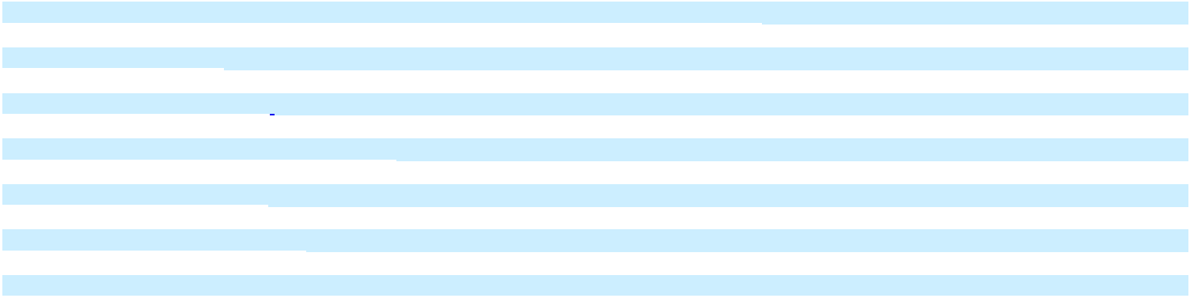

REPORT OF INDEPENDENT REGISTERED PUBLIC ACCOUNTING FIRM

To the shareholders and the Board of Directors of Photronics, Inc.

Opinion on the Financial Statements

We have audited the accompanying consolidated balance sheets of Photronics, Inc., and subsidiaries (the “Company”) as of October 31, 2025 and 2024, the related consolidated statements of income, comprehensive income, equity, and cash flows for each of the three years in the period ended October 31, 2025, and the related notes (collectively referred to as the “financial statements”). In our opinion, the financial statements present fairly, in all material respects, the financial position of the Company as of October 31, 2025 and October 31, 2024, and the results of its operations and its cash flows for each of the three years in the period ended October 31, 2025, in conformity with accounting principles generally accepted in the United States of America.

We have also audited, in accordance with the standards of the Public Company Accounting Oversight Board (United States) (PCAOB), the Company's internal control over financial reporting as of October 31, 2025, based on criteria established in Internal Control — Integrated Framework (2013) issued by the Committee of Sponsoring Organizations of the Treadway Commission, and our report dated December 17, 2025, expressed an unqualified opinion on the Company's internal control over financial reporting.

Basis for Opinion

These financial statements are the responsibility of the Company’s management. Our responsibility is to express an opinion on the Company’s financial statements based on our audits. We are a public accounting firm registered with the PCAOB and are required to be independent with respect to the Company in accordance with the U.S. federal securities laws and the applicable rules and regulations of the Securities and Exchange Commission and the PCAOB.

We conducted our audits in accordance with the standards of the PCAOB. Those standards require that we plan and perform the audit to obtain reasonable assurance about whether the financial statements are free of material misstatement, whether due to error or fraud. Our audits included performing procedures to assess the risks of material misstatement of the financial statements, whether due to error or fraud, and performing procedures that respond to those risks. Such procedures included examining, on a test basis, evidence regarding the amounts and disclosures in the financial statements. Our audits also included evaluating the accounting principles used and significant estimates made by management, as well as evaluating the overall presentation of the financial statements. We believe that our audits provide a reasonable basis for our opinion.

Critical Audit Matter

The critical audit matter communicated below is a matter arising from the current-period audit of the financial statements that was communicated or required to be communicated to the audit committee and that (1) relates to accounts or disclosures that are material to the financial statements and (2) involved our especially challenging, subjective, or complex judgments. The communication of critical audit matters does not alter in any way our opinion on the financial statements, taken as a whole, and we are not, by communicating the critical audit matter below, providing a separate opinion on the critical audit matter or on the accounts or disclosures to which they relate.

Revenue – Contracts with Customers— Refer to Note 1 & 10 of the financial statements.

Critical Audit Matter Description

The Company recognizes revenue over time for in-process production orders that have not shipped for contracts with customers for which it has an enforceable right to bill and collect consideration, including a reasonable profit, in the event the in-process orders are cancelled by the customers. In addition, as photomasks are manufactured to customer specifications, they have no alternative use to the Company. This results in the Company recording a corresponding contract asset as of period-end for these contracts. Significant judgment is exercised by the Company in determining the amount of revenue to recognize for these contracts and the corresponding contract asset, specifically in estimating the point within the production cycle at which the production orders stand in relation to the Company’s enforceable right within the contract. Pursuant to these contracts, revenue recognized over time and the associated contract asset as of October 31, 2025 was $12.7 million.

38

We identified the determination of revenue recognized over time for in-process productions orders as of October 31, 2025 as a critical auditing matter because of the significant estimates and assumptions management makes in determining the amount of revenue to recognize for these contracts. This required a high degree of audit judgment and an increased extent of effort when performing audit procedures to evaluate the reasonableness of management’s determination of the progress point of in-process orders and the amount of revenue recognized over time and the corresponding contract asset as of October 31, 2025.

How the Critical Audit Matter Was Addressed in the Audit

Our audit procedures related to the Company’s determination of the progress point of in-process orders and resulting revenue recognized over time and corresponding contract asset as of October 31, 2025 included the following:

We tested the operating effectiveness of controls over management’s determination of the point in the production process and correlation to stated contractual rights.
We tested the mathematical accuracy of management’s calculations of revenue and the associated timing of revenue recognized in the consolidated financial statements.
We tested the accuracy and completeness of the in-process orders report by performing physical observations.
We selected a sample of in-process production orders as of October 31, 2025 and performed the following procedures for each selection:

- Obtained and read the customer agreement/purchase order, invoice, and quote to determine whether the company has an enforceable right to bill and collect consideration.

- Evaluated management’s identification of significant contract terms and resulting revenue recognition for the in-process production order.

- Evaluated management estimate of the production point for the in-process order and corresponding revenue recognition and contract asset based on the Company’s enforceable right within the contract.

- Recalculated revenue recognized by testing actual costs incurred and by recalculating percentage completion based on total expected costs for each sampled order.

/s/ Deloitte & Touche LLP

Boston, Massachusetts

December 17, 2025

We have served as the Company’s auditor since 1991.

39

PHOTRONICS, INC.

Consolidated Balance Sheets

(in thousands, except per share amounts)

 |  |  |  | October 31, |  |  |  | October 31,
 |  |  |  | 2025 |  |  |  | 2024
ASSETS
Current assets:
Cash and cash equivalents |  | $ |  | 492,256 |  | $ |  | 598,485
Short-term investments |  |  |  | 95,909 |  |  |  | 42,184
Accounts receivable, net of allowance of $1,166 in 2025 and $1,126 in 2024 |  |  |  | 195,921 |  |  |  | 200,830
Inventories |  |  |  | 61,767 |  |  |  | 56,527
Other current assets |  |  |  | 44,199 |  |  |  | 33,036
Total current assets |  |  |  | 890,052 |  |  |  | 931,062
Property, plant and equipment, net |  |  |  | 854,436 |  |  |  | 745,257
Deferred income taxes |  |  |  | 40,207 |  |  |  | 23,059
Other assets |  |  |  | 19,839 |  |  |  | 12,681
Total assets |  | $ |  | 1,804,534 |  | $ |  | 1,712,059
LIABILITIES AND EQUITY
Current liabilities:
Current portion of long-term debt |  | $ |  | 11 |  | $ |  | 17,972
Accounts payable |  |  |  | 84,209 |  |  |  | 78,717
Accrued liabilities |  |  |  | 81,653 |  |  |  | 87,122
Total current liabilities |  |  |  | 165,873 |  |  |  | 183,811
Long-term debt |  |  |  | 13 |  |  |  | 25
Other liabilities |  |  |  | 41,341 |  |  |  | 47,464
Total liabilities |  |  |  | 207,227 |  |  |  | 231,300
Commitments and contingencies (Note 16)
Equity:
Preferred stock, $0.01 par value, 2,000 shares authorized, none issued and outstanding |  |  |  | - |  |  |  | -
Common stock, $0.01 par value, 150,000 shares authorized, 57,633 shares issued and outstanding at October 31,
2025, and 61,949 shares issued and outstanding at October 31, 2024 |  |  |  | 576 |  |  |  | 619
Additional paid-in capital |  |  |  | 486,934 |  |  |  | 514,757
Retained earnings |  |  |  | 772,199 |  |  |  | 691,807
Accumulated other comprehensive loss |  |  |  | (86,120) |  |  |  | (86,319)
Total Photronics, Inc. shareholders’ equity |  |  |  | 1,173,589 |  |  |  | 1,120,864
Noncontrolling interests |  |  |  | 423,718 |  |  |  | 359,895
Total equity |  |  |  | 1,597,307 |  |  |  | 1,480,759
Total liabilities and equity |  | $ |  | 1,804,534 |  | $ |  | 1,712,059


See accompanying notes to consolidated financial statements.

40

PHOTRONICS, INC.

Consolidated Statements of Income

(in thousands, except per share amounts)

Year Ended
 | October 31, |  | October 31, |  | October 31,
 | 2025 |  | 2024 |  | 2023

Revenue

Cost of goods sold

Gross profit

Operating expenses:

Selling, general and administrative

Research and development

Total operating expenses

Other operating expense

Operating income

Other income (expense):

Foreign currency transactions impacts, net

Interest income and other income, net

Interest expense

Income before income tax provision

Income tax provision

Net income


Net income attributable to noncontrolling interests

Net income attributable to Photronics, Inc. shareholders

Earnings per share:


$ | 849,294 |  | $ | 866,946 |  | $ | $892,076
 | 549,464 |  |  | 551,000 |  |  | 555,914
 | 299,830 |  |  | 315,946 |  |  | 336,162
 | 75,625 |  |  | 77,760 |  |  | 69,458
 | 15,804 |  |  | 16,576 |  |  | 13,654
 | 91,429 |  |  | 94,336 |  |  | 83,112
 | (240) |  |  | (92) |  |  | -
 | 208,161 |  |  | 221,518 |  |  | 253,050
 | (8,310) |  |  | 2,168 |  |  | 2,466
 | 21,988 |  |  | 24,063 |  |  | 14,863
 | (55) |  |  | (334) |  |  | (433)
 | 221,784 |  |  | 247,415 |  |  | 269,946
 | 31,550 |  |  | 63,567 |  |  | 70,312
 | 190,234 |  |  | 183,848 |  |  | 199,634
 | 53,829 |  |  | 53,160 |  |  | 74,149
$ | 136,405 |  | $ | $130,688 |  | $ | $125,485

Basic |  | $ | 2.29 |  | $ | 2.12 |  | $ | $2.05
Diluted | $ |  | 2.28 | $ |  | 2.09 | $ |  | $2.03
Weighted-average number of common shares outstanding:
Basic |  |  | 59,606 |  |  | 61,726 |  |  | 61,139
Diluted |  |  | 59,920 |  |  | 62,391 |  |  | 61,755
See accompanying notes to consolidated financial statements.
 | 41

PHOTRONICS, INC.

Consolidated Statements of Comprehensive Income

(in thousands)

 |  |  |  |  |  |  | Year Ended
 |  |  |  | October 31, |  |  | October 31, |  |  |  |  |  | October 31,
 |  |  |  | 2025 |  |  |  | 2024 |  |  |  |  | 2023
Net income | $ |  |  | 190,234 | $ |  | 183,848 |  |  | $ |  |  | 199,634
Other comprehensive income (loss), net of tax:
Foreign currency translation adjustments |  |  |  | 9,954 |  |  | 8,630 |  |  |  |  |  | 5,615
Other |  |  |  | 239 |  |  | (81) |  |  |  |  |  | (3)
Net other comprehensive income |  |  |  | 10,193 |  |  | 8,549 |  |  |  |  |  | 5,612
Comprehensive income |  |  |  | 200,427 |  |  | 192,397 |  |  |  |  |  | 205,246
Less: comprehensive income attributable to noncontrolling interests |  |  |  | 63,823 |  |  | 59,293 |  |  |  |  |  | 70,039
Comprehensive income attributable to Photronics, Inc. shareholders | $ |  |  | 136,604 | $ |  | 133,104 |  |  | $ |  |  | 135,207
See accompanying notes to consolidated financial statements.

42

Balance as of October 31, 2022 Net income

Other comprehensive income (loss)

Shares issued under equity plans

Share-based compensation expense

Balance as of October 31, 2023 Net income

Other comprehensive income

Shares issued under equity plans

Share-based compensation expense

Balance as of October 31, 2024 Net income

Other comprehensive income Shares issued under equity plans Share-based compensation expense Purchase and retirement of common stock through repurchase program

Balance as of October 31, 2025

PHOTRONICS, INC.

Consolidated Statements of Equity

Years Ended October 31, 2025, 2024 and 2023

(in thousands)

Photronics, Inc. Shareholders

 |  |  |  |  |  |  |  |  | Accumulated
 |  |  |  |  |  | Additional |  |  |  | Other |  |  | Non-
 | Common Stock |  |  |  |  | Paid-In |  | Retained | Comprehensive |  |  | Controlling |  |  | Total
Shares |  |  | Amount |  |  | Capital |  | Earnings | Income (Loss) |  |  |  | Interests |  | Equity
60,791 |  | $ | 608 |  | $ | 493,741 | $ | 435,634 | $ | (98,456) |  | $ | 230,562 | $ | 1,062,089
- |  |  | - |  |  | - |  | 125,485 |  | - |  |  | 74,149 |  | 199,634
- |  |  | - |  |  | - |  | - |  | 9,722 |  |  | (4,110) |  | 5,612
519 |  |  | 5 |  |  | 268 |  | - |  | - |  |  | - |  | 273
- |  |  | - |  |  | 8,001 |  | - |  | - |  |  | - |  | 8,001
61,310 |  | $ | 613 |  | $ | 502,010 | $ | 561,119 | $ | (88,734) |  | $ | 300,601 | $ | 1,275,609
- |  |  | - |  |  |  |  | 130,688 |  | - |  |  | 53,160 |  | 183,848
- |  |  | - |  |  | - |  | - |  | 2,415 |  |  | 6,134 |  | 8,549
639 |  |  | 6 |  |  | (1,143) |  | - |  | - |  |  | - |  | (1,137)
- |  |  | - |  |  | 13,890 |  | - |  | - |  |  | - |  | 13,890
61,949 |  | $ | 619 |  | $ | 514,757 | $ | 691,807 | $ | (86,319) |  | $ | 359,895 | $ | 1,480,759
- |  |  | - |  |  | - |  | 136,405 |  | - |  |  | 53,829 |  | 190,234
- |  |  | - |  |  | - |  | - |  | 199 |  |  | 9,994 |  | 10,193
672 |  |  | 6 |  |  | 149 |  | - |  | - |  |  | - |  | 155
- |  |  | - |  |  | 13,388 |  | - |  | - |  |  | - |  | 13,388
(4,988) |  |  | (49) |  |  | (41,360) |  | (56,013) |  | - |  |  | - |  | (97,422)
57,633 |  | $ | 576 |  | $ | 486,934 | $ | 772,199 | $ | (86,120) |  | $ | 423,718 | $ | 1,597,307
 |  |  |  |  |  | 43

PHOTRONICS, INC.

Consolidated Statements of Cash Flows

(in thousands)

 |  |  |  |  | Year Ended
 |  |  | October 31, |  |  |  | October 31, |  |  |  | October 31,
 |  |  | 2025 |  |  |  | 2024 |  |  |  | 2023
Cash flows from operating activities:
Net income | $ |  | 190,234 |  | $ |  | 183,848 |  | $ |  | 199,634
Adjustments to reconcile net income to net cash provided by operating activities:
Depreciation and amortization of property, plant and equipment |  |  | 77,258 |  |  |  | 82,433 |  |  |  | 80,473
Amortization of intangible assets |  |  | 347 |  |  |  | 372 |  |  |  | 362
Share-based compensation |  |  | 13,388 |  |  |  | 13,890 |  |  |  | 8,001
Deferred income taxes |  |  | (17,168) |  |  |  | (1,389) |  |  |  | (927)
Changes in assets, liabilities, and other:
Accounts receivable |  |  | 6,309 |  |  |  | (2,541) |  |  |  | 4,026
Inventories |  |  | (4,942) |  |  |  | (6,154) |  |  |  | 1,236
Other current assets |  |  | (4,715) |  |  |  | 628 |  |  |  | 9,665
Accounts payable, accrued liabilities and other |  |  | (12,913) |  |  |  | (9,643) |  |  |  | (294)
Net cash provided by operating activities |  |  | 247,798 |  |  |  | 261,444 |  |  |  | 302,176
Cash flows used in investing activities:
Purchases of property, plant and equipment |  |  | (188,137) |  |  |  | (130,942) |  |  |  | (131,295)
Purchases of short-term investments |  |  | (129,649) |  |  |  | (100,558) |  |  |  | (20,192)
Proceeds from maturities of short-term investments |  |  | 76,823 |  |  |  | 72,836 |  |  |  | 47,537
Government incentives |  |  | 2,158 |  |  |  | 2,229 |  |  |  | 2,522
Purchases of intangible assets |  |  | (94) |  |  |  | (89) |  |  |  | (117)
Other |  |  | - |  |  |  | 59 |  |  |  | -
Net cash used in investing activities |  |  | (238,899) |  |  |  | (156,465) |  |  |  | (101,545)
Cash flows used in financing activities:
Repayments of debt |  |  | (17,972) |  |  |  | (6,621) |  |  |  | (18,439)
Common stock repurchases |  |  | (97,422) |  |  |  | - |  |  |  | -
Proceeds from share-based arrangements |  |  | 2,231 |  |  |  | 1,916 |  |  |  | 1,248
Net settlements of restricted stock awards |  |  | (2,094) |  |  |  | (3,025) |  |  |  | (1,302)
Net cash used in financing activities |  |  | (115,257) |  |  |  | (7,730) |  |  |  | (18,493)
Effects of exchange rate changes on cash, cash equivalents, and restricted cash |  |  | 228 |  |  |  | 2,127 |  |  |  | (2,680)
Net change in cash, cash equivalents, and restricted cash |  |  | (106,130) |  |  |  | 99,376 |  |  |  | 179,458
Cash, cash equivalents, and restricted cash at beginning of year |  |  | 601,243 |  |  |  | 501,867 |  |  |  | 322,409
Cash, cash equivalents, and restricted cash at end of year |  |  | 495,113 |  |  |  | 601,243 |  |  |  | 501,867
Less: Ending restricted cash |  |  | 2,857 |  |  |  | 2,758 |  |  |  | 2,575
Cash and cash equivalents at end of year | $ |  | 492,256 |  | $ |  | 598,485 |  | $ |  | 499,292
Supplemental disclosure of non-cash information:
Accruals for property, plant and equipment not yet paid | $ |  | 12,173 |  | $ |  | 5,217 |  | $ |  | 18,607
Expected refundable federal investment tax credit | $ |  | 10,925 |  | $ |  | 5,013 |  | $ |  | -
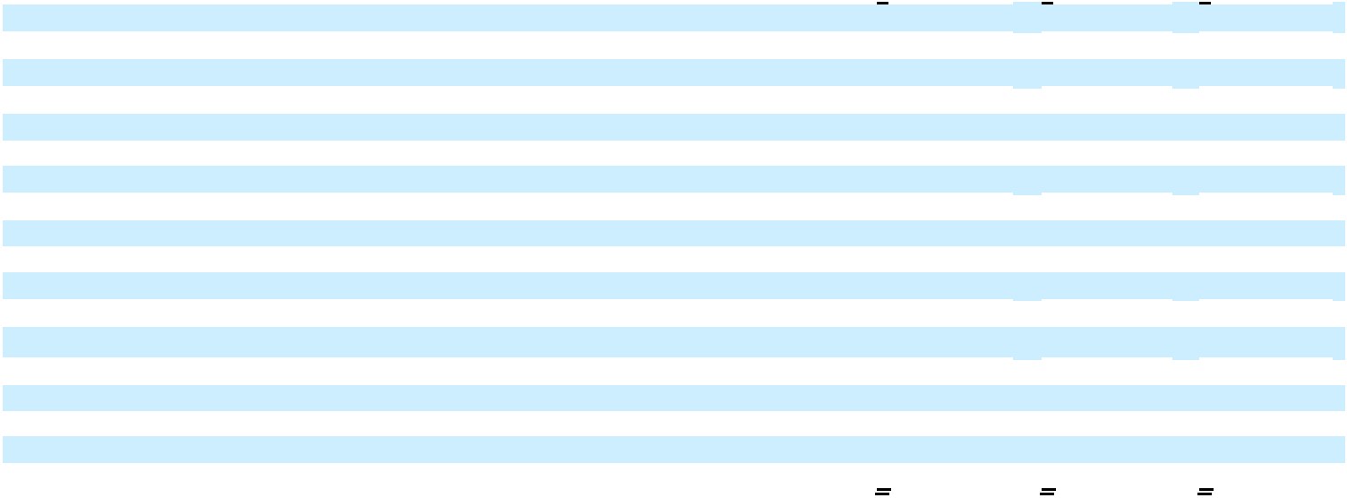

See accompanying notes to consolidated financial statements.

44

PHOTRONICS, INC.

Notes to Consolidated Financial Statements

Years Ended October 31, 2025, October 31, 2024 and October 31, 2023

(in thousands, except share amounts)

NOTE 1 - SUMMARY OF SIGNIFICANT ACCOUNTING POLICIES

Nature of Business and Basis of Presentation

Description of Business

Photronics, Inc. (“Photronics”, “the Company”, “we”, “our”, or “us”) is one of the world’s leading manufacturers of photomasks, which are high-precision photographic quartz or glass plates containing microscopic images of electronic circuits. Photomasks are a key element in the manufacture of ICs and FPDs, and are used as masters to transfer circuit patterns onto semiconductor wafers and FPD substrates during the fabrication of integrated circuits, a variety of FPDs and, to a lesser extent, other types of electrical and optical components. The Company currently has eleven manufacturing facilities, located in Taiwan (3), China (2), South Korea (1), the United States (3), and Europe (2).

Basis of Presentation

The consolidated financial statements are prepared in conformity with accounting principles generally accepted in the United States of America (“U.S. GAAP”). The accounting policies used to prepare these financial statements are the same as those used to prepare the consolidated financial statements in prior years, except as described in these notes or for the adoption of new standards as outlined below.

Principles of Consolidation

The accompanying consolidated financial statements include the accounts of Photronics, Inc., its wholly owned subsidiaries, in which Photronics is considered the primary beneficiary, and the majority-owned subsidiaries which it controls.

All intercompany balances and transactions have been eliminated in consolidation.

Noncontrolling interests in subsidiaries related to Photronics ownership interests of less than 100% are reported as Noncontrolling interests in the consolidated balance sheets. The results of noncontrolling ownership interests held by Photronics, net of tax, are reported as Net (income) attributable to noncontrolling interests in the consolidated statements of income.

Estimates and Assumptions

The preparation of financial statements in conformity with U.S. GAAP requires Photronics to make estimates and assumptions that affect amounts reported in them. The Company’s estimates are based on historical experience and on various assumptions that are believed to be reasonable, based on the facts and circumstances available at the time they are made. Subsequent actual results may differ from such estimates. The Company reviews these estimates periodically and reflects any effects of revisions in the period in which they are determined.

Translation of Foreign Currency Financial Statements

Photronics reporting currency is the U.S. dollar. The functional currency of the majority of Photronics foreign subsidiaries is their local currency. As such, amounts included in the consolidated statements of income, comprehensive income, cash flows, and changes in equity are translated using average exchange rates during each period. Assets and liabilities are translated at period-end exchange rates and resulting foreign currency translation adjustments are recorded in the consolidated balance sheets as a component of Accumulated other comprehensive loss.

45

Foreign Currency Transactions

Monetary assets and liabilities denominated in currencies other than the functional currency are remeasured into their respective functional currencies at exchange rates in effect at the balance sheet date. The resulting exchange gain or loss is included in Photonics’ consolidated statements of income as Foreign currency transactions impact, net.

Cash and Cash Equivalents

Cash and cash equivalents include cash and highly liquid investments with an original maturity of three months or less, readily convertible to known amounts of cash, and so near to their maturity that they present insignificant risk of changes in value because of changes in interest rates. Restricted cash is included with cash and cash equivalents when reconciling the beginning-of-period and end-of-period total amounts shown on the consolidated statements of cash flows. The carrying values of cash equivalents approximate their fair values, due to the short-term maturities of these instruments.

Restricted Cash

Restricted cash in the amounts of $2.9 million and $2.8 million are included in Other assets on the Company’s October 31, 2025 and October 31, 2024, consolidated balance sheets, respectively. The restrictions on these amounts are primarily related to land lease agreements and customs requirements.

Investments

The Company’s classification of investments is as follows:

- Maturing within three months or less from the date of purchase

- Maturing, as of the date of purchase, more than three months, but

with remaining maturities of less than one year, from the balance sheet date Maturing one year or more from the balance sheet date -

Cash and cash equivalents

Short-term investments Long-term

marketable investments

Based upon the Company’s intent and ability to hold its time deposits to maturity, maturities of which range up to twelve months at purchase, such securities are classified as held-to-maturity and are carried at amortized cost, which approximates market value. The Company’s U.S. Government Securities, commercial paper and money market funds are classified as available-for-sale. Available-for-sale investments are reported at fair value, with unrealized gains or losses (net of tax) reported in Accumulated other comprehensive income (loss). In the event of a sale of these securities, the Company would determine the cost of the investment sold at the specific individual security level and would include any gain or loss in Interest income and other income, net, where the Company also reports periodic interest earned and the amortization (accretion) of discounts (premiums) related to these investments.

When evaluating the investments for other-than-temporary impairment, the Company reviews factors such as length of time and extent to which fair value has been below cost basis, the financial condition of the issuer, and the Company’s ability and intent to hold the investment for a period of time, which may be sufficient for anticipated recovery in market values.

Accounts Receivable, Unbilled Receivables and Allowance for Credit Losses

We generally record the Company’s accounts receivable at their billed amounts. The Company recognizes unbilled receivables when the Company has satisfied its performance obligations, has an unconditional right to consideration, but has not yet issued an invoice. All outstanding past due customer invoices are reviewed for collectability during, and at the end of, every reporting period. To the extent that the Company believes a loss on the collection of a customer invoice is probable, the Company records the loss and credits an allowance for credit losses. In the event that an amount is determined to be uncollectible, the Company charges the allowance for credit losses and derecognizes the related receivable. Refer to the Company’s revenue recognition policy, below, for additional information on the Company’s accounting for accounts receivable.

46

Inventories

Inventories are stated at the lower of cost, determined under the first-in, first-out (“FIFO”) method, or net realizable value. Please refer to Note 4 for additional information on the Company’s inventories. Inventory reserves are established when conditions indicate that the net realizable value is less than cost due to assigned expiration dates or other causes based on individual facts and circumstances. If net realizable value is less than cost at the balance sheet date, the carrying amount is reduced to the realizable value, and the difference is recognized as a loss on valuation of inventories within cost of sales.

Property, Plant and Equipment, Net

Property, plant and equipment, except as described below under “Impairment of Long-Lived Assets,” is stated at cost less accumulated depreciation and amortization. Repairs and maintenance, as well as renewals and replacements of a routine nature, are charged to operations as incurred, while those that improve or extend the lives of existing assets are capitalized. Upon sale or other disposition, the cost of the asset and its related accumulated depreciation are removed from the accounts, and any resulting gain or loss is reflected in earnings.

Depreciation and amortization, essentially all of which are included in Cost of goods sold in the Company’s consolidated statements of income, are computed using the straight-line method over the estimated useful lives of the related assets. Buildings and improvements are depreciated over 10 to 39 years, machinery and equipment over 5 to 15 years, and furniture, fixtures, and office equipment over 3 to 5 years. Leasehold improvements are amortized over the lesser of the life of the lease or the estimated useful life of the improvement. The Company employs judgment when making assumptions about the estimated useful lives and depreciation periods the Company assigns to property, plant and equipment, and when events or changes in circumstances such as a significant industry downturn, plant closures, technological obsolescence, or other occurrences indicate that their carrying amounts may not be recoverable.

Impairment of Long-Lived Assets

Long-lived assets are reviewed for impairment whenever events or changes in circumstances indicate that the carrying amount of such assets may not be recoverable. Determinations of recoverability are based upon the Company’s judgment and estimates of undiscounted future cash flows resulting from the use of the assets and their eventual disposition. Measurement of an impairment loss for long-lived assets that the Company expects to hold and use is based on the fair value of the assets, determined using a market or income approach, compared with the carrying value of the asset. The carrying values of assets determined to be impaired would be reduced to their estimated fair values.

Property, plant and equipment and other long-lived assets to be sold or otherwise disposed of are reported at the lower of carrying amount or fair value less cost to sell.

Stock Repurchases

The Company records stock repurchases under the cost method, recording the entire cost of the acquired stock. When the Company retires the Company’s repurchased shares, any excess of the repurchase price paid over par value is allocated between additional paid-in capital and retained earnings.

47

Revenue Recognition

The Company recognizes revenue when, or as, control of a good or service transfers to a customer, in an amount that reflects the consideration to which the Company expects to be entitled in exchange for transferring those goods or services. The Company accounts for an arrangement as a revenue contract when each party has approved and is committed to perform under the contract, the rights of the contracting parties regarding the goods or services to be transferred and the payment terms are identifiable, the arrangement has commercial substance, and collection of consideration is probable. Substantially all of the Company’s revenue comes from the sales of photomasks. The Company typically contracts with the Company’s customers to sell sets of photomasks, which are comprised of multiple layers, the predominance of which the Company invoices as they ship to customers. As the photomasks are manufactured to customer specifications, they have no alternative use to the Company and, as the Company’s contracts generally provide the Company with the right to payment for work completed to date, the Company recognizes revenue as the Company performs, or “over time,” on most of the Company’s contracts. The Company measures the Company’s performance to date using an input method, which is based on the Company’s estimated costs to complete the various manufacturing phases of a photomask. At the end of a reporting period, there are a number of uncompleted revenue contracts on which the Company has performed; for any such contracts under which the Company is entitled to be compensated for the Company’s costs incurred plus a reasonable profit, the Company recognizes revenue and a corresponding contract asset for such performance. The Company accounts for shipping and handling activities that the Company performs after a customer obtains control of a good as being activities to fulfill the Company’s promise to transfer the good to the customer, rather than as promised services, or performance obligations, under the contract. The Company reports the Company’s revenue net of any sales or similar taxes the Company collects on behalf of governmental entities.

As stated above, photomasks are manufactured to customer specifications in accordance with their proprietary designs; thus, they are individually unique. Due to their uniqueness and other factors, their transaction prices are individually established through negotiations with customers; consequently, the Company’s photomasks do not have standard or “list” prices. The transaction prices of the vast majority of the Company’s revenue contracts include only fixed amounts of consideration. In certain instances, such as when the Company offers a customer an early payment discount, an estimate of variable consideration would be included in the transaction price, but only to the extent that a significant reversal of revenue would not occur when the uncertainty related to the variability was resolved.

Contract Assets and Contract Liabilities

The Company recognizes a contract asset when the Company’s performance under a contract precedes the Company’s receipt of consideration from a customer, or before payment is due, and the Company’s receipt of consideration is conditional upon factors other than the passage of time. Contract assets reflect the Company’s transfer of control to customers of photomasks that are in process or completed but not yet shipped to customers. A receivable is recognized when the Company has an unconditional right to payment for the Company’s performance, which generally occurs when the Company ships the photomasks. The Company’s contract assets primarily consist of a significant amount of the Company’s in-process production orders and fully manufactured photomasks which have not yet shipped, for which the Company has an enforceable right to collect consideration (including a reasonable profit) in the event the in-process orders are cancelled by customers. On an individual contract basis, the Company nets contract assets with contract liabilities (deferred revenue) for financial reporting purposes. The Company’s net credit losses on the accounts receivable during 2025 were immaterial. The Company did not impair any contract assets or accounts receivable in 2025 or 2024.

Contract Costs

The Company pays commissions to third-party sales agents for certain sales that they procure on the Company’s behalf. However, the basis of the commissions are the transaction prices of the sales, which are completed in less than one year; thus, no relationship is established with a customer that will result in future business. Therefore, the Company would not recognize any portion of these sales commissions as costs of obtaining a contract, nor does the Company currently foresee other circumstances under which the Company would recognize such assets.

Remaining Performance Obligations

As the Company is typically required to fulfill customer orders within a short time period, the Company’s backlog of orders is generally not in excess of one to two weeks for IC photomasks and two to three weeks for FPD photomasks. As allowed under ASC 606 – Revenue Contracts with Customers, the Company has elected not to disclose the Company’s remaining performance obligations, which represent the costs associated with the completion of the manufacturing process of in-process photomasks related to contracts that have an original duration of one year or less.

48

Product Warranties

The Company’s photomasks are sold under warranties that generally range from one to twenty-four months. The Company warrants that the Company’s photomasks conform to customer specifications, and the Company will typically repair, replace, or issue a refund for any photomasks that fail to do so. The warranties do not represent separate performance obligations in the Company’s revenue contracts. Historically, customer claims under warranties have been immaterial.

Leases

The Company determines if an agreement is, or contains, a lease on the earlier of the date of the agreement or the date on which the Company commits to entering the agreement and evaluates at that time whether the lease is an operating lease or a finance lease. The Company recognizes right-of-use assets and lease liabilities for operating and finance leases with terms greater than 12 months. Please refer to Note 11 – Leases for additional information.

The Company’s involvement in lease arrangements has typically been as a lessee. The Company determines if an agreement is, or contains, a lease on the earlier of the date of the agreement or the date on which the Company commits to entering the agreement. An arrangement is determined to be a lease when it conveys to the Company the right to control the use of an identified asset for a period of time in exchange for consideration. The Company’s having the right to control an identified asset is determined by whether the Company is entitled to substantially all of its economic benefits and can direct its use. The Company recognizes leases on the Company’s consolidated balance sheet when a lessor makes an asset underlying a lease having a term in excess of twelve months available for the Company’s use. As allowed under ASC Topic 842 – “Leases” (“Topic 842”), the Company has elected 1) not to apply the recognition requirements to leases that, at their commencement dates, have lease terms of twelve months or less and do not include options to purchase their underlying assets that the Company is reasonably certain to exercise and 2) for all classes of assets, the practical expedient to not separate lease components of a contract from non-lease components of a contract.

If an arrangement is determined to be, or includes a lease, the Company then applies the classification criteria in ASC 842 - Leases to determine whether the lease is a finance lease or an operating lease. For both types of leases, at their commencement dates (which are the dates on which a lessor makes an underlying asset available for the Company’s use), the Company recognizes Right-of-Use (“ROU”) assets, which represent the Company’s rights to use the underlying assets, and lease liabilities which represent the Company’s obligation to make payments for such rights. The present value of lease payments over the term of the lease provides the basis for the initial measurement of ROU assets and their related lease liabilities. Variable lease payments, other than those that are dependent on an index or on a rate (at which they are measured on their commencement dates), are not included in the measurement of ROU assets and their related lease liabilities. Lease terms include extension periods if the lease agreement includes an option to extend the lease that the Company is reasonably certain to exercise.

The initial measurement process for finance leases and operating leases is the same, except that, for operating leases, the Company generally applies the Company’s incremental borrowing rates for collateralized borrowings over terms similar to those of the leases to determine the lease liability while, for finance leases, the Company uses the interest rates implicit in the leases. The initial measurement of ROU assets may require further adjustments for lease prepayments and initial direct costs the Company incurs.

Operating leases are expensed on a straight-line basis over the terms of the leases, and are included in the consolidated statement of income in Cost of goods sold, Selling, general and administrative, or Research and development expense in accordance with the use of the underlying asset. Finance lease ROU assets are amortized over the estimated useful life of the underlying asset; the expenses are included in the consolidated statement of income in Cost of goods sold. Finance lease liabilities are subsequently remeasured by increasing the liability to reflect interest accrued during a period and decreasing the liability to reflect payments made during the period. Interest expense incurred on finance leases is included in Interest expense, net on the consolidated statements of income.

49

Cash paid for operating leases and interest paid for finance leases are included in the consolidated statement of cash flows as operating activities in Accounts payable, accrued liabilities and other; cash paid for finance lease principal is included in Repayments of debt in the financing activities section of the consolidated statement of cash flows.

Share-Based Compensation

We recognize share-based compensation expense on a straight-line basis over the requisite service period during which the awards are expected to vest. Share-based compensation expense includes the estimated effects of forfeitures, which are adjusted over the requisite service period to the extent actual forfeitures differ, or are expected to differ, from such estimates. Changes in estimated forfeitures are recognized in the period of change and will impact the amount of expense to be recognized in future periods. Determining the appropriate option pricing model, calculating the grant date fair value of share-based awards, and estimating forfeiture rates requires considerable judgment, including estimations of stock price volatility and the expected term of options granted.

We use the Black-Scholes option pricing model to value employee stock options. The Company estimates stock price volatility based on daily averages of the Company’s common stock’s historical volatility over a term approximately equal to the estimated time period the grant will remain outstanding. The expected term of options and forfeiture rate assumptions are derived from historical data.

Research and Development

Research and development costs are expensed as incurred and consist primarily of development efforts related to high-end process technologies for advanced subwavelength reticle solutions for IC and FPD photomask technologies. Research and development expenses were $15.8 million, $16.6 million, and $13.7 million for the years ended October 31, 2025, 2024 and 2023, respectively.

Government Grants

The Company receives or expects to receive in the future, various types of government assistance, primarily in the form of grants or refundable tax credits. Government assistance is recognized when there is reasonable assurance that: (1) the Company will comply with the relevant conditions and (2) the assistance will be received. Government assistance related to reimbursing fixed asset purchases, such as reimbursement grants and refundable federal investment tax credits, are recorded as a reduction to the related asset(s), which then reduces depreciation expense over the expected useful life of the asset on a straight-line basis. If some, or all, of the amount of government assistance becomes repayable (e.g. due to non-fulfillment of the grant conditions) or there is no longer reasonable assurance the amount will be received (e.g. due to additional interpretive guidance) then the adjustment is accounted for prospectively as a change in accounting estimate. The effect of the change in estimate is recognized in the period in which management concludes that it is no longer reasonably assured that all of the grant conditions will be met. A corresponding financial liability is recognized for the amount of the repayment, if any.

The Company accounts for funds the Company receives from government grants by either reducing the costs of the assets (if the grant relates to capital expenditures) or expenses which could be Cost of goods sold, Selling, general and administrative, or Research and development expenses in the consolidated statements of income. If the funds the Company receives cannot be attributed to specific assets or expenses, they would be recognized as other income, and included in Interest income and other income, net in the consolidated statements of income. Funds the Company receive from government grants are classified in the Company’s consolidated statements of cash flows as either Net cash provided by operating activities or Net cash provided by investing activities, in accordance with how the Company expends the funds. When a grant is received before conditions of the grant have been met, the grant is recorded in Accrued liabilities or Other liabilities in the Consolidated Balance Sheets.

The Company expects to receive refundable federal investment tax credits through the CHIPS Act in connection with ongoing capital expenditure expansion projects. As a result, as of October 31, 2025, the Company has reduced property, plant and equipment, net by $15.9 million of which $5.0 million was recorded during fiscal year 2024. The application submitted in 2024 for direct capital grants through the CHIPS Act in connection with the proposed projects is still under review process.

For the years ended October 31, 2025, 2024, and 2023, the Company’s subsidiaries in China received cash subsidies from local government authorities related to the acquisition of property, plant, and equipment in the amounts of $2.2 million, $2.1 million, and $2.5 million, respectively. The Company has recorded these subsidies as reductions of property, plant, and equipment.

50

Income Taxes

The income tax provision is computed on the basis of the income or loss before income taxes for each entity in its respective tax jurisdiction. Deferred income taxes reflect the tax effects of differences between the carrying amounts of assets and liabilities for financial reporting purposes and their amounts used for income tax purposes, as well as the tax effects of net operating losses and tax credit carryforwards. We employ judgment and make assumptions when establishing valuation allowances for deferred income tax assets, if their realization is not deemed to be more likely than not, by considering future market growth, operating forecasts, future taxable income, and the mix of earnings among the tax jurisdictions in which we operate. Accordingly, income taxes charged against earnings may have been impacted by changes in the valuation allowances. We are eligible for investment tax credits in U.S. and non-U.S. tax jurisdictions. We account for investment tax credits under the “flow-through” method of accounting. As permitted in ASC 740 “Income Taxes”, under the flow-through method of accounting, the tax benefit from an investment tax credit is recorded as a reduction of income taxes in the period in which the credit is generated.

We consider income taxes in each of the tax jurisdictions in which we operate in order to determine our effective income tax rate. Our current income tax expense is thus identified, and temporary differences resulting from differing treatments of items for tax and financial reporting purposes are assessed. These differences result in deferred tax assets, which are presented on our consolidated balance sheets, and deferred tax liabilities, which are included in Other liabilities on our consolidated balance sheets.

We account for uncertain tax positions by recording a liability for unrecognized tax benefits resulting from uncertain tax positions taken, or expected to be taken, in our tax returns. We include any applicable interest and penalties related to uncertain tax positions in the liability and in our income tax provision.

Earnings Per Share

Basic earnings per share attributed to Photronics shareholders is computed independently for each period presented and is based on the weighted-average number of common shares outstanding for the period, excluding any dilutive common share equivalents. Diluted earnings per share (“EPS”) reflects the potential dilution that could occur if certain share-based payment awards were exercised or earned.

Variable Interest Entities

We account for the investments the Company makes in certain legal entities in which equity investors do not have: 1) sufficient equity at risk for the legal entity to finance its activities without additional subordinated financial support or, 2) as a group, the holders of the equity investment at risk do not have either the power, through voting or similar rights, to direct the activities of the legal entity that most significantly impact the entity’s economic performance or, 3) the obligation to absorb the expected losses of the legal entity or the right to receive expected residual returns of the legal entity as “variable interest entities”, or “VIEs”.

We consolidate the results of any such entity in which the Company has determined that the Company has a controlling financial interest. The Company would have a “controlling financial interest” (and thus be considered the “primary beneficiary” of the entity) in such an entity when the Company has both the power to direct the activities that most significantly affect the VIE’s economic performance and the obligation to absorb the losses of, or right to receive the benefits from, the VIE that could be potentially significant to the VIE. On a quarterly basis, the Company reassesses whether the Company has a controlling financial interest in any investments the Company has in these entities.

We would account for investments the Company makes in VIEs in which the Company has determined that the Company does not have a controlling financial interest but have a significant influence over, and hold at least a twenty percent ownership interest in, using the equity method. An investment not meeting the parameters to be accounted for under the equity method would be accounted for using the cost method, unless the investment had a readily determinable fair value, at which value it would then be reported.

51

Recent Accounting Pronouncements

In November 2024, the Financial Accounting Standards Board (the “FASB”) issued Accounting Standards Update (“ASU”) No. 2024-03, Income Statement - Reporting Comprehensive Income - Expense Disaggregation Disclosures (Subtopic 220-40): Disaggregation of Income Statement Expenses (“ASU 2024-03”) and in January 2025, the FASB issued ASU No. 2025-01, Income Statement - Reporting Comprehensive Income - Expense Disaggregation Disclosures (Subtopic 220-40): Clarifying the Effective Date, which clarified the effective date of ASU 2024-03. ASU 2024-03 will require the Company to disclose the amounts of purchases of inventory, employee compensation, depreciation and intangible asset amortization, as applicable, as well as qualitatively describe remaining amounts included in those captions. The guidance in this ASU will be effective for Photronics in its fiscal year 2028 Form 10-K, with early application of the amendments allowed. The Company is currently evaluating the impact the adoption of this ASU may have on the Company’s consolidated financial statements and related disclosures.

In December 2023, the FASB issued ASU 2023-09, “Income Taxes (Topic 740): Improvements to Income Tax Disclosures”, to enhance the transparency and decision usefulness of income tax disclosures. The amendments in this ASU related to the rate reconciliation and income taxes paid disclosures to improve the transparency of income tax disclosures by requiring (1) consistent categories and greater disaggregation of information in the rate reconciliation and (2) income taxes paid disaggregated by jurisdiction. The amendments allow investors to better assess, in their capital allocation decisions, how an entity’s worldwide operations and related tax risks and tax planning and operational opportunities affect its income tax rate and prospects for future cash flows. The guidance in this ASU will be effective for Photronics in its fiscal year 2026 Form 10-K, with early application of the amendments allowed. The Company is currently evaluating the effect of this ASU adoption on its disclosures.

In November 2023, the FASB issued ASU 2023-07, “Segment Reporting (Topic 280): Improvements to Reportable Segment Disclosures”, which improves reportable segment disclosure requirements, primarily through enhanced disclosures about significant segment expenses. The guidance in this ASU is effective for Photronics in its fiscal year 2025 Form 10-K. The Company adopted ASU 2023-07, please see NOTE 18 – SEGMENT REPORTING.

NOTE 2 – ACCOUNTS RECEIVABLE, NET
The components of Accounts Receivable, net at the balance sheet dates are presented below.
 |  |  | October 31, |  |  | October 31,
 |  | 2025 |  |  |  | 2024
Accounts Receivable | $ | 166,511 |  |  | $ | 172,741
Unbilled Receivables |  | 30,576 |  |  |  | 29,215
Allowance for Credit Losses |  | (1,166) |  |  |  | (1,126)
 | $ | 195,921 |  |  | $ | 200,830
NOTE 3 - OTHER CURRENT ASSETS
Presented below are the components of Other current assets at the balance sheet dates.
 |  |  | October 31, |  |  | October 31,
 |  | 2025 |  |  |  | 2024
Contract assets | $ | 12,670 |  |  | $ | 11,532
Prepaid expenses |  | 8,504 |  |  |  | 5,770
Recoverable value added taxes |  | 3,104 |  |  |  | 2,684
Prepaid and refundable income taxes |  | 4,385 |  |  |  | 1,875
Other ⁽¹⁾ |  | 15,536 |  |  |  | 11,175
 | $ | 44,199 |  |  | $ | 33,036

- Includes expected refundable federal investment tax credits through the CHIPS Act in the amount of $10.9 million and $5.0 million as of October 31, 2025 and 2024, respectively.

52

NOTE 4 - INVENTORIES
The components of Inventories at the balance sheet dates are presented below.
 |  |  |  | October 31, |  |  |  | October 31,
 |  |  | 2025 |  |  |  |  | 2024
Raw materials |  | $ | 60,150 |  |  | $ |  | 56,128
Work in process |  |  | 1,616 |  |  |  |  | 398
Finished goods |  |  | 1 |  |  |  |  | 1
 |  | $ | 61,767 |  |  | $ |  | 56,527
NOTE 5 - PROPERTY, PLANT AND EQUIPMENT, NET
Presented below are the components of Property, plant and equipment, net at the balance sheet dates.
 |  |  |  | October 31, |  |  |  | October 31,
 |  |  | 2025 |  |  |  |  | 2024
Land |  | $ | 12,245 |  |  | $ |  | 11,419
Buildings and improvements |  |  | 192,860 |  |  |  |  | 188,756
Machinery and equipment |  |  | 2,109,456 |  |  |  |  | 1,990,610
Leasehold improvements |  |  | 20,474 |  |  |  |  | 19,268
Furniture, fixtures, and office equipment |  |  | 19,394 |  |  |  |  | 18,091
Construction in progress |  |  | 134,880 |  |  |  |  | 91,213
 |  |  | 2,489,309 |  |  |  |  | 2,319,357
Accumulated depreciation and amortization |  |  | (1,634,873) |  |  |  |  | (1,574,100)
 |  | $ | 854,436 |  |  | $ |  | 745,257

Information on ROU assets resulting from finance leases, at the balance sheet dates, is presented below. During 2025, the Company exercised its early buy-out option for a high-end lithography tool and a high-end inspection tool. Please refer to Note 8 for further information.

 |  | October 31, |  |  | October 31,
 |  | 2025 |  |  | 2024
Machinery and equipment | $ | 54 |  | $ | 42,815
Accumulated amortization |  | (53) |  |  | (10,522)
 | $ | 1 |  | $ | 32,293

The following table presents depreciation expense (including the amortization of ROU assets) related to property, plant and equipment incurred during the reporting periods.

 |  |  |  |  |  | Years Ended
 |  |  |  |  | October 31, |  |  | October 31, |  |  | October 31,
 |  |  |  |  | 2025 |  |  | 2024 |  |  | 2023
Depreciation and amortization expense | $ |  |  |  | 77,258 | $ |  | 82,433 | $ |  | 80,472
 | 53

NOTE 6 - PDMCX JOINT VENTURE

In January 2018, Photronics, Inc., through its wholly-owned Photronics Singapore PTE. LTD. subsidiary (hereinafter, within this Note “we”, “Photronics”, “us”, or “our”), and DNP, through its wholly owned subsidiary DNP Asia Pacific PTE, Ltd., entered into a joint venture under which DNP obtained a 49.99% interest in the Company’s IC business in Xiamen, China. The joint venture, which the Company refers to as “PDMCX”, was established to develop and manufacture photomasks for semiconductors. The Company entered into this joint venture to enable the Company to compete more effectively for the merchant photomask business in China, and to benefit from the additional resources and investment that DNP provides to enable the Company to offer advanced-process technology to the Company’s customers.

In 2020, in combination with local financing obtained by PDMCX, Photronics and DNP fulfilled their investment obligations under the PDMCX operating agreement (“the Agreement”). Liens were granted to the local financing entity on property, plant, and equipment and were paid off during fiscal year 2023 and there was no remaining debt at October 31, 2023.

Under the Agreement, should either Photronics’ or DNP’s ownership interest fall below 20.0% for a period of more than six consecutive months, such party (an “exiting party”) has the option to sell to the other party, and the other party has the option to purchase from such exiting party, the exiting party’s remaining ownership interest. In either case, the sales of ownership interests would be at the exiting party’s ownership percentage of the joint venture’s net book value, with closing to take place within three business days of obtaining required approvals and clearance.

The following table presents net income the Company recorded from the operations of PDMCX during the reporting periods.
 |  |  |  |  | Years Ended
 |  |  |  | October 31, |  |  | October 31, |  |  | October 31,
 |  |  |  | 2025 |  |  | 2024 |  |  | 2023
Net income from PDMCX | $ |  |  | 19,462 | $ |  | 20,074 | $ |  | 25,098

As required by the guidance in ASC Topic 810 - “Consolidation”, the Company evaluated the Company’s involvement in PDMCX for the purpose of determining whether the Company should consolidate its results in the Company’s financial statements. The initial step of the Company’s evaluation was to determine whether PDMCX was a VIE. Due to its lack of sufficient equity at risk to finance its activities without additional subordinated financial support, the Company determined that it is a VIE. Having made this determination, the Company then assessed whether the Company was the primary beneficiary of the VIE, and concluded that the Company was the primary beneficiary during the current and prior years reporting periods; thus, as required, the PDMCX financial results have been consolidated with Photronics. The Company’s conclusion was based on the fact that the Company held a controlling financial interest in PDMCX (which resulted from the Company’s having the power to direct the activities that most significantly impacted its economic performance) and had both the obligation to absorb losses and the right to receive benefits that could potentially be significant to PDMCX. The Company’s conclusion that the Company had the power to direct the activities that most significantly affected the economic performance of PDMCX during the current and prior year periods were based on the Company’s right to appoint the majority of its Board of Directors, which has, among others, the powers to manage the business (through its rights to appoint and evaluate PDMCX’s management), incur indebtedness, enter into agreements and commitments, and acquire and dispose of PDMCX’s assets. In addition, as a result of the 50.01% variable interest the Company held during the current and prior year periods, the Company had the obligation to absorb losses, and the right to receive benefits, that could potentially be significant to PDMCX.

The following table presents the carrying amounts of PDMCX assets and liabilities included in the Company’s consolidated balance sheets. General creditors of PDMCX do not have recourse to the assets of Photronics (other than the net assets of PDMCX); therefore, the Company’s maximum exposure to loss from PDMCX is the Company’s interest in the carrying amount of the net assets of the joint venture.

 |  |  | October 31, |  |  |  |  |  | October 31,
 |  |  |  | 2025 |  |  |  |  | 2024
Classification |  |  | Carrying |  |  | Photronics |  |  | Carrying |  |  | Photronics
Classification |  |  | Amount |  |  | Interest |  |  | Amount |  |  | Interest
Current assets | $ |  | 180,289 | $ |  | 90,163 | $ |  | 174,059 | $ |  | 87,047
Noncurrent assets |  |  | 166,756 |  |  | 83,395 |  |  | 151,039 |  |  | 75,535
Total assets |  |  | 347,045 |  |  | 173,558 |  |  | 325,098 |  |  | 162,582
Current liabilities |  |  | 23,193 |  |  | 11,599 |  |  | 40,691 |  |  | 20,350
Noncurrent liabilities |  |  | 2,970 |  |  | 1,485 |  |  | 3,320 |  |  | 1,660
Total liabilities |  |  | 26,163 |  |  | 13,084 |  |  | 44,011 |  |  | 22,010
Net assets | $ |  | 320,882 | $ |  | 160,474 | $ |  | 281,087 | $ |  | 140,572
 | 54

NOTE 7 - ACCRUED LIABILITIES
Presented below are the components of Accrued liabilities at the balance sheet dates.
 |  |  | October 31, |  |  | October 31,
 |  |  | 2025 |  |  |  | 2024
Compensation related expenses |  | $ | 26,284 | $ |  | 31,188
Income taxes |  |  | 21,094 |  |  | 24,200
Contract liabilities |  |  | 9,491 |  |  | 12,375
Property, plant, and equipment |  |  | 7,291 |  |  | 2,670
Value added and other taxes |  |  | 3,799 |  |  | 2,837
Service contracts |  |  | 2,226 |  |  | 1,448
Operating leases |  |  | 1,975 |  |  | 1,925
Telecommunications and utilities |  |  | 1,328 |  |  | 1,040
Other |  |  | 8,165 |  |  | 9,439
Accrued liabilities |  | $ | 81,653 |  | $ | 87,122
NOTE 8 - DEBT

As of October 31, 2025 and October 31, 2024, the Current portion of long-term debt and the Long-term debt balances were comprised of finance leases as described below:

 |  |  | October 31, |  |  | October 31,
 |  |  | 2025 |  |  | 2024
Principal due:
Next 12 months | $ |  | 11 |  |  | 17,972
 | $
Months 13 – 24 |  |  | 12 |  |  | 12
Months 25 – 36 |  |  | 1 |  |  | 12
Months 37 – 48 |  |  | - |  |  | 1
Months 49 – 60 |  |  | - |  |  | -
Long-term debt |  |  | 13 |  |  | 25
Total debt |  | $ | 24 |  |  | 17,997
Interest rate at balance sheet date |  |  | N/A |  |  | N/A
Basis spread on interest rates |  |  | N/A |  |  | N/A
Interest rate reset |  |  | N/A |  |  | N/A
Maturity date |  |  | N/A |  |  | N/A
Periodic payment amount |  |  | Varies as |  |  | Varies as
Periodic payment amount |  | Lease matures |  |  |  | Lease matures
Periodic payment frequency |  |  | Monthly |  |  | Monthly
Loan collateral (carrying amount) | $ |  | 1 |  | (1) | 32,293 (1)

- Represents the carrying amount at the balance sheet date of the related ROU assets, in which the lessors have secured interests.

55

Finance Leases

In February 2021, the Company entered into a five-year $7.2 million finance lease for a high-end inspection tool. Monthly payments on the lease, which commenced in February 2021, were $0.1 million per month. Upon the fiftieth monthly payment and prior to payment of the fifty-first monthly payment, the Company could exercise an early buyout option to purchase the tool for $2.4 million. After the original term or any renewal periods, the Company could return the tool, elect to extend the lease, or purchase the tool at its fair market value. The Company exercised the early buyout option to purchase the tool for $2.4 million during the fiscal year 2025.

In December 2020, the Company entered into a five-year $35.5 million finance lease for a high-end lithography tool. Monthly payments on the lease, which commenced in January 2021, increased from $0.04 million during the first three months to $0.6 million for the following nine months, followed by forty-eight monthly payments of $0.5 million. The lease agreement provided an early buyout option to purchase the tool for $14.1 million, which the Company exercised during the fiscal year 2025.

Xiamen Working Capital Loans

In November 2018, PDMCX obtained approval for revolving, unsecured credit of CNY 200 million ($25 million), pursuant to which PDMCX may enter into separate loan agreements with varying terms to maturity. In December 2022, the Company repaid the Company’s entire outstanding balance of CNY 25.6 million ($3.6 million). The interest rates are variable, based on the CNY Loan Prime Rate of the National Interbank Funding Center. Interest incurred on the loans related to the amount borrowed was eligible for reimbursement through incentives provided by the Xiamen Torch Hi-Tech Industrial Development Zone, which provided such reimbursements up to a prescribed limit and duration. This facility is subject to annual reviews and extensions. In July 2025, the Company was issued an extension to the revolving, unsecured credit agreement for CNY 200 million or USD 25 million with an expiration date of July 31, 2026. As of October 31, 2025, PDMCX had no outstanding borrowings against the approval.

Interest Paid for Debt

Interest payments were $0.1 million in 2025, $0.3 million in 2024, and $0.5 million in 2023. The weighted-average interest rate on the Company’s current portion of long-term debt for the periods ended October 31, 2025 and October 31, 2024 was 5.9% and 1.5%, respectively.

NOTE 9 - OTHER LIABILITIES

Presented below are the components of Other liabilities at the balance sheet dates.

 |  |  |  |  | October 31, |  |  | October 31,
 |  |  |  |  | 2025 |  |  | 2024
Unrecognized tax benefit | $ |  |  |  | 11,379 | $ |  | 14,720
Post employment benefit |  |  |  |  | 13,218 |  |  | 12,993
Contract liabilities |  |  |  |  | 5,041 |  |  | 8,910
Tax payable |  |  |  |  | 4,530 |  |  | 4,310
Operating lease |  |  |  |  | 3,960 |  |  | 3,037
Other |  |  |  |  | 3,213 |  |  | 3,494
Other liabilities | $ |  |  |  | 41,341 | $ |  | 47,464
 | 56

NOTE 10 - REVENUE

The following tables present the Company’s revenue for the years ended October 31, 2025, October 31, 2024, and October 31, 2023, disaggregated by product type, geographic origin, and timing of recognition.

 |  |  |  |  |  |  |  |  |  | Year Ended
 |  |  |  |  |  |  |  | October 31, |  |  |  |  | October 31, |  |  |  | October 31,
Revenue by Product Type |  |  |  |  |  |  |  | 2025 |  |  |  | 2024 |  |  |  |  | 2023
IC
High-end |  | $ |  |  |  |  |  | 238,865 | $ |  |  | 228,469 |  |  | $ |  | 194,939
Mainstream |  |  |  |  |  |  |  | 376,239 |  |  |  | 409,682 |  |  |  |  | 456,340
 | Total IC | $ |  |  |  |  |  | 615,104 | $ |  |  | 638,151 |  |  | $ |  | 651,279
FPD
High-end |  | $ |  |  |  |  |  | 195,520 | $ |  |  | 195,365 |  |  | $ |  | 200,842
Mainstream |  |  |  |  |  |  |  | 38,670 |  |  |  | 33,430 |  |  |  |  | 39,955
 | Total FPD | $ |  |  |  |  |  | 234,190 | $ |  |  | 228,795 |  |  | $ |  | 240,797
 |  | $ |  |  |  |  |  | 849,294 | $ |  |  |  | 866,946 |  | $ |  | 892,076
 |  |  |  |  |  |  |  |  |  | Year Ended
 |  |  |  |  |  |  |  | October 31, |  |  |  | October 31, |  |  |  |  | October 31,
Revenue by Geographic Origin* |  |  |  |  |  |  |  | 2025 |  |  |  | 2024 |  |  |  |  | 2023
Taiwan |  | $ |  |  |  |  |  | 283,844 | $ |  |  | 288,275 |  |  | $ |  | 316,889
China |  |  |  |  |  |  |  | 221,005 |  |  |  | 232,941 |  |  |  |  | 245,378
South Korea |  |  |  |  |  |  |  | 158,524 |  |  |  | 158,017 |  |  |  |  | 162,235
United States |  |  |  |  |  |  |  | 148,915 |  |  |  | 146,652 |  |  |  |  | 128,879
Europe |  |  |  |  |  |  |  | 34,075 |  |  |  | 39,244 |  |  |  |  | 36,579
Other |  |  |  |  |  |  |  | 2,931 |  |  |  | 1,817 |  |  |  |  | 2,116
 |  | $ |  |  |  |  |  | 849,294 | $ |  |  | 866,946 |  |  | $ |  | 892,076
* This table disaggregates revenue by the location in which it was earned.
 |  |  |  |  |  |  |  |  |  | Year Ended
 |  |  |  |  |  |  |  | October 31, |  |  |  | October 31, |  |  |  |  | October 31,
Revenue by Timing of Recognition |  |  |  |  |  |  |  | 2025 |  |  |  | 2024 |  |  |  |  | 2023
Over time |  | $ |  |  |  |  |  | 818,404 | $ |  |  | 831,500 |  |  | $ |  | 838,628
At a point in time |  |  |  |  |  |  |  | 30,890 |  |  |  | 35,446 |  |  |  |  | 53,448
 |  | $ |  |  |  |  |  | 849,294 | $ |  |  | 866,946 |  |  | $ |  | 892,076
 |  | 57

Contract Assets and Contract Liabilities
The following table provides information about the Company’s contract balances at the balance sheet dates.
 |  |  |  |  |  |  |  |  |  |  | October 31, |  |  |  |  | October 31,
Classification |  |  |  |  |  |  |  |  |  |  | 2025 |  |  |  |  | 2024
Contract Assets |  |  |  |  |  |  |  | $ |  |  |  |  | $
Other current assets |  |  |  |  |  |  |  |  |  |  | 12,670 |  |  |  |  | 11,532
Contract Liabilities
Accrued liabilities |  |  |  |  |  |  |  | $ |  |  | 9,491 |  | $ |  |  | 12,375
Other liabilities |  |  |  |  |  |  |  |  |  |  | 5,041 |  |  |  |  | 8,910
 |  |  |  |  |  |  |  | $ |  |  |  | 14,532 | $ |  |  | 21,285
The following table presents revenue recognized from contract liabilities that existed at the beginning of the reporting periods.
 |  |  |  |  |  | October 31, |  |  |  |  | October 31, |  |  |  |  | October 31,
 |  |  |  |  |  | 2025 |  |  |  |  | 2024 |  |  |  |  | 2023
Revenue recognized from beginning liability |  |  |  | $ |  | 9,414 |  |  | $ |  | 12,222 |  |  | $ |  | 13,966

The Company’s invoice terms generally range from net thirty to ninety days, depending on both the geographic market in which the transaction occurs and the Company’s payment agreements with specific customers. In the event that the Company’s evaluation of a customer’s business prospects and financial condition indicate that the customer presents a collectability risk, the Company will modify terms of sale, which may require payment in advance of performance. At the time of adoption, the Company elected the practical expedient allowed under ASC Topic 606 “Revenue from Contracts with Customers” (“Topic 606”) that permits the Company not to adjust a contract’s promised amount of consideration to reflect a financing component when the period between when the Company transfers control of goods or services to customers and when the Company is paid is one year or less.

In instances when the Company is paid in advance of the Company’s performance, the Company records a contract liability and, as allowed under the practical expedient in Topic 606, recognize interest expense only if the period between when the Company receives payment from the customer and the date when the Company expects to be entitled to the payment is greater than one year. Historically, advance payments the Company has received from customers have generally not preceded the completion of the Company’s performance obligations by more than one year.

58

NOTE 11 - LEASES
The following table provides information on operating and finance leases included in the Company’s consolidated balance sheets.
 |  |  |  |  |  |  |  | October 31, |  |  | October 31,
Classification |  |  |  |  |  |  |  | 2025 |  |  | 2024
ROU Assets – Operating Leases
Other assets |  |  |  |  | $ |  |  | 5,976 | $ |  | 5,010
ROU Assets – Finance Leases
Property, plant and equipment, net |  |  |  |  | $ |  |  | 1 | $ |  | 32,293
Lease Liabilities – Operating Leases
Accrued liabilities |  |  |  |  | $ |  |  | 1,975 | $ |  | 1,925
Other liabilities |  |  |  |  |  |  |  | 3,960 |  |  | 3,037
 |  |  |  |  | $ |  |  | 5,935 | $ |  | 4,962
Lease Liabilities – Finance Leases
Current portion of long-term debt |  |  |  |  | $ |  |  | 11 | $ |  | 17,972
Long-term debt |  |  |  |  |  |  |  | 13 |  |  | 25
 |  |  |  |  | $ |  |  | 24 | $ |  | 17,997


The following table presents future lease payments under noncancelable operating and finance leases as of October 31, 2025. Imputed interest represents the difference between undiscounted cash flows and discounted cash flows.

 |  |  | Operating |  | Finance
Fiscal Year |  |  | Leases |  | Leases
2026 | $ |  | 2,109 |  | 12
2027 |  |  | 1,686 |  | 12
2028 |  |  | 532 |  | 1
2029 |  |  | 216 |  | -
2030 and thereafter |  |  | 2,088 |  | -
Total lease payments | $ |  | 6,631 |  | 25
Imputed interest |  |  | (696) |  | (1)
Lease liabilities |  | $ | 5,935 |  | 24
 | 59

The following table presents lease costs for 2025, 2024, and 2023.
 |  |  |  |  | Year Ended
 |  |  |  | October 31, |  |  | October 31, |  |  | October 31,
 |  |  |  | 2025 |  |  | 2024 |  |  | 2023
Operating lease costs | $ |  |  | 2,348 | $ |  | 2,255 | $ |  | 2,278
Short-term lease costs | $ |  |  | 1,280 | $ |  | 1,273 | $ |  | 462
Variable lease costs | $ |  |  | 599 | $ |  | 595 | $ |  | 656
Interest on finance lease | $ |  |  | 2 | $ |  | 330 | $ |  | 426
Amortization of ROU assets | $ |  |  | 19 | $ |  | 2,950 | $ |  | 2,870

The following table presents statistical information related to the Company’s operating and finance leases. The information presented is as of the balance sheet dates.

 |  | October 31, 2025 |  |  |  |  | October 31, 2024
 |  | Weighted- |  |  |  |  | Weighted-
 |  | average |  |  |  |  | average
 |  | remaining |  | Weighted- |  |  | remaining |  | Weighted-
 |  | lease term (in |  | average discount |  |  | lease term (in |  | average
Classification |  | years) |  | rate |  |  | years) |  | discount rate
Operating leases |  | 8.1 | 3.1% |  |  |  | 2.8 | 3.2%
Finance leases |  | 2.1 | 5.9% |  |  |  | 0.2 | 1.5%

The following table presents the effects of leases on the Company’s 2025, 2024, and 2023 consolidated statements of cash flows, and provides leases-related non-cash information for those years.

 |  |  |  |  |  | Year Ended
 |  |  |  |  | October 31, |  |  | October 31, |  |  | October 31,
 |  |  |  |  | 2025 |  |  | 2024 |  |  | 2023
Operating cash flows used for operating leases | $ |  |  |  | 2,341 | $ |  | 2,241 | $ |  | 2,271
Operating cash flows used for finance leases | $ |  |  |  | 2 | $ |  | 330 | $ |  | 429
Financing cash flows used for finance leases | $ |  |  |  | 11 | $ |  | 6,621 | $ |  | 6,521
ROU assets obtained in exchange for operating lease obligations | $ |  |  |  | 2,824 | $ |  | 842 | $ |  | 5,116
 | 60

NOTE 12 - SHARE-BASED COMPENSATION

On April 2, 2025, at its annual meeting of shareholders, the shareholders of Photronics, Inc., approved the Company’s 2025 Equity Incentive Compensation Plan (the “2025 Plan”) under which incentive stock options, non-qualified stock options, stock grants, stock-based awards, restricted stock, restricted stock units, stock appreciation rights, performance units, performance stock, and other stock or cash awards may be granted. The maximum number of shares of common stock that may be issued under the 2025 Plan is five million shares. At the time of approval of the 2025 Plan, the Company’s 2016 Equity Incentive Compensation Plan (which was largely replicated by the 2025 Plan) was due to expire in early 2026 and had a limited quantity of shares remaining available for issuance. Awards may be granted to officers, employees, directors, consultants, advisors, and independent contractors of Photronics or its subsidiaries. In the event of a change in control (as defined in the 2025 Plan), the vesting of awards may be accelerated. The 2025 Plan prohibits further awards from being issued under prior plans.

The table below presents information on the Company’s share-based compensation expenses for the three most recent fiscal years.

 |  |  |  |  |  | Year Ended
 |  |  |  | October 31, |  |  |  | October 31, |  |  |  | October 31,
 |  |  |  | 2025 |  |  |  | 2024 |  |  |  | 2023
Expense reported in:
Cost of goods sold | $ |  |  | 3,233 | $ |  |  | 2,704 | $ |  |  | 1,259
Selling, general, and administrative |  |  |  | 8,954 |  |  |  | 10,124 |  |  |  | 5,962
Research and development |  |  |  | 1,201 |  |  |  | 1,062 |  |  |  | 780
Total expense incurred | $ |  |  | 13,388 | $ |  |  | 13,890 | $ |  |  | 8,001
Expense by award type:
Restricted stock awards * | $ |  |  | 11,966 | $ |  |  | 13,868 | $ |  |  | 7,909
Restricted stock units |  |  |  | 1,216 |  |  |  | - |  |  |  | -
Stock options |  |  |  | - |  |  |  | - |  |  |  | 1
Employee stock purchase plan |  |  |  | 206 |  |  |  | 22 |  |  |  | 91
Total expense incurred | $ |  |  | 13,388 |  | $ |  | 13,890 |  | $ |  | 8,001
Income tax benefits of share-based compensation | $ |  |  | 3,002 | $ |  |  | 1,156 | $ |  |  | 715

- During the year ended October 31, 2024, upon the departure of two executives from the Company and in accordance with the terms of their separation agreements, previously granted time-vesting restricted stock awards accelerated vesting. The Company accounted for the effects of the accelerated vesting of these stock awards as a modification, and recognized $1.2 million of incremental stock-based compensation expense for the acceleration of restricted stock awards, within selling, general and administrative expenses on the Consolidated Statements of Income for the year ended October 31, 2024.

Restricted Stock Awards

The Company periodically grants restricted stock awards, the restrictions on which typically lapse over a service period of one to four years. The fair values of the awards are determined on the date of grant, based on the closing stock price of the Company’s common stock. A summary of restricted stock award activity during 2025 and the status of the Company’s restricted stock awards as of October 31, 2025, is presented below.

 |  |  |  | Weighted-Average
 |  | Number of |  |  |  | Fair Value at
Restricted Stock |  | Shares |  |  |  | Grant Date
Outstanding at October 31, 2024 | 1,423,602 |  |  | $ | 23.23
Granted | 583,238 |  |  |  | 23.42
Vested | (527,292) |  |  |  | 21.43
Cancelled |  | (73,876) |  |  | 24.14
Outstanding at October 31, 2025 |  | 1,405,672 |  | $ | 23.93
Expected to vest as of October 31, 2025 | 1,303,385 |  |  | $ | 23.89

61

The table below presents additional information on the Company’s restricted stock awards for the three most recent fiscal years.

 |  |  |  |  | Year Ended
 |  |  |  | October 31, |  |  | October 31, |  |  | October 31,
 |  |  |  | 2025 |  |  | 2024 |  |  | 2023
Number of shares granted |  |  |  | 583,238 |  |  | 865,050 |  |  | 791,925
Weighted-average grant-date fair value of awards (in dollars per share) | $ |  |  | 23.42 | $ |  | 29.50 | $ |  | 16.84
Compensation costs not yet recognized | $ |  |  | 21,862 | $ |  | 21,303 | $ |  | 12,760
Weighted-average amortization period (in years) |  |  |  | 2.6 |  |  | 2.8 |  |  | 2.8
Fair value of awards for which restrictions lapsed | $ |  |  | 11,302 | $ |  | 9,755 | $ |  | 6,256
Shares outstanding at balance sheet date |  |  |  | 1,405,672 |  |  | 1,423,602 |  |  | 1,238,297

Restricted Stock Units

Commencing Q2 FY25, the Company began granting restricted stock units, the restrictions on which typically lapse over a service period of one to four years. The fair value of the awards is determined on the date of grant, based on the closing price of the Company’s common stock. A summary of restricted stock unit activity during 2025 and the status of the Company’s restricted stock unit awards as of October 31, 2025, is presented below.

 |  |  |  |  |  |  |  |  |  |  | Weighted-Average
 |  |  |  |  |  |  | Number of |  |  |  |  | Fair Value at
Restricted Stock Units |  |  |  |  |  |  |  | Units |  |  |  | Grant Date
Outstanding at October 31, 2024 |  |  |  |  |  |  |  | - |  | $ |  |  | -
Granted | 178,166 |  |  |  |  |  |  |  |  |  |  | 21.09
Vested | (41,514) |  |  |  |  |  |  |  |  |  |  | 22.52
Cancelled |  |  |  |  |  |  | - |  |  |  |  | -
Outstanding at October 31, 2025 |  |  |  |  |  | 136,652 |  |  |  |  | $ | 20.65
Expected to vest as of October 31, 2025 | 134,366 |  |  |  |  |  |  |  |  | $ |  | 20.59

The table below presents additional information on the Company’s restricted stock unit awards for the three most recent fiscal years.

 |  |  |  |  |  |  |  | Year Ended
 |  |  |  |  | October 31, |  |  | October 31, |  |  |  |  | October 31,
 |  |  |  |  | 2025 |  |  | 2024 |  |  |  |  | 2023
Number of units granted |  |  |  |  | 178,166 |  |  |  |  | - |  |  | -
Weighted-average grant-date fair value of awards (in dollars per share) | $ |  |  |  | 21.09 |  |  | $ |  | - | $ |  | -
Compensation costs not yet recognized | $ |  |  |  | 2,485 |  |  | $ |  | - | $ |  | -
Weighted-average amortization period (in years) |  |  |  |  | 3.4 |  |  |  |  | - |  |  | -
Fair value of awards for which restrictions lapsed | $ |  |  |  | 935 |  |  | $ |  | - | $ |  | -
Restricted stock units outstanding at balance sheet date |  |  |  |  | 136,652 |  |  |  |  | - |  |  | -
 | 62

Stock Options

Option awards generally vest in one to four years and have a ten-year contractual term. All incentive and non-qualified stock option grants must have an exercise price no less than the market value of the underlying common stock on the date of grant. The grant-date fair values of options are based on closing prices of the Company’s common stock on the dates of grant and are calculated using the Black-Scholes option pricing model. Expected volatility is based on the historical volatility of the Company’s common stock. The Company uses historical option exercise behavior and employee termination data to estimate expected term, which represents the period of time that options granted are expected to remain outstanding. The risk-free rate of return for the estimated term of an option is based on the U.S. Treasury yield curve in effect at the date of grant.

The table below presents a summary of stock options activity during 2025 and information on stock options outstanding at October 31, 2025.

 |  |  |  |  |  |  |  | Weighted-Average
 |  |  | Weighted-Average |  |  |  |  |  |  | Remaining |  |  |  |  |  |  |  |  | Aggregate
 | Shares |  |  | Exercise Price |  |  |  | Contractual Life |  |  |  |  |  |  |  | Intrinsic Value
Outstanding at October 31, 2024 | 277,625 |  | $ | 10.39
Granted | - |  | $ | -
Exercised | (162,550) |  | $ | 10.45
Cancellations, forfeitures, and adjustments | (1,000) |  | $ | 11.35
Outstanding at October 31, 2025 | 114,075 |  | $ | 10.30 |  |  |  |  |  |  |  |  |  | 1.64 years |  |  | $ |  | 1,551
Exercisable at October 31, 2025 | 114,075 |  | $ | 10.30 |  |  |  |  |  |  |  |  |  | 1.64 years |  | $ |  |  | 1,551
Expected to vest as of October 31, 2025 | - |  | $ | - |  |  |  |  |  |  |  |  |  | - years |  |  | $ |  | -

The table below presents additional information on stock option awards for the three most recent fiscal years.

 |  |  |  | Year Ended
 |  |  | October 31, |  |  | October 31, |  |  | October 31,
 |  |  | 2025 |  |  | 2024 |  |  | 2023
Number of options granted in period |  |  | - |  |  | - |  |  | -
Total intrinsic value of options exercised | $ |  | 2,127 | $ |  | 2,981 | $ |  | 1,654
Cash received from option exercises | $ |  | 1,698 | $ |  | 1,888 | $ |  | 1,101
Compensation cost not yet recognized | $ |  | - | $ |  | - | $ |  | -
Weighted-average amortization period for cost not yet recognized (in years) |  |  | - |  |  | - |  |  | -

Employee Stock Purchase Plan

The Company’s Employee Stock Purchase Plan (“ESPP”) permits employees to purchase Photronics, Inc. common shares at 85% of the lower of the closing market price at the commencement or ending date of the Plan year (which is approximately one year from the commencement date). The Company recognizes the ESPP expense over that same period. As of October 31, 2025, the maximum number of shares of common stock approved by the Company’s shareholders to be purchased under the ESPP was 1.85 million shares, of which approximately 1.7 million shares had been issued through October 31, 2025. As of October 31, 2025, there is $0.2 million of unrecognized compensation cost.

63

NOTE 13 - EMPLOYEE RETIREMENT PLANS

The Company maintains a 401(k) Savings and Profit-Sharing Plan (“401(k) Plan”) which covers all full and certain part-time U.S. employees who have completed three months of service and are 18 years of age or older. Under the terms of the 401(k) Plan, employees may contribute up to 50% of their salary, subject to certain maximum amounts, which will be matched by the Company at 100% of the employee's contributions that are up to 4% of the employee's compensation. Employee and employer contributions vest immediately upon contribution. Contribution expense for the 401(k) plan was $1.2 million, $1.2 million, and $0.8 million in fiscal year 2025, 2024, and 2023, respectively.

NOTE 14 – INCOME TAXES

On December 15, 2022, the European Union (EU) Member States formally adopted the EU’s Pillar Two Directive, which generally provides for a minimum effective tax rate of 15%, as established by the Organization for Economic Co-operation and Development (OECD) Pillar Two Framework. The EU effective dates are January 1, 2024, and January 1, 2025, for different aspects of the directive. A significant number of other countries are expected to continue to implement similar legislation with varying effective dates.

The Company is currently subject to Pillar Two, but we estimate that the financial impact is immaterial. We will continue to monitor further developments to determine any potential impact in the countries in which we operate.

Income before the income tax provisions consists of the following:
 |  |  |  |  |  |  | Year Ended
 |  |  |  | October 31, |  |  | October 31, |  |  |  | October 31,
 |  |  |  |  | 2025 |  |  | 2024 |  |  | 2023
United States | $ |  |  |  | 10,225 |  | $ | 20,145 |  | $ | (1,737)
Foreign |  |  |  |  | 211,559 |  |  | 227,270 |  |  | 271,683
 | $ |  |  |  | 221,784 |  | $ | 247,415 |  | $ | 269,946
Income Tax Provision
The components of our income tax provisions are presented below.
 |  |  |  |  |  |  | Year Ended
 |  |  |  |  | October 31, |  |  | October 31, |  |  | October 31,
 |  |  |  |  | 2025 |  |  | 2024 |  |  | 2023
Current:
Federal | $ |  |  |  | - |  | $ | - |  | $ | -
State |  |  |  |  | 60 |  |  | 95 |  |  | 14
Foreign |  |  |  |  | 48,658 |  |  | 64,861 |  |  | 71,225
 |  |  |  |  | 48,718 |  |  | 64,956 |  |  | 71,239
Deferred:
Federal |  |  |  |  | (14,320) |  |  | - |  |  | -
State |  |  |  |  | (731) |  |  | 13 |  |  | 12
Foreign |  |  |  |  | (2,117) |  |  | (1,402) |  |  | (939)
 |  |  |  |  | (17,168) |  |  | (1,389) |  |  | (927)
Total |  | $ |  |  | 31,550 |  | $ | 63,567 |  | $ | 70,312
 | 64

The table below presents a reconciliation of income taxes calculated by applying the statutory U.S. federal income tax rate to our income tax provisions of the reporting periods.

U.S. federal income tax at statutory rate

Changes in valuation allowance

Foreign rate differential

Tax credits

Uncertain tax positions, including reserves, settlements and resolutions

Lease Buyout

Other, net

Income tax provision
 |  | Photronics
Reporting | U.S. Statutory | Effective Tax
Period | Tax Rates | Rates
2025 | 21.0% | 14.2%

Year Ended

 | October 31, |  |  | October 31, |  |  | October 31,
 | 2025 |  |  | 2024 |  |  | 2023
$ | 46,575 |  | $ | 51,957 |  | $ | 56,689
 | (19,858) |  |  | (1,986) |  |  | (256)
 | 7,075 |  |  | 10,695 |  |  | 11,394
 | (4,648) |  |  | (5,209) |  |  | (2,425)
 | (2,790) |  |  | 6,226 |  |  | 3,328
 | 3,402 |  |  | - |  |  | -
 | 1,794 |  |  | 1,884 |  |  | 1,582
$ |  |  | $ |  |  | $
$ | 31,550 |  | $ | 63,567 |  | $ | 70,312

Primary Reasons for Differences

Non-U.S. pre-tax income being taxed at higher statutory rates in non-U.S. jurisdictions, the establishment of uncertain tax positions in non-U.S. jurisdiction and release of valuation allowance against certain U.S. Federal and state tax attributes that have been determined to be partially realizable

2024 | 21.0% | 25.7% | Non-U.S. pre-tax income being taxed at higher statutory rates in non-U.S.
 |  |  | jurisdictions, the establishment of uncertain tax positions in non-U.S.
 |  |  | jurisdiction and loss jurisdiction pre-tax losses not being benefited due to
 |  |  | valuation allowances.
2023 | 21.0% | 26.0% | Non-U.S. pre-tax income being taxed at higher statutory rates in non-U.S.
 |  |  | jurisdictions, the establishment of uncertain tax positions in non-U.S.
 |  |  | jurisdiction and loss jurisdiction pre-tax losses not being benefited due to
 |  |  | valuation allowances.
 |  |  | 65

Deferred Income Tax Assets and Liabilities
The net deferred income tax assets consist of the following:
 |  |  |  |  | As of
 |  |  |  |  | October 31, |  |  | October 31,
Deferred income tax assets |  |  |  |  | 2025 |  |  | 2024
 |  |  |  |  |  |  | $
Net operating losses |  |  |  | $ | 15,150 |  | $ | 18,941
Reserves not currently deductible |  |  |  |  | 9,134 |  |  | 9,892
Tax credit carryforwards |  |  |  |  | 12,658 |  |  | 12,550
Share-based compensation |  |  |  |  | 3,327 |  |  | 3,102
Property, plant and equipment |  |  |  |  | 5,402 |  |  | 10,710
Research intangibles |  |  |  |  | 3,904 |  |  | 2,721
Lease liabilities |  |  |  |  | 32 |  |  | 4,116
Other |  |  |  |  | 2,999 |  |  | 1,857
 |  |  |  |  | 52,606 |  |  | 63,889
Valuation allowances |  |  |  |  | (10,777) |  |  | (30,633)
Deferred income tax liabilities |  |  |  |  | 41,829 |  |  | 33,256
ROU assets |  |  |  |  | (32) |  |  | (7,351)
Other |  |  |  |  | (2,126) |  |  | (3,315)
 |  |  |  |  | (2,158) |  |  | (10,666)
Net deferred income tax assets |  |  |  | $ | 39,671 |  | $ | 22,590
Classification
Deferred income tax assets |  |  |  | $ | 40,207 |  | $ | 23,059
Other liabilities |  |  |  |  | (536) |  |  | (469)
 |  |  |  | $ | 39,671 |  | $ | 22,590

We have established a valuation allowance for the portion of our deferred tax assets that, based on the weight of all available evidence, we believe is more likely than not to expire before it can be utilized. In 2025, the valuation allowance against certain federal and state tax attributes was released as a result of management’s determination that these deferred tax asset benefits are now more likely than not to be realized. The portion of deferred tax assets that is still not expected to be realizable before expiration continues to be subject to a valuation allowance.

Due to the Tax Cuts and Jobs Act, which was signed into law in December 2017, as of fiscal year end 2018, U.S. deferred taxes were no longer provided on the undistributed earnings of non-U.S. subsidiaries. Our policy to indefinitely reinvest these earnings in non-U.S. operations remains unchanged for the purpose of determining deferred tax liabilities for U.S. state and foreign withholding taxes. Therefore, should we elect in the future to repatriate the remaining foreign earnings deemed to be indefinitely reinvested, we may incur additional state and foreign withholding tax expense on those earnings, the amount of which is not practicable to compute.

66

Tax Credits and Carryforwards

The following tables present our available operating loss and credit carryforwards as of October 31, 2025, and their related expiration periods.

Operating Loss Carryforwards | Amount |  |  | Expiration Period
Federal | $ | 38,499 |  | 2030-Indefinite
State |  | 131,012 |  | 2026-Indefinite
Foreign |  | 1,023 |  | 2027-Indefinite
Tax Credit Carryforwards |  | Amount |  | Expiration Period
Federal research and development | $ | 5,943 |  | 2026-2045
CHIPS Act (Federal 48D credit) |  | 2,273 |  | 2043
State |  | 5,624 |  | 2026-2039

Uncertain Tax Positions

We include unrecognized tax benefits in Other liabilities, and we include any applicable interest and penalties related to uncertain tax positions in our income tax provision.

A reconciliation of the beginning and ending amounts of unrecognized tax benefits is presented below. The amounts in the table include settlements of non-U.S. audits.

Balance at beginning of year before interest and penalties (Reductions) additions of tax positions in prior years Additions based on current year tax positions Settlements
Lapses of statutes of limitations

Balance at end of year before interest and penalties Interest and penalties

Balance at end of year including interest and penalties

Year Ended
 |  | October 31, |  |  |  |  | October 31, |  |  |  |  | October 31,
 |  | 2025 |  |  |  |  | 2024 |  |  |  |  | 2023
$ |  | 13,692 |  |  | $ |  | 8,332 |  |  | $ |  | 5,204
 |  | (2,230) |  |  |  |  | 86 |  |  |  |  | 209
 |  | 3,918 |  |  |  |  | 6,139 |  |  |  |  | 3,361
 |  | (4,515) |  |  |  |  | (835) |  |  |  |  | (423)
 |  | (37) |  |  |  |  | (30) |  |  |  |  | (19)
 |  | 10,828 |  |  |  |  | 13,692 |  |  |  |  | 8,332
 |  | 551 |  |  |  |  | 1,028 |  |  |  |  | 576
$ |  | 11,379 |  |  | $ |  | 14,720 |  |  | $ |  | 8,908

The following table presents additional information on our uncertain tax positions, as of the balance sheet dates.
 |  | October 31, |  |  | October 31,
 |  | 2025 |  |  | 2024
Unrecognized tax benefits that, if recognized, would impact the effective tax rate | $ | 11,379 | $ |  | 14,720
Accrued interest and penalties related to uncertain tax positions | $ | 551 | $ |  | 1,028
67

Although the timing of the reversal of uncertain tax positions may be uncertain, as they can be dependent upon the settlement of tax audits or expirations of statutes of limitations, the Company believes that the amount of uncertain tax positions (including accrued interest and penalties, and net of tax benefits) that may be resolved over the next twelve months is approximately $1.0 million. Resolution of these uncertain tax positions may result from either or both the lapses of statutes of limitations and tax settlements. The Company is no longer subject to tax authority examinations in the U.S., major foreign, or state tax jurisdictions for years prior to fiscal year 2019. During Q4 FY25, the Company resolved a routine income tax audit by authorities in a foreign jurisdiction and as a result released approximately $4.0 million of related income tax reserves at October 31, 2025.

Subsequent to the balance sheet date one of the subsidiaries in a foreign jurisdiction reached a settlement with the local tax authority for the FY24 income tax audit, the impact is immaterial and will be recorded in Q1 FY26. In addition, the Company was also notified that it will be subject to a routine income tax audit by authorities in another foreign jurisdiction. The audit process is in its initial stages, and at this time, the Company is unable to reasonably estimate any potential impact from the tax audit.

Income Tax Payments and Refunds

The table below presents income taxes paid and refunds of income taxes received during the reporting periods.

 |  |  |  |  |  | Year Ended
 |  |  |  | October 31, |  |  |  | October 31, |  |  |  | October 31,
 |  |  |  | 2025 |  |  |  | 2024 |  |  |  | 2023
Income taxes paid | $ |  |  | 60,374 | $ |  |  | 62,520 | $ |  |  | 70,362
Income tax refunds received | $ |  |  | 356 | $ |  |  | 2,519 | $ |  |  | 485
NOTE 15 - EARNINGS PER SHARE
The calculation of basic and diluted earnings per share is presented below.
 |  |  |  |  |  | Year Ended
 |  |  |  | October 31, |  |  |  | October 31, |  |  |  | October 31,
(in thousands, except for per share data) |  |  |  | 2025 |  |  |  | 2024 |  |  |  | 2023
Net income attributable to Photronics, Inc. shareholders | $ |  |  | 136,405 | $ |  |  | 130,688 | $ |  |  | 125,485
Weighted-average common shares outstanding (in thousands):
Basic |  |  |  | 59,606 |  |  |  | 61,726 |  |  |  | 61,139
Effect of dilutive securities:
Share-based payment awards |  |  |  | 314 |  |  |  | 665 |  |  |  | 616
Potentially dilutive common shares |  |  |  | 314 |  |  |  | 665 |  |  |  | 616
Weighted-average common shares-Diluted |  |  |  | 59,920 |  |  |  | 62,391 |  |  |  | 61,755
Earnings per share:
Net Income attributable to Photronics shareholders - Basic | $ |  |  | 2.29 | $ |  |  | 2.12 | $ |  |  | 2.05
Net Income attributable to Photronics shareholders - Diluted | $ |  |  | 2.28 | $ |  |  | 2.09 | $ |  |  | 2.03

The table below sets forth the outstanding weighted-average share-based payment awards that were excluded from the calculation of diluted earnings per share because their exercise price exceeded the average market value of the common shares for the period or, under application of the treasury stock method, they were otherwise determined to be antidilutive.

 |  |  |  | Year Ended
 |  | October 31, |  | October 31, |  | October 31,
 | 2025 |  | 2024 |  | 2023
Share-based payment awards, in shares |  | 792 |  | 371 |  | 136
Total potentially dilutive shares excluded | 792 |  | 371 |  | 136
 | 68

NOTE 16 - COMMITMENTS AND CONTINGENCIES

We are subject to various claims that arise in the ordinary course of business. The Company believes that the Company’s potential liability under such claims, individually and in the aggregate, will not have a material effect on the Company’s consolidated financial statements. As of October 31, 2025, and October 31, 2024, the Company was not involved in environmental litigation to which a government was a party.

NOTE 17 - CHANGES IN ACCUMULATED OTHER COMPREHENSIVE INCOME (LOSS) BY COMPONENT

The following tables set forth the changes in the Company’s accumulated other comprehensive income (loss) by component (net of tax) for the years ended October 31, 2025, and October 31, 2024.

Year Ended October 31, 2025
 | Foreign Currency
 |  | Translation
 | Adjustments |  |  |  | Other |  |  | Total
Balance at October 31, 2024 | $ | (85,587) |  | $ | (732) |  | $ | (86,319)
Other comprehensive income (loss) |  | 9,954 |  |  | 239 |  |  | 10,193
Other comprehensive income (loss) attributable to noncontrolling interests |  | (9,880) |  |  | (114) |  |  | (9,994)
Balance at October 31, 2025 | $ | (85,513) |  | $ | (607) |  | $ | (86,120)
 |  | Year Ended October 31, 2024
 | Foreign Currency
 |  | Translation
 | Adjustments |  |  |  | Other |  |  | Total
Balance at October 31, 2023 | $ | (88,044) |  | $ | (690) |  | $ | (88,734)
Other comprehensive income (loss) |  | 8,630 |  |  | (81) |  |  | 8,549
Other comprehensive income (loss) attributable to noncontrolling interests |  | (6,173) |  |  | 39 |  |  | (6,134)
Balance at October 31, 2024 | $ | (85,587) |  | $ | (732) |  | $ | (86,319)

NOTE 18 - SEGMENT REPORTING

The Company operates and manages its business as one operating and reportable segment based on the organizational structure of the Company and information reviewed by the Company’s Chief Executive Officer, who is also the chief operating decision maker (“CODM”). The CODM allocates capital resources across the Company’s entire asset base to maximize profitability without regard to geography, legal entity, or end market basis and evaluates the performance based on consolidated net income attributable to Photronics, Inc. shareholders.

69

The following table presents selected financial information with respect to the Company’s single operating segment for the years ended October 31, 2025, 2024, and 2023:

Revenues
Cost of goods sold

Gross Profit

Selling, general and administrative expense

Research and development expense
Other operating expense

Operating Income

Non-operating income, net
Income tax provision

Net income attributable to noncontrolling interests

Net income attributable to Photronics, Inc. shareholders

NOTE 19 - RISKS AND CONCENTRATIONS

Year Ended October 31,

2025 2024 2023
- 849,294 $866,946$892,076

 | (549,464) |  |  | (551,000) |  | (555,914)
 | 299,830 |  |  | 315,946 |  | 336,162
 | (75,625) |  |  | (77,760) |  | (69,458)
 | (15,804) |  |  | (16,576) |  | (13,654)
 | (240) |  |  | (92) |  | -
 | 208,161 |  |  | 221,518 |  | 253,050
 | 13,623 |  |  | 25,897 |  | 16,896
 | (31,550) |  |  | (63,567) |  | (70,312)
 | (53,829) |  |  | (53,160) |  | (74,149)
 | 136,405 |  |  | 130,688 |  | 125,485

Financial instruments that potentially subject the Company to credit risk principally consist of trade accounts receivable and short-term cash investments. The Company sells the Company’s products primarily to semiconductor and FPD manufacturers in Asia, North America, and Europe. The Company believes that the concentration of credit risk in the Company’s trade receivables is substantially mitigated by the Company’s ongoing credit evaluation process and relatively short collection terms. The Company does not generally require collateral from customers. The Company establishes an allowance for credit losses based upon factors surrounding the credit risk of specific customers, historical trends, and other information.

Our cash and cash equivalents are deposited in several financial institutions, including institutions located within all of the countries in which the Company manufactures photomasks. Portions of deposits in some of these institutions may exceed the amount of insurance available for such deposits at these institutions. As these deposits are generally redeemable upon demand and are held by high quality, reputable institutions, the Company considers them to bear minimal credit risk. The Company further mitigates credit risks related to the Company’s cash and cash equivalents by spreading such risk among a number of institutions.

The following table presents the percentages of the Company’s net accounts receivable attributable to customers that accounted for more than ten percent of the total balance as of the balance sheet dates.

 |  | October 31, |  |  | October 31,
 |  | 2025 |  |  | 2024
Customer A |  | 19.6% |  |  | 19.2%
Customer B |  | 7.0% |  |  | 14.6%

The following table presents the percentages of the Company’s revenue attributable to customers that accounted for more than ten percent of the total revenue during the reporting periods.

Year Ended
 |  | October 31, | October 31, | October 31,
 | 2025 |  | 2024 | 2023
Customer A | 16% |  | 15% | 14%
Customer B | 13% |  | 12% | 10%
Customer C | 8% |  | 9% | 13%
 | 70

As of the balance sheet dates, the Company’s long-lived assets and net assets were, by geographic area, as presented below.

 | October 31, 2025 |  |  |  |  |  |  |  |  |  | October 31, 2024
 | Long-lived |  |  |  |  |  |  |  |  |  | Long-lived
 | Assets |  |  |  |  |  | Net Assets |  |  |  | Assets |  |  |  | Net Assets
China | 263,950 |  | $ |  |  |  | 427,616 |  | $ |  | 256,072 | $ |  |  | 379,460
Europe and Other | 9,709 |  |  |  |  |  | (1,353) |  |  |  | 7,010 |  |  |  | (420)
United States | 200,815 |  |  |  |  |  | 158,402 |  |  |  | 144,634 |  |  |  | 217,890
South Korea | 139,501 |  |  |  |  |  | 348,996 |  |  |  | 123,631 |  |  |  | 315,597
Taiwan | 240,461 |  |  |  |  |  | 663,646 |  |  |  | 213,910 |  |  |  | 568,232
 |  |  |  |  |  |  |  |  | $ |  |  | $
 | 854,436 |  | $ |  |  |  | 1,597,307 |  | $ |  | 745,257 |  |  |  | 1,480,759
NOTE 20 - RELATED PARTY TRANSACTIONS

One of our executive officers is related to an individual in a position of authority at one of the Company’s largest customers. The Company recorded revenue from this customer of $137.3 million, $127.0 million, and $126.5 million, in 2025, 2024, and 2023, respectively. As of October 31, 2025, and October 31, 2024, the Company had accounts receivable of $38.3 million and $38.8 million, respectively, from this customer.

The Company believes the terms of the transactions described above were negotiated at arm’s length and were no less favorable to the Company than terms the Company could have obtained from unrelated third parties.

NOTE 21 - FAIR VALUE MEASUREMENTS

The accounting framework for determining fair value includes a hierarchy for ranking the quality and reliability of the information used to measure fair value, which enables the reader of the financial statements to assess the inputs used to develop those measurements. The fair value hierarchy consists of three tiers as follows:

Level 1- These are investments where values are based on unadjusted quoted prices for identical assets in an active market the Company has the ability to access.

Level 2- These are investments where values are based on quoted market prices that are not active or model derived valuations in which all significant inputs are observable in active markets.

Level 3- These are investments where values are derived from techniques in which one or more significant inputs are unobservable.

The following are the major categories of assets measured at fair value on a recurring basis using quoted prices in active markets for identical assets (Level 1), significant other observable inputs (Level 2) and significant unobservable inputs (Level 3):

 |  |  | October 31, 2025 |  |  |  |  |  |  |  |  |  | October 31, 2024
 | Cash and cash |  |  |  | Short-term |  |  | Total Fair |  | Cash and cash |  |  |  |  |  | Short-term |  |  | Total Fair
 |  | equivalents |  |  | investments |  |  | Value |  |  | equivalents |  |  |  |  | investments |  |  | Value
Cash | $ | 222,166 | $ |  | - | $ |  | 222,166 | $ |  | 414,074 |  | $ |  |  | - | $ |  | 414,074
Level 1
U.S. Government Securities |  | 3,789 |  |  | 25,157 |  |  | 28,946 |  |  | - |  |  |  |  | - |  |  | -
Money market funds |  | 11,159 |  |  | - |  |  | 11,159 |  |  | 36,322 |  |  |  |  | - |  |  | 36,322
Level 2
Commercial paper |  | 30,747 |  |  | 2,259 |  |  | 33,006 |  |  | - |  |  |  |  | - |  |  | -
Time deposits |  | 224,395 |  |  | 68,493 |  |  | 292,888 |  |  | 148,089 |  |  |  |  | 42,184 |  |  | 190,273
Restricted Cash ⁽¹⁾ | $ | 492,256 | $ |  | 95,909 | $ |  | 588,165 | $ |  | 598,485 |  | $ |  |  | 42,184 | $ |  | 640,669
Restricted Cash ⁽¹⁾ |  | 2,857 |  |  |  |  |  |  |  |  | 2,758
Cash, cash equivalents, and restricted cash | $ | 495,113 |  |  |  |  |  |  | $ |  | 601,243
- Restricted cash is included in other assets and primarily relates to customs requirements and land lease agreements.

71

The table below provides information on the Company’s available-for-sale short-term investments.

 |  |  |  |  | October 31, 2025 |  |  |  |  |  |  |  |  |  |  | October 31, 2024
 |  | Amortized |  | Unrealized |  | Unrealized |  |  |  |  | Carrying |  | Amortized |  | Unrealized |  | Unrealized |  |  |  |  | Carrying
 |  |  | Cost |  | Gains | Losses |  |  |  |  | Value |  |  | Cost |  | Gains | Losses |  |  |  |  | Value
U.S. Government Securities | $ |  | 25,148 | $ | 9 | $ | - |  | $ |  | 25,157 |  | $ | - | $ | - | $ | - |  | $ |  | -
Commercial paper |  |  | 2,259 |  | - |  | - |  |  |  | 2,259 |  |  | - |  | - |  | - |  |  |  | -
Time deposits |  |  | 68,493 |  | - |  | - |  |  |  | 68,493 |  |  | 42,184 |  | - |  | - |  |  |  | 42,184
Total | $ |  | 95,900 | $ | 9 | $ | - |  | $ |  | 95,909 |  | $ | 42,184 | $ | - | $ | - |  | $ |  | 42,184

NOTE 22 - SHARE REPURCHASE PROGRAM

In September 2020, the Company’s Board of Directors authorized the repurchase of up to $100 million of its common stock, pursuant to a repurchase plan under Rule 10b-18 of the Exchange Act. The repurchase authorization by the Board of Directors has no expiration date, does not obligate the Company to acquire any common stock, and is subject to market conditions. From September 2020 through October 2022, the Company repurchased 5.8 million shares at a cost of $68.3 million. In August 2024, the Board of Directors authorized an increase to the Company’s existing share repurchase program from the remaining $31.7 million up to $100 million. In June 2025, the Board of Directors authorized an additional $25 million share repurchase. In fiscal year 2025, the Company repurchased 5.0 million shares at a cost of $97.4 million (an average of $19.52 per share). All shares repurchased under the program have been retired prior to the end of the fiscal year in which they were purchased. As of October 31, 2025, $27.6 million remained available under this authorization for the repurchase of additional shares.

The table below presents information on the repurchase program for the three most recent fiscal years.

 |  | 2025 |  |  | 2024 |  |  | 2023
 |  | Purchases |  |  | Purchases |  |  | Purchases
Number of shares repurchased (in thousands) |  | 4,988 |  |  | - |  |  | -
Cost of shares repurchased (in millions) | $ | 97.4 |  | $ | - |  | $ | -
Average price paid per share | $ | 19.52 |  | $ | - |  | $ | -
 | 72

ITEM 9. CHANGES IN AND DISAGREEMENTS WITH ACCOUNTANTS ON ACCOUNTING AND FINANCIAL DISCLOSURE

None.

ITEM 9A. CONTROLS AND PROCEDURES

Evaluation of Disclosure Controls and Procedures

Our management, with the participation of our Chief Executive Officer and Chief Financial Officer, evaluated the effectiveness of our disclosure controls and procedures as of October 31, 2025. We have established and currently maintain disclosure controls and procedures, as such term is defined in Rules 13a-15(e) and 15d-15(e) of the Exchange Act, designed to provide reasonable assurance that information required to be disclosed in our reports filed under the Exchange Act, is recorded, processed, summarized and reported within the time periods specified in the Securities and Exchange Commission’s rules and forms, and that such information is accumulated and communicated to management, including our Chief Executive Officer and Chief Financial Officer, as appropriate, to allow for timely decisions regarding required disclosure. In designing and evaluating disclosure controls and procedures, management recognized that any controls and procedures, no matter how well designed and operated, can provide only reasonable assurance of achieving the desired control objectives, and management necessarily was required to apply its judgment in evaluating the cost- benefit relationship of possible controls and procedures. Based on an evaluation of our disclosure controls and procedures as of October 31, 2025, our Chief Executive Officer and Chief Financial Officer concluded that, as of such date, our disclosure controls and procedures were effective at a reasonable assurance level.

Management’s Report on Internal Control over Financial Reporting

Management is responsible for establishing and maintaining adequate internal control over financial reporting, as such term is defined in Rules 13a-15(f) and 15d-15(f) of the Exchange Act. Under the supervision and with the participation of our management, including our principal executive officer and principal financial officer, the Company conducted an evaluation of the effectiveness of the internal control over financial reporting based on criteria established in the Internal Control Integrated Framework (2013) issued by the Committee of Sponsoring Organizations of the Treadway Commission (COSO).

Because of its inherent limitations, internal control over financial reporting may not prevent or detect misstatements.

Also, projections of any evaluation of effectiveness to future periods are subject to the risk that controls may become inadequate because of changes in conditions, or that the degree of compliance with the policies or procedures may deteriorate.

Management assessed the effectiveness of our internal control over financial reporting as of October 31, 2025, based on the criteria set forth by the COSO. Management, under the supervision and with the participation of our Chief Executive Officer and Chief Financial Officer, concluded that our internal control over financial reporting was effective as of October 31, 2025.

The Company’s independent registered public accounting firm, Deloitte & Touche LLP, has audited the effectiveness of the Company’s internal control over financial reporting as of October 31, 2025, as stated in their report on page 74 of this Form 10-K.

Changes in Internal Control over Financial Reporting

There were no changes to our internal control over financial reporting during the fourth quarter of fiscal year 2025 that have materially affected, or are reasonably likely to materially affect, our internal control over financial reporting.

73

REPORT OF INDEPENDENT REGISTERED PUBLIC ACCOUNTING FIRM

To the shareholders and the Board of Directors of Photronics, Inc.

Opinion on Internal Control over Financial Reporting

We have audited the internal control over financial reporting of Photronics, Inc., and subsidiaries (the “Company”) as of October 31, 2025, based on criteria established in Internal Control — Integrated Framework (2013) issued by the Committee of Sponsoring Organizations of the Treadway Commission (COSO). In our opinion, the Company maintained, in all material respects, effective internal control over financial reporting as of October 31, 2025, based on criteria established in Internal Control — Integrated Framework (2013) issued by COSO.

We have also audited, in accordance with the standards of the Public Company Accounting Oversight Board (United States) (PCAOB), the consolidated financial statements as of and for the year ended October 31, 2025, of the Company and our report dated December 17, 2025, expressed an unqualified opinion on those financial statements.

Basis for Opinion

The Company’s management is responsible for maintaining effective internal control over financial reporting and for its assessment of the effectiveness of internal control over financial reporting, included in the accompanying “Management’s Report on Internal Control Over Financial Reporting.” Our responsibility is to express an opinion on the Company’s internal control over financial reporting based on our audit. We are a public accounting firm registered with the PCAOB and are required to be independent with respect to the Company in accordance with the U.S. federal securities laws and the applicable rules and regulations of the Securities and Exchange Commission and the PCAOB.

We conducted our audit in accordance with the standards of the PCAOB. Those standards require that we plan and perform the audit to obtain reasonable assurance about whether effective internal control over financial reporting was maintained in all material respects. Our audit included obtaining an understanding of internal control over financial reporting, assessing the risk that a material weakness exists, testing and evaluating the design and operating effectiveness of internal control based on the assessed risk, and performing such other procedures as we considered necessary in the circumstances. We believe that our audit provides a reasonable basis for our opinion.

Definition and Limitations of Internal Control over Financial Reporting

A company’s internal control over financial reporting is a process designed to provide reasonable assurance regarding the reliability of financial reporting and the preparation of financial statements for external purposes in accordance with generally accepted accounting principles. A company’s internal control over financial reporting includes those policies and procedures that (1) pertain to the maintenance of records that, in reasonable detail, accurately and fairly reflect the transactions and dispositions of the assets of the company; (2) provide reasonable assurance that transactions are recorded as necessary to permit preparation of financial statements in accordance with generally accepted accounting principles, and that receipts and expenditures of the company are being made only in accordance with authorizations of management and directors of the company; and (3) provide reasonable assurance regarding prevention or timely detection of unauthorized acquisition, use, or disposition of the company’s assets that could have a material effect on the financial statements.

Because of its inherent limitations, internal control over financial reporting may not prevent or detect misstatements. Also, projections of any evaluation of effectiveness to future periods are subject to the risk that controls may become inadequate because of changes in conditions, or that the degree of compliance with the policies or procedures may deteriorate.

/s/ Deloitte & Touche LLP

Boston, Massachusetts

December 17, 2025

74

ITEM 9B. OTHER INFORMATION

Rule 10b5-1 Trading Arrangements

Our directors and officers (as defined in Rule 16a-1 under the Exchange Act) may from time to time enter into plans or other arrangements for the purchase or sale of our shares that are intended to satisfy the affirmative defense conditions of Rule 10b5–1(c) or may represent a non-Rule 10b5-1 trading arrangement under the Exchange Act.

No such plans or arrangements were adopted or terminated, including by modification, by any director or officer (as defined in Rule 16a-1 under the Exchange Act) during the quarter ended October 31, 2025.

ITEM 9C. DISCLOSURE REGARDING FOREIGN JURISDICTIONS THAT PREVENT INSPECTION

Not applicable.

PART III

ITEM 10. DIRECTORS, EXECUTIVE OFFICERS AND CORPORATE GOVERNANCE

The information required by Items 401, 405 and 407(c)(3), (d)(4) and (d)(5), and 408(b) of Regulation S-K is set forth in our 2025 Definitive Proxy Statement which will be filed with the Securities and Exchange Commission pursuant to Regulation 14A of the Exchange Act within 120 days after the end of the fiscal year covered by this Form 10-K under the caption “PROPOSAL 1 - ELECTION OF DIRECTORS,” “DELINQUENT SECTION 16(A) REPORTS” and in the third paragraph under the caption “MEETINGS AND COMMITTEES OF THE BOARD,” and is incorporated in this report by reference. The information as to Executive Officers is included in our 2025 Definitive Proxy Statement under the caption “EXECUTIVE OFFICERS” and is incorporated in this report by reference.

We have adopted a code of ethics that applies to our principal executive officer, chief financial officer or principal financial officer and principal accounting officer. A copy of the code of ethics may be obtained, free of charge, by writing to the Vice President, General Counsel, and Corporate Secretary of Photronics, Inc. at 15 Secor Road, Brookfield, Connecticut 06804.

ITEM 11. EXECUTIVE COMPENSATION

The information required by Item 402 of Regulation S-K and paragraph (e)(4) and (e)(5) of Item 407 is set forth in our 2025 Definitive Proxy Statement under the captions “EXECUTIVE COMPENSATION,” “CERTAIN AGREEMENTS,” “DIRECTORS’ COMPENSATION,” “COMPENSATION COMMITTEE INTERLOCKS AND INSIDER PARTICIPATION” and “COMPENSATION COMMITTEE REPORT ON EXECUTIVE COMPENSATION,” respectively, and is incorporated in this report by reference.

ITEM 12. SECURITY OWNERSHIP OF CERTAIN BENEFICIAL OWNERS AND MANAGEMENT AND RELATED STOCKHOLDER MATTERS

The information required by Item 201(d) of Regulation S-K is set forth in our 2025 Definitive Proxy Statement under the caption “EQUITY COMPENSATION PLAN INFORMATION” and is incorporated in this report by reference. The information required by Item 403 of Regulation S-K is set forth in our 2025 Definitive Proxy Statement under the caption “OWNERSHIP OF COMMON STOCK BY DIRECTORS, OFFICERS AND CERTAIN BENEFICIAL OWNERS”, and is incorporated in this report by reference.

ITEM 13. CERTAIN RELATIONSHIPS AND RELATED TRANSACTIONS, AND DIRECTOR INDEPENDENCE

The information required by Items 404 and Item 407(a) of Regulation S-K is set forth in our 2025 Definitive Proxy Statement under the captions “MEETINGS AND COMMITTEES OF THE BOARD” and “RELATED PARTY TRANSACTIONS”, respectively, and is incorporated in this report by reference.

75

ITEM 14. PRINCIPAL ACCOUNTANT FEES AND SERVICES

The information required by Item 9(e) of Rule 14a-101 of the Exchange Act is set forth in our 2025 Definitive Proxy Statement under the captions “Independent Registered Public Accounting Firm Fees” and “AUDIT COMMITTEE REPORT,” and is incorporated in this report by reference.

PART IV

ITEM 15. EXHIBITS AND FINANCIAL STATEMENT SCHEDULES

The following documents are filed as part of this report:

Page

No.

- Financial Statements: See “INDEX TO CONSOLIDATED FINANCIAL STATEMENTS” in Part II, Item 8 of this Form 10-K for a
list of financial statements filed as part of this report. | 37

- Financial Statement Schedules

All schedules are omitted because they are immaterial or not applicable.

3. Exhibit Index 77

76

EXHIBIT INDEX
 |  |  |  |  |  |  |  |  |  |  |  |  | Filed or
 |  |  |  |  |  |  |  |  |  |  |  |  | Furnished
 |  |  |  |  |  |  |  | Incorporated by Reference |  |  |  |  | Herewith
Exhibit |  |  |  |  |  |  |  |  |  |  |  | Filing
Number |  |  |  |  |  | Description |  | Form |  | Exhibit |  | Date
3.1 |  |  |  |  |  | Certificate of Incorporation as amended July 9, 1986, April 9, 1990, |  | 10-K | 3.1 |  |  | 12/23/2019
 |  |  |  |  |  | March 16, 1995, November 13, 1997, April 15, 2002 and June 20, 2005
3.2 |  |  |  |  |  | Amended and Restated By-laws of the Company dated as of September |  | 8-K | 3.2 |  |  | 9/13/2016
 |  |  |  |  |  | 7, 2016
4.1 |  |  |  |  |  | Description of Securities of the Company |  | 10-K | 4.1 |  |  | 12/23/2019
4.2 |  |  |  |  |  | Certificate of Amendment with Respect to Series A Preferred Stock, |  | 8-K | 3.1 |  |  | 9/24/2019
 |  |  |  |  |  | dated September 24, 2019
10.1 |  |  |  |  |  | The Company’s 1992 Employee Stock Purchase Plan |  | 10-K | 10.1 |  |  | 12/20/2017
10.2 |  |  |  |  |  | Amendment to the Employee Stock Purchase Plan as of March 24, |  | 10-K | 10.2 |  |  | 1/6/2017
 |  |  |  |  |  | 2004⁺
10.3 |  |  |  |  |  | Amendment to the Employee Stock Purchase Plan as of April 8, 2010⁺ |  | 10-K | 10.4 |  |  | 1/7/2016
10.4 |  |  |  |  |  | Amendment to the Employee Stock Purchase Plan as of March 28, |  | 10-K | 10.4 |  |  | 12/21/2018
 |  |  |  |  |  | 2012⁺
10.5 |  |  |  |  |  | Amendment to the Employee Stock Plan as of December 18, 2019⁺ |  | 10-K | 10.5 |  |  | 12/23/2019
 |  |  |  |  |  | 2016 Equity Incentive Compensation Plan⁺ |  | DEF 14A |  |  |  | 2/29/2016
10.6 |  |  |  |  |  |  |  | DEF 14A |  |  |  | 2/29/2016
 |  |  |  |  |  |  |  |  | 10.1 |  |  | 3/21/2023
10.7 |  |  |  |  |  | Amendment to the 2016 Equity Incentive Compensation Plan |  | 8-K |  |  |  | 3/21/2023
 |  |  |  |  |  | The Company’s 2007 Long-Term Equity Incentive Plan⁺ |  | 10-K | 10.9 |  |  | 1/16/2009
10.8 |  |  |  |  |  |  |  | 10-K |  |  |  | 1/16/2009
10.9 |  |  |  |  |  | Amendment to the 2007 Long-Term Equity Incentive Plan as of April 8, |  | 10-K | 10.10 |  |  | 1/14/2011
 |  |  |  |  |  | 2010⁺
10.10 |  |  |  |  |  | 2010⁺ |  | 10-K | 10.8
 |  |  |  |  |  | Amendment to the 2007 Long Term Equity Incentive Plan as of April |  | 10-K |  |  |  | 1/6/2015
 |  |  |  |  |  | 11, 2014⁺
10.11 |  |  |  |  |  | 2011 Executive Incentive Compensation Plan effective as of November |  | 10-K | 10.9 |  |  | 1/6/2015
 |  |  |  |  |  | 1, 2010⁺
 | 10.12 |  |  |  |  | 1, 2010⁺ |  | 10-K
 |  |  |  |  |  | Form of Restricted Stock Award Agreement |  | 10-K | 10.12 |  |  | 12/26/2023
10.13 |  |  |  |  |  | Joint Venture Operating Agreement dated November 20, 2013, between |  | 10-K | 10.20 |  |  | 1/6/2015
 |  |  |  |  |  | the Company and Dai Nippon Printing Co., Ltd.
10.14 |  |  |  |  |  | Outsourcing Agreement dated November 20, 2013, among the |  | 10-K | 10.21 |  |  | 1/6/2015
 |  |  |  |  |  | Company, Dai Nippon Printing Co., Ltd and Photronics Semiconductor
 |  |  |  |  |  | Mask Corporation
10.15 |  |  |  |  |  | License Agreement dated November 20, 2013, between the Company |  | 10-K | 10.22 |  |  | 1/6/2015
 |  |  |  |  |  | and Photronics Semiconductor Mask Corporation#
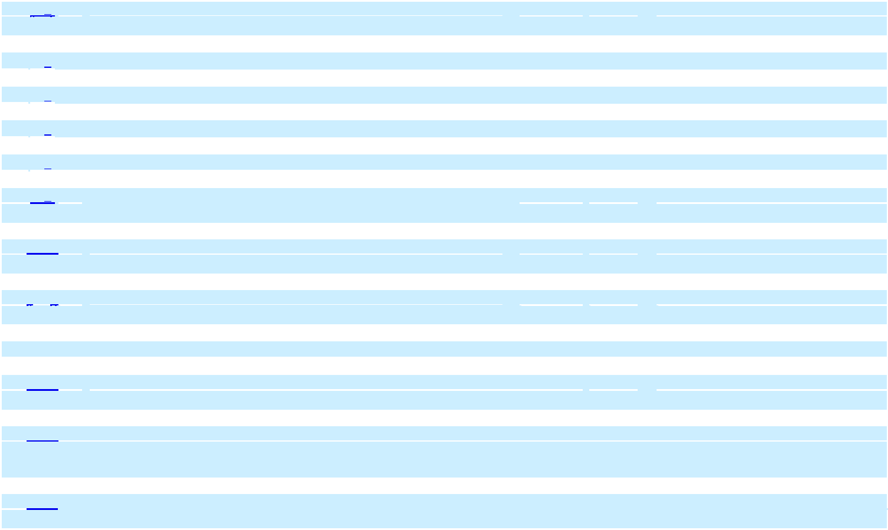

77

10.16

10.17

10.18

10.19

10.20

10.21

10.22

10.23

10.24

10.26

10.27

10.28

10.29

Executive Employment Agreement between the Company and | 10-K | 10.18 | 12/23/2019
Christopher J. Progler, Vice President, Chief Technology Officer dated
September 10, 2007⁺
Executive Employment Agreement between the Company and Richelle | 10-K | 10.30 | 1/7/2016
E. Burr dated May 21, 2010⁺
Executive Employment Agreement between the Company and John P. | 10-K | 10.31 | 12/20/2017
Jordan dated September 5, 2017⁺
Employment Agreement dated March 9, 2020, between Photronics Dai | 10-Q | 10.36 | 3/11/2020
Nippon Mask Corporation, Photronics and Frank Lee
Form of Amendment to Executive Employment Agreement dated March | 10-K | 10.23 | 12/23/2019
16, 2012+
Fourth Amended and Restated Credit Agreement dated as of September | 10-K | 10.24 | 12/21/2018
27, 2018, among Photronics, Inc. the Foreign Subsidiary Borrower Party
Thereto, the Lender Party Thereto, JPMorgan Chase Bank, N.A. as
Administrative and Collateral Agent and Bank of America, N.A. as
syndication agent
Third Amended and Restated Security Agreement entered into as of | 10-K | 10.25 | 12/21/2018
September 27, 2018, by and among Photronics, Inc., the subsidiaries of
the Company and JPMorgan Chase Bank N.A
Fixed Asset Loan Agreement between Photronics DNP Mask | 10-K | 10.26 | 12/21/2018
Corporation Xiamen and Industrial and Commercial Bank China
Limited Xiamen Xiang’an Branch
Working Capital Loan Agreement between Industrial and Commercial | 10-K | 10.27 | 12/21/2018
Bureau China Limited Xiamen Xiang’an Branch and Photronics DNP
Mask Corporation Xiamen effective as of November 7, 2018
Investment Agreement between Xiamen Torch Hi-Tech Industrial | 10-Q | 10.35 | 9/2/2016
Development Zone Management Committee and Photronics Singapore
Pte. Ltd.
Amendment No. 1 to the Investment Agreement between Xiamen Torch | 10-K | 10.29 | 12/23/2019
Hi-Tech Industrial Development Zone Management Committee and
Photronics Singapore Pte, Ltd. #
Amendment No. 2 to the Investment Agreement between Xiamen Torch | 10-Q | 10.41 | 3/10/2022
Hi-Tech Industrial Development Zone, People’s Government of
Xiang’an Xiamen, Photronics Singapore Pte. Ltd., DNP Asia Pacific Pte
and Xiamen American Japan Photronics Mask Co., Ltd. #
Amendment No. 3 to the Investment Agreement between Xiamen Torch | 10-Q | 10.42 | 3/10/2022
Hi-Tech Industrial Development Zone, People’s Government of
Xiang’an Xiamen, Photronics Singapore Pte. Ltd., DNP Asia Pacific Pte
and Xiamen American Japan Photronics Mask Co., Ltd. #
78


10.30 |  |  |  | Joint Venture Operating Agreement dated May 16, 2017, among | 10-Q/A | 10.27 | 12/19/2017
 |  |  |  | Photronics, Photronics Singapore, DNP, and DNP Asia Pacific
10.31 |  |  |  | Outsourcing Agreement dated May 16, 2017, among Photronics, DNP, | 10-Q | 10.28 | 6/8/2017
 |  |  |  | Photronics DNP Photomask Corporation (“PDMC”) and PDMCX
10.32 |  |  |  | Amended and Restated License Agreement dated May 16, 2017 | 10-Q/A | 10.29 | 12/19/2017
 |  |  |  | between DNP and PDMC#
10.33 |  |  |  | Investment Cooperation Agreement between Hefei State Hi-tech | 10-K | 10.42 | 12/20/2017
 |  |  |  | Industry Development Zone and Photronics UK, Ltd.
10.34 |  |  |  | Master Lease Agreement dated October 12, 2020, between TD | 10-K | 10.38 | 1/15/2021
 |  |  |  | Equipment Finance and the Company
10.35 |  |  |  | Master Lease Agreement Dated September 5, 2019 between Bank of | 10-Q | 10.28 | 9/5/2019
 |  |  |  | America and the Company
10.36 |  |  |  | Fixed Asset Loan Contract dated October 1, 2020, between Hefei | 10-K | 10.39 | 1/15/2021
 |  |  |  | Photronics Mask Corporation and China Construction Bank Corporation
10.37 |  |  |  | Maximum Mortgage Contract dated October 1, 2020 between | 10-K | 10.40 | 1/15/2021
 |  |  |  | Photronics Mask Corporation Hefei and China Construction Bank
 |  |  |  | Corporation Hefei Shushan Branch
10.38 |  |  |  | Separation Agreement and General Release between Photronics, Inc. | 8-K | 10.1 | 1/23/2024
 |  |  |  | and John Jordan dated February 23, 2024
10.39 |  |  |  | Separation Agreement, General Release, and Consulting Agreement, | 8-K | 10.1 | 10/4/2024
 |  |  |  | dated September 30, 2024 between Photronics Inc, and Richelle Burr
10.40 |  |  |  | Employment Agreement between Photronics, Inc. and George | 8-K | 10.1 | 4/17/2025
 |  |  |  | Macricostas dated April 11, 2025 +
10.41 |  |  |  | Photronics, Inc. 2025 Equity Incentive Compensation Plan + | S-8 | 4.3 | 4/25/2025
10.42 |  |  |  | Employment Agreement between Photronics, Inc. and Eric Rivera dated | 8-K | 10.1 | 5/2/2025
 |  |  |  | April 30, 2025 +
10.43 |  |  |  | Form of Directors Indemnification Agreement + | 10-Q | 10.1 | 6/11/2025
10.44 |  |  |  | Amended Employment Agreement between Photronics, Inc. and George | 8-K | 10.1 | 7/2/2025
 |  |  |  | Macricostas dated June 27, 2025 +
 | 19 |  |  | Insider Trading Policy | 10-K | 19 | 12/26/2023
 | 21 |  |  | List of Subsidiaries of the Company | 10-K | 21 | 12/19/2024
23.1 |  |  |  | Consent of Deloitte & Touche LLP, Independent Registered Public | 10-K | 23.1 | X
 |  |  |  | Accounting Firm
31.1 |  |  |  | Certification of Chief Executive Officer pursuant to Rule 13a-14(a)/15d- | 10-K | 31.1 | X
 |  |  |  | 14(a) of the Exchange Act, as adopted pursuant to Section 302 of the
 |  |  |  | Sarbanes-Oxley Act of 2002
 |  |  | 79
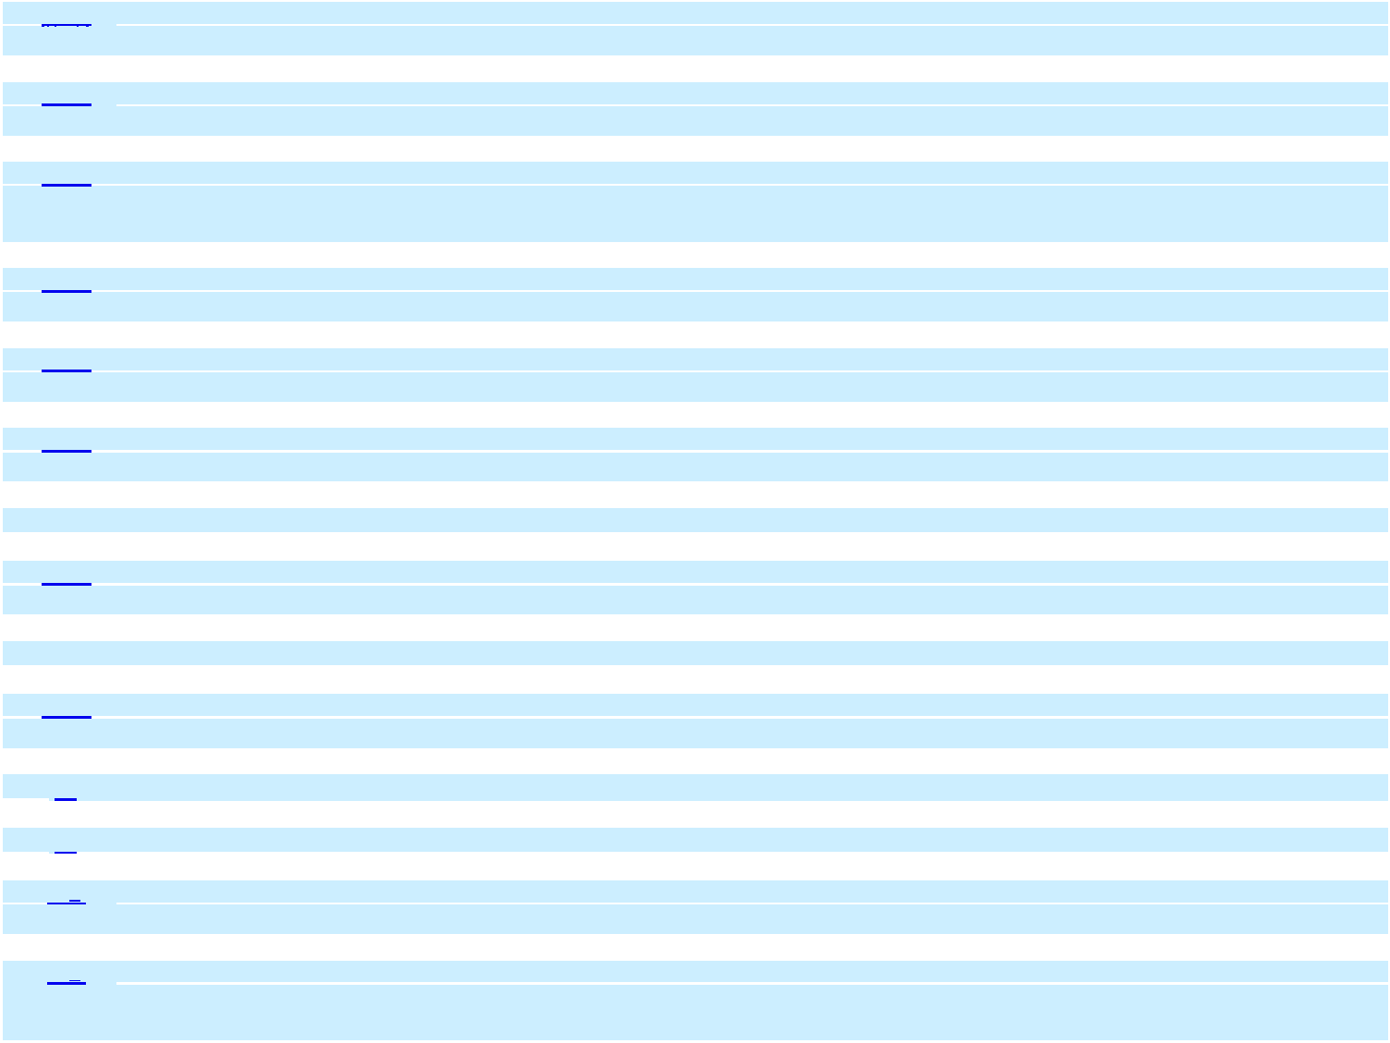

31.2 |  |  |  | Certification of Chief Financial Officer pursuant to Rule 13a-14(a)/15d- | 10-K | 32.2 | X
 |  |  |  | 14(a) of the Exchange Act, as adopted pursuant to Section 302 of the
 |  |  |  | Sarbanes-Oxley Act of 2002
32.1 |  |  |  | Certification of Chief Executive Officer pursuant to 18 U.S.C. Section | 10-K | 32.1 | X
 |  |  |  | 1350 as adopted pursuant to Section 906 of the Sarbanes-Oxley Act of
 |  |  |  | 2002
32.2 |  |  |  | Certification of Chief Financial Officer pursuant to 18 U.S.C. Section | 10-K | 32.2 | X
 |  |  |  | 1350 as adopted pursuant to Section 906 of the Sarbanes-Oxley Act of
 |  |  |  | 2002
 | 97 |  |  | Compensation Recovery Policy effective October 2, 2023 | 10-K | 97 | 12/26/2023
101.INS |  |  |  | Inline XBRL Instance Document (the instance document does not | 10-K | 101.INS | X
 |  |  |  | appear in the Interactive Data File because its XBRL tags are embedded
 |  |  |  | within the Inline XBRL document)
101.SCH |  |  |  | Inline XBRL Taxonomy Extension Schema Document | 10-K | 101.SCH | X
101.CAL |  |  |  | Inline XBRL Taxonomy Extension Calculation Linkbase Document | 10-K | 101.CAL | X
101.DEF |  |  |  | Inline XBRL Taxonomy Extension Definition Linkbase Document | 10-K | 101.DEF | X
101.LAB |  |  |  | Inline XBRL Taxonomy Extension Label Linkbase Document | 10-K | 101.LAB | X
101.PRE |  |  |  | Inline XBRL Taxonomy Extension Presentation Linkbase Document | 10-K | 101.PRE | X
104 |  |  |  | Cover Page Interactive Data File (formatted as inline XBRL and |  |  | X
 |  |  |  | contained in, Exhibit 101)

- Represents a management contract or compensatory plan or arrangement.

- Portions of this exhibit have been omitted pursuant to a request for confidential treatment filed with the Securities and Exchange Commission.

The Company will provide a copy of any exhibit upon receipt of a written request for the particular exhibit or exhibits desired. All requests should be addressed to the Company’s Vice President, General Counsel and Corporate Secretary at the address of the Company’s principal executive offices.

ITEM 16. FORM 10-K SUMMARY

Not applicable.

80

SIGNATURES

Pursuant to the requirements of Section 13 or 15(d) of the Exchange Act, the registrant has duly caused this report to be signed on its behalf by the undersigned, thereunto duly authorized.

PHOTRONICS, INC.

(Registrant)

By /s/ Eric Rivera

Eric Rivera

Executive Vice President, Chief Financial Officer

(Principal Financial Officer / Principal Accounting Officer)

December 17, 2025

Pursuant to the requirements of the Exchange Act, this report has been signed below by the following persons on behalf of the registrant and in the capacities and on the dates indicated.

By | /s/ George C. Macricostas | December 17, 2025
 | George C. Macricostas
 | Chairman of the Board of Directors and Chief Executive Officer
 | (Principal Executive Officer)
By | /s/ Eric Rivera | December 17, 2025
 | Eric Rivera
 | Executive Vice President, Chief Financial Officer
 | (Principal Financial Officer / Principal Accounting Officer)
By | /s/ Dr. Frank Lee | December 17, 2025
 | Dr. Frank Lee
 | Director
By | /s/ Adam Lewis | December 17, 2025
 | Adam Lewis
 | Lead Independent Director
By | /s/ David A. Garcia | December 17, 2025
 | David A. Garcia
 | Director
By | /s/ Daniel Liao | December 17, 2025
 | Daniel Liao
 | Director
By | /s/ Constantine S. Macricostas | December 17, 2025
 | Constantine S. Macricostas
 | Director
By | /s/ Mary Paladino | December 17, 2025
 | Mary Paladino
 | Director
By | /s/ Mitchell G. Tyson | December 17, 2025
 | Mitchell G. Tyson
 | Director
 |  | 81

(THIS PAGE INTENTIONALLY LEFT BLANK)

(THIS PAGE INTENTIONALLY LEFT BLANK)

CORPORATE INFORMATION

Independent Registered Public Accounting Firm

Deloitte & Touche LLP

115 Federal Street

Winthrop Center, Floors 12-15

Boston, MA 02110

Registrar and Transfer Agent

Computershare

P.O. Box 43006

Providence, RI 02940-3009

Investor Contact and General Information

For answers to general questions about Photronics, Inc., please call (203) 775-9000. You may also forward your inquiries via e-mail to irinformation@photronics.com

Notice of Annual Meeting

The Company’s Annual Meeting will be held on April 8, 2026 at 8:30 am Eastern Time.

The meeting will be conducted in person at the offices of Photronics, Inc., 15 Secor Road, Building 1, Brookfield, CT 06804 and on the Internet via live webcast at

web.viewproxy.com/PLAB/2026

NASDAQ Symbol

PLAB

Manufacturing Network

Asian Division

Cheonan, Choongnam, Korea

Hefei, China

Hsin-Chu City, Taiwan (2)

Taichung, Taiwan

Xiamen, China

European Division

Dresden, Germany

Wales, United Kingdom

North American Division

Allen, Texas

Boise, Idaho

Brookfield, Connecticut

Board of Directors

Michelle Almeida

Senior Vice President and Treasurer, Compass Datacenters

David A. Garcia

Strategic Advisor

Frank Lee, PhD

President, PDMC

Adam Lewis, Lead Independent Director

Managing Director and Head of Digital Infrastructure Investment Banking, Citizens Capital Markets

Daniel Liao

Co-Founder, Eunodata Co., Ltd

Constantine S. Macricostas

Founder, Photronics, Inc.

George C. Macricostas, Chairman

Chief Executive Officer, Photronics, Inc.

Mary Paladino, CPA

Executive Vice President and Chief Financial Officer, Quality Medical Management Services USA, LLC

Mitchell G. Tyson

Independent Business Strategy and Clean Energy Consultant

Executive Officers

George C. Macricostas

Chairman of the Board and Chief Executive Officer

Frank Lee, PhD

President, PDMC

Eric Rivera

President, Chief Financial Officer

H. K. Park

Senior Vice President, General Manager of FPD Operations

David Wang

Senior Vice President, COO of IC Operations


PHOTRONICS, INC.

15 SECOR ROAD

BROOKFIELD, CT 06804

www.photronics.com

MANUFACTURING FACILITIES:

ALLEN, TX BOISE, ID BROOKFIELD, CT

DRESDEN, GERMANY WALES, U.K.

HEFEI, CHINA XIAMEN, CHINA

CHEONAN, CHOONGNAM, KOREA

HSIN- CHU CITY, TAIWAN (2) TAICHUNG, TAIWAN


Service + Technology + Global

15 SECOR ROAD, BROOKFIELD, CT 06804  (203) 775-9000  WWW.PHOTRONICS.COM

