UNITED STATES

SECURITIES AND EXCHANGE COMMISSION

Washington, D.C. 20549

FORM 10-Q

(Mark One)

- QUARTERLY REPORT PURSUANT TO SECTION 13 OR 15 (d) OF THE SECURITIES EXCHANGE ACT OF 1934 For the quarterly period ended January 30, 2022

- TRANSITION REPORT PURSUANT TO SECTION 13 OR 15 (d) OF THE SECURITIES EXCHANGE ACT OF 1934 For the transition period from ___ to ___

Commission file number 0-15451


PHOTRONICS, INC.

(Exact name of registrant as specified in its charter)

Connecticut |  |  | 06-0854886
(State or other jurisdiction of incorporation or organization) |  |  | (IRS Employer Identification No.)
15 Secor Road, Brookfield, Connecticut |  |  | 06804
(Address of principal executive offices) |  |  |  | (Zip Code)
Registrant’s telephone number, including area code |  |  | (203) 775-9000
 | Securities registered pursuant to Section 12(b) of the Act:
Title of each class |  | Trading Symbol(s) |  | Name of each exchange on which registered
COMMON |  | PLAB |  | NASDAQ Global Select Market
PREFERRED STOCK PURCHASE RIGHTS |  | N/A |  | N/A

Indicate by check mark whether the registrant (1) has filed all reports required to be filed by Section 13 or 15(d) of the Securities Exchange Act of 1934 during the preceding 12 months (or for such shorter periods that the registrant was required to file such reports), and (2) has been subject to such filing requirements for the past 90 days.
Yes ☒ No ☐

Indicate by check mark whether the registrant has submitted electronically every Interactive Data File required to be submitted pursuant to Rule 405 of Regulation S-T (§232.405 of this chapter) during the preceding 12 months (or for such shorter period that the registrant was required to submit and post such files).
Yes ☒ No ☐

Indicate by check mark whether the registrant is a large accelerated filer, an accelerated filer, a non-accelerated filer, a smaller reporting company, or an emerging growth company. See the definitions of “large accelerated filer”, “accelerated filer”, “smaller reporting company”, and “emerging growth company” in Rule 12b-2 of the Exchange Act. (Check one):

Large Accelerated Filer Smaller Reporting Company

☒

☐

Accelerated Filer Emerging growth company

☐

☐

Non-Accelerated Filer

☐

If an emerging growth company, indicate by check mark if the registrant has elected not to use the extended transition period for complying with any new or revised financial accounting standards provided pursuant to Section 13(a) of the Exchange Act. ☐

Indicate by check mark whether the registrant is a shell company (as defined in Rule 12b-2 of the Exchange Act).

Yes ☐ No ☒

The registrant had 61,729,440 shares of common stock outstanding as of March 3, 2022.

Table of Contents
 |  |  |  |  |  |  |  |  |  |  | PHOTRONICS, INC.
 |  |  |  |  |  |  | QUARTERLY REPORT ON FORM 10-Q
 |  |  |  |  |  |  |  |  |  |  | January 30, 2022
 |  |  |  |  |  |  |  | TABLE OF CONTENTS
Glossary of Terms and Acronyms |  |  |  |  |  |  |  |  |  |  |  |  |  |  |  |  |  |  |  | 3
Forward-Looking Statements |  |  |  |  |  |  |  |  |  |  |  |  |  |  |  |  |  |  |  | 4
PART I. |  | FINANCIAL INFORMATION
Item 1. |  | Condensed Consolidated Financial Statements (unaudited) |  |  |  |  |  |  |  |  |  |  |  |  |  |  |  |  |  | 5
 |  | Condensed Consolidated Balance Sheets |  |  |  |  |  |  |  |  |  |  |  |  |  |  |  |  |  | 5
 |  | Condensed Consolidated Statements of Income |  |  |  |  |  |  |  |  |  |  |  |  |  |  |  |  |  | 6
 |  | Condensed Consolidated Statements of Comprehensive Income |  |  |  |  |  |  |  |  |  |  |  |  |  |  |  |  |  | 7
 |  | Condensed Consolidated Statements of Equity |  |  |  |  |  |  |  |  |  |  |  |  |  |  |  |  |  | 8
 |  | Condensed Consolidated Statements of Cash Flows |  |  |  |  |  |  |  |  |  |  |  |  |  |  |  |  |  | 9
 |  | Notes to Condensed Consolidated Financial Statements |  |  |  |  |  |  |  |  |  |  |  |  |  |  |  |  |  | 10
Item 2. |  | Management’s Discussion and Analysis of Financial Condition and Results of Operations |  |  |  |  |  |  |  |  |  |  |  |  |  |  |  |  |  | 25
Item 3. |  | Quantitative and Qualitative Disclosures about Market Risk |  |  |  |  |  |  |  |  |  |  |  |  |  |  |  |  |  | 31
Item 4. |  | Controls and Procedures |  |  |  |  |  |  |  |  |  |  |  |  |  |  |  |  |  | 32
PART II. |  | OTHER INFORMATION
Item 1. |  | Legal Proceedings |  |  |  |  |  |  |  |  |  |  |  |  |  |  |  |  |  | 32
Item 2. |  | Unregistered Sales of Equity Securities and Use of Proceeds |  |  |  |  |  |  |  |  |  |  |  |  |  |  |  |  |  | 32
Item 6. |  | Exhibits |  |  |  |  |  |  |  |  |  |  |  |  |  |  |  |  |  | 33
 |  | 2

Table of Contents

 | Glossary of Terms and Acronyms
Definitions of certain terms and acronyms that may appear in this report are provided below.
AMOLED | Active-matrix organic light-emitting diode. A technology used in mobile devices.
ASC | Accounting Standards Codification
ASP | Average Selling Price
ASU | Accounting Standards Update
Chip stacking | Placement of a computer chip on top of another computer chip, resulting in the reduction of the distance between
 | the chips in a circuit board
COVID-19 | Covid virus 2019, an infectious disease that was declared a pandemic by the World Health Organization in March
 | 2020
DNP | Dai Nippon Printing Co., Ltd.
EUV | A wafer lithography technology using the industry standard extreme ultraviolet (EUV) wavelength. EUV
 | photomasks function by selectively reflecting or blocking light, in contrast to conventional photomasks which
 | function by selectively transmitting or blocking light
Exchange Act | The Securities Exchange Act of 1934 (as amended)
FASB | Financial Accounting Standards Board
Form 10-K | Annual Report on Form 10-K
Form 10-Q | Quarterly Report on Form 10-Q
FPDs | Flat-panel displays, or “displays”
Generation | In reference to flat panel displays, refers to the size range of the underlying substrate to which a photomask is
 | applied. Higher generation (or “G”) numbers represent larger substrates
High-end (photomasks) | For IC, photomasks that are 28nm or smaller; for FPD, AMOLED, G10.5+, and LTPS photomasks
ICs | Integrated circuits, or semiconductors
LIBOR | London Inter-Bank Offered Rate
LTM (free cash flow) | Last Twelve Months Free Cash Flow
LTPS | Low-Temperature Poly Silicon, a polycrystalline silicon synthesized at relatively low temperatures;
 | polycrystalline silicon in thin-film transistors (TFTs) are used in liquid-crystal display (LCD) flat panels and to
 | drive organic light-emitting diode (OLED) displays
MLA | Master Lease Agreement
Optical proximity correction | A photolithography enhancement technique applied to compensate for the limitations of light to maintain the edge
 | placement integrity of an original design, after processing, into the etched image on a silicon wafer
PDMCX | Xiamen American Japan Photronics Mask Co., Ltd., a joint venture of Photronics and DNP
Phase-shift photomasks | Photomasks that take advantage of the interference generated by phase differences to improve image resolution in
 | photolithography
RMB | Chinese renminbi
ROU (assets) | Right-of-use asset
SEC | Securities and Exchange Commission
Securities Act | The Securities Act of 1933 (as amended)
U.S. GAAP | Accounting principles generally accepted in the United States of America
Wafer | A wafer, or silicon wafer, is a thin slice of semiconductor material that, in the fabrication of microelectronics,
 | serves as the substrate for microelectronic devices built in and upon the wafer
 | 3

Table of Contents

Forward-Looking Statements

This Form 10-Q contains forward-looking statements, as defined by the SEC. The Private Securities Litigation Reform Act of 1995 provides a “safe harbor” for forward-looking statements made by us, or on our behalf. Forward-looking statements are statements other than statements of historical fact, including, without limitation, those statements that include such words as “anticipates”, “believes”, “estimates”, “expects”, “intends”, “may”, “plans”, “predicts”, and similar expressions, and, without limitation, may address our future plans, objectives, goals, strategies, events, or performance, as well as underlying assumptions and other statements that are other than statements of historical facts. On occasion, in other documents filed with the SEC, press releases, conferences, or by other means, we may discuss, publish, disseminate, or otherwise make available, forward-looking statements, including statements contained within Part I, Item 2 – “Management’s Discussion & Analysis of Financial Condition and Results of Operations” of this Form 10-Q.

Forward-looking statements involve risks and uncertainties, which could cause actual results or outcomes to differ materially from those expressed. Our expectations, beliefs and projections are expressed in good faith and are believed by us to have a reasonable basis, including, without limitation, management’s examination of historical operating trends, information contained in our records, and information we’ve obtained from other parties. However, we can offer no assurance that our expectations, beliefs, or projections will be realized, accomplished or achieved.

Forward-looking statements within this Form 10-Q speak only as of the date of its filing, and we undertake no obligation to update any such statements to reflect changes in events or circumstances that may subsequently occur. Users of this Form 10-Q are cautioned that various factors may cause actual results to differ materially from those contained in any forward-looking statements found within this Form 10-Q and that they should not place undue reliance on any forward-looking statement. In addition, all forward-looking statements, whether written or oral and whether made by us or on our behalf, are expressly qualified by the risk factors provided in Item 1A “Risk Factors” of our Form 10-K, as well as any additional risk factors we may provide in our Quarterly Reports on Form 10-Q.

4

Table of Contents
PART I. | FINANCIAL INFORMATION
Item 1. | CONDENSED CONSOLIDATED FINANCIAL STATEMENTS
 |  | PHOTRONICS, INC.
 |  | Condensed Consolidated Balance Sheets
 |  | (in thousands, except per share amounts)
 |  | (unaudited)
 |  |  |  | January 30, |  |  | October 31,
 |  |  |  | 2022 |  |  | 2021
ASSETS
Current assets:
Cash and cash equivalents |  |  | $ | 314,195 |  | $ | 276,670
Accounts receivable, net of allowance of $1,157 in 2022 and $1,218 in 2021 |  |  |  | 170,673 |  |  | 174,447
Inventories |  |  |  | 61,971 |  |  | 55,249
Other current assets |  |  |  | 50,940 |  |  | 44,250
Total current assets |  |  |  | 597,779 |  |  | 550,616
Property, plant and equipment, net |  |  |  | 692,289 |  |  | 696,553
Deferred income taxes |  |  |  | 24,447 |  |  | 24,353
Other assets |  |  |  | 20,733 |  |  | 22,680
Total assets |  |  | $ | 1,335,248 |  | $ | 1,294,202
LIABILITIES AND EQUITY
Current liabilities:
Current portion of long-term debt |  |  | $ | 18,307 |  | $ | 22,248
Accounts payable |  |  |  | 94,914 |  |  | 81,534
Accrued liabilities |  |  |  | 77,873 |  |  | 72,366
Total current liabilities |  |  |  | 191,094 |  |  | 176,148
Long-term debt |  |  |  | 78,540 |  |  | 89,446
Other liabilities |  |  |  | 26,448 |  |  | 28,046
Total liabilities |  |  |  | 296,082 |  |  | 293,640
Commitments and contingencies
Equity:
Preferred stock, $0.01 par value, 2,000 shares authorized, none issued and outstanding |  |  |  | - |  |  | -
Common stock, $0.01 par value, 150,000 shares authorized, 60,564 shares issued and outstanding at January 30,
2022, and 60,024 shares issued and outstanding at October 31, 2021 |  |  |  | 606 |  |  | 600
Additional paid-in capital |  |  |  | 487,342 |  |  | 484,672
Retained earnings |  |  |  | 339,912 |  |  | 317,849
Accumulated other comprehensive income |  |  |  | 10,565 |  |  | 20,571
Total Photronics, Inc. shareholders’ equity |  |  |  | 838,425 |  |  | 823,692
Noncontrolling interests |  |  |  | 200,741 |  |  | 176,870
Total equity |  |  |  | 1,039,166 |  |  | 1,000,562
Total liabilities and equity |  |  | $ | 1,335,248 |  | $ | 1,294,202

See accompanying notes to condensed consolidated financial statements.

5

Table of Contents
 | PHOTRONICS, INC.
 | Condensed Consolidated Statements of Income
 | (in thousands, except per share amounts)
 | (unaudited)
 |  |  | Three Months Ended
 |  |  | January 30, |  |  | January 31,
 |  |  | 2022 |  |  | 2021
Revenue |  | $ | 189,827 |  | $ | 152,067
Cost of goods sold |  |  | 129,964 |  |  | 121,538
Gross profit |  |  | 59,863 |  |  | 30,529
Operating expenses:
Selling, general and administrative |  |  | 15,727 |  |  | 14,053
Research and development |  |  | 5,939 |  |  | 4,710
Total operating expenses |  |  | 21,666 |  |  | 18,763
Operating income |  |  | 38,197 |  |  | 11,766
Other income (expense):
Foreign currency transactions impact, net |  |  | 5,268 |  |  | 1,382
Interest income and other income, net |  |  | 334 |  |  | 121
Interest expense |  |  | (895) |  |  | (823)
Income before income tax provision |  |  | 42,904 |  |  | 12,446
Income tax provision |  |  | 11,178 |  |  | 2,937
Net income |  |  | 31,726 |  |  | 9,509
Net income attributable to noncontrolling interests |  |  | 8,662 |  |  | 1,473
Net income attributable to Photronics, Inc. shareholders |  | $ | 23,064 |  | $ | 8,036
Earnings per share:
Basic |  | $ | 0.38 |  | $ | 0.13
Diluted |  | $ | 0.38 |  | $ | 0.13
Weighted-average number of common shares outstanding:
Basic |  |  | 60,158 |  |  | 62,475
Diluted |  |  | 60,936 |  |  | 63,005

See accompanying notes to condensed consolidated financial statements.

6

Table of Contents
 | PHOTRONICS, INC.
 | Condensed Consolidated Statements of Comprehensive Income
 | (in thousands)
 | (unaudited)
 |  |  | Three Months Ended
 |  |  | January 30, |  |  | January 31,
 |  |  | 2022 |  |  | 2021
Net income |  | $ | 31,726 |  | $ | 9,509
Other comprehensive (loss) income, net of tax of $0:
Foreign currency translation adjustments |  |  | (9,831) |  |  | 18,289
Other |  |  | 37 |  |  | (1)
Net other comprehensive (loss) income |  |  | (9,794) |  |  | 18,288
Comprehensive income |  |  | 21,932 |  |  | 27,797
Less: comprehensive income attributable to noncontrolling interests |  |  | 8,874 |  |  | 5,690
Comprehensive income attributable to Photronics, Inc. shareholders |  | $ | 13,058 |  | $ | 22,107
See accompanying notes to condensed consolidated financial statements.
7

Table of Contents
 |  |  |  |  |  |  |  |  | PHOTRONICS, INC.
 |  |  |  | Condensed Consolidated Statements of Equity
 |  |  |  |  |  |  |  |  | (in thousands)
 |  |  |  |  |  |  |  |  | (unaudited)
 |  |  |  |  |  |  |  |  | Three Months Ended January 30, 2022
 |  |  |  |  |  |  | Photronics, Inc. Shareholders
 |  |  |  |  |  |  |  |  |  |  |  |  |  |  |  |  | Accumulated
 |  | Common Stock |  |  |  |  |  | Additional |  |  |  |  |  |  |  |  |  |  | Other |  |  |  | Non-
 |  |  |  |  |  |  |  |  | Paid-in |  |  | Retained |  | Treasury |  |  | Comprehensive |  |  |  | controlling |  |  |  |  | Total
 |  | Shares |  | Amount |  |  |  |  | Capital |  | Earnings |  |  |  | Stock |  |  |  | Income |  |  | Interests |  |  |  | Equity
Balance at October 31, 2021 |  | 60,024 |  | $ | 600 |  | $ |  | 484,672 |  | $ | 317,849 |  | $ | - |  | $ |  | 20,571 |  | $ |  | 176,870 |  | $ | 1,000,562
Net income |  | - |  |  | - |  |  |  | - |  |  | 23,064 |  |  | - |  |  |  | - |  |  |  | 8,662 |  |  | 31,726
Other comprehensive (loss)
income |  | - |  |  | - |  |  |  | - |  |  | - |  |  | - |  |  |  | (10,006) |  |  |  | 212 |  |  | (9,794)
Shares issued under equity
plans |  | 728 |  |  | 7 |  |  |  | 2,733 |  |  | - |  |  | - |  |  |  | - |  |  |  | - |  |  | 2,740
Share-based compensation
expense |  | - |  |  | - |  |  |  | 1,457 |  |  | - |  |  | - |  |  |  | - |  |  |  | - |  |  | 1,457
Contribution from
noncontrolling interest |  | - |  |  | - |  |  |  | - |  |  | - |  |  | - |  |  |  | - |  |  |  | 14,997 |  |  | 14,997
Purchase of treasury stock |  | - |  |  | - |  |  |  | - |  |  | - |  |  | (2,522) |  |  |  | - |  |  |  | - |  |  | (2,522)
Retirement of treasury stock |  | (188) |  |  | (1) |  |  |  | (1,520) |  |  | (1,001) |  |  | 2,522 |  |  |  | - |  |  |  | - |  |  | -
Balance at January 30, 2022 |  | 60,564 |  | $ | 606 |  |  | $ | 487,342 |  | $ | 339,912 |  | $ | - |  |  | $ | 10,565 |  |  | $ | 200,741 |  | $ | 1,039,166
 |  |  |  |  |  |  |  |  | Three Months Ended January 31, 2021
 |  |  |  |  |  |  | Photronics, Inc. Shareholders
 |  |  |  |  |  |  |  |  |  |  |  |  |  |  |  |  |  | Accumulated
 |  | Common Stock |  |  |  |  |  | Additional |  |  |  |  |  |  |  |  |  |  | Other |  |  |  | Non-
 |  |  |  |  |  |  |  |  | Paid-in |  |  | Retained |  |  | Treasury |  | Comprehensive |  |  |  | controlling |  |  |  |  | Total
 |  | Shares |  | Amount |  |  |  |  | Capital |  | Earnings |  |  |  | Stock |  |  |  | Income |  |  | Interests |  |  |  | Equity
Balance at October 31, 2020 |  | 63,138 |  | $ | 631 |  | $ |  | 507,336 |  | $ | 279,037 |  | $ | - |  | $ |  | 17,958 |  | $ |  | 157,304 |  | $ | 962,266
Net income |  | - |  |  | - |  |  |  | - |  |  | 8,036 |  |  | - |  |  |  | - |  |  |  | 1,473 |  |  | 9,509
Other comprehensive income |  | - |  |  | - |  |  |  | - |  |  | - |  |  | - |  |  |  | 14,071 |  |  |  | 4,217 |  |  | 18,288
Shares issued under equity
plans |  | 368 |  |  | 4 |  |  |  | 337 |  |  | - |  |  | - |  |  |  | - |  |  |  | - |  |  | 341
Share-based compensation
expense |  | - |  |  | - |  |  |  | 1,301 |  |  | - |  |  | - |  |  |  | - |  |  |  | - |  |  | 1,301
Purchase of treasury stock |  | - |  |  | - |  |  |  | - |  |  | - |  |  | (13,209) |  |  |  | - |  |  |  | - |  |  | (13,209)
Balance at January 31, 2021 |  | 63,506 |  | $ | 635 |  |  | $ | 508,974 |  | $ | 287,073 |  | $ | (13,209 | ) |  | $ | 32,029 |  |  | $ | 162,994 |  | $ | 978,496

See accompanying notes to condensed consolidated financial statements.

8

Table of Contents
 | PHOTRONICS, INC.
 | Condensed Consolidated Statements of Cash Flows
 | (in thousands)
 | (unaudited)
 |  |  | Three Months Ended
 |  |  | January 30, |  |  | January 31,
 |  |  | 2022 |  |  | 2021
Cash flows from operating activities:
Net income |  | $ | 31,726 |  | $ | 9,509
Adjustments to reconcile net income to net cash provided by operating activities:
Depreciation and amortization |  |  | 20,810 |  |  | 23,724
Share-based compensation |  |  | 1,457 |  |  | 1,301
Changes in assets and liabilities:
Accounts receivable |  |  | 3,269 |  |  | (2,011)
Inventories |  |  | (7,020) |  |  | 2,095
Other current assets |  |  | (6,730) |  |  | (824)
Accounts payable, accrued liabilities, and other |  |  | 15,618 |  |  | (7,507)
Net cash provided by operating activities |  |  | 59,130 |  |  | 26,287
Cash flows from investing activities:
Purchases of property, plant and equipment |  |  | (19,175) |  |  | (17,532)
Government incentives |  |  | - |  |  | 397
Other |  |  | (43) |  |  | (61)
Net cash used in investing activities |  |  | (19,218) |  |  | (17,196)
Cash flows from financing activities:
Repayments of debt |  |  | (15,192) |  |  | (7,796)
Purchases of treasury stock |  |  | (2,522) |  |  | (13,209)
Contribution from noncontrolling interest |  |  | 14,997 |  |  | -
Proceeds from debt |  |  | - |  |  | 6,205
Proceeds from share-based arrangements |  |  | 3,840 |  |  | 765
Net settlements of restricted stock awards |  |  | (1,458) |  |  | (315)
Net cash used in financing activities |  |  | (335) |  |  | (14,350)
Effects of exchange rate changes on cash, cash equivalents, and restricted cash |  |  | (2,057) |  |  | 5,195
Net increase (decrease) in cash, cash equivalents, and restricted cash |  |  | 37,520 |  |  | (64)
Cash, cash equivalents, and restricted cash at beginning of period |  |  | 279,680 |  |  | 281,602
Cash, cash equivalents, and restricted cash at end of period |  |  | 317,200 |  |  | 281,538
Less: Ending restricted cash |  |  | 3,005 |  |  | 2,999
Cash and cash equivalents at end of period |  | $ | 314,195 |  | $ | 278,539
Supplemental disclosure of non-cash information:
Accruals for property, plant and equipment purchased during the period |  | $ | 7,092 |  | $ | 4,938
See accompanying notes to condensed consolidated financial statements.
9

Table of Contents

PHOTRONICS, INC.

Notes to Condensed Consolidated Financial Statements

(unaudited)

(in thousands, except share amounts and per share data)

NOTE 1 - BASIS OF FINANCIAL STATEMENT PRESENTATION

Photronics, Inc. (“Photronics”, “the Company”, “we”, “our”, or “us”) is one of the world’s leading manufacturers of photomasks, which are high-precision photographic quartz or glass plates containing microscopic images of electronic circuits. Photomasks are a key element in the manufacture of semiconductors and flat-panel displays (“FPDs” or “displays”), and are used as masters to transfer circuit patterns onto semiconductor wafers and FPD substrates during the fabrication of integrated circuits (“ICs” or “semiconductors”), a variety of FPDs and, to a lesser extent, other types of electrical and optical components. We currently have eleven manufacturing facilities, which are located in Taiwan (3), Korea, China (2), the United States (3), and Europe (2).

The accompanying unaudited condensed consolidated financial statements (“the financial statements”) have been prepared in accordance with U.S. GAAP for interim financial information, and with the instructions to Form 10-Q and Article 10 of Regulation S-X. Accordingly, they do not include all of the information and footnotes required by U.S. GAAP for annual financial statements. In the opinion of management, adjustments, all of which are of a normal recurring nature, considered necessary for a fair presentation have been included. The financial statements include the accounts of Photronics, its wholly owned subsidiaries, and the majority-owned subsidiaries which it controls. All intercompany balances and transactions have been eliminated in consolidation. These financial statements should be read in conjunction with the consolidated financial statements and accompanying notes included in our Form 10-K for the fiscal year ended October 31, 2021, where we discuss and provide additional information about our accounting policies and the methods and assumptions used in our estimates.

The preparation of financial statements in conformity with U.S. GAAP requires us to make estimates and assumptions that affect amounts reported in them. Our estimates, including those on the impact of COVID-19, are based on historical experience and on various assumptions that we believe to be reasonable under the circumstances. Our estimates are based on the facts and circumstances available at the time they are made. Subsequent actual results may differ from such estimates. We review these estimates periodically and reflect any effects of revisions in the period in which they are determined.

Our business is typically impacted during the first quarter of our fiscal year by the North American, European, and Asian holiday periods, as some customers reduce their development and buying activities during this period. Operating results for the interim period are not necessarily indicative of the results that may be expected for the fiscal year ending October 31, 2022. For further information, refer to the consolidated financial statements, and notes thereto, included in our Annual Report on Form 10-K for the year ended October 31, 2021.

NOTE 2 - INVENTORIES

Inventories are stated at the lower of cost, determined under the first-in, first-out (“FIFO”) method, or net realizable value. Presented below are the components of inventory at the balance sheet dates:

 |  |  | January 30, |  |  | October 31,
 |  |  | 2022 |  |  | 2021
Raw materials | $ |  | 60,243 |  | $ | 54,019
Work in process |  |  | 1,544 |  |  | 1,121
Finished goods |  |  | 184 |  |  | 109
 | $ |  | 61,971 |  | $ | 55,249
 | 10

Table of Contents
NOTE 3 - PROPERTY, PLANT AND EQUIPMENT, NET
Property, plant and equipment consists of the following:
 |  |  | January 30, |  |  |  | October 31,
 |  |  | 2022 |  |  |  | 2021
Land |  | $ | 12,279 |  |  | $ | 12,442
Buildings and improvements |  |  | 181,174 |  |  |  | 181,922
Machinery and equipment |  |  | 1,950,583 |  |  |  | 1,961,474
Leasehold improvements |  |  | 21,709 |  |  |  | 21,751
Furniture, fixtures and office equipment |  |  | 15,770 |  |  |  | 15,534
Construction in progress |  |  | 47,008 |  |  |  | 35,009
 |  |  | 2,228,523 |  |  |  | 2,228,132
Accumulated depreciation and amortization |  |  | (1,536,234) |  |  |  | (1,531,579)
 |  | $ | 692,289 |  |  | $ | 696,553
ROU assets resulting from finance leases are included in the table above as follows:
 |  |  | January 30, |  |  |  | October 31,
 |  |  | 2022 |  |  |  | 2021
Machinery and equipment |  | $ | 42,760 |  |  | $ | 42,760
Accumulated amortization |  |  | (2,644) |  |  |  | (1,933)
 |  | $ | 40,116 |  |  | $ | 40,827

Depreciation and amortization expense for property, plant and equipment (including amortization expense for ROU assets) was $20.7 million and $22.6 million for the three-month periods ended January 30, 2022, and January 31, 2021.

NOTE 4 - PDMCX JOINT VENTURE

In January 2018, Photronics, Inc. through its wholly owned Singapore subsidiary (hereinafter, within this Note “we”, “Photronics”, “us”, or “our”), and DNP, through its wholly owned subsidiary “DNP Asia Pacific PTE, Ltd.” entered into a joint venture under which DNP obtained a 49.99% interest in our IC business in Xiamen, China. The joint venture, which we refer to as “PDMCX”, was established to develop and manufacture photomasks for leading-edge and advanced-generation semiconductors. We entered into this joint venture to enable us to compete more effectively for the merchant photomask business in China, and to benefit from the additional resources and investment that DNP provides to enable us to offer advanced-process technology to our customers. In 2020, in combination with local financing obtained by PDMCX, Photronics and DNP fulfilled their investment obligations under the PDMCX operating agreement (“the Agreement”). As discussed in Note 5, liens were granted to the local financing entity on property, plant and equipment with a January 30, 2022, total carrying value of $88.4 million, as collateral for the loans.

Under the Agreement, DNP is afforded, under certain circumstances, the right to put its interest in PDMCX to Photronics. These circumstances include disputes regarding the strategic direction of PDMCX that may arise after the initial two-year term of the Agreement and cannot be resolved between the two parties. As of the date of issuance of these financial statements, DNP had not indicated its intention to exercise this right. In addition, both Photronics and DNP have the option to purchase, or put, their interest from, or to, the other party, should their ownership interest fall below twenty percent for a period of more than six consecutive months. Under all such circumstances, the sales of ownership interests would be at the exiting party’s ownership percentage of the joint venture’s net book value, with closing to take place within three business days of obtaining required approvals and clearance.

We recorded net income from the operations of PDMCX of $1.9 million during the three-month period ended January 30, 2022, and a loss of $0.1 million during the three-month period ended January 31, 2021, respectively. General creditors of PDMCX do not have recourse to the assets of Photronics (other than the net assets of PDMCX), and our maximum exposure to loss from PDMCX at January 30, 2022, was $81.3 million.

11

Table of Contents

As required by the guidance in Topic 810 - “Consolidation” of the Accounting Standards Codification (“ASC”), we evaluated our involvement in PDMCX for the purpose of determining whether we should consolidate its results in our financial statements. The initial step of our evaluation was to determine whether PDMCX was a variable interest entity (“VIE”). Due to its lack of sufficient equity at risk to finance its activities without additional subordinated financial support, we determined that it was a VIE. Having made this determination, we then assessed whether we were the primary beneficiary of the VIE, and concluded that we were the primary beneficiary during the current and prior year reporting periods; thus, as required, the PDMCX financial results have been consolidated with Photronics. Our conclusion was based on the facts that we held a controlling financial interest in PDMCX (which resulted from our having the power to direct the activities that most significantly impacted its economic performance) and had the obligation to absorb losses and the right to receive benefits that could potentially be significant to PDMCX. Our conclusions that we had the power to direct the activities that most significantly affected the economic performance of PDMCX during the current and prior year reporting periods were based on our right to appoint the majority of its board of directors, which has, among others, the powers to manage the business (through its rights to appoint and evaluate PDMCX’s management), incur indebtedness, enter into agreements and commitments, and acquire and dispose of PDMCX’s assets. In addition, as a result of the 50.01% variable interest we held during the current and prior-year periods, we had the obligation to absorb losses, and the right to receive benefits, that could potentially be significant to PDMCX.

The carrying amounts of PDMCX assets and liabilities included in our condensed consolidated balance sheets are presented in the following table, together with our exposure to loss related to these assets and liabilities.

 |  |  |  | January 30, |  |  |  |  |  | October 31,
 |  |  |  | 2022 |  |  |  |  |  | 2021
 |  |  |  | Carrying |  |  | Photronics |  |  | Carrying |  |  | Photronics
Classification |  |  |  | Amount |  |  | Interest |  |  | Amount |  |  | Interest
Current assets |  |  | $ | 80,953 |  | $ | 40,485 |  | $ | 59,745 |  | $ | 29,879
Noncurrent assets |  |  |  | 143,353 |  |  | 71,690 |  |  | 137,799 |  |  | 68,913
Total assets |  |  |  | 224,306 |  |  | 112,175 |  |  | 197,544 |  |  | 98,792
Current liabilities |  |  |  | 28,209 |  |  | 14,107 |  |  | 26,559 |  |  | 13,282
Noncurrent liabilities |  |  |  | 33,542 |  |  | 16,774 |  |  | 42,917 |  |  | 21,463
Total liabilities |  |  |  | 61,751 |  |  | 30,881 |  |  | 69,476 |  |  | 34,745
Net assets | $ |  |  | 162,555 |  | $ | 81,294 |  | $ | 128,068 |  | $ | 64,047
 | 12

Table of Contents

NOTE 5 - DEBT

The tables below provide information on our long-term debt.

 |  |  |  |  |  | Xiamen |  |  |  | Hefei
 |  |  | Xiamen |  |  | Working |  |  |  | Equipment |  |  |  | Finance
As of January 30, 2022 |  | Project Loans |  |  |  | Capital Loans |  |  |  | Loan |  |  |  | Leases |  |  | Total
Principal due:
Next 12 months | $ |  | 5,708 | $ |  | 1,006 |  | $ |  | 4,717 |  | $ |  | 6,876 |  | $ | 18,307
Months 13 – 24 | $ |  | 9,277 | $ |  | 3,523 |  | $ |  | 4,717 |  | $ |  | 6,537 |  | $ | 24,054
Months 25 – 36 |  |  | 10,221 |  |  | - |  |  |  | 6,290 |  |  |  | 20,308 |  |  | 36,819
Months 37 – 48 |  |  | 9,434 |  |  | - |  |  |  | 5,613 |  |  |  | 2,620 |  |  | 17,667
Long-term debt | $ |  | 28,932 | $ |  | 3,523 |  | $ |  | 16,620 |  | $ |  | 29,465 |  | $ | 78,540
Total | $ |  | 34,640 | $ |  | 4,529 |  | $ |  | 21,337 |  | $ |  | 36,341 |  | $ | 96,847

Interest rate at balance sheet date

Basis spread on interest rates

Interest rate reset

Maturity date

Periodic payment amount

Periodic payment frequency

Loan collateral (carrying amount)

 | 4.65% | 4.61% |  | 4.20% |  | (3)
 | 0.00 | 76.00 |  | (45.00) |  | N/A
 | Quarterly | Monthly/Annually |  | Annually |  | N/A
 | December |  |  | September |  | (3)
 | 2025 | July 2023 |  | 2025 |  | (3)
Varies as loans |  | Increases as loans |  | Varies ⁽¹⁾ |  | (3)
 | mature | mature |  | Varies ⁽¹⁾ |  | (3)
 | Semiannual,
on individual |  | Semiannual, on | Semiannual⁽²⁾
$ | loans | individual loans |  |  | $ | Monthly
$ | 88,356 | N/A | $ | 85,558 | $ | 40,116
 |  |  |  |  |  | (4)

- First five loan repayments will each be for 7.5 percent of the approved 200 million RMB loan principal; last five installments will each be for 12.5 percent of the approved loan principal.

- Semiannual repayments commence in March 2022.

- See Note 7 for periodic payment amounts.

- Amount represents the carrying amount of the related right-of-use asset, in which the lessors have a secured interest.

13

Table of Contents
 |  |  |  |  |  |  | Xiamen |  |  | Hefei
 |  |  |  | Xiamen |  |  | Working |  |  | Equipment |  |  | Finance
 | As of October 31, 2021 |  | Project Loans |  |  |  | Capital Loans |  |  | Loan |  |  | Leases |  |  |  | Total
Principal due:
Next 12 months |  | $ |  | 2,068 | $ |  | 8,197 |  | $ | 4,694 |  | $ | 7,289 |  | $ |  | 22,248
Months 13 – 24 |  | $ |  | 10,071 | $ |  | 4,005 |  | $ | 4,693 |  | $ | 6,512 |  | $ |  | 25,281
Months 25 – 36 |  |  |  | 10,278 |  |  | - |  |  | 6,257 |  |  | 6,610 |  |  |  | 23,145
Months 37 – 48 |  |  |  | 9,902 |  |  | - |  |  | 5,585 |  |  | 17,961 |  |  |  | 33,448
Months 49 – 60 |  |  |  | 7,572 |  |  | - |  |  | - |  |  | - |  |  |  | 7,572
Long-term debt |  | $ |  | 37,823 | $ |  | 4,005 |  | $ | 16,535 |  | $ | 31,083 |  | $ |  | 89,446
Total |  |  | $ | 39,891 |  | $ | 12,202 |  | $ | 21,229 |  | $ | 38,372 |  |  | $ | 111,694

Interest rate at balance sheet date

Basis spread on interest rates Interest rate reset

Maturity date

Periodic payment amount

Periodic payment frequency

Loan collateral (carrying amount)

 | 4.65% | 4.53% - 4.61% |  | 4.20% |  | (3)
 | 0.00 | 67.75 - 76.00 |  | (45.00) |  | N/A
 | Quarterly | Monthly/Annually |  | Annually |  | N/A
 | December |  |  |  |  | (3)
 | 2025 | July 2023 | September 2025 |  |  | (3)
Varies as loans |  | Increases as loans |  | Varies⁽¹⁾ |  | (3)
 | mature | mature |  | Varies⁽¹⁾ |  | (3)
 | Semiannual,
on individual |  | Semiannual, on | Semiannual⁽²⁾
$ | loans | individual loans |  |  | Monthly
$ | 90,096 | N/A | $ | 86,487 | $ | 40,826
 |  |  |  |  |  | (4)

- First five loan repayments will each be for 7.5 percent of the approved 200 million RMB loan principal; last five installments will each be for 12.5 percent of the approved loan principal.

- Semiannual repayments commence in March 2022.

- See Note 7 for interest rates on lease liabilities, maturity dates, and periodic payment amounts.

- Represents the carrying amount at the balance sheet date of the related ROU assets, in which the lessors have secured interests.

Xiamen Project Loans

In November 2018, PDMCX obtained approval to borrow 345.0 million RMB from the Industrial and Commercial Bank of China. From November 2018 through July 2020, PDMCX entered into separate loan agreements (the “Project Loans”) for the entire approved amount and, as of January 30, 2022, 220.3 million RMB ($34.6 million) remained outstanding. The Project Loans were used to finance certain capital expenditures at the PDMCX facility and are collateralized by liens granted on the land use right, building, and certain equipment located at the facility. The interest rates on the Project Loans are variable (based on the RMB Loan Prime Rate of the National Interbank Funding Center), and interest incurred on the loans is eligible for reimbursement through incentives provided by the Xiamen Torch Hi-Tech Industrial Development Zone, which provide for such reimbursements up to a prescribed limit and duration. The Project Loans are subject to covenants and provisions, certain of which relate to the assets pledged as security for the loans, all of which we were in compliance with at January 30, 2022.

Xiamen Working Capital Loans

In November 2018, PDMCX obtained approval for revolving, unsecured credit of the equivalent of $25.0 million, pursuant to which PDMCX may enter into separate loan agreements with varying terms to maturity. This facility is subject to annual reviews and extension. Unless extended, this facility will expire in October 2022. As of January 30, 2022, PDMCX had 28.8 million RMB ($4.5 million) outstanding against the approval. The interest rates are variable, based on the RMB Loan Prime Rate of the National Interbank Funding Center. Interest incurred on the loans is eligible for reimbursement through incentives provided by the Xiamen Torch Hi-Tech Industrial Development Zone, which provide for such reimbursements up to a prescribed limit and duration.

14

Table of Contents

Hefei Equipment Loan

In October 2020, our Hefei, China, facility was approved to borrow 200 million RMB (approximately $31.4 million, at the balance sheet date) from the China Construction Bank Corporation. This credit facility is subject to annual reviews and extension, with the most recent extension set to expire in August 2022. The loan proceeds were used to fund the purchase of two lithography tools at the Hefei facility. As of January 30, 2022, we had borrowed 135.7 million RMB ($21.3 million) against this approval (all of which was then outstanding), and 64.3 million RMB ($10.1 million) remained available to borrow. The interest rate on the loan is variable and based on the RMB Loan Prime Rate of the National Interbank Funding Center. The borrowings are secured by the Hefei facility, its related land use right, and certain manufacturing equipment. The Hefei Equipment Loan is subject to covenants and provisions, certain of which relate to the assets pledged as security for the loan, including covenants for the ratio of total liabilities to total assets and the ratio of current assets to current liabilities, all of which we were in compliance with at January 30, 2022.

Finance Leases

In February 2021, we entered into a five-year $7.2 million finance lease for a high-end inspection tool and, in December 2020, we entered into a $35.5 million lease for a high-end lithography tool. See Note 7 for additional information on these leases.

Corporate Credit Agreement

In September 2018, we entered into a five-year amended and restated credit agreement (the “Credit Agreement”), which has a $50 million borrowing limit, with an expansion capacity to $100 million. The Credit Agreement is secured by substantially all of our assets located in the United States and common stock we own in certain subsidiaries. The Credit Agreement includes covenants around minimum interest coverage ratio, total leverage ratio, and minimum unrestricted cash balance (all of which we were in compliance with at January 30, 2022), and limits the amount of cash dividends, distributions, and redemptions we can pay on our common stock to an aggregate annual amount of $50 million. We had no outstanding borrowings against the Credit Agreement at January 30, 2022. The interest rate on the Credit Agreement (1.11% at January 30, 2022) is based on our total leverage ratio at 1-month LIBOR plus a spread, as defined in the Credit Agreement.

NOTE 6 - REVENUE

We recognize revenue when, or as, control of a good or service transfers to a customer, in an amount that reflects the consideration to which we expect to be entitled in exchange for transferring those goods or services. We account for an arrangement as a revenue contract when each party has approved and is committed to perform under the contract, the rights of the contracting parties regarding the goods or services to be transferred and the payment terms are identifiable, the arrangement has commercial substance, and collection of consideration is probable. Substantially all of our revenue comes from the sales of photomasks. We typically contract with our customers to sell sets of photomasks, which are comprised of multiple layers, the predominance of which we invoice as they ship to customers. As the photomasks are manufactured to customer specifications, they have no alternative use to us and, as our contracts generally provide us with the right to payment for work completed to date, we recognize revenue as we perform, or “over time”, on most of our contracts. We measure our performance to date using an input method, which is based on our estimated costs to complete the various manufacturing phases of a photomask. At the end of a reporting period, there are a number of uncompleted revenue contracts on which we have performed; for any such contracts under which we are entitled to be compensated for our costs incurred plus a reasonable profit, we recognize revenue and a corresponding contract asset for such performance. We account for shipping and handling activities that we perform after a customer obtains control of a good as being activities to fulfill our promise to transfer the good to the customer, rather than as promised services, or performance obligations, under the contract. We report our revenue net of any sales or similar taxes we collect on behalf of government entities.

As stated above, photomasks are manufactured to customer specifications in accordance with their proprietary designs; thus, they are individually unique. Due to their uniqueness and other factors, their transaction prices are individually established through negotiations with customers; consequently, our photomasks do not have standard or “list” prices. The transaction prices of the vast majority of our revenue contracts include only fixed amounts of consideration. In certain instances, such as when we offer a customer an early payment discount, an estimate of variable consideration would be included in the transaction price, but only to the extent that a significant reversal of revenue would not occur when the uncertainty related to the variability was resolved.

Contract Assets, Contract Liabilities, and Accounts Receivable

We recognize a contract asset when our performance under a contract precedes our receipt of consideration from a customer, or before payment is due, and our receipt of consideration is conditional upon factors other than the passage of time. Contract assets reflect our transfer of control of photomasks that are in process or completed but not yet shipped to customers. A receivable is recognized when we have an unconditional right to payment for our performance, which generally occurs when we ship the photomasks. Our contract assets primarily consist of a significant amount of our in-process production orders and fully manufactured photomasks which have not yet shipped, for which we have an enforceable right to collect consideration (including a reasonable profit) in the event the in-process orders are cancelled by customers. On an individual contract basis, we net contract assets with contract liabilities (deferred revenue) for financial reporting purposes. Contract assets of $11.8 million are included in Other current assets, and contract liabilities of $19.5 million and $5.2 million are included in Accrued liabilities and Other liabilities, respectively, in our January 30, 2022, condensed consolidated balance sheet. Our October 31, 2021, condensed consolidated balance sheet includes contract assets of $9.9 million, included in Other current assets, and contract liabilities of $14.7 million and $5.2 million are included in Accrued liabilities and Other liabilities, respectively. We did not impair any contract assets during the three-month periods ended January 30, 2022, or January 31, 2021. We recognized $4.2 million of revenue from the settlement of contract liabilities that existed at the beginning of the three-month period ended January 30, 2022, and recognized $2.5 million of revenue in the respective prior year period, that related to the settlement of contract liabilities that existed at the beginning of that period.

15

Table of Contents

We generally record our accounts receivable at their billed amounts. All outstanding past due customer invoices are reviewed for collectibility during, and at the end of, every reporting period. To the extent we believe a loss on the collection of a customer invoice is probable, we record the loss and credit an allowance for credit losses. In the event that an amount is determined to be uncollectible, we charge the allowance for credit losses and derecognize the related receivable. We did not incur any credit losses on our accounts receivable during the three-month periods ended January 30, 2022, or January 31, 2021.

Our invoice terms generally range from net thirty to ninety days, depending on both the geographic market in which the transaction occurs and our payment agreements with specific customers. In the event that our evaluation of a customer’s business prospects and financial condition indicate that the customer presents a collectibility risk, we modify terms of sale, which may require payment in advance of performance. At the time of adoption, we elected the practical expedient allowed under ASC Topic 606 “Revenue from Contracts with Customers” (“Topic 606”) that permits us not to adjust a contract’s promised amount of consideration to reflect a financing component when the period between when we transfer control of goods or services to customers and when we are paid is one year or less.

In instances when we are paid in advance of our performance, we record a contract liability and, as allowed under the practical expedient in Topic 606, recognize interest expense only if the period between when we receive payment from the customer and the date when we expect to be entitled to the payment is greater than one year. Historically, advance payments we have received from customers have generally not preceded the completion of our performance obligations by more than one year.

Disaggregation of Revenue

The following tables present our revenue for the three-month periods ended January 30, 2022, and January 31, 2021, disaggregated by product type, geographic origin, and timing of recognition.

 |  |  |  |  |  | Three Months Ended
 |  |  |  |  |  | January 30, |  |  | January 31,
 |  |  |  |  |  | 2022 |  |  | 2021
Revenue by Product Type
IC
High-end |  |  |  | $ |  | 46,534 |  | $ | 36,780
Mainstream |  |  |  |  |  | 83,227 |  |  | 68,176
 | Total IC |  |  | $ |  | 129,761 |  | $ | 104,956
FPD
High-end |  |  |  | $ |  | 46,276 |  | $ | 34,645
Mainstream |  |  |  |  |  | 13,790 |  |  | 12,466
 | Total FPD |  |  | $ |  | 60,066 |  | $ | 47,111
 |  |  |  | $ |  | 189,827 |  | $ | 152,067
 |  |  |  | 16

Table of Contents
 |  |  |  |  | Three Months Ended
 |  |  |  |  | January 30, |  | January 31,
 |  |  |  |  | 2022 |  |  | 2021
Revenue by Geographic Origin*
Taiwan |  |  |  | $ | 67,841 |  | $ | 56,590
China |  |  |  |  | 45,953 |  |  | 20,997
Korea |  |  |  |  | 39,515 |  |  | 38,783
United States |  |  |  |  | 27,176 |  |  | 26,604
Europe |  |  |  |  | 8,914 |  |  | 8,575
Other |  |  |  |  | 428 |  |  | 518
 |  |  |  | $ | 189,827 |  | $ | 152,067
* This table disaggregates revenue by the location in which it was earned.
 |  |  |  |  | Three Months Ended
 |  |  |  |  | January 30, |  | January 31,
 |  |  |  |  | 2022 |  |  | 2021
Revenue by Timing of Recognition
Over time |  |  |  | $ | 170,264 |  | $ | 141,284
At a point in time |  |  |  |  | 19,563 |  |  | 10,783
 |  |  |  | $ | 189,827 |  | $ | 152,067

Contract Costs

We pay commissions to third-party sales agents for certain sales they procure on our behalf. However, the bases of the commissions are the transaction prices of the sales, which are completed in less than one year; thus, no relationship is established with a customer that will result in future business. Therefore, we do not recognize any portion of these sales commissions as costs of obtaining a contract, nor do we currently foresee other circumstances under which we would recognize contract obtainment costs as assets.

Remaining Performance Obligations

As we are typically required to fulfill customer orders within a short period of time, our backlog of orders has historically been two to three weeks for FPD photomasks and one to two weeks of backlog for IC photomasks. However, the demand for some IC photomasks has expanded beyond the industry’s capacity to supply them within the traditional time period, thus the backlog in some cases can expand to as long as 2 to 3 months. As allowed under Topic 606, we have elected not to disclose our remaining performance obligations, which represent the costs associated with the completion of the manufacturing process of in-process photomasks related to contracts that have an original duration of one year or less.

Product Warranties

Our photomasks are sold under warranties that generally range from one to twenty-four months. We warrant that our photomasks conform to customer specifications and will typically repair, replace, or issue a refund for (at our option) any photomasks that fail to do so. The warranties do not represent separate performance obligations in our revenue contracts. Historically, customer claims under warranties have been immaterial.

NOTE 7 - LEASES

Our involvement in lease arrangements has typically been as a lessee. We determine if an agreement is or contains a lease on the earlier of the date of the agreement or the date on which we commit to entering the agreement. Our evaluation considers whether the agreement includes an identified asset and whether it affords us the right to control the asset. Our having the right to control the identified asset is determined by whether we are entitled to substantially all of its economic benefits and can direct its use.

17

Table of Contents

We recognize leases on our consolidated balance sheet when a lessor makes an asset underlying a lease having a term in excess of twelve months available for our use. As allowed under ASC Topic 842 – “Leases” (“Topic 842”), we have elected not to apply the recognition requirements to leases that, at their commencement dates, have lease terms of twelve months or less and do not include options to purchase their underlying assets that we are reasonably certain to exercise. The present value of lease payments over the term of the lease provides the basis for the initial measurement of ROU assets and their related lease liabilities. We measure finance lease liabilities using the rates implicit in the leases; operating lease liabilities are measured using our incremental borrowing rates, for collateralized loans, at the commencement date. Variable lease payments, other than those that are dependent on an index or on a rate, are not included in the measurement of ROU assets and their related lease liabilities. Lease terms include extension periods if the lease agreement includes an option to extend the lease that we are reasonably certain to exercise. As allowed under Topic 842, we have elected, for all classes of assets, the practical expedient to not separate lease components of a contract from nonlease components of a contract.

In February 2021, we entered into a five-year $7.2 million finance lease for a high-end inspection tool. Monthly payments on the lease, which commenced in February 2021, are $0.1 million per month. Upon the payment of the fiftieth monthly payment and prior to payment of the fifty-first monthly payment, we may exercise an early buyout option to purchase the tool for $2.4 million. If we do not exercise the early buyout option, then at the end of the five-year lease term, the lease shall continue to renew on a month-to-month basis at the same rental terms; at our option, after the original term or any renewal periods, we may return the tool, elect to extend the lease, or purchase the tool at its fair market value. Since we are reasonably certain that we will exercise the early buyout option, our lease liability reflects such exercise and we have classified the lease as a finance lease. The interest rate implicit in the lease is 1.08%.

In December 2020, we entered into a five-year $35.5 million finance lease for a high-end lithography tool. Monthly payments on the lease, which commenced in January 2021, increased from $0.04 million during the first three months to $0.6 million for the following nine months, to be followed by forty-eight monthly payments of $0.5 million. As of the due date of the forty-eighth monthly payment, we may exercise an early buyout option to purchase the tool for $14.1 million. If we do not exercise the early buyout option, then at the end of the five-year lease term, at our option, we may return the tool, elect to extend the lease term for a period and a lease payment to be agreed with lessor at the time, or purchase the tool for its then-fair market value as determined by the lessor. Since we are reasonably certain that we will exercise the early buyout option, our lease liability reflects such exercise and we have classified the lease as a finance lease. The interest rate implicit in the lease is 1.58%. The lease agreement incorporates the covenants included in our Corporate Credit Agreement, which are detailed in Note 5, and includes a cross-default provision for any agreement or instrument with an outstanding, committed balance greater than $5.0 million in which we are the indebted party.

The following table provides information on operating and finance leases included in our consolidated balance sheets.

 |  |  |  |  |  |  |  | January 30, |  |  | October 31,
Classification |  |  |  |  |  |  |  | 2022 |  |  | 2021
ROU Assets – Operating Leases
Other assets |  |  |  |  |  | $ |  | 4,977 |  | $ | 5,581
ROU Assets – Finance Leases
Property, plant and equipment, net |  |  |  |  |  | $ |  | 40,116 |  | $ | 40,827
Lease Liabilities – Operating Leases
Accrued liabilities |  |  |  |  |  | $ |  | 2,233 |  | $ | 2,273
Other liabilities |  |  |  |  |  |  |  | 2,690 |  |  | 3,246
 |  |  |  |  |  |  | $ | 4,923 |  | $ | 5,519
Lease Liabilities – Finance Leases
Current portion of long-term debt |  |  |  |  |  | $ |  | 6,876 |  | $ | 7,289
Long-term debt |  |  |  |  |  |  |  | 29,465 |  |  | 31,083
 |  |  |  |  |  | $ |  | 36,341 |  | $ | 38,372
 |  |  |  |  |  | 18

Table of Contents

The following table presents future lease payments under noncancelable operating and finance leases as of January 30, 2022. Imputed interest represents the difference between undiscounted cash flows and discounted cash flows.

 |  | Operating |  | Finance Lease
 |  | Leases
Remainder of fiscal year 2022 | $ | 1,741 |  | $ | 7,117
2023 |  | 1,367 |  |  | 6,938
2024 |  | 817 |  |  | 20,592
2025 |  | 643 |  |  | 2,924
2026 |  | 394 |  |  | -
Thereafter |  | 154 |  |  | -
Total lease payments |  | 5,116 |  |  | 37,571
Imputed interest |  | (193) |  |  | (1,230)
Lease liabilities | $ | 4,923 |  | $ | 36,341
The following table presents lease costs for the three month periods ended January 30, 2022, and January 31, 2021.
 |  | Three Months Ended
 |  | January 30, |  |  | January 31,
 |  | 2022 |  |  | 2021
Operating lease costs | $ | 589 |  | $ | 664
Short-term lease costs | $ | 120 |  | $ | 46
Variable lease costs | $ | 123 |  | $ | 144
Interest on lease liabilities | $ | 97 |  | $ | 35
Amortization of ROU assets | $ | 711 |  | $ | -

The following table presents statistical information related to our operating and finance leases. The information presented is as of the balance sheet dates.

 |  | January 30, |  |  |  | October 31,
 |  | 2022 |  |  |  | 2021
 |  | Weighted- |  |  |  | Weighted-
 |  | average |  |  |  | average
 |  | remaining |  |  |  | remaining
 |  | lease |  | Weighted- |  | lease |  | Weighted-
 |  | term (in |  | average |  | term (in |  | average
Classification |  | years) |  | discount rate |  | years) |  | discount rate
Operating leases |  | 3.4 |  | 2.4% |  | 3.5 |  | 2.4%
Finance leases |  | 3.8 |  | 1.5% |  | 3.3 |  | 1.5%

The following table presents the effects on our condensed consolidated statements of cash flows, and provides leases-related non-cash information for the periods presented.

 |  |  | Three Months Ended
 |  |  | January 30, |  |  | January 31,
 |  |  | 2022 |  |  | 2021
Operating cash flows used for operating leases |  | $ | 561 |  | $ | 603
Operating cash flows used for finance leases | $ |  | 143 |  | $ | 35
Financing cash flows used for finance leases | $ |  | 2,031 |  | $ | -
ROU assets obtained in exchange for operating lease obligations | $ |  | 31 |  | $ | 267
ROU assets obtained in exchange for finance lease obligations | $ |  | - |  | $ | 35,560
 | 19

Table of Contents

NOTE 8 - SHARE-BASED COMPENSATION

In March 2016, shareholders approved our current equity incentive compensation plan (the “Plan”), under which incentive stock options, non-qualified stock options, stock grants, stock-based awards, restricted stock, restricted stock units, stock appreciation rights, performance units, performance stock, and other stock or cash awards may be granted. Shares to be issued under the Plan may be authorized and unissued shares, issued shares that have been reacquired by us (in the open market or in private transactions), or a combination thereof. The maximum number of shares of common stock approved that may be issued under the Plan is four million shares. Awards may be granted to officers, employees, directors, consultants, advisors, and independent contractors of Photronics or its subsidiaries. In the event of a change in control (as defined in the Plan), the vesting of awards may be accelerated. The Plan, aspects of which are more fully described below, prohibits further awards from being issued under prior plans. The table below presents information on our share-based compensation expenses for the three-month periods ended January 30, 2022, and January 31, 2021.

 |  | Three Months Ended
 | January 30, |  |  | January 31,
 |  | 2022 |  | 2021
Expense reported in:
Cost of goods sold | $ | 143 |  | $ | 112
Selling, general and administrative |  | 1,180 |  |  | 1,097
Research and development |  | 134 |  |  | 92
Total expense incurred | $ | 1,457 |  | $ | 1,301
Expense by award type:
Restricted stock awards | $ | 1,367 |  | $ | 1,171
Stock options |  | 38 |  |  | 84
ESPP |  | 52 |  |  | 46
Total expense incurred | $ | 1,457 |  | $ | 1,301
Income tax benefits of share-based compensation (in millions) | $ | 0.1 |  | $ | -
Share-based compensation cost capitalized | $ | - |  | $ | -

Restricted Stock

We periodically grant restricted stock awards, the restrictions on which typically lapse over a service period of one to four years. The fair value of the awards is determined on the date of grant, based on the closing price of our common stock. The table below presents information on our restricted stock awards for the three-months ended January 30, 2022, and January 31, 2021.

 |  | Three Months Ended
 |  | January 30, |  |  | January 31,
 |  | 2022 |  |  | 2021
Number of shares granted in period |  | 535,400 |  |  | 541,200
Weighted-average grant-date fair value of awards (in dollars per share) | $ | 19.28 |  | $ | 11.13
Compensation cost not yet recognized | $ | 15,106 |  | $ | 10,564
Weighted-average amortization period for cost not yet recognized (in years) |  | 3.0 |  |  | 3.0
Shares outstanding at balance sheet date |  | 1,128,179 |  |  | 1,059,001
20

Table of Contents

Stock Options

Option awards generally vest in one to four years, and have a ten-year contractual term. All incentive and non-qualified stock option grants must have an exercise price no less than the market value of the underlying common stock on the date of grant. The grant-date fair values of options are based on closing prices of our common stock on the dates of grant and are calculated using the Black-Scholes option pricing model. Expected volatility is based on the historical volatility of our common stock. We use historical option exercise behavior and employee termination data to estimate expected term, which represents the period of time that options are expected to remain outstanding. The risk-free rate of return for the estimated term of an option is based on the U.S. Treasury yield curve in effect at the date of grant. The table below presents information on our stock options for the three-months ended January 30, 2022, and January 31, 2021.

 |  | Three Months Ended
 | January 30, |  |  | January 31,
 |  | 2022 |  | 2021
Number of options granted in period |  | - |  |  | -
Cash received from option exercised | $ | 3,714 |  | $ | 658
Compensation cost not yet recognized | $ | 71 |  | $ | 282
Weighted-average amortization period for cost not yet recognized (in years) |  | 1.0 |  |  | 1.6

Information on outstanding and exercisable option awards as of January 30, 2022, is presented below.

 |  |  |  |  |  |  |  | Weighted-
 |  |  |  |  |  | Weighted- |  | Average
 |  |  |  |  |  | Average |  | Remaining |  |  | Aggregate
 |  |  |  |  |  | Exercise |  | Contractual |  |  | Intrinsic
Options |  | Shares |  |  |  | Price |  | Life (in years) |  |  | Value
Outstanding at January 30, 2022 | 769,513 |  |  | $ |  | 9.81 |  | 4.0 | $ |  | 5,797
Exercisable at January 30, 2022 | 745,287 |  |  | $ |  | 9.81 |  | 3.9 | $ |  | 5,613

NOTE 9 - INCOME TAXES

We calculate our provision for income taxes at the end of each interim reporting period on the basis of an estimated annual effective tax rate adjusted for tax items that are discrete to each period.

The effective tax rate of 26.1% differs from the U.S. statutory rate of 21.0% in the three-month period ended January 30, 2022, primarily due to the non-recognition of the tax benefit of losses that, in certain jurisdictions, have been offset by valuation allowances, non-U.S. pre-tax income being taxed at higher statutory rates in the non-U.S. jurisdictions, and the establishment of uncertain tax positions in non-U.S. jurisdiction.

The effective tax rate of 23.6% in the three-month period ended January 31, 2021, differs from the U.S. statutory rate of 21.0% primarily due to the non-recognition of the tax benefit of losses that, in certain jurisdictions, have been offset by valuation allowances and non-U.S. pre-tax income being taxed at higher statutory rates in the non-U.S. jurisdictions that were partially offset by the benefits of investment credits in a foreign jurisdiction.

Although the timing of the expirations of statutes of limitations may be uncertain, as they can be dependent upon the settlement of tax audits, we believe that the amount of uncertain tax positions (including interest and penalties, and net of tax benefits) that may be resolved over the next twelve months is immaterial. Resolution of these uncertain tax positions may result from either or both the lapses of statutes of limitations and tax settlements. We are no longer subject to tax authority examinations in the U.S. and major foreign or state jurisdictions for years prior to fiscal year 2016. The table below presents information on our unrecognized tax benefits as of the balance sheet dates.

 | January 30, |  |  | October 31,
 |  | 2022 |  |  | 2021
Unrecognized tax benefits related to uncertain tax positions | $ | 3,854 |  | $ | 3,758
Unrecognized tax benefits that, if recognized, would impact the effective tax rate | $ | 3,854 |  | $ | 3,758
Accrued interest and penalties related to uncertain tax positions | $ | 271 |  | $ | 223
21

 | Table of Contents
NOTE 10 - EARNINGS PER SHARE
 | The calculation of basic and diluted earnings per share is presented below.
 |  |  |  | Three Months Ended
 |  |  |  | January 30, |  |  | January 31,
 |  |  |  | 2022 |  |  | 2021
Net income attributable to Photronics, Inc. shareholders |  |  | $ | 23,064 |  | $ | 8,036
Effect of dilutive securities |  |  |  | - |  |  | -
Earnings used for diluted earnings per share |  |  | $ | 23,064 |  | $ | 8,036
Weighted-average common shares computations:
Weighted-average common shares used for basic earnings per share |  |  |  | 60,158 |  |  | 62,475
Effect of dilutive securities:
 | Share-based payment awards |  |  | 778 |  |  | 530
Potentially dilutive common shares |  |  |  | 778 |  |  | 530
Weighted-average common shares used for diluted earnings per share |  |  |  | 60,936 |  |  | 63,005
Basic earnings per share |  |  | $ | 0.38 |  | $ | 0.13
Diluted earnings per share |  |  | $ | 0.38 |  | $ | 0.13

The table below illustrates the outstanding weighted-average share-based payment awards that were excluded from the calculation of diluted earnings per share because their exercise price exceeded the average market value of the common shares for the period or, under application of the treasury stock method, they were otherwise determined to be antidilutive.

 | Three Months Ended
 | January 30, |  | January 31,
 | 2022 |  | 2021
Share-based payment awards | 165 |  | 826
Total potentially dilutive shares excluded | 165 |  | 826
NOTE 11 - COMMITMENTS AND CONTINGENCIES

As of January 30, 2022, the Company had commitments outstanding for capital expenditures of approximately $108.2 million, primarily for purchases of high-end equipment.

We are subject to various other claims that arise in the ordinary course of business. We believe that our potential liability under such claims, individually or in the aggregate, will not have a material effect on our consolidated financial statements.

22

Table of Contents

NOTE 12 - CHANGES IN ACCUMULATED OTHER COMPREHENSIVE INCOME BY COMPONENT

The following tables set forth the changes in our accumulated other comprehensive income by component (net of tax of $0) for the three-month periods ended January 30, 2022 and January 31, 2021.

 |  | Three Months Ended January 30, 2022
 |  | Foreign
 |  | Currency
 |  | Translation
 | Adjustments |  |  |  | Other |  |  | Total
Balance at October 31, 2021 | $ | 21,476 |  | $ | (905) |  | $ | 20,571
Other comprehensive (loss) income, net of tax of $0 |  | (9,831) |  |  | 37 |  |  | (9,794)
Less: other comprehensive income attributable to noncontrolling interests |  | 194 |  |  | 18 |  |  | 212
Balance at January 30, 2022 | $ | 11,451 |  | $ | (886) |  | $ | 10,565
 |  | Three Months Ended January 31, 2021
 |  | Foreign
 |  | Currency
 |  | Translation
 | Adjustments |  |  |  | Other |  |  | Total
Balance at October 31, 2020 | $ | 18,828 |  | $ | (870) |  | $ | 17,958
Other comprehensive (loss) income, net of tax of $0 |  | 18,289 |  |  | (1) |  |  | 18,288
Less: other comprehensive income attributable to noncontrolling interests |  | 4,217 |  |  | - |  |  | 4,217
Balance at January 31, 2021 | $ | 32,900 |  | $ | (871) |  | $ | 32,029
NOTE 13 - FAIR VALUE MEASUREMENTS

The accounting framework for determining fair value includes a hierarchy for ranking the quality and reliability of the information used to measure fair value, which enables the reader of the financial statements to assess the inputs used to develop those measurements. The fair value hierarchy consists of three tiers as follows: Level 1, defined as quoted market prices (unadjusted) in active markets for identical securities; Level 2, defined as inputs other than Level 1 that are observable, either directly or indirectly; and Level 3, defined as unobservable inputs that are not corroborated by market data.

The fair values of our cash and cash equivalents (Level 1 measurements), accounts receivable, accounts payable, and certain other current assets and current liabilities (Level 2 measurements) approximate their carrying values due to their short-term maturities. The fair values of our variable rate debt instruments are a Level 2 measurement and approximate their carrying values due to the variable nature of the underlying interest rates. We did not have any assets or liabilities measured at fair value, on a recurring or a nonrecurring basis, at January 30, 2022, or October 31, 2021.

NOTE 14 - SHARE REPURCHASE PROGRAMS

In September 2020, the Company’s board of directors authorized the repurchase of up to $100 million of its common stock, pursuant to a repurchase plan under Rule 10b5-1 of the Securities Act. We commenced repurchasing shares under this authorization on September 16, 2020. All of the shares repurchased under this authorization prior to January 30, 2022, were retired prior to that date. As of January 30, 2022, $31.7 million was available under this authorization for the purchase of additional shares. The table below presents information on this repurchase program.

 |  | Three Months |  |  |  |  | Three Months
 |  |  | Ended |  |  |  | Ended
 |  |  | January 30, |  |  |  | January 31,
 |  |  | 2022 |  |  |  | 2021
Number of shares repurchased (in thousands) |  |  | 188 |  |  |  | 1,222
Cost of shares repurchased | $ |  | 2,522 |  | $ |  | 13,209
Average price paid per share | $ |  | 13.43 |  | $ |  | 10.81
 | 23

Table of Contents

NOTE 15 - RECENT ACCOUNTING PRONOUNCEMENTS

Accounting Standards Updates Adopted

In December 2019, the FASB issued ASU 2019-12, “Income Taxes (Topic 740): Simplifying the Accounting for Income Taxes”, as part of its overall simplification initiative to reduce costs and complexity of applying accounting standards while maintaining or improving the usefulness of the information provided to users of financial statements. The FASB’s amendments primarily impact ASC 740, Income Taxes, and may impact both interim and annual reporting periods. We adopted ASU 2019-12 on November 1, 2021; the effect of the adoption was immaterial.

Accounting Standards Updates to be Adopted

In November 2021, the FASB issued ASU 2021-10, “Government Assistance (Topic 832): Disclosures by Business Entities about Government Assistance”, to increase the transparency of government assistance including the disclosure of the types of assistance an entity receives, an entity’s method of accounting for government assistance, and the effect of the assistance on an entity’s financial statements. The guidance in this Update will be effective for Photronics in its fiscal year 2023 Form 10-K, with early application of the amendments allowed. The amendments are to be applied prospectively to all transactions within the scope of the amendments that are reflected in financial statements at the date of initial application and new transactions that are entered into after the date of initial application or, retrospectively to those transactions. We are currently evaluating the effect the adoption of this ASU may have on our disclosures.

In March 2020, the FASB issued ASU 2020-04, “Reference Rate Reform (Topic 848): Facilitation of the Effects of Reference Rate Reform on Financial Reporting”, which provides optional expedients and exceptions to applying the guidance on contract modifications, hedge accounting, and other transactions, to simplify the accounting for transitioning from LIBOR, and other interbank offered rates expected to be discontinued, to alternative reference rates. The guidance in this Update was effective upon its issuance; if elected, it is to be applied prospectively through December 31, 2022. We are currently evaluating the effect the potential adoption of this ASU may have on our consolidated financial statements.

24

Table of Contents

Item 2. MANAGEMENT’S DISCUSSION AND ANALYSIS OF FINANCIAL CONDITION AND RESULTS OF OPERATIONS

Overview

Management’s discussion and analysis (“MD&A”) of the Company’s financial condition and results of operations should be read in conjunction with its condensed consolidated financial statements and related notes. Various segments of this MD&A contain forward-looking statements, all of which are presented based on current expectations, which may be adversely affected by uncertainties and risk factors (presented throughout this filing and in the Company’s Form 10-K for fiscal 2021), that may cause actual results to materially differ from these expectations.

We sell substantially all of our photomasks to semiconductor designers and manufacturers, and manufacturers of FPDs. Photomask technology is also being applied to the fabrication of other higher-performance electronic products such as photonics, microelectronic mechanical systems and certain nanotechnology applications. Our selling cycle is tightly interwoven with the development and release of new semiconductor and display designs and applications, particularly as they relate to the semiconductor industry’s migration to more advanced product innovation, design methodologies, and fabrication processes. The demand for photomasks primarily depends on design activity rather than sales volumes from products manufactured using photomask technologies. Consequently, an increase in semiconductor or display sales does not necessarily result in a corresponding increase in photomask sales. However, the reduced use of customized ICs, reductions in design complexity, other changes in the technology or methods of manufacturing or designing semiconductors, or a slowdown in the introduction of new semiconductor or display designs could reduce demand for photomasks ‒ even if the demand for semiconductors and displays increases. Advances in semiconductor, display, and photomask design and production methods that shift the burden of achieving device performance away from lithography could also reduce the demand for photomasks. Historically, the microelectronics industry has been volatile, experiencing periodic downturns and slowdowns in design activity. These negative trends have been characterized by, among other things, diminished product demand, excess production capacity, and accelerated erosion of selling prices, with a concomitant effect on revenue and profitability.

We are typically required to fulfill customer orders within a short period of time. This results in a minimal level of backlog, typically two to three weeks of backlog for FPD photomasks and one to two weeks of backlog for IC photomasks. However, the demand for some IC photomasks has expanded beyond the industry’s capacity to supply them within the traditional time period, thus the backlog in some cases can expand to as long as 2-3 months.

The global semiconductor and FPD industries are driven by end markets which have been closely tied to consumer-driven applications of high-performance devices, including, but not limited to, mobile display devices, mobile communications, and computing solutions. While we cannot predict the timing of the industry’s transition to volume production of next-generation technology nodes, or the timing of up and down-cycles with precise accuracy, we believe that such transitions and cycles will continue into the future, beneficially and adversely affecting our business, financial condition, and operating results as they occur. We believe our ability to remain successful in these environments is dependent upon the achievement of our goals of being a service and technology leader and efficient solutions supplier, which we believe should enable us to continually reinvest in our global infrastructure.

Impact of the COVID-19 Pandemic

All of our facilities have continued to operate throughout the COVID-19 pandemic. The pandemic, particularly at its height, impacted our business in a number of ways including customer shut downs, which led to delays in new photomask design releases, and travel restrictions, which delayed tool installations and servicing. To date we have not experienced significant raw material shortages, however, supply chain disruptions could potentially delay or prevent us from fulfilling customer orders. While our business has continued to grow over the course of the pandemic, we cannot predict its future impact on our business with a high level of certainty.

25

Table of Contents

Results of Operations

Three-Months ended January 30, 2022

The following table presents selected operating information expressed as a percentage of revenue. The columns may not foot due to rounding.

 |  | Three Months Ended
 | January 30, |  | October 31, |  | January 31,
 | 2022 |  | 2021 |  | 2021
Revenue | 100.0% |  | 100.0% |  | 100.0%
Cost of goods sold | 68.5 |  | 71.3 |  | 79.9
Gross margin | 31.5 |  | 28.7 |  | 20.1
Selling, general and administrative expenses | 8.3 |  | 7.9 |  | 9.2
Research and development expenses | 3.1 |  | 2.3 |  | 3.1
Operating income | 20.1 |  | 18.5 |  | 7.7
Other income, net | 2.5 |  | 2.1 |  | 0.4
Income before income tax provision | 22.6 |  | 20.6 |  | 8.2
Income tax provision | 5.9 |  | 4.8 |  | 1.9
Net income | 16.7 |  | 15.8 |  | 6.3
Net income attributable to noncontrolling interests | 4.6 |  | 4.9 |  | 1.0
Net income attributable to Photronics, Inc. shareholders | 12.2% |  | 10.9% |  | 5.3%

Note: All the following tabular comparisons, unless otherwise indicated, are for the three-months ended January 30, 2022 (Q1 FY22), October 31, 2021 (Q4 FY21), and January 31, 2021 (Q1 FY21). The columns may not foot due to rounding.

Revenue

Our quarterly revenues can be affected by the seasonal purchasing practices of our customers. As a result, demand for our products is typically reduced during the first quarter of our fiscal year by the North American, European, and Asian holiday periods, as some of our customers reduce their development and, consequently, their buying activities during those periods.

The following tables present changes in disaggregated revenue in Q1 FY22 from revenue in prior reporting periods.

Quarterly Changes in Revenue by Product Type

 |  |  |  | Q1 FY22 from Q4 FY21 |  |  |  |  |  |  |  |  | Q1 FY22 from Q1 FY21
 |  |  |  | Revenue in |  |  | Increase |  |  | Percent |  |  | Increase |  | Percent
 |  |  |  | Q1 FY22 |  |  | (Decrease) |  |  | Change |  |  | (Decrease) |  | Change
IC
High-end * |  |  | $ | 46.5 | $ |  | 4.0 |  |  | 9.3% |  | $ | 9.8 |  | 26.5%
Mainstream |  |  |  | 83.2 |  |  | 0.4 |  |  | 0.4% |  |  | 15.1 |  | 22.1%
 | Total IC |  | $ | 129.8 | $ |  | 4.3 |  |  | 3.4% |  | $ | 24.8 |  | 23.6%
FPD
High-end * |  |  | $ | 46.3 | $ |  | 5.3 |  |  | 12.9% |  | $ | 11.6 |  | 33.6%
Mainstream |  |  |  | 13.8 |  |  | (1.1) |  |  | (7.2)% |  |  | 1.3 |  | 10.6%
 | Total FPD |  | $ | 60.1 | $ |  | 4.2 |  |  | 7.6% |  | $ | 13.0 |  | 27.5%
Total Revenue |  |  | $ | 189.8 | $ |  | 8.5 |  |  | 4.7% |  | $ | 37.8 |  | 24.8%

* High-end photomasks typically have higher average selling prices (ASPs) than mainstream products.

26

Table of Contents
Quarterly Changes in Revenue by Geographic Origin**
 |  |  | Q1 FY22 from Q4 FY21 |  |  |  |  |  |  |  |  |  | Q1 FY22 from Q1 FY21
 |  |  | Revenue in |  |  | Increase |  |  | Percent |  |  |  | Increase |  | Percent
 |  |  | Q1 FY22 |  |  | (Decrease) |  |  | Change |  |  |  | (Decrease) |  | Change
Taiwan |  | $ | 67.8 |  | $ | (1.3) |  |  | (1.9)% |  |  | $ | 11.3 |  | 19.9%
China |  |  | 46.0 |  |  | 7.6 |  |  | 19.9% |  |  |  | 25.0 |  | 118.9%
Korea |  |  | 39.5 |  |  | 1.7 |  |  | 4.6% |  |  |  | 0.7 |  | 1.9%
United States |  |  | 27.2 |  |  | 0.6 |  |  | 2.3% |  |  |  | 0.6 |  | 2.1%
Europe |  |  | 8.9 |  |  | (0.1) |  |  | (0.7)% |  |  |  | 0.3 |  | 3.9%
Other |  |  | 0.4 |  |  | 0.0 |  |  | (4.5)% |  |  |  | (0.1) |  | (17.4)%
 |  | $ | 189.8 |  | $ | 8.5 |  |  | 4.7% |  | $ |  | 37.8 |  | 24.8%

** This table disaggregates revenue by the location in which it was earned.

Revenue in Q1 FY22 of $189.8 million increased 4.7% compared with Q4 FY21 and 24.8% from Q1 FY21.

IC revenue increased 3.4% and 23.6%, compared with Q4 FY21 and Q1 FY21, respectively. These increases were driven by strong demand for high-end logic photomasks in Asia and improved demand for mainstream photomasks used for computer chips needed for the production of internet-of-things products, 5G wireless technology applications, cryptocurrency mining, and consumer products. The strengthened demand for mainstream photomasks also allowed for better pricing.

FPD revenue increased 7.6% in Q1 FY22, compared with Q4 FY21, and 27.5% compared with Q1 FY21. Improved demand for photomasks used in high-end mobile AMOLED and G10.5+ applications gave rise to these increases. Revenues from mainstream FPD products were up 10.6% from the prior year quarter but declined 7.2% consecutively due to capacity being dedicated to high-end production.

Gross Margin

Three Months Ended

 |  |  |  |  |  |  |  | Percent |  |  |  |  | Percent
 |  | Q1 FY22 |  |  |  | Q4 FY21 |  | Change |  |  | Q1 FY21 |  | Change
Gross profit $ |  | 59.9 |  | $ |  | 51.9 |  | 15.3% $ |  |  | 30.5 |  | 96.1%
Gross margin |  | 31.5% |  |  |  | 28.7% |  |  |  |  | 20.1%

Gross margin increased by 2.8 percentage points in Q1 FY22, from Q4 FY21, primarily as a result of the increase in revenue from the prior quarter. Material costs increased 2.4% from the prior quarter, but decreased, as a percentage of revenue, by 60 basis points. Labor costs increased 6.8% (20 basis points, as a percentage of revenue), primarily driven by higher labor costs in Asia. Equipment and other overhead costs decreased 3.3%, or 250 basis points as a percentage of revenue, primarily driven by increased tool utilization for customer qualifications, which also drove the increase in our research and development costs in the current quarter.

Gross margin increased by 11.4 percentage points in Q1 FY22, from Q1 FY21, primarily as a result of the increase in revenue from the prior year quarter. Material costs increased 10.4% from the prior year quarter, but decreased 360 basis points, as a percentage of revenue. Labor costs increased 9.3% from the prior year quarter, but fell 160 basis points as a percent of revenue; the increase was primarily the result of increased labor costs in Asia. Equipment and other overhead costs rose 3.1%, but fell 630 basis points, as a percentage of revenue. Increased outsourced manufacturing costs, which were partially offset by decreased depreciation expense, were the most significant contributors to the net increase in equipment and other overhead costs.

Selling, General and Administrative Expenses

Selling, general and administrative expenses were $15.7 million in Q1 FY22, compared with $14.3 million in Q4 FY21, and $14.1 million in Q1 FY21. The increase from Q4 FY21 was primarily the result of increased professional fees of $0.7 million and compensation and related expenses of $0.4 million, and the increase from the prior-year quarter was primarily the result of increased compensation and related expenses of $1.5 million.

27

Table of Contents

Research and Development Expenses

Research and development expenses, which primarily consist of development and qualification efforts related to high-end process technologies for high-end IC and FPD applications, were $5.9 million in Q1 FY22, compared with $4.1 million in Q4 FY21; the increase was primarily caused by increased development activities in the U.S. Research and development expenses increased by $1.2 million in Q1 FY22, compared with $4.7 million in Q1 FY21, with increased development activities in the U.S. exceeding a decrease of activities at our Asia-based facilities.

Other Income (Expense)

 |  |  |  | Three Months Ended
 |  |  |  | Q1 FY22 |  |  |  | Q4 FY21 |  |  | Q1 FY21
Foreign | currency | transactions
impact, net |  | $ |  | 5.3 |  | $ |  | 4.3 |  | $ | 1.4
Interest expense |  |  |  | (0.9) |  |  |  | (1.0) |  |  | (0.8)
Interest income and other income,
net |  |  |  | 0.3 |  |  |  | 0.5 |  |  | 0.1
Other income (expense) |  |  | $ | 4.7 |  |  | $ | 3.8 |  | $ | 0.7

Other income (expense) increased $0.9 million in Q1 QY22, compared with Q4 FY21, primarily due to favorable movements of the South Korean won against the U.S. dollar offsetting unfavorable movements of the RMB against the U.S. dollar. Other income (expense) increased $4.0 million in Q1 FY22, compared with Q1 FY21, primarily due to favorable movements of the South Korean won and the New Taiwan dollar against the U.S. dollar, which were partially offset by unfavorable movements of the RMB against the U.S. dollar.

Income Tax Provision
 |  |  | Three Months Ended
 |  |  | Q1 FY22 |  |  | Q4 FY21 |  |  |  | Q1 FY21
Income tax provision | $ |  | 11.2 |  | $ | 8.7 |  | $ |  | 2.9
Effective income tax rate |  |  | 26.1% |  |  | 23.3% |  |  |  | 23.6%

The effective income tax rate is sensitive to the jurisdictional mix of earnings, due, in part, to the non-recognition of tax benefits on losses in jurisdictions with valuation allowances where the tax benefit of the losses is not available.

The effective income tax rate increase in Q1 FY22, compared with Q4 FY21, is primarily due to a decrease in credits in a non-US jurisdiction and an increase of uncertain tax positions in non-U.S. jurisdictions in Q1 FY22.

The effective income tax rate increase in Q1 FY22, compared with Q1 FY21, is primarily due to a decrease in credits in a non-US jurisdiction and an increase of uncertain tax positions in non-U.S. jurisdictions in Q1 FY22.

Net Income Attributable to Noncontrolling Interests

Net income attributable to noncontrolling interests was $8.7 million in Q1 FY22, compared with $8.8 million in Q4 FY21, and $1.5 million in Q1 FY21. The decrease from the prior quarter was due to lower net income at our China-based IC facility, which was partially offset by increased net income at our Taiwan-based IC facility. The increase from the prior-year quarter resulted from increased net income at both of these majority-owned facilities in the current-year quarter.

Liquidity and Capital Resources

Cash and cash equivalents totaled $314.2 million and $276.7 million as of January 30, 2022, and October 31, 2021, respectively. As of the most recent balance sheet date, total cash and cash equivalents included $255.1 million held by foreign subsidiaries. Net Cash, a non-GAAP financial measure as defined and discussed in the “Non-GAAP financial measures” section below, was $217.3 million and $165.0 million as of January 30, 2022 and October 31, 2021. Our primary sources of liquidity are our cash on hand, cash we generate from operations, and borrowing capacity we have available from financial institutions. Our corporate credit agreement has a $50 million borrowing limit, with an expansion capacity to $100 million. Although we have not accessed funds under our corporate credit facilities since 2011, it continues to afford us financial flexibility. In addition, in China, we currently have approximately $30.6 million of borrowing capacity to support local operations. See Note 5 to the condensed consolidated financial statements for additional information.

28

Table of Contents

We continually evaluate alternatives for efficiently funding our capital expenditures and ongoing operations. These reviews may result in our engagement in a variety of financing transactions, in the transfer of cash among subsidiaries, and/or the repatriation of cash to the U.S. The transfer of funds among subsidiaries could be subject to foreign withholding taxes; in certain jurisdictions, repatriation of these funds to the U.S. may subject them to U.S. state income taxes and/or local country withholding taxes. We believe that our liquidity, including available financing, is sufficient to meet our requirements through the next twelve months and thereafter for the foreseeable future. Through the utilization of our existing liquidity, cash we generate from operations, and (potentially) our borrowing capacity under our financing arrangements, we plan to continue to invest in our business, with our investments targeted to align with our customers’ technology road maps. In addition, we stand ready to invest in mergers, acquisitions, or strategic partnerships, should the right opportunity be available.

We estimate capital expenditures for the remainder of FY22 will be approximately $81 million; these investments will be targeted towards high-end and mainstream point tools that will increase our operating capacity and efficiency, and enable us to support our customers’ near-term demands. As of January 30, 2022, we had outstanding capital commitments of approximately $108 million and recognized liabilities related to capital equipment purchases of approximately $10 million. Although payment timing could vary, primarily as a result of the timing of tool installation and testing, we currently estimate that we will fund $100 million of our total $118 million committed and recognized obligations for capital expenditures over the next twelve months. Please refer to Notes 5 and 7, respectively, to the condensed consolidated financial statements for information on our outstanding debt and lease commitments.

In September 2020, the Company’s board of directors authorized the repurchase of up to $100 million of its common stock, pursuant to a repurchase plan under Rule 10b5-1 of the Securities Act. This authorization does not obligate the Company to repurchase any dollar amount or number of shares of common stock. As of January 30, 2022, our current share repurchase program had approximately $31.7 million remaining under its authorization. Depending on market conditions, we may utilize some or the entire remaining approved amount to reacquire additional shares.

As discussed in Note 4 to the condensed consolidated financial statements, DNP, the noncontrolling interest in our China-based joint venture has, under certain circumstances, the right to put its interest in the joint venture to Photronics, or to purchase our interest in the joint venture. Under all such circumstances, the sale of DNP’s interest would be at its ownership percentage of the joint venture’s net book value, with closing to take place within three business days of obtaining required approvals and clearance. As of the date of issuance of this report, DNP had not indicated its intention to exercise this right. As of January 30, 2022, Photronics and DNP each had net investments in this joint venture of approximately $81.3 million.

Cash Flows
 |  | Three Months Ended
 |  | January 30, |  |  |  | January 31,
 |  | 2022 |  |  |  | 2021
Net cash provided by operating activities | $ | 59.1 |  | $ |  | 26.3
Net cash used in investing activities | $ | (19.2) |  | $ |  | (17.2)
Net cash used in financing activities | $ | (0.3) |  |  | $ | (14.4)

Operating Activities: Net cash provided by operating activities reflects net income adjusted for certain non-cash items, including depreciation and amortization, share-based compensation, and the effects of changes in operating assets and liabilities. Net cash provided by operating activities increased by $32.8 million in Q1 FY22, compared with Q1 FY21, due to increased net income and net changes in working capital, predominantly in Asia.

Free Cash Flow and LTM Free Cash Flow both of which are non-GAAP financial measures as discussed in the “Non-GAAP financial measures” section below, increased by $30.8 and $11.1 million, respectively, compared with Q1 FY21, primarily due to the increase in Net cash provided by operating activities discussed above.

29

Table of Contents

Investing Activities: Net cash flows used in investing activities primarily consisted of purchases of property, plant and equipment, which increased $1.6 million in Q1 FY22, as compared with Q1 FY21. The remainder of the $2.0 million increase was primarily due to our receiving $0.4 million of investment related government incentives in China in Q1 FY21; we did not receive any investment related government incentives in Q1 FY22.

Financing Activities: Net cash flows used in financing activities primarily consist of share repurchases, proceeds from and repayments of debt, and contributions from and distributions to noncontrolling interests. Net cash used in financing activities decreased by $14.0 million in Q1 FY22, compared with Q1 FY21, primarily due to a contribution from noncontrolling interests in our majority owned subsidiaries in Taiwan and China of $15.0 million, decreased share repurchases of $10.7 million, and increased debt repayments of $7.4 million. In addition, we received debt proceeds of $6.2 million in Q1 FY21, and did not incur debt in Q1 FY22.

Non-GAAP Financial Measures

We consider Free Cash Flow, LTM Free Cash Flow, and Net Cash, which are “non-GAAP financial measures” (as such term is defined by the SEC), to be useful metrics in measuring our cash-generating performance. (Note that we may define these terms differently than other companies that use similarly named non-GAAP financial measures.) These non-GAAP metrics are not intended to represent funds available for our discretionary use or to be used as a substitute for Cash and cash equivalents or Net cash provided by operating activities, as measured under GAAP. The following tables reconcile Free Cash Flow to Net cash provided by operating activities and present the calculations of LTM Free Cash Flow for Q1 FY22 and Q1 FY21. The columns may not foot due to rounding.

 |  |  | Three Months Ended
 |  |  | January 30, |  |  |  | January 31,
 |  |  | 2022 |  |  |  | 2021
Free Cash Flow
Net cash provided by operating activities |  | $ | 59.1 |  | $ |  | 26.3
Purchases of property, plant and equipment |  |  | (19.2) |  |  |  | (17.5)
Government incentives |  |  | - |  |  |  | 0.4
Free Cash Flow |  | $ | 40.0 |  | $ |  | 9.2

 |  |  | Q1 FY22 |  |  |  | Q1 FY21
LTM Free Cash Flow
First three months of the respective fiscal year |  | $ | 40.0 |  | $ |  | 9.2
October fiscal year end |  |  | 47.4 |  |  |  | 77.4
First three months of the prior year |  |  | (9.2) |  |  |  | (19.4)
LTM |  | $ | 78.3 |  | $ |  | 67.2

The following table reconciles Cash and cash equivalents to Net Cash at the balance sheet dates. The increase in Net Cash was primarily driven by an increase in Net cash provided by operating activities, as discussed above. The columns may not foot due to rounding.

 |  |  | As of
 |  |  | January 30, |  |  |  | October 31,
 |  |  | 2022 |  |  |  | 2021
Net Cash
Cash and cash equivalents |  | $ | 314.2 |  | $ |  | 276.7
Current portion of Long-term debt |  |  | (18.3) |  |  |  | (22.2)
Long-term debt |  |  | (78.5) |  |  |  | (89.4)
Net Cash |  | $ | 217.3 |  | $ |  | 165.0
 |  |  |  |  |  | 30

Table of Contents

Business Outlook

Our current business outlook and guidance was provided in the Photronics Q1-FY22 Earnings Release, Earnings Presentation, and Investor conference call, but is not incorporated herein. These can be accessed in the investor section of our website - www.photronics.com.

Our future results of operations and the other forward-looking statements contained in this filing and in the Photronics Q1-FY22 Earnings Presentation and the related earnings call and slide deck involve a number of risks and uncertainties, some of which are discussed in Part I, Item 1A of our 2021 Form 10-K. A number of other unforeseeable factors could cause actual results to differ materially from our expectations.

Critical Accounting Estimates

Please refer to Part II, Item 7 of our 2021 Form 10-K for discussion of our critical accounting estimates. There have been no changes to our critical accounting estimates since the filing of our Annual Report on Form 10-K for the year ended October 31, 2021.

Item 3. QUANTITATIVE AND QUALITATIVE DISCLOSURES ABOUT MARKET RISK

Foreign Currency Exchange Rate Risk

We conduct business in several major international currencies throughout our worldwide operations, and our financial performance may be affected by fluctuations in the exchange rates of these currencies. Changes in exchange rates can positively or negatively affect our reported revenue, operating income, assets, liabilities, and equity. The functional currencies of our Asian subsidiaries are the South Korean won, the New Taiwan dollar, the RMB, and the Singapore dollar. The functional currencies of our European subsidiaries are the British pound and the euro. In addition, we engage in transactions in, and have exposures to, the Japanese yen.

We attempt to minimize our risk of foreign currency transaction losses by producing products in the same country in which the products are sold (thereby generating revenues and incurring expenses in the same currency), and by managing our working capital. However, in some instances, we sell products in a currency other than the functional currency of the country where it was produced, or purchase products in a currency that differs from the functional currency of the purchasing entity. In addition, to the extent practicable, we attempt to reduce our exposure to foreign currency exchange fluctuations by converting cash and cash equivalents into the functional currency of the subsidiary which holds the cash. We may also enter into derivative contracts to mitigate our exposure to foreign currency fluctuations when we have a significant purchase obligation, or a significant receivable denominated in a currency that differs from the functional currency of the transacting subsidiary. We do not enter into derivatives for speculative purposes. There can be no assurance that this approach will protect us from the need to recognize significant foreign currency transaction gains and losses, especially in the event of a significant adverse movement in the value of any foreign currency in which we conduct business against any of our functional currencies, including the U.S. dollar.

Our primary net foreign currency exposures as of January 30, 2022, included the South Korean won, the Japanese yen, the New Taiwan dollar, the RMB, the Singapore dollar, the British pound sterling, and the euro. As of that date, a 10% adverse movement in the value of currencies different from the functional currencies of our subsidiaries would have resulted in a net unrealized pre-tax loss of $34.0 million, which represents a decrease of $1.1 million from our exposure at October 31, 2021. Our most significant exposures at January 30, 2022, related to the South Korean won, the RMB, and the New Taiwan Dollar to the U.S. dollar, which were, respectively, $12.0 million, $10.3 million, and $5.8 million at that date. We do not believe that a 10% change in the exchange rates of non-US dollar currencies, other than the aforementioned currencies and the Japanese yen, would have had a material effect on our January 30, 2022, condensed consolidated financial statements.

Interest Rate Risk

A 10% adverse movement in the interest rates on our variable rate borrowings would not have had a material effect on our January 30, 2022, condensed consolidated financial statements.

31

Table of Contents

Item 4. CONTROLS AND PROCEDURES

Evaluation of Disclosure Controls and Procedures

We have established and currently maintain disclosure controls and procedures, as such term is defined in Rules 13a-15(e) and 15d-15(e) of the Exchange Act, designed to provide reasonable assurance that information required to be disclosed in reports filed under the Exchange Act, is recorded, processed, summarized and reported within the time periods specified in the SEC rules and forms, and that such information is accumulated and communicated to management, including our chief executive officer and chief financial officer, as appropriate, to allow for timely decisions regarding required disclosure. In designing and evaluating disclosure controls and procedures, management recognized that any controls and procedures, no matter how well designed and operated, can provide only reasonable assurance of achieving the desired control objectives, and management necessarily was required to apply its judgment in evaluating the cost-benefit relationship of possible controls and procedures.

Our management, under the supervision and with the participation of our chief executive officer and chief financial officer, evaluated the effectiveness of the design and operation of our disclosure controls and procedures as of the end of the period covered by this report. Based upon that evaluation, our chief executive officer and chief financial officer concluded that our disclosure controls and procedures were effective at a reasonable assurance level as of the end of the period covered by this report.

Changes in Internal Control over Financial Reporting

There was no change in our internal control over financial reporting during the first fiscal quarter that has materially affected, or is reasonably likely to materially affect, our internal control over financial reporting.

PART II. OTHER INFORMATION

Item 1. LEGAL PROCEEDINGS

Please refer to Note 11 within Item 1 of this report for information on legal proceedings involving the Company.

Item 2. UNREGISTERED SALES OF EQUITY SECURITIES AND USE OF PROCEEDS

Issuer Purchases of Equity Securities

In September 2020, the Company’s board of directors authorized the repurchase of up to $100 million of its common stock, pursuant to a repurchase plan under Rule 10b5-1 of the Securities Act. The share repurchase program commenced on September 14, 2020, and all shares repurchased under this program prior to January 30, 2022, were retired prior to that date. The following table presents information on our common stock repurchase activity for the first fiscal quarter of 2022.

 |  |  |  |  |  |  |  | Total Number of Shares |  |  |  | Dollar Value of
 |  | Total Number of |  |  | Average Price |  |  |  | Purchased as Part of |  | Shares That May
 |  | Shares Purchased |  |  |  | Paid |  |  | Publicly Announced |  | Yet Be Purchased
 |  | (in millions) |  |  |  | Per share |  |  | Program (in millions) |  |  | (in millions)
Period
November 1, 2021 – November 28, 2021 |  | 0.1 |  | $ |  | 13.45 |  | 0.1 |  |  | $ | 32.9
November 29, 2021 – December 26, 2021 |  | 0.1 |  | $ |  | 13.41 |  | 0.1 |  |  | $ | 31.7
Total |  | 0.2 |  |  |  |  |  |  | 0.2

Certain of our debt agreements and lease arrangements include limitations on the amounts of dividends we may pay. Please refer to Notes 5 and 7 of the condensed consolidated financial statements for information on these limitations.

32

Table of Contents
Item 6. EXHIBITS
 |  |  |  |  |  |  |  |  |  |  |  | Incorporated by Reference |  |  |  |  |  |  |  |  |  |  | Filed or
 |  | Exhibit |  |  |  |  |  |  |  |  |  |  |  |  | File |  |  |  |  | Filing |  | Furnished
Number |  |  |  |  |  |  |  | Description |  |  | Form Number Exhibit |  |  |  |  |  |  |  |  | Date |  |  | Herewith
10.41 |  |  |  |  |  |  | Amendment No. 2 to the Investment Agreement between Xiamen Torch Hi- |  |  |  |  |  |  |  |  |  |  |  |  |  |  |  | X
 |  |  |  |  |  |  | Tech Industrial Development Zone, People’s Government of Xiang’an Xiamen,
 |  |  |  |  |  |  | Photronics Singapore Pte. Ltd., DNP Asia Pacific Pte and Xiamen American
 |  |  |  |  |  |  | Japan Photronics Mask Co., Ltd.
10.42 |  |  |  |  |  |  | Amendment No. 3 to the Investment Agreement between Xiamen Torch Hi- |  |  |  |  |  |  |  |  |  |  |  |  |  |  |  | X
 |  |  |  |  |  |  | Tech Industrial Development Zone, People’s Government of Xiang’an Xiamen,
 |  |  |  |  |  |  | Photronics Singapore Pte. Ltd., DNP Asia Pacific Pte and Xiamen American
 |  |  |  |  |  |  | Japan Photronics Mask Co., Ltd.
31.1 |  |  |  |  |  |  | Certification of Chief Executive Officer pursuant to Rule 13a-14(a)/15d-14(a) |  |  |  |  |  |  |  |  |  |  |  |  |  |  |  | X
 |  |  |  |  |  |  | of the Exchange Act, as adopted pursuant to Section 302 of
 |  |  |  |  |  |  | the Sarbanes-Oxley Act of 2002.
31.2 |  |  |  |  |  |  | Certification of Chief Financial Officer pursuant to Rule 13a-14(a)/15d-14(a) |  |  |  |  |  |  |  |  |  |  |  |  |  |  |  | X
 |  |  |  |  |  |  | of the Exchange Act, as adopted pursuant to Section 302 of
 |  |  |  |  |  |  | the Sarbanes-Oxley Act of 2002.
32.1 |  |  |  |  |  |  | Certification of Chief Executive Officer pursuant to 18 U.S.C. Section 1350, as |  |  |  |  |  |  |  |  |  |  |  |  |  |  |  | X
 |  |  |  |  |  |  | adopted pursuant to Section 906 of the Sarbanes-Oxley Act of 2002.
32.2 |  |  |  |  |  |  | Certification of Chief Financial Officer pursuant to 18 U.S.C. Section 1350, as |  |  |  |  |  |  |  |  |  |  |  |  |  |  |  | X
 |  |  |  |  |  |  | adopted pursuant to Section 906 of the Sarbanes-Oxley Act of 2002.
101.INS |  |  |  |  |  |  | Inline XBRL Instance Document (the instance document does not appear in the |  |  |  |  |  |  |  |  |  |  |  |  |  |  |  | X
 |  |  |  |  |  |  | Interactive Data File because its XBRL tags are embedded within the Inline
 |  |  |  |  |  |  | XBRL document)
101.SCH |  |  |  |  |  |  | Inline XBRL Taxonomy Extension Schema Document |  |  |  |  |  |  |  |  |  |  |  |  |  |  |  | X
101.CAL |  |  |  |  |  |  | Inline XBRL Taxonomy Extension Calculation Linkbase Document |  |  |  |  |  |  |  |  |  |  |  |  |  |  |  | X
101.DEF |  |  |  |  |  |  | Inline XBRL Taxonomy Extension Definition Linkbase Document |  |  |  |  |  |  |  |  |  |  |  |  |  |  |  | X
101.LAB |  |  |  |  |  |  | Inline XBRL Taxonomy Extension Label Linkbase Document |  |  |  |  |  |  |  |  |  |  |  |  |  |  |  | X
101.PRE |  |  |  |  |  |  | Inline XBRL Taxonomy Extension Presentation Linkbase Document |  |  |  |  |  |  |  |  |  |  |  |  |  |  |  | X
104 |  |  |  |  |  |  | Cover Page Interactive Data File (formatted as inline XBRL and contained in |  |  |  |  |  |  |  |  |  |  |  |  |  |  |  | X
 |  |  |  |  |  |  | Exhibit 101)
 |  |  |  |  |  |  | 33

Table of Contents

SIGNATURES

Pursuant to the requirements of the Exchange Act, the Registrant has duly caused this report to be signed on its behalf by the undersigned thereunto duly authorized.

Photronics, Inc.

(Registrant)

By: | /s/ JOHN P. JORDAN | By: |  | /s/ ERIC RIVERA
 | JOHN P. JORDAN |  |  | ERIC RIVERA
 | Executive Vice President, |  |  | Vice President,
 | Chief Financial Officer |  |  | Corporate Controller
 | (Principal Financial Officer) |  |  | (Principal Accounting Officer)
Date: | March 9, 2022 | Date: | March 9, 2022
 |  | 34

Exhibit 10.41
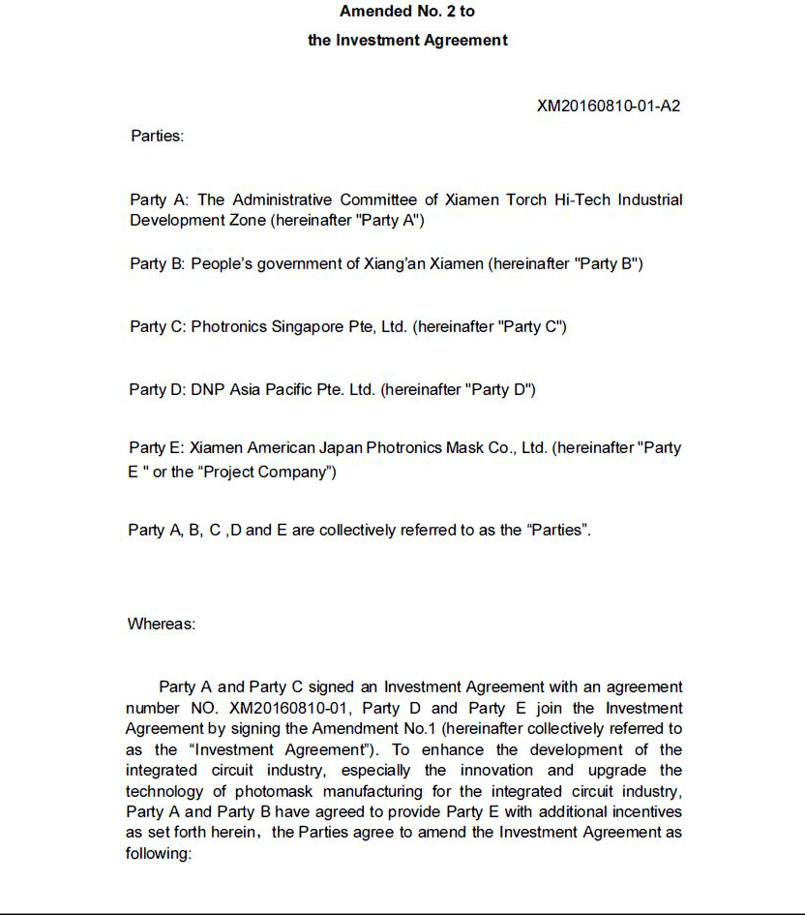

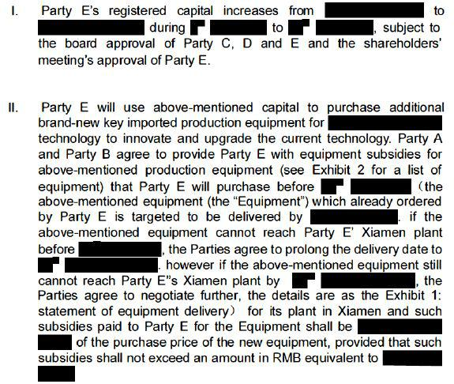

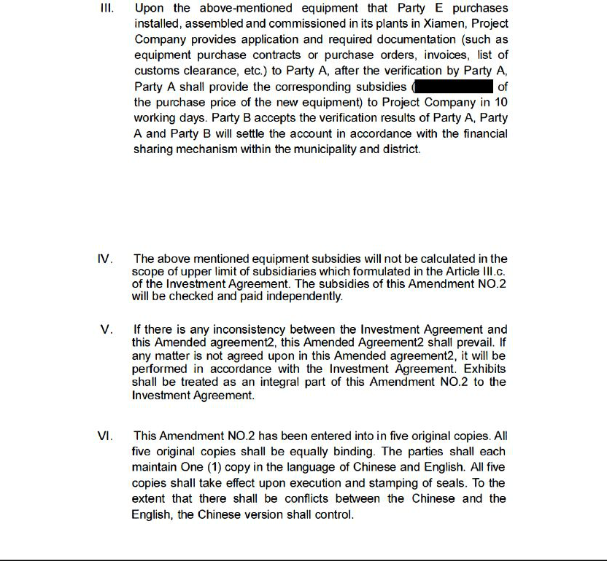

[SIGNATURE AND SEAL PAGE]

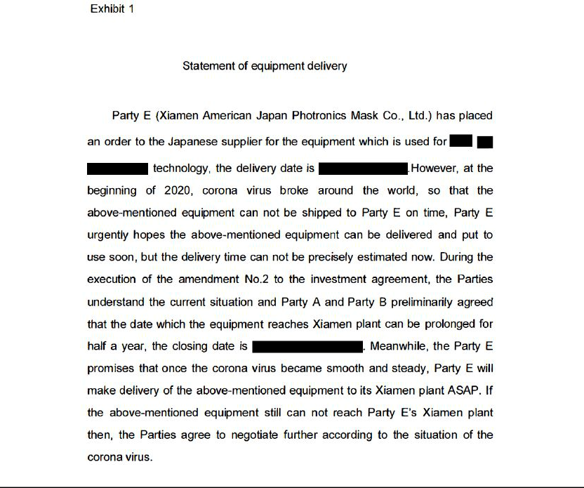

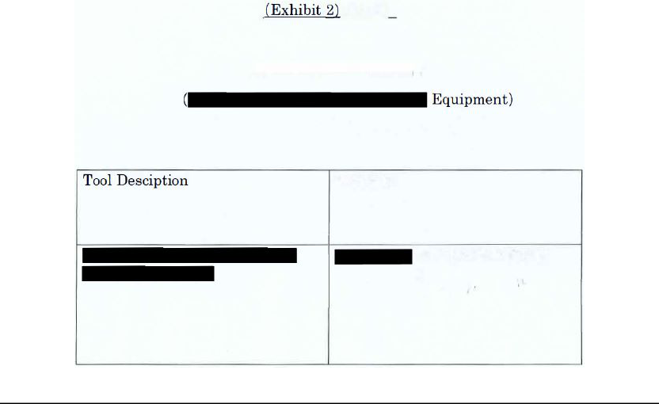

Exhibit 10.42
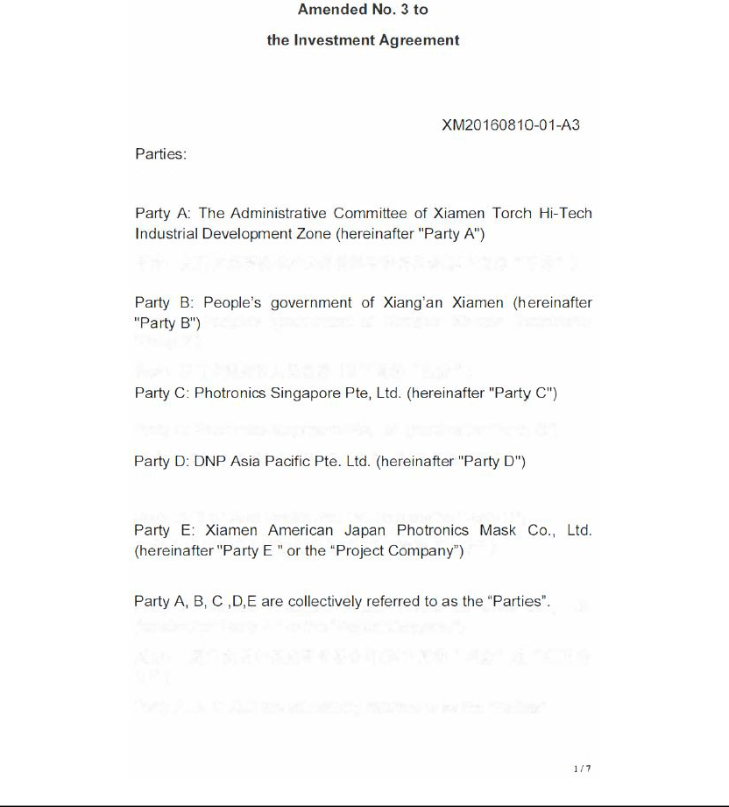

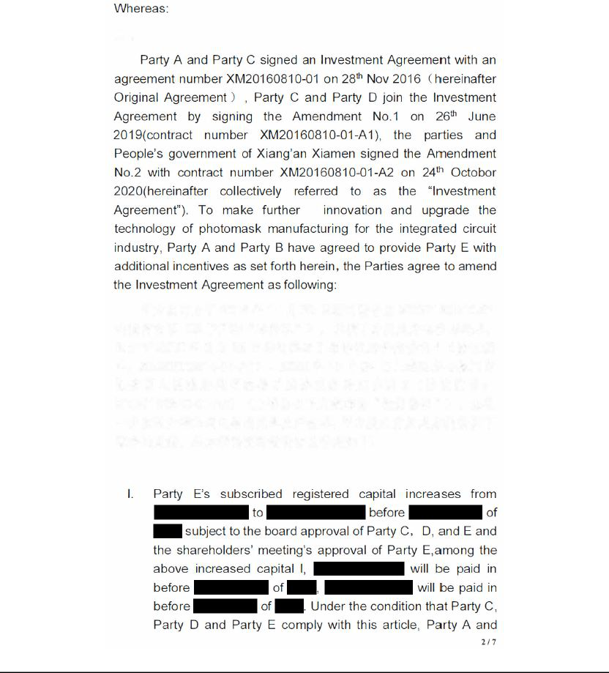

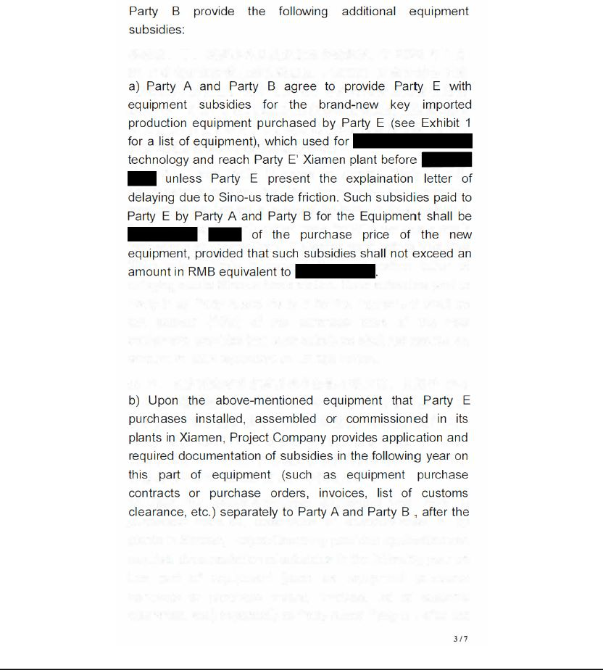

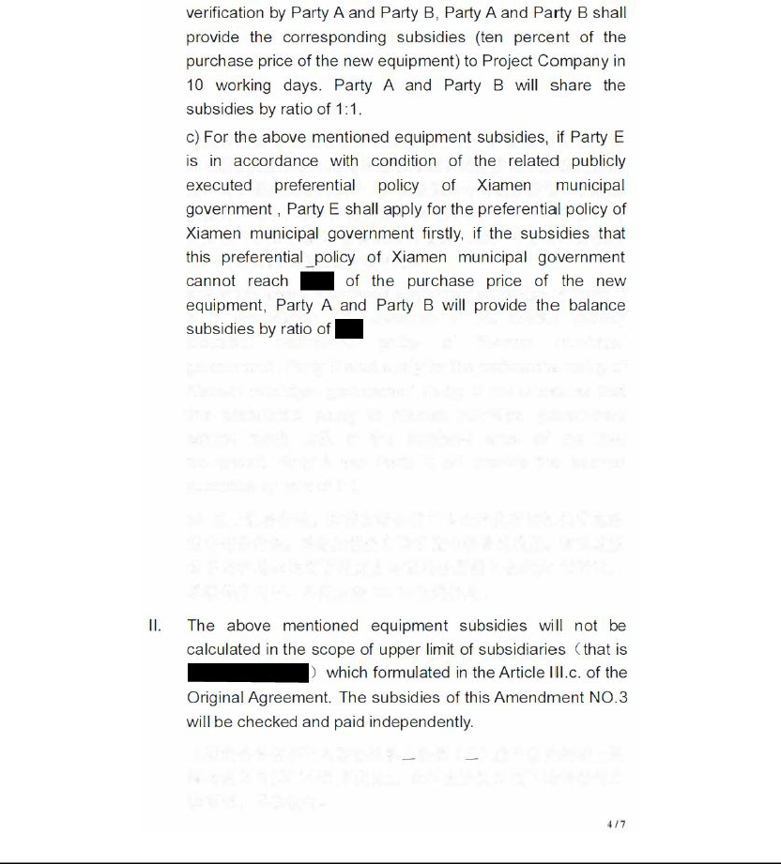

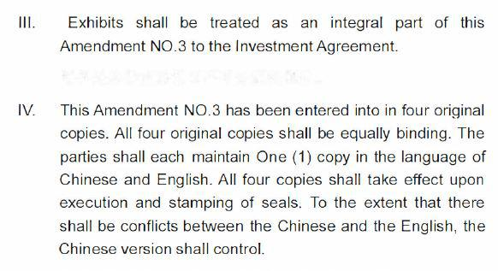

EXHIBIT 31.1

I, Peter S. Kirlin, certify that:

- I have reviewed this quarterly report on Form 10-Q of Photronics, Inc.

- Based on my knowledge, this report does not contain any untrue statement of a material fact or omit to state a material fact necessary to make the statements made, in light of the circumstances under which such statements were made, not misleading with respect to the period covered by this report.

- Based on my knowledge, the financial statements, and other financial information included in this report, fairly present in all material respects the financial condition, results of operations and cash flows of the registrant as of, and for, the periods presented in this report.

- The registrant’s other certifying officer and I are responsible for establishing and maintaining disclosure controls and procedures (as defined in Exchange Act Rules 13a-15(e) and 15d-15(e)) and internal control over financial reporting (as defined in Exchange Act Rules 13a-15(f) and 15d-15(f)) for the registrant and have:

  - designed such disclosure controls and procedures, or caused such disclosure controls and procedures to be designed under our supervision, to ensure that material information relating to the registrant, including its consolidated subsidiaries, is made known to us by others within those entities, particularly during the period in which this report is being prepared;

  - designed such internal control over financial reporting, or caused such internal control over financial reporting to be designed under our supervision, to provide reasonable assurance regarding the reliability of financial reporting and the preparation of financial statements for external purposes in accordance with generally accepted accounting principles;

  - evaluated the effectiveness of the registrant’s disclosure controls and procedures and presented in this report our conclusions about the effectiveness of the disclosure controls and procedures, as of the end of the period covered by this report based on such evaluation; and

  - disclosed in this report any change in the registrant’s internal control over financial reporting that occurred during the registrant’s most recent fiscal quarter (the registrant’s fourth fiscal quarter in the case of an annual report) that has materially affected, or is reasonably likely to materially affect, the registrant’s internal control over financial reporting; and

- The registrant’s other certifying officer and I have disclosed, based on our most recent evaluation of internal control over financial reporting, to the registrant’s auditors and the audit committee of the registrant’s board of directors (or persons performing the equivalent functions):

  - all significant deficiencies and material weaknesses in the design or operation of internal control over financial reporting which are reasonably likely to adversely affect the registrant’s ability to record, process, summarize and report financial information; and

  - any fraud, whether or not material, that involves management or other employees who have a significant role in the registrant’s internal control over financial reporting.

/s/ PETER S. KIRLIN

Peter S. Kirlin

Chief Executive Officer

March 9, 2022

EXHIBIT 31.2

I, John P. Jordan, certify that:

- I have reviewed this quarterly report on Form 10-Q of Photronics, Inc.

- Based on my knowledge, this report does not contain any untrue statement of a material fact or omit to state a material fact necessary to make the statements made, in light of the circumstances under which such statements were made, not misleading with respect to the period covered by this report.

- Based on my knowledge, the financial statements, and other financial information included in this report, fairly present in all material respects the financial condition, results of operations and cash flows of the registrant as of, and for, the periods presented in this report.

- The registrant’s other certifying officer and I are responsible for establishing and maintaining disclosure controls and procedures (as defined in Exchange Act Rules 13a-15(e) and 15d-15(e)) and internal control over financial reporting (as defined in Exchange Act Rules 13a-15(f) and 15d-15(f)) for the registrant and have:

  - designed such disclosure controls and procedures, or caused such disclosure controls and procedures to be designed under our supervision, to ensure that material information relating to the registrant, including its consolidated subsidiaries, is made known to us by others within those entities, particularly during the period in which this report is being prepared;

  - designed such internal control over financial reporting, or caused such internal control over financial reporting to be designed under our supervision, to provide reasonable assurance regarding the reliability of financial reporting and the preparation of financial statements for external purposes in accordance with generally accepted accounting principles;

  - evaluated the effectiveness of the registrant’s disclosure controls and procedures and presented in this report our conclusions about the effectiveness of the disclosure controls and procedures, as of the end of the period covered by this report based on such evaluation; and

  - disclosed in this report any change in the registrant’s internal control over financial reporting that occurred during the registrant’s most recent fiscal quarter (the registrant’s fourth fiscal quarter in the case of an annual report) that has materially affected, or is reasonably likely to materially affect, the registrant’s internal control over financial reporting; and

- The registrant’s other certifying officer and I have disclosed, based on our most recent evaluation of internal control over financial reporting, to the registrant’s auditors and the audit committee of the registrant’s board of directors (or persons performing the equivalent functions):

  - all significant deficiencies and material weaknesses in the design or operation of internal control over financial reporting which are reasonably likely to adversely affect the registrant’s ability to record, process, summarize and report financial information; and

  - any fraud, whether or not material, that involves management or other employees who have a significant role in the registrant’s internal control over financial reporting.

/s/ JOHN P. JORDAN

John P. Jordan

Chief Financial Officer

March 9, 2022

EXHIBIT 32.1

Section 1350 Certification of the Chief Executive Officer

I, Peter S. Kirlin, Chief Executive Officer of Photronics, Inc. (the “Company”), certify, to my knowledge, pursuant to Section 906 of the Sarbanes-Oxley Act of 2002, 18 U.S.C. Section 1350, that:

- The Quarterly Report on Form 10-Q of the Company for the quarter ended January 30, 2022 (the “Report”) fully complies with the requirements of Section 13(a) or 15(d) of the Securities Exchange Act of 1934; and

- The information contained in the Report fairly presents, in all material respects, the financial condition and results of operations of the Company.

The foregoing certification is being furnished pursuant to 18 U.S.C. § 1350 and will not be deemed “filed” for purposes of Section 18 of the Exchange Act, or otherwise subject to the liability of that section. Such certification will not be deemed to be incorporated by reference into any filing under the Securities Act or the Exchange Act, except to the extent that the registrant specifically incorporates it by reference.

/s/ PETER S. KIRLIN

Peter S. Kirlin

Chief Executive Officer

March 9, 2022

EXHIBIT 32.2

Section 1350 Certification of the Chief Financial Officer

I, John P. Jordan, Chief Financial Officer of Photronics, Inc. (the “Company”), certify, to my knowledge, pursuant to Section 906 of the Sarbanes-Oxley Act of 2002, 18 U.S.C. Section 1350, that:

- The Quarterly Report on Form 10-Q of the Company for the quarter ended January 30, 2022 (the “Report”) fully complies with the requirements of Section 13(a) or 15(d) of the Securities Exchange Act of 1934; and

- The information contained in the Report fairly presents, in all material respects, the financial condition and results of operations of the Company.

The foregoing certification is being furnished pursuant to 18 U.S.C. § 1350 and will not be deemed “filed” for purposes of Section 18 of the Exchange Act, or otherwise subject to the liability of that section. Such certification will not be deemed to be incorporated by reference into any filing under the Securities Act or the Exchange Act, except to the extent that the registrant specifically incorporates it by reference.

/s/ JOHN P. JORDAN

John P. Jordan

Chief Financial Officer

March 9, 2022

